

□**TEHMI NA AFZAL**

RESILIENCE

**CREATIVE CORNER**

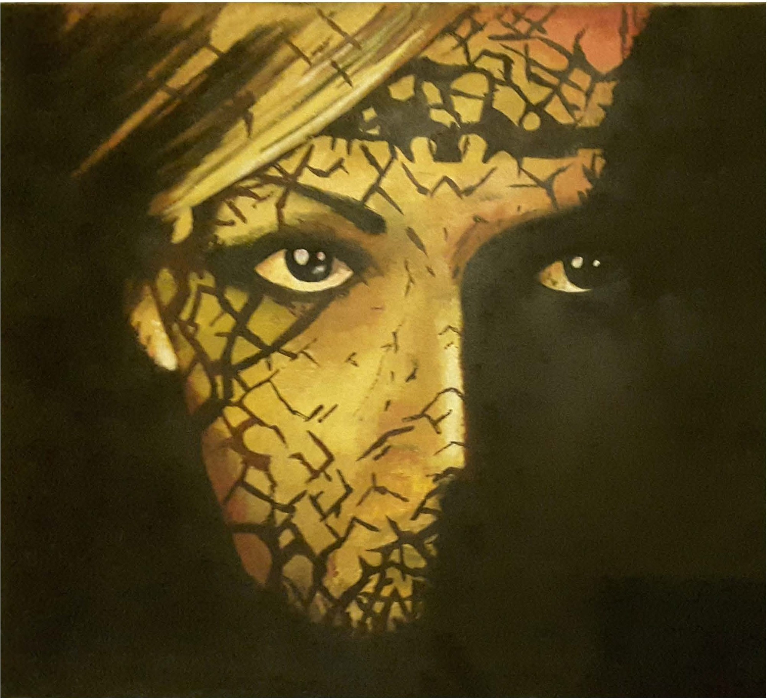

The artist has illustrated the self of a female in way to resilience. The marks and scars on the face depict the blows and wounds to the self resulted from social restrictions and gender discrimination. The focus in the eyes symbolizes the determination of the self in the face of oppression. The resilience is shown to be spreading from the nasion, healing the scars, hence gradually leading to complete resilience.

*PAGE 43 OCTOBER-DECEMBER 2015* I *VOLUME 12 NUMBER 4*