# EARLY RECOGNITION OF TRAUMATIC STRESS DISORDERS IN PRIMARY HEALTHCARE SETTINGS; CAN IT MAKE A DIFFERENCE?

YAQUB M., CORRIGAN F., RICHARDSON P., ROUTH R.

Argyll and Bute hospital, Scotland.

**CORRESPONDENCE: DR MEHBOOB YAQUB,** E-mail: [dr.yaqub@barchester.com](mailto:dr.yaqub@barchester.com)

## ABSTRACT

**OBJECTIVE**

To see whether the provision of specialist trauma focussed therapies (eye movement desensitisation & reprocessing and sensory motor psychotherapy) in secondary psychiatric services improved primary care clinicians' awareness and recognition of traumatic stress disorders or not.

### STUDY DESIGN

Retrospective study

### PLACE AND DURATION OF STUDY

The study was carried out in Argyll and Bute area of Scotland, United Kingdom from May 2008 to October 2008 for a period of 6 months.

### SUBJECTS AND METHOD

All the non-psychotic and traumatic stress disorders related referrals to the community mental health teams of four sectors (North Argyll, Mid Argyll, Kintyre and Cowal) from primary care clinicians were compared. North Argyll and Mid Argyll were the two areas where specialist trauma focussed therapies were available to patients.

### RESULTS

North Argyll had significantly higher number of traumatic stress related referrals as compared with the other three areas (p=0.001), but number of overall non-psychotic referrals were highest not in North Argyll but in Kintyre (p=0.018).

### CONCLUSION

Improved awareness and recognition of traumatic stress disorders in North Argyll appeared to be due to specialist traumatherapiesavailable in thisarea, acting as an indirect awareness raising activity. Direct awareness raising interventions can improve recognition of traumatic stress disorders in other areas as well, resulting in rapid access of clients to relevanttreatments.

### KEYWORDS

Post-traumatic stress disorder, EMDR, Sensory motor psychotherapy.

## INTRODUCTION

Posttraumatic stress disorder (PTSD) causes significant psychological and physical distress among patients. Stein MB, et al. reported that 11.8% primary care attendees met diagnostic criteria for PTSD1 2 Early recognition of common disorders like PTSD is important as this helps access to appropriate treatment early during the course of illness. This in turn reduces the burden on medical as well as psychiatric services because traumatised patients are often high utilizers of medical care'·'. Awareness among primary care clinicians for early identification and intervention is also vital' as early attention to psychological trauma can even help to prevent PTSD in high risk populations, while early treatment of PTSD can prevent it from becoming a chronic illness•.

Research has shown that psychological trauma is frequently overlooked in primary care *1 11* Service user level (fear of retribution, guilt, shame, low self­ esteem, learned helplessness) and provider level barriers (education deficit, time constraints, physician discomfort addressing violence, misunderstanding of patient needs, lack of awareness and limited knowledge of PTSD resources and treatment) contribute to poor identification of psychological trauma related disorders". Many studies have stressed the importance of improved screening for traumatic events and PTSD"·" in primary as well as secondary care in order to identify these treatable conditions early to prevent patients' sufferings from chronic and complex condition". One of the challenges to early recognition is the variable presentation of traumatic stress disorders". In some cases presenting symptoms are not severe enough to reach the diagnostic threshold, hence referred to as sub-threshold PTSD'•. This can pose further difficulties to prompt recognition of psychological trauma as well as anxiety and depressive disorders which are aetiologically based in trauma. In our study, we investigated whether primary care clinicians, who saw the benefits of treatment of Traumatic stress disorders, could recognise psychological trauma better among patients under their care. We compared the referral patterns in the four geographical sectors of Argyll and Bute council in Highlands of Scotland (figure 1). Unlike Kintyre and Cowal, North Argyll and Mid Argyll provided specialist trauma therapies namely eye movement desensitization and reprocessing (EMDR)11 1 and sensory-motor psychotherapy (SP)19•

Over a period of ten years, the North Argyll sector Consultant Psychiatrist, Psychiatric trainees, during their posting, if chose to train in specialist trauma therapies, four community psychiatric nurses (CPNs) in North Argyll and two CPNs in Mid Argyll had voluntarily trained and been offering specialist trauma therapies *11•* 1 1 None of the primary care practices in all four study areas had received any training or direct awareness raising information about diagnosis of traumatic stress disorders, apart from

*OCTOBER· DECEMBER 2016* I *VOLUME 13 NUMBER 4 PAGE25*

|  |  |
| --- | --- |
|  | letters from clinicians about diagnosis and treatment. This provided questionnaires to the researchers in the pre-addressed and pre­ an opportunity to assess whether provision of such therapies in these stamped envelopes.Patients unwilling to participate did not need to two areas (North and Mid Argyll) had any effect on referrers' ability to respond at all. The only information about participants available to identify psychological trauma any differently as compared to other researchers was the area they belonged to as additional approvals two areas, reflected by relative differences, if any, in number of were required for researchersbased in one area to access identifiable referrals from Primary care. information of patients in other areas. As such there was no way to know whether the patients who sent the questionnaires back were  **Figure I** the same as identified by their referring doctors as suffering from  Argyll and Bute in Highlands of Scotland traumatic stressrelated disorders.  11 patients were excluded from the sample due to alcohol and illicit drugs use as main problems according to referral letters from primary care (4 from North Argyll, 3 from Cowal and 4 from Kintyre). The population estimates for the four areas of our study were taken from Scottish neighbourhood statistics20 and these were 19960, 7933, 10233 & 15343 for North Argyll, Mid Argyll, Kintyre and Cowal respectively.  Hence,the collected data included the following:   1. Population estimates for the four areas 2. The number of non-psychotic referrals to the CMHTs 3. The number of responses from the patients who believed that   **SUBJECTSAND METHODS** their main problems were due to psychological trauma.  **Participants Instrument**  The four sectors selected for our study (figure 1) are predominantly The questionnaire selected for our study was the 20 item version of rural and are part of a single local authority council along the west the Centrality of Events Scale (CES) which has a high reliability (a= coastal line and are known to have demographic characteristics .94) and a good correlation with the symptoms of PTSD". comparable to the rest of Scotland according to Scottish Questionnaires were used to increase the validity of the participants' neighbourhood statistics (an internet based resource by the Scottish responses about their problems, instead of a simple 'yes' or 'no' government)'". Argyll and Bute hospital is a central inpatient facility response to the question of having history of significant while the outpatient services were provided separately in each of psychological trauma. The participants were asked to complete the these sectors within the community mental health teams' (CMHTs) questionnaire if they had a significant psychological trauma in the bases. An area covered by a single community mental health team past and they believed that the trauma was significantly contributing was considered as one sector for ease of collection and handling of to their current mental health issues. If there was more than one data in our study because North Argyll (NA) and Kintyre were covered traumatic incident, the participants were asked to fill in the by two community teams each. So the area with the larger questionnaire in relation to the event perceived to be most serious. population size was selected. Following Ethics approval, we The questionnaires were sent to all the individuals at the same time reviewed case notes and studied all the referrals to the CMHTs from and they were requested to respond within 4 weeks of the date of May 2008 to October 2008 for a period of 6 months retrospectively. issue of the questionnaires.  One doctor from each of these teams studied the referral letters from  primary care to the CMHTs and recorded the stated reasons for **Procedure**  referrals by the referring clinicians. These reasons for referrals were  used as the provisional diagnoses given by the referring clinicians. The data was analysed on SPSS vl 7. Using the estimated population  of these areas, expected non-psychotic and expected trauma-related All the non-psychotic provisional diagnoses were included. referrals were calculated to analyse observed number of referrals Patients with cognitive deficits were excluded. against the expected number. The expected number of referrals was Patients with the main problems of alcohol and/or other calculated as part of chi square analysis taking in to account the size substance misuse disorders with or without co-morbid of the local population of each of these four areas.  psychiatric conditions were excluded.  **RESULTS**  The relevant community mental health teams then sent  questionnaires to all the 'non-psychotic' patientsoftheirown sectors A total of 223 patients were identified from the primary care along with consent forms and covering letters. The patients were clinicians' letters as being referred for a 'non-psychotic problem' requested to fill in the questionnaires if they were willing to following application of exclusion and inclusion criteria. Out of these participate and believed that their problems were mainly because of non-psychotic patients, 31 were referred specifically for  their past psychological trauma(s). Participants sent consent forms psychological trauma as their main problems (table 1).  back to their own community mental health teams and |
| *PAGE26 OCTOBER-DECEMBER 2016* I *VOLUME 13 NUMBER 4* |

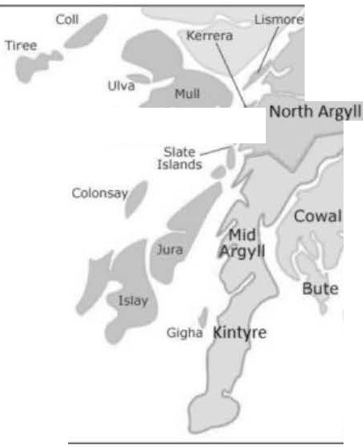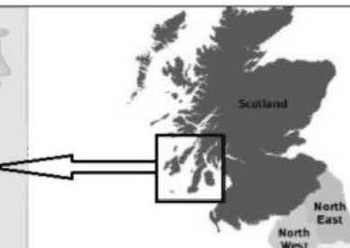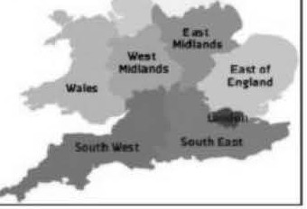

**Table** I

The higher number of psychological trauma related referrals did not

Observed vs Expected non-psychotic and traumatic stress related referrals in the 4 areas

|  |  |  |  |
| --- | --- | --- | --- |
| **Overall Non-psychotic referrals** | | | |
| **Region** | **Observed N** | **Expected N** | **Residual** |
| Kintyre | 56 | 42.7 | 13.3 |
| NA | 90 | 83.2 | 6.8 |
| MA | 21 | 33.1 | -12.1 |
| Cowal | 56 | 64.0 | -8.0 |
| Total | 223 |  |  |
| X'(3) = 10.12, p = 0.018  Kintyre (and North Argyll to a lesser degree) has proportionately more referrals than expected | | | |
| **Traumatic stress related referrals** | | | |
| **Region** | **Observed**  **N** | **Expected**  **N** | **Residual** |
| Kintyre | I (0) | 6.1 | -5.1 |
| NA | 23 | 11.9 | II.I |
| MA | 2 | 4.7 | -2.7 |
| Cowal | 6 | 9.2 | -3.2 |
| Total | 32 (3I) |  |  |
| X'(3)= 17.211, p=0.001  orth Argyll has proportionately more such referrals than expected as compared to the other 3 regions | | | |

As evident from the analysis, there is a significant difference in the frequency of non-psychotic referrals across the four regions with Kintyre having the highest number of observed as compared with the expected. However, the referrals for psychological trauma were significantly higher in North Argyll as compared with the other three sectors. When the number of non-psychotic referrals in North Argyll was compared separately with Kintyre and the other two (Mid Argyll and Cowal), North Argyll's total non-psychotic referrals were neither significantly higher than Mid Argyll and Cowal (figure 2), nor significantly less than Kintyre (p=0.2558).

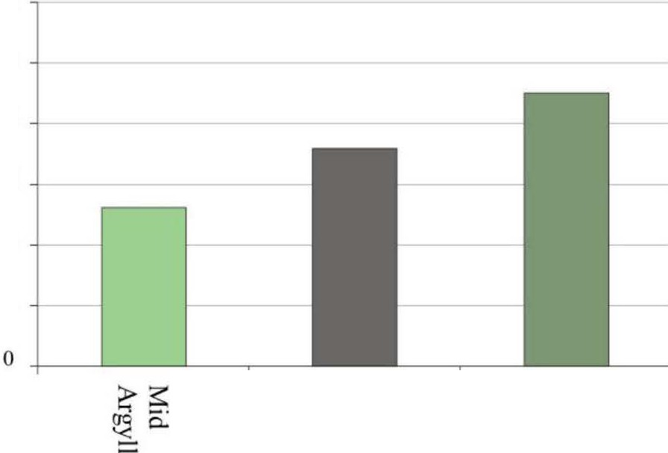

*Fig11re2: Comparison of the ratios a/referrals ro the area poplllatio11of the 11011 psychotic referrals in Mid Argyll (21), Cowal (56), North Argyll (90){p=0.0658]*

significantly increase the net non-psychotic referrals in North Argyll, although the non psychotic referrals were still more than the expected proportion of the sector's population. The figure 3 demonstrates that within the observed overall non-psychotic referrals, North Argyll primary care doctors were identifying psychological trauma significantly more than those in the other three sectors.

*Figllre3: Comparison of the 11011-psychotic & psychalogica/ trauma referrals as proportion of the area pop11/ario11. Nllmber ofpsyc/wlogica/ trauma referrals:*

*Total 31 (our of 223), Mid Argyll (2 Olli of 21). Cowal (6 ollt of 56), Ki11tyre*

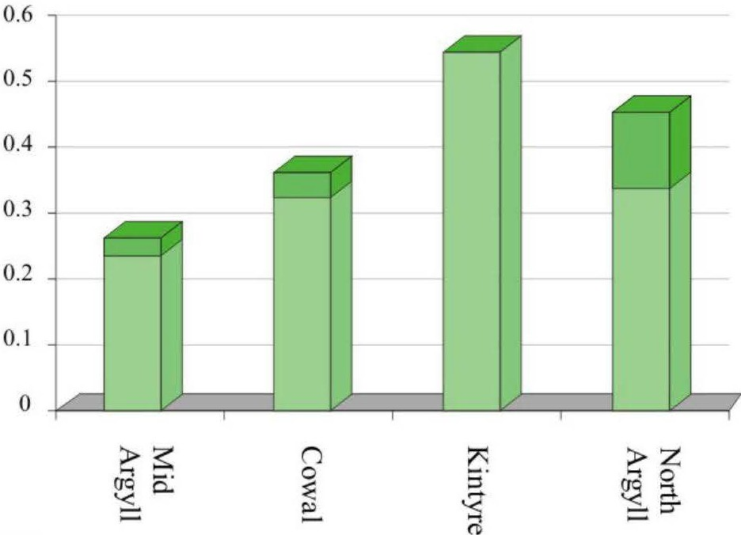

* **Psych trauma Non psychotic**

*(0 ourof 56). North Argyll (23 ouro/90)*

The 33 participants who responded with completed questionnaires (table 2) were 20-70 years of age and included 14 males and 19 females. There was one patient who wrote to the CMHT that he did not want to complete the questionnaire as it reminded him of his traumatic past so he was not included.

**Table 2**

Patients' perception of their problems being due to psychological trauma (questionnaires returned)

|  |  |  |  |
| --- | --- | --- | --- |
| **Region** | **Observed** | **Expected N** | **Residual** |
| Kintyre | I | 6.3 | -5.3 |
| North Argyll | 22 | 12.3 | 9.7 |
| Mid Argyll | 2 | 4.9 | -2.9 |
| Cowal | 8 | 9.5 | 1.5 |
| Total | 33 |  |  |
| X'(3) = 14.02, p = 0.003,North Argyll bas proportionately more questionnaires returned than expected. | | | |

## DISCUSSION

Our geographical area of study was a mix of urban and rural areas similar to other rural and urban areas nationally20 (e.g., working age population, employment deprivation, prescription for mental illnesses, hospital admissions). These four areas of the same council

*OCTOBER-DECEMBER 2016* I *VOLUME 13 NUMBER 4 PAGE27*

were also comparable demographically and in terms of provision of the mental health care except the provision of specialist trauma focussed therapies in two of the areas. The results showed that the overall non-psychotic referrals from primary care clinicians were not proportionate to the area population and the identification of traumatic stress related problems. Primary care clinicians in North Argyll clearly identified significantly more patients with traumatic stress related problems as compared with other three areas. The results also showed that the significantly more identified cases of traumatic stress related problems did not increase the total number of the non-psychotic referrals, implying that clinicians in other three areas were not identifying the traumatic stress related problems in their patients. Moreover, there were no known significant large scale traumatic events in past, suggesting against any possibility of increased prevalence of traumatic stress disorders in North Argyll alone. Searches from the local council archives and Scottish fire and rescue service data (accessed under The Freedom of Information, Scotland Act 2002) confirmed it. Hence this difference seems highly likely to be a reflection of better identification rather than increased prevalence of traumatic stress disorders in North Argyll which can be best explained by availability of specialist trauma focussed therapies in the absence of any other known awareness-raising interventions in North Argyll.

These results also indicates that referrers in other three areas (Mid Argyll, Kintyre and Cowal) did identify patients in need of further assessment by secondary care psychiatric services (hence comparable overall non-psychotic referrals) but a significant number of patients with traumatic stress disorders may instead have been referred with other non-psychotic provisional impressions. This raises further possibility of this group of patients receiving treatment for conditions they actually did not suffer from, at least until they were referred to the secondary care services. So a significant number of individuals in Mid Argyll, Kintyre and Cowal may have otherwise been suffering in the community for a long time without appropriate evidence based treatment for traumatic stress disorders including PTSD. Delays in treatment of such disorders do have a known adverse impact on overall productivity in life"·". Earlier identification of traumatic stress disorders could allow primary care clinicians to start appropriate pharmacological treatment and also allow them to refer these patients for psychological therapy early which is the mainstay of treatment". Such patients can also result in an additional burden on the healthcare system when there are delays in identifying the problem correctly and symptoms are treated ineffectively as suggested by some studies that this group of patients are high utilizers of medical care'-' as well. Further research is required to specifically study the cost of delay in recognition and treatment of traumatic stress disorders.

The provision of specialist trauma therapy in Mid Argyll region did not appear to have any significant impact on the identification of psychological trauma in primary care. This can be explained by the fact that none of the psychiatrists in Mid Argyll was involved in specialist trauma therapy. In contrast, in North Argyll, detailed letters were sent to the general practitioners following assessments and treatment sessions, providing the referrers with information about the problems and management of their patients. This is a standard practice among medical/clinical staff in all localities. While non­ medical staff would document details of the treatment sessions in

the case notes retained in secondary care, communication through letters to the general practitioners about these sessions did not take place even though the specialist trauma focussed therapies were provided to some patients.

## CONCLUSION

North Argyll had a significantly higher number of referrals of patients suffering from traumatic stress disorders including PTSD. Considering the comparable overall non-psychotic referrals to other three areas (figure 3), this difference can be attributed to increased awareness among referrers who recognised these conditions better which are amenable to treatment with the specialist trauma therapies provided in North Argyll area area. There is a need to raise the awareness among primary care clinicians in the other three areas, to allow early identification and effective treatment of patients with traumatic stress disorders. This better awareness in North Argyll was achieved through a slow process of treating effectively many patients over a period of few years but direct awareness-raising activities and trainings in all four areas could help not only to improve this process further in North Argyll, but also help the early identification of potentially treatable conditions in other three areas.

## LIMITATIONS AND SUGGESTIONS

There were some methodological limitations in our study. We used only the GP referral letters for provisional impressions, as all doctors are trained to have a basic understanding of psychiatric illnesses"during undergraduate medical education. Hence the referrals from non-medical professionals were not included. Despite this method's benefit of providing a degree of validity to the provisional impressions, loss of some of the cases due to lack of identification can not be ruled out. However, the fact that the patients' responses were not less in number as compared with the referrals from primary care clinicians, reflects that even if the patients identified by primary care clinicians were to be different from the patients who responded, inclusion of all the cases would have meant a larger number of patients suffering from traumatic stress which were not being identified. Diagnostic interviews for dual diagnosis'• in patients with substance misuse problems could not be carried out because researchers needed further approvals to approach patients of CMHTs they were not based at and this could cause delay in starting study possibly to the point of two researchers to rotate to areas outside the study area as part of their training, making it impossible to carry of the study as per ethics approval conditions. Potentially this may have led to loss of some cases of PTSD or other trauma-related conditions. Patients' previous or current case notes were not used to getthe final diagnoses as in many cases the patients were only assessed by the members of the teams who were not trained to make formal diagnoses (e.g.,nurses). For researchers or an independent interviewer to be able to make formal diagnosis, patient contact was necessary, which was not possible due the ethics approval conditions forthis study and time constraints.

Since independent diagnostic interviews of the referred patients were not carried out, we considered the service users' impressions to compare with the number of referrals from primary care clinicians. To increase the validity of the service users' self impression, questionnaires with fairly good correlation to symptoms of PTSD

*PAGE28 OCTOBER· DECEMBER 2016* I *VOLUME 13 NUMBER 4*



were used".This method also had its limitation because it is possible that some of the patients referred by the GPs did not respond at all while some participants not identified by the GPs as having trauma­ related conditions may have responded with questionnaires. If this happened at all, it could be argued that this was likely to have affected the data from all the four areas similarly. Unfortunately, analyses between number of referrals with traumatic stress related conditions by referring clinicians and patients' responses could not be carried out reliably due to small sample sizes (table 2) and a further study with larger sample size and a closer comparison between the two may provide more useful information in this regard.

**REFERENCES**

1. Stein MB, McQuaid JR, Pedrelli P, Lenox R, McCahill ME. Posttraumatic stress disorder in primary care medical setting. Gen Hosp Psychiatry.2000; 22: 261-269.
2. Mcfarlane AC, Atchison M, Rafalowicz E, Papay R. Physical symptoms in post-traumatic stress disorder. Journal of psychosomatic research. 1994; 38: 715-726.
3. Walker EA, Gelfand A, Katon W, et al: Adult health status of women HMO members with histories of abuse and neglect. Am J Med. 1999; 107: 332-339.
4. McCauley J, Kern DE, Kolodner K, Derogatis LR, Bass EB. Relation of low-severity violence to women's health. J Gen Intern Med. 1998; 13:687-691.
5. McNally RJ, Bryant RA, Ehlers A. Does early psychological intervention promote recovery from posttraumatic stress? Psychological Science in the Public Interest. 2003; 4: 45-79.
6. Litz BT, Gray MJ, Bryant RA, Adler AB. Early intervention for trauma: Current status and future direction. Clinical Psychology: Science and practice.2002; 9:112-134.
7. Simpson TL, Westerberg VS, Little LM, Trujillo M. Screening for childhood physical and sexual abuse among outpatient substance abusers. Journal of Substance Abuse Treatment. 1994; 11:347-358.
8. Jacobson A, Richardson B. Assault experiences of 100 psychiatric inpatients: Evidence of the need for routine inquiry. Am J Psychiatry. 1987; 144: 908-913.
9. Davidson JR. Recognition and treatment of posttraumatic stress disorder. JAMA 2001; 286: 584-8.
10. Amaya-Jackson L, Davidson JR, Hughes DC, Swartz **M,** Reynolds V, George LK, Blazer DG. Functional impairment and utilization of services associated with posttraumatic stress in the community. J Trauma Stress. 1999; 12: 709-24.
11. Zimmerman **M,** Mattia JI. Is posttraumatic stress disorder underdiagnosed in routine clinical settings? Journal of Nervous & Mental Disease. 1999; 187: 420-428.
12. Freedy JR, Brock CD. Spotting and treating PTSD in primary care. The journal of family practice. 201O; 59 (2):75-80.
13. Brady KT. Posttraumatic stress disorder and comorbidity: recognizing the many faces of PTSD. J Clin Psychiatry 1997; 58 (suppl 9): 12-5.
14. Lange JT, Lange CL, Rex B.G. Primary Care Treatment of Post­ traumatic Stress Disorder. American family physician. 2000; 62: 1035-40.
15. Cantor C, Price J. Traumatic entrapment, appeasement and

complex post-traumatic stress disorder: evolutionary perspectives of hostage reactions, domestic abuse and the

Stockholm syndrome. Australian and New Zealand Journal of Psychiatry. 2007;41: 377-84.

1. Grubaugh AL, Magruder KM, Waldrop AE, Elhai JD, Knapp RG,

Frueh BC. Sub threshold PTSD in primary care prevalence, psychiatric disorders, healthcare use, and functional status. Journal of Nervous and Mental Disorders. 2005; 193: 658-664.

1. Shapiro F. Efficacy of the eye movement desensitization procedure in the treatment of traumatic memories. Journal of Traumatic Stress Studies.1989; 2: 199-223.
2. Shapiro F. Eye movement desensitization: A new treatment for post-traumatic stress disorder. Journal of Behavioural Therapy and Experimental Psychiatry. 1989; 20: 211-217.
3. Odgen P, Pain C, Fisher J. A sensorimotor approach to the

treatment of trauma and dissociation. Psychiatric Clinics of North America. 2006; 29: 263-279.

1. Scottish Neighbourhood Statistics. <http://www.sns.gov.uk/> default.aspx
2. Berntsen D, Rubin DC. The centrality of event scale: A measure of integrating a trauma into one's identity and its relation to post­ traumatic stress disorder symptoms. Behaviour Research and Therapy. 2006;44:219-231.
3. Boscarino JA, Adams RE, Figley CR. Worker productivity and outpatient service use after the September 11th attacks: results from the New York City terrorism outcome study. Am J Ind Med. 2006;49(8):670-82.
4. Shelby RA, Golden-Kreutz DM, Andersen BL. PTSD diagnoses, subsyndromal symptoms, and comorbidities contribute to impairments for breast cancer survivors. Journal of Traumatic Stress. 2008; 21(2): 165-172.
5. NICE Guidelines.<http://www.nice.org.uk/CG26>
6. Crisp A.Psychiatric contributions to the undergraduate medical curriculum. Psychiatric Bulletin 1994; 18: 257-9.
7. Boudewyns PA, Hyer L, Albrecht JW, Woods MG. Chronic combat-related PTSD and concurrent substance abuse: Implications for treatment of this frequent "dual diagnosis". Journal ofTraumaticStress. 1991;4(4): 549-560.

*OCTOBER-DECEMBER 2016* I *VOLUME 13 NUMBER 4 PAGE29*