

**C. E:Af IVE: CORNE-R**

BIPOLARAFFECTIVE DISORDER

**ASMA ARSHAD**

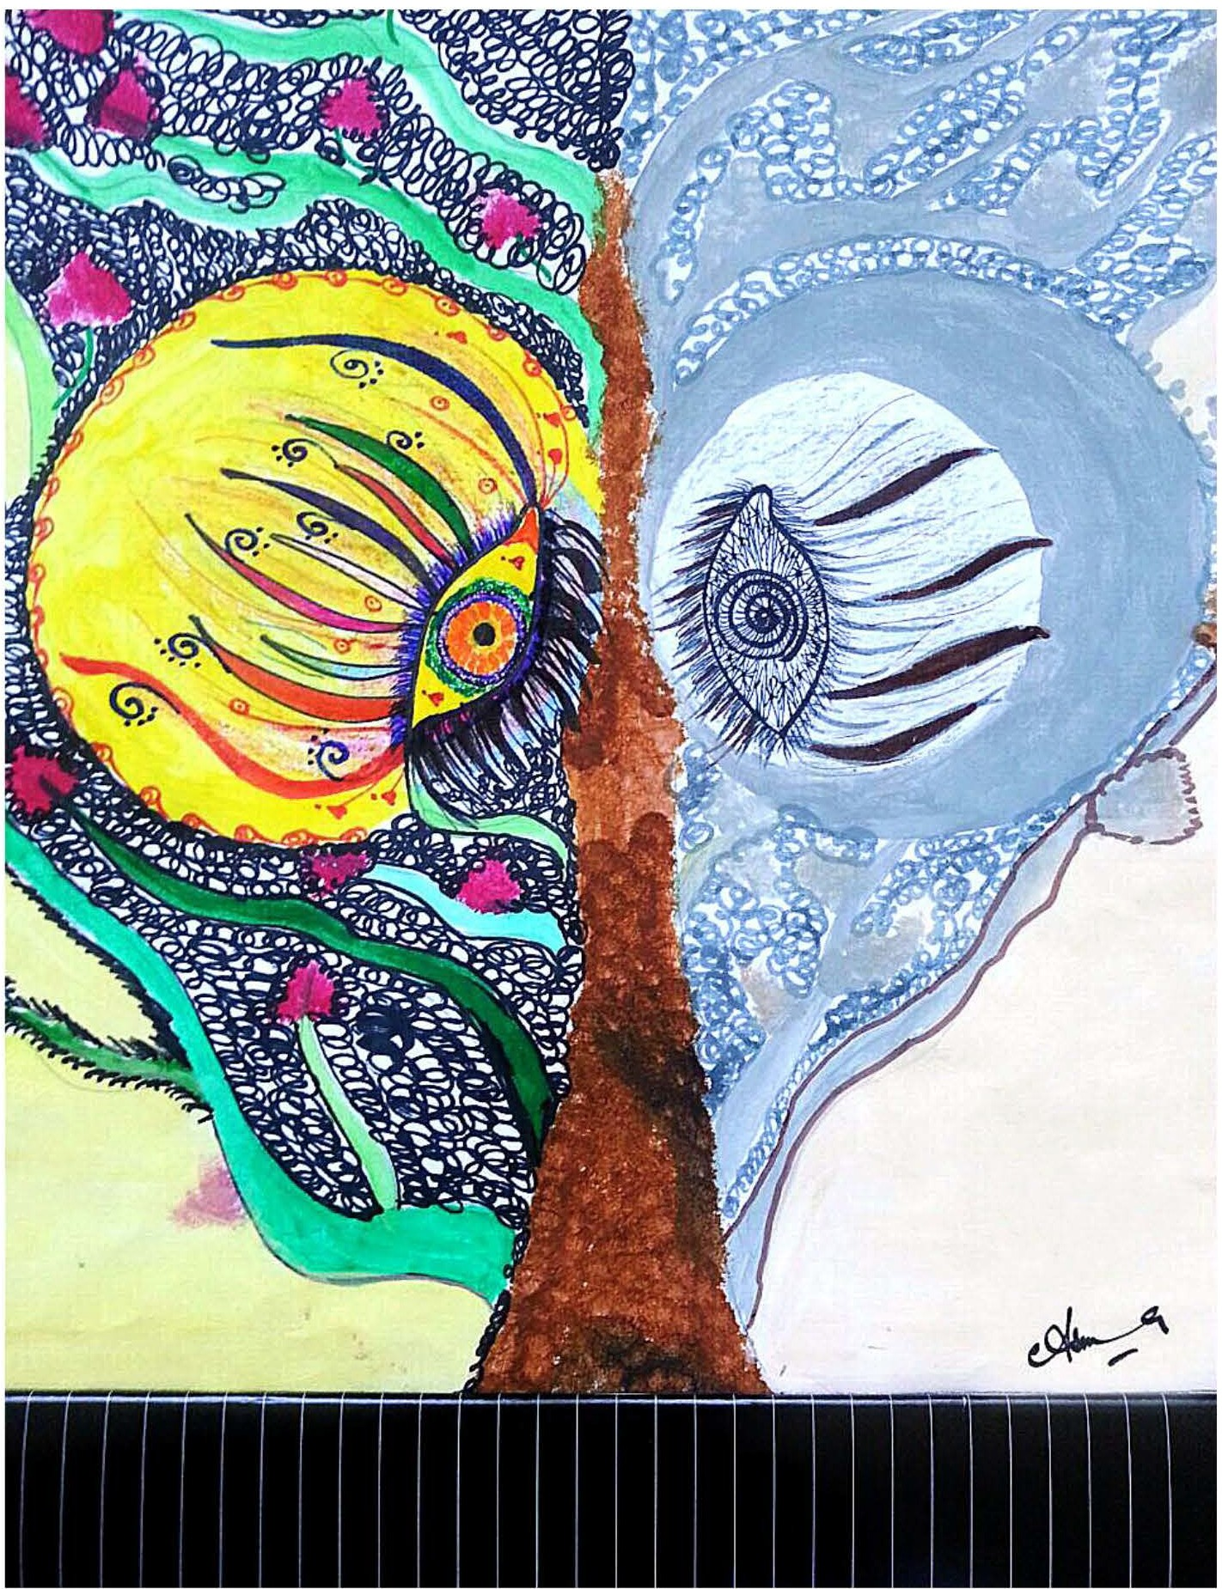

This illustration is based on the idea of bipolar disorder, mental condition marked by alternating periods of elation and depression. Colorful side of delineation is presentation of elevated mood and other is of low mood.

*JULY-SEPTEMBER 2015* I *VOLUME 12 NUMBER 3 PAGE 40*