□HISTRIONIC PERSONALITY DISORDER

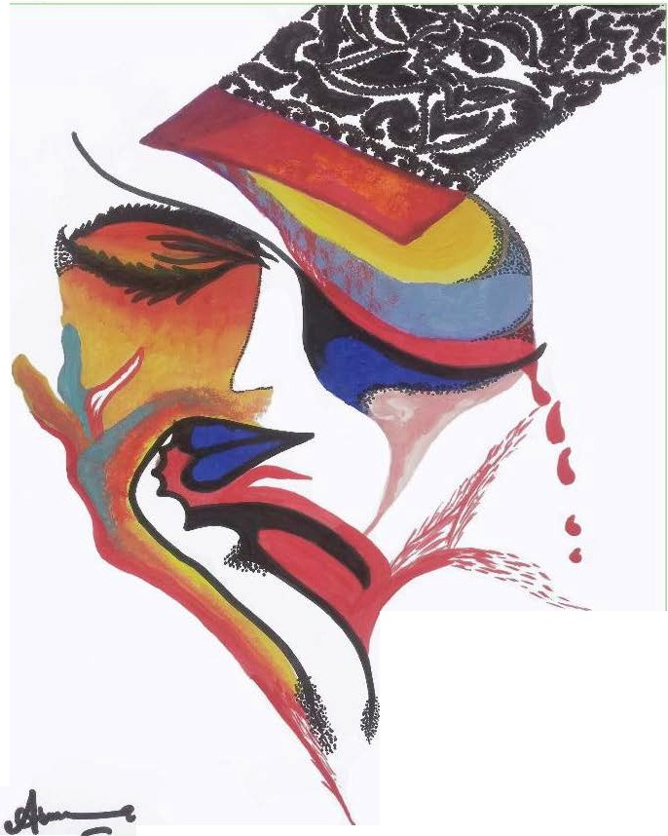

**Asma Bajwa**

The pamt1n9 indicates the emblems of histrionic personality disorder. Basically I tried to depict thephenomenon ol self indulgence for excessive need of approval and to be the focus of others attention. To gratify this **unrestrained need becomes dramatically vivacious and flirtatious makes loud and in** appropriateappearances.

**Asma Bajwa**

*JAN(IA.flY.MA.ROI J'11* I *VO/I/MF 17 NIIMRFR 1*