

□HOPE

**HOORIA KHAWAR**

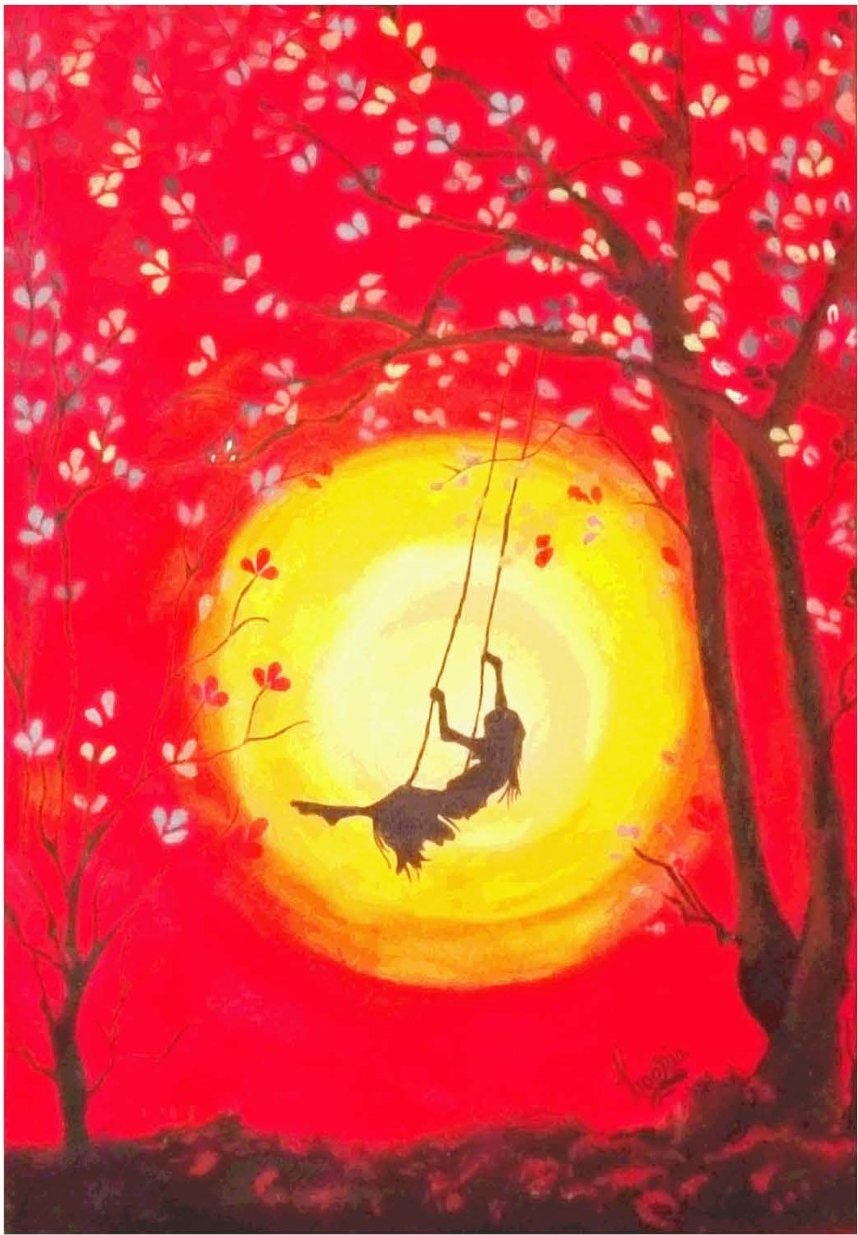

"An image of hope that has failed the words; a self explanatory convergence of hope from image in the eyes to meaning in the mind.

*PAGE40 APRIL -JUNE 2016* I *VOLUME 13 NUMBER 2*