**CREATIVE CORNER**

**NIGHTMARE**



**ISHRAT**

National Textile University, Faisalabad.

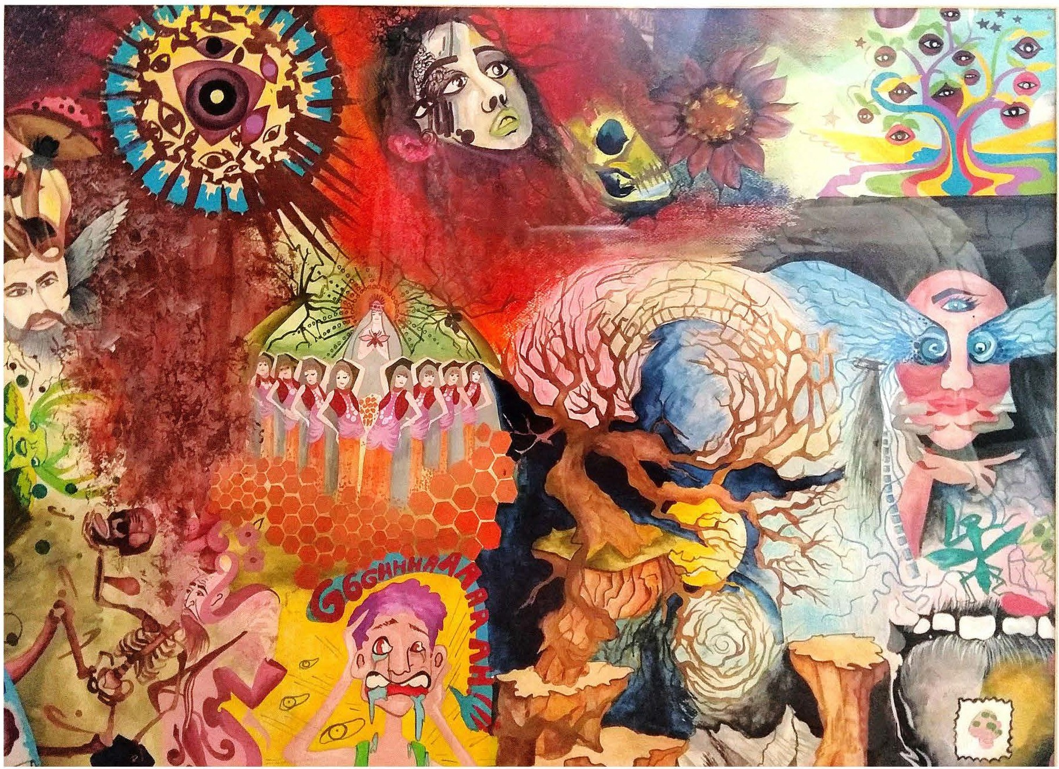

lshrat has named her art as nightmare.Illustration is said to be a pictorial expression of her personalized experience of bad dreams. The depiction representsbizarre ideas, fears, scary scenes, and fright thattogether composeaperfect nightmare.Image isa too fitting display of a trailof adverse possibilitiesof bad happenings that may jeopardize the refreshing serenity of the sleep.

*APRIL -JUNE 2019* I *VOLUME 16 NUMBER 2 PAGE41*