ORIGINAL ARTICLE

**FRONTLINE STAFF PERCEPTIONS OF THE SAFEWARDS MODEL ON A FORENSIC PSYCHIATRIC UNIT IN CANADA**

## TARIQ HASSAN1, BRITTANY BISHOP2, IMTIAZ DOGAR3, NIALL GALBRAITH4

1Department of Psychiatry, Queen's University, Kingston, Canada

2Trent University, 1600 West Bank Drive Peterborough, Ontario, Canada

3Department of Psychiatry & Behavioral Science, Faisalabad Medical University, Faisalabad

4Department of Psychology, University of Wolverhampton, UK.

Submitted: June 02, 2021

Accepted: December 21, 2021

**CORRESPONDENCE: DR. TARIQ HASSAN** E-mail: [hassant@providencecare.ca](mailto:hassant@providencecare.ca)

# ABSTRACT

## OBJECTIVE

To obtain feedback regarding the Safewards program from frontline staff on an inpatient forensic unit, in order to determine their opinions if the program was effective, and how the program could be improved.

## STUDY DESIGN

Qualitative study design.

## PLACE AND DURATION OF THE STUDY

The study was carried out at Forensic Psychiatric Unit in Canada, during a period of three months (1st January 2020 to 31st March 2020).

## SUBJECTS AND METHODS

All psychiatric nurses and other frontline staff on the Forensic unit of a psychiatric hospital were invited to participate in a voluntary, anonymous, semi-structured interview with a research student.

## RESULTS

The majority of staff expressed that Safewards is an effective and useful program that was worth the time it took to implement, and expressed some suggestions for improvement.

## CONCLUSION

More experienced staff are more likely to feel that the program is unnecessary, and newer staff are more likely to feel that they lack sufficient training.

## KEY WORDS

Safewards model, frontline staff, Forensic Psychiatric Unit.

# INTRODUCTION

In a Forensic Psychiatric Ward, safety of staff and patients need to be a top priority. Patient's aggression, self-harm and violence can pose serious risks to staff and patients, and can lead to containment methods such as physical or chemical restraints to control these types of conflicts. Safewards is a program designed for inpatient psychiatric wards that attempts to better understand and model why these conflict and containment events arise, and provides interventions that can be implemented on the ward to attempt to reduce the number of incidents.1,2 A number of studies have shown the effectiveness of Safewards in reducing the number of conflict and containment events in both general and forensic psychiatric wards.3-6

One randomized controlled trial involving 31 different acute psychiatric wards found that after implementing the 10 Safewards interventions, rates of conflict were reduced by 15%, and rates of containment were reduced by 23.2% (as measured by the Patient- staff Conflict Checklist).3 However, studies conducted on Safewards have so far been quantitative in nature, and no studies on forensic wards to date have examined the impact of Safewards on the staff, or asked for their feedback in order to continue to improve upon Safewards after implementation. Frontline staff using the program regularly can provide insight into the best methods for implementation, advice on how to increase staff engagement with the program and advice for other psychiatric wards considering implementing Safewards. In this study, we interviewed frontline staff using Safewards on a regular basis on a forensic psychiatric ward, in order to gain insights into the program and how it might be improved upon further.

# SUBJECTS AND METHODS

A qualitative method, specifically content analysis9 was adopted for this study, in order to analyse rich interview data on staff perceptions, thoughts, opinions and feelings. Content analysis is a transparent and iterative process of analysis in which the analyst immerses themselves in the data before categorizing it into clusters to find meaning. Although thought of as a qualitative method, a positivist approach was taken, whereby content was also quantified. The objectives of the study were:

* To obtain firsthand accounts and feedback regarding the Safewards program from frontline staff on the forensic unit, three years after implementation of the program (eg. what works, what does not work, what they like and do not like about the program, how effective it is, etc.).
* To explore viewpoints from frontline staff regarding which factors contributed to improved effectiveness and implementation of the program, and which factors interfered with effective implementation of the program.
* To explore staff impressions on improvements to the Safewards program that can benefit new wards adopting the program.

All psychiatric nurses and other frontline staff (non- physicians, but those that would use Safewards regularly and putting the interventions into practice) on the Forensic unit of a psychiatric hospital were invited to participate in a voluntary, anonymous, semi-structured interview with a research student. Eleven respondents were interviewed (n=11) for 5-15 minutes periods on the ward in a private location. Interviews occurred across multiple days so that a variety of staff members had the opportunity to complete an interview. Participation was voluntary and written informed consent was obtained from all participants. A semi-structured interview was conducted using an interview guide created to extract all relevant information, and the interviews were audio recorded in order to accurately capture all information provided. The responses from the interviews were de-identified and transcribed by the research student to extract relevant conceptual categories. All study participants were assigned a unique identifier. All notes, recordings and consent forms from the interviews could only be accessed by the research student, with physical copies being stored in a locked filing cabinet, to maintain the anonymity of the participants. Research Ethics Board approval was obtained from the hospital prior to the start of this study.

## Analysis

Content analysis was conducted in the stages consistent with Hsieh & Shannon10 and adopted an inductive, bottom- up process: 1) familiarisation with the data; 2) generation of codes from the transcripts; 3) following coding, broader concepts were developed and then refined following an iterative review process.

# RESULTS

Eleven of 44 frontline staff members from the Forensic Psychiatric Ward who were familiar with Safewards and using it on a regular basis agreed to participate in semi- structured interviews. Years of experience of the participants ranged from 2 years to 42 years (mean=18.18 years). Ten of 11 participants stated that they use Safewards on every shift.

The participants were asked if they felt as though they had

received enough training on Safewards during implementation. The common concepts that participants seemed to echo throughout the interview could be classified as expressing one of three main opinions:

* It is effective and useful
* It is a repeat of what we do already
* I do not have enough training to have an opinion

Seven participants agreed that they had received sufficient training, while three did not think they had received enough training, and one stated that they "did not think training was necessary because all of it is common sense." The view point that Safewards is unnecessary because it is "common sense" and "things staff should already be doing anyways" was expressed by 2 of the 11 participants. Similarly, uncommon was the concept that the participants did not understand Safewards enough and/or receive enough training to fully form an opinion about the model (n=2). The most common main view point expressed was that participants felt Safewards was an effective and useful program that they wished everyone on the ward could use consistently (n=7). Of those that expressed the opinion that Safewards is a repeat of things already being done, the average years of experience of these participants (n=2) was 28.5 years. Of those that expressed the opinion that they did not understand Safewards enough to fully form an opinion, the average years of experience was 2.5 years.

Some of the opinions given when asked "what is the best thing about Safewards?" included:

* It makes everything more of a team effort
* It sends positive messages
* It prevents de-escalation
* It is a good way to quantify and organize skills for new staff
* It creates a safer work environment.
* The core value of setting out to make the ward safer
* Better communication between staff and patients

Staff were also asked which of the ten interventions they believed to be the most effective or most useful. 'Clear and mutual expectations' were mentioned most often, followed by 'bad news mitigation', 'positive words,' and 'reassurance.' See Figure 1 (Number represents the number of participants that mentioned that intervention as being one of the most effective).

In terms of the drawbacks of Safewards, opinions expressed included:

* It was implemented too slowly and over too long a time frame
* It is a repeat of what should already come naturally
* Some staff were reluctant at first
* Some staff do not use Safewards consistently
* Some staff did not feel they received sufficient training.

When asked if there were any changes the participants would make to the current way that Safewards was being used on the forensic ward, most participants said 'no' (7/11), with the only suggestions being:

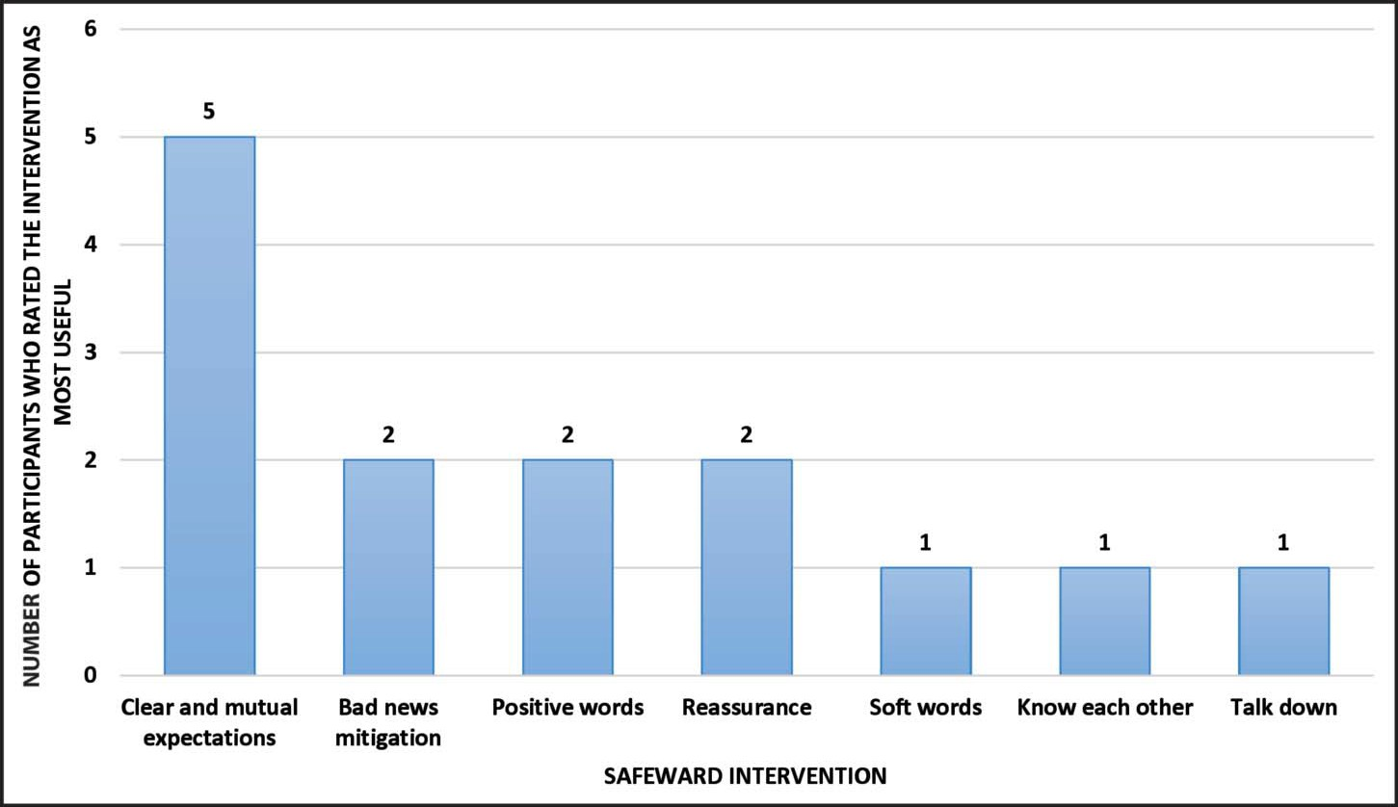

**Figure 1**

**Best/Most Effective Safewards Interventions.**

* More people should be involved in the implementation so it can be implemented faster and with more staff engaged
* Incorporate more 'calm down' methods
* Everyone should use the model consistently
* Have more training sessions after the initial implementation for new staff/as refresher courses

It was, however, noted that many of the interventions had already been adapted to the unique needs of the ward over time and throughout implementation, which would negate the need for any more changes at this point.

Upon first hearing of Safewards, the majority of participants 6 out of 11 admitted to having reservations and concerns about the feasibility and success of the program. However, these participants stated that their reservations dissipated after learning more about Safewards, seeing how it worked for them and how it could be adapted to the specific needs and challenges of the forensic ward. When asked about longevity of the program and if staff thought it would continue to be used regularly, all participants believed it would (n=11). Upon asking if staff thought Safewards had made a positive difference for the patients, 8 of 11

participants thought it had. While when inquired if staff thought Safewards had made a positive difference for the staff, 10 of 11 participants thought it had, although with some admitting it may have made more of a difference for some staff versus others.

At the end of the interview, staff were asked to reflect on the time and effort it took to implement and train staff on Safewards, and decide whether they thought in the end it was worth the effort. A common concept to emerge (9 out of 11 participants) was that participants thought it was worth the time and effort, with the two other participants being unsure, as they did not feel they had received any training. In terms of advice for other psychiatric wards considering implementing Safewards, staff responded:

* "Be patient. It might not be a big turnout at the beginning, but eventually it will become routine"
* "It's not a big change from usual practice, but it can provide a new perspective"
* "Make implementation a collaborative effort"
* "It works if there is enough buy-in, and you will be able to shape it to your specific unit"
* "It's a good idea, it's very positive"
* "Be open. I know it sounds daunting but in the end the patients did buy in"
* "Great for new staff"
* "Be open, give it a chance"
* "Keep an open mind"
* "It is a great example of client-centered care. There are many positive things about it"
* "It's a great idea as long as there are enough people using it"

# DISCUSSION

Safewards is an evidence-based program designed for in- patient Psychiatric Wards. This program aims to decrease the number of conflict and containment events (such as the need for chemical or physical restraints), and to provide interventions that can be implemented on the ward to attempt to reduce the number of such incidents.1,2 This study has used semi-structured interviews to gather key insights into the thoughts, feelings and opinions about the Safewards model from frontline staff members who use the program on an inpatient Forensics ward.

This information could be useful in order to gain a better understanding of how to improve implementation of the model, including training for staff. For example, all staff interviewed expressed one of three main opinions: 1) They thought Safewards was a good program, and they wished everyone on the ward was using it more consistently (n=7); or 2) Safewards was unnecessary as these skills should already be known and used by staff (n=2); or 3) they did not have enough training or expertise on Safewards to form an opinion (n=2).

The staff that did not think Safewards was necessary, were more experienced and had been working in their position for longer (27+ years of experience). This may be because those staff feels as though over time they have already developed many of the skills Safewards is trying to teach, or have already developed their own preferred way of handling conflict situations. This information could be useful to those considering implementing Safewards on an inpatient psychiatric ward. For example, it may be useful to have these type of staff (who are more experienced and perhaps more resistant to change) act as 'champions' of the interventions during implementation. One of the study demonstrated how co-creation of the Safewards model increases staff engagement and buy-in, therefore increasing the chances of the program being effective at reducing conflict and containment on the inpatient ward.7 Similarly, involving and 'celebrating' those who may be least likely to become invested in the program from the beginning may increase overall staff engagement.

Those staff that stated that they did not have a thorough enough understanding of Safewards had the least amount of experience (<3 years). This may suggest that continued training and updates may be important for new staffs that arrive on the ward after the initial implementation period; these updates could also act as refresher courses for those staff already familiar with Safewards.

Research on Safewards suggests that one of the most important factors influencing the effectiveness of the program is staff engagement and 'buy-in.' Of the studies examining Safewards that found absent or very little reduction in the amount of conflict and containment events, low staff compliance with the program was noted as one of the main factors. For example, a study found no effect on the reduction of conflict, and containment events after Safewards implementation in 6 secure forensic units.8 However, adherence to the program was also measured, and was found to be low due to "prevailing operational priorities, including heightened acuity in the research sites, demands on staffing resources, criticism of the process of implementation and staff attitudinal barriers."8 The information and feedback provided by staff in this study may lead to improved implementation methods that encourage staff who are hesitant and additionally increase staff engagement, increasing the likelihood of Safewards being effective at reducing rates of conflict and containment.

## Strengths and Limitations

The strengths of this study include the qualitative method used, which is better able to capture thoughts, feelings and opinions of the frontline staff using the model, and the opportunity to have spoken directly with those using the model daily. Limitations of the study include the small sample size (n=11) and limitations associated with a qualitative methodology such as subjectivity and potential lack of statistical reliability. Although our findings cannot be generalized to Safewards in other locations, our study does enhance existing literature by providing in-depth insight into some of the issues and concerns that can exist in staff who operate within the Safewards programme.

# CONCLUSIONS

Safety of staff and patients is a critical concern on inpatient psychiatric wards, and especially on Forensic wards. The Safewards model is an evidence-based program designed to decrease aggression, self-harm, violence and conflict on these wards. This qualitative study sought to obtain feedback regarding the Safewards program from frontline staff on the inpatient Forensic Unit, three years after implementation of the program, to determine their opinions on what parts of the program are most effective, and how the program could improve. Overall, most staff expressed that Safewards is an effective and useful program that was worth the time to implement and train staff and that they would recommend it for other inpatient wards, although some staff members expressed that ongoing training or 'updates' would be helpful. It was found that older, more experienced staff were more likely to feel that the program was unnecessary, and younger staff were found more likely to feel that they lacked sufficient training. This feedback, taken in consideration with other studies that show that

Safewards is effective at reducing rates of conflict and containment, should be useful to other inpatient psychiatric wards considering implementation of the Safewards model.

**Declaration of Interest:** The authors have no conflict of interests to declare.

**Funding Statement:** Funding was neither requested nor required for this project and publication.

# REFERENCES

1. Bowers L. Safewards: a new model of conflict and containment on psychiatric wards. J Psychiatr Ment Health Nurs. 2014; 21(6):499-508.
2. Bowers L, Alexander J, Bilgin H, Botha M, Dack C, James K, et al. Safewards: the empirical basis of the model and a critical appraisal. J Psychiatr Ment Health Nurs. 2014; 21(4):354-64.
3. Bowers L, James K, Quirk A, Simpson A, Sugar, Stewart D, et al. Reducing conflict and containment rates on acute psychiatric wards: the safewards cluster randomized controlled trial. Int J Nurs Stud. 2015;52(9):1412-22.
4. Stensgaard L, Andersen MK, Nordentoft M, Hjorthoj C. Implementation of the safewards model to reduce the use of coercive measures in adult psychiatric inpatient units: an interrupted time-series analysis. J Psychiatr Res. 2018; 105:147-52.
5. Maguire T, Ryan J, Fullam R, McKenna B. Evaluating the introduction of the safewards model to a medium to long- term forensic mental health ward. J Forensic Nurs. 2018;14(4):214-22.
6. Fletcher J, Spittal M, Brophy L, Tibble H, Kinner S, Elsom S, et al. Outcomes of the Victorian safewards trial in 13 wards: impact on seclusion rates and fidelity measurement. Int J

Ment Health Nurs. 2017;26(5):461-71.

1. Kipping SM, De Souza JL, Marshall LA. Co-creation of the safewards model in a forensic mental health care facility. Issues in Ment Health Nurs. 2019; 40(1):2-7.
2. Price O, Burbery P, Leonard S, Doyle M. Evaluation of safewards in forensic mental health: analysis of a multicomponent intervention intended to reduce levels of conflict and containment in inpatient mental health settings. Ment Health Prac. 2016; 19(8):14-21.
3. Elo S, Kyngäs H. The qualitative content analysis process. J Adv Nurs. 2008; 62(1):107-15.
4. Hsieh HF, Shannon SE. Three approaches to qualitative content analysis. Qual Health Res. 2005; 15(9):1277-88.

