# MEMORIAL REFERENCE

LATE PROF. DR MALIK HUSSAIN MUBBASHAR

1st August 1945 - 10th August 2020

The Department of Psychiatry and Behavioural Sciences, JPMC hosted a program in the memory of late Prof. Dr. Malik Hussain Mubbashar, MBBS, DPM, FRCP, FRCPsych, Sitar-i-Imtiaz, Hilal-i- Imtiaz, the legend of Psychiatry and the “Teacher of The Teachers” on Saturday, August 15th 2020. This event was titled “**Remembering a Legend & Visionary”** and hosted by Pakistan Psychiatric Society (PPS) and other Psychiatric Fraternities & Organisations (WPA, PAMH & SMHA).

Prof. Dr Malik Hussain Mubbashar was an institution in himself, and his academic children (students) are presently heading most of the teaching institutions not only in Pakistan but also at leading departments abroad.

Various stalwarts of Psychiatry and academicians participated in the event, both in person and virtually. Among them were Prof. Syed Haroon Ahmed, Prof. Unaiza Niaz, Dr. Naeem Siddiqi, Dr. Majid Ali Abidi, Dr. Afzal Javed, Prof. Mowadat Rana, Prof. Fareed Aslam Minhas, Prof. Tayyab Tahir, Senator Dr. Karim Khawaja, Prof. Bikha Ram (Vice Chancellor of LUMHS), Prof. Zafar Haider, Prof. Raza ur Rehman, Dr. Mian Mukhtar ul Haq Azeemi, Dr. Ayesha Minhas, Dr. Jamil Junejo and from the family of Late Prof Dr. Malik Hussain Mubbashar, his sons Dr. Sabooh Mubbashar, Dr. M. Imtiaz Mubbashar and daughter Dr. Maryam Mubbashar.

The program started at 12:30 pm with recitation of verses from the Holy Quran by Dr. Hira, followed by Eulogies for late Prof. Dr. Malik Hussain Mubbashar, by: **Prof. Dr. Muhammad Iqbal Afridi, President of PPS stated:** “Today we all are here to remember a legend who was not only a pioneer of Psychiatry in Pakistan, but had great contributions for Psychiatry worldwide. It was an honor for me to work under his supervision. He was the one who encouraged me for pursuing FCPS. Words are not enough to define his contributions in the field of Psychiatry.”

## Prof. Unaiza Niaz:

“Prof. Dr. Malik Hussain Mubbashar was one of the most dynamic, exceptionally brilliant Psychiatrist in the history of Pakistani Psychiatry. His sudden demise has left scores of youngPsychiatrists and his colleagues both at home and abroad very sad. He was the founder of Psychiatry, a great teacher and mentor of the most of the head of psychiatric units in Pakistan. His Sufi life in the later decades of his life was fascinating for us all. He was rare human being indeed.”

**Prof. Syed Haroon Ahmed, President of PAMH (Pakistan Association of Mental Health):** “In 1965, Psychiatry was limited to mental hospitals, mental health was a low priority and high prevalence disorder. During that time Malik Hussain Mubbashar had showed a commitment to

psychiatry. People used call him “Mental health Mubbashar” instead of Malik Hussain Mubbashar. I had an idea that a highly intelligent person joined Psychiatry and will take Psychiatry to the highest level and he did. Psychiatry has lost a great man which is irreplaceable”.

## Dr. Afzal Javed, President Elect of WPA (World Psychiatric Association):

“Prof. Dr. Malik Hussain Mubbashar is always regarded as an important professional for the specialty of psychiatry in Pakistan, and his sudden demise came as a great shock for family, friends and especially the psychiatric family of all of our country. He was a great advocate of mental health, and throughout his career he demonstrated remarkable enthusiasm and extra ordinary commitment to profession, to his patients, carers and students. His academic interests were the hallmark of his passion for Psychiatry. He promoted Psychiatry especially for its practice in low income countries. He has certainly left a great vacuum. Nobody can ignore his contributions & influences in the field of Psychiatry & he will always be missed for his exceptional role in promoting psychiatry as a well acknowledges branch of medicine.”

**Dr. M. Imtiaz Hussain Mubbashar (Psychiatrist and Son of Late Prof. Dr. Malik Hussain Mubbashar):** “Thank you all for this gathering. I think it is his contributions in the field of Psychiatry, that Pakistan Psychiatric Society and other Psychiatric Fraternities & Organisations (WPA, PAMH & SMHA) are paying a tribute to him. He used to say “*A psychiatrist is one, whose hands are tied and eyes are closed. He cannot diagnose a patient by palpating a sulci and gyri or by seeing a swelling or tumor. He can only diagnose a case by spoken words & eyes of soul.*” His words which I always carry with me, that, it's not only doctor examining the patient but also patient examining the doctors. He was a master clinician. His beautifully crafted and culturally appropriate info care, bio psychosocial formulation of affective and anxiety disorders, his confidentiality and sensitive exploration of taboo ego dystonic thoughts & urges in context of OCD, his delicate balance of validation and gentle challenges in expanding insights in context of functional and dissociative disorders, his almost magically ability like reflex hammer of eliciting and grooming mania and hypomania with his bright effect of 'Allah ho' and patient saying 'Allah ho' to diagnose mania, his mastery of internal medicine and ever vigilant clinical years looking for thyroid dysfunction, early signs of Parkinsonism, IBS, temporal lobe epilepsy, vertebral spondylosis and other mental conditions presenting with psychiatric symptoms.Prof. Mubbashar left all of us with his vast treasures of knowledge, experiences and insights. My prayer is that each of us to continue to feel his presence at bedsides, clinics, and conference rooms with gentle reassuring hands and strong guiding eyes to continue his cruise for propagation of Psychiatry in

*JULY - SEPTEMBER 2020*

*VOLUME 17 NUMBER 3*

*PAGE 41*

# Journal of Pakistan Psychiatric Society

Pakistan and across the world. Lastly, I will request all of us to invest our life for consoling or offering support to the grief of those who are solely affected by his loss, his patients with mental and psychological illness and family & loved ones.”

## Prof. Tayyab Tahir:

Whenever I see a patient today, Prof. Mubbashar's words always strike my mind. He used to say, “The day when you lose patience to see a patient, you lost touch with profession.” He taught me the true meaning of this profession.

Prof. Bikharam, Vice Chancellor of Liaquat University of Medical and Health Sciences, Senator Dr. Karim Khawaja, Dr. Mian Mukhtar ul Haq Azeemi, Dr. Haider Hazrat Ali, all displayed their deep condolence for loss of this great personality in field of Psychiatry.

The program ended at 1:30 pm with Dua (prayer) by Dr. Majid Ali Abidi, and Prof.Afridi- President of PPS thanked all the participants for joining the memoriam.

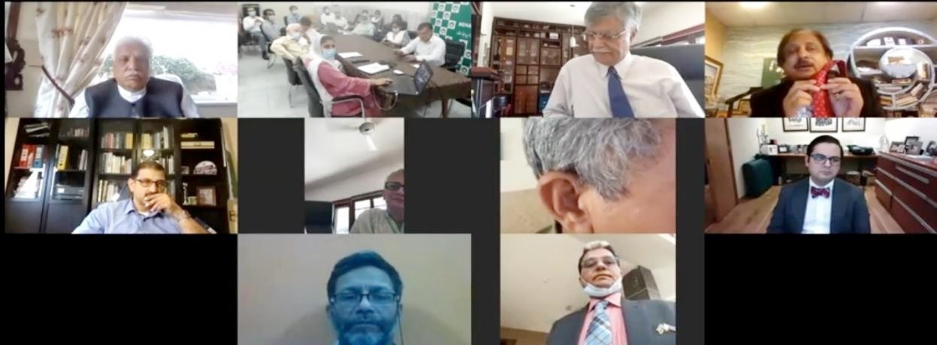

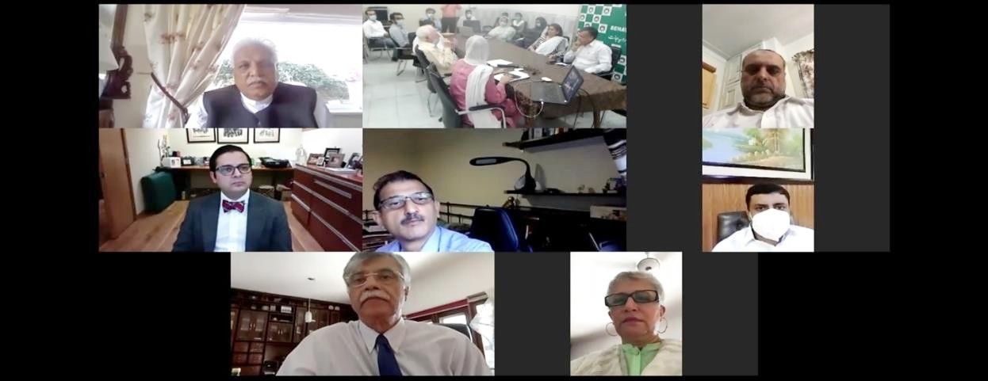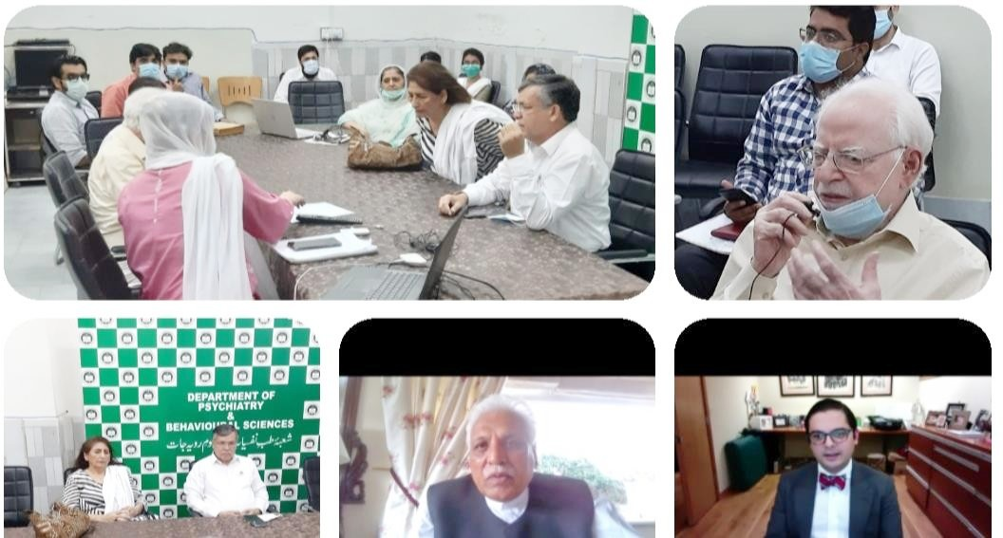

*PAGE 40 JULY - SEPTEMBER 2020 VOLUME 17 NUMBER 3*