MEMORIAM

MENTAL HEALTH WARRIORS LOST IN COVID-19

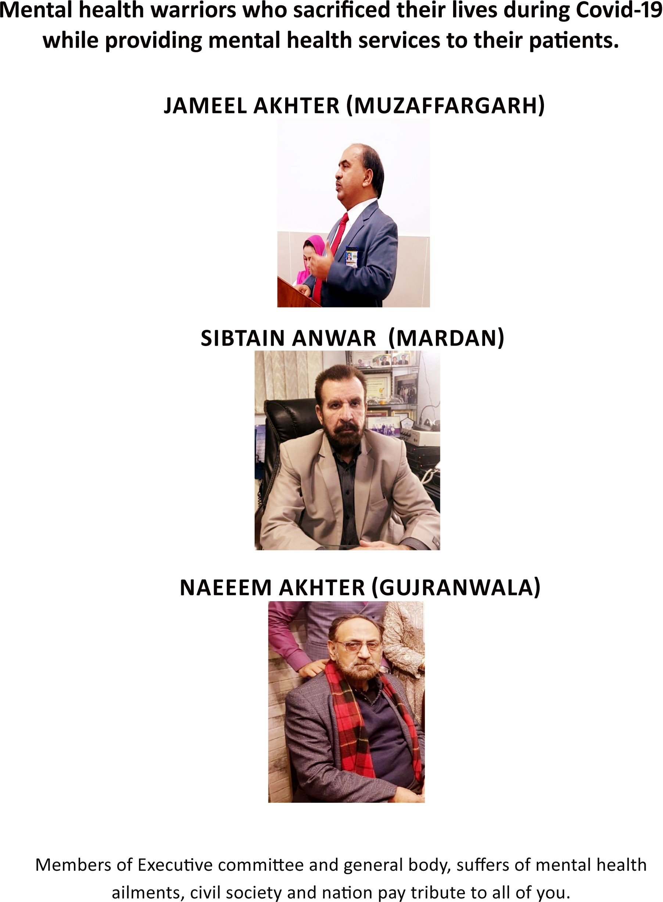

JULY - SEPTEMBER 2020

VOLUME 17 NUMBER 3

PAGE 43