□ MOODS

CREAT VE CO NE

**MUHAMMAD SALEEM ANSARI**



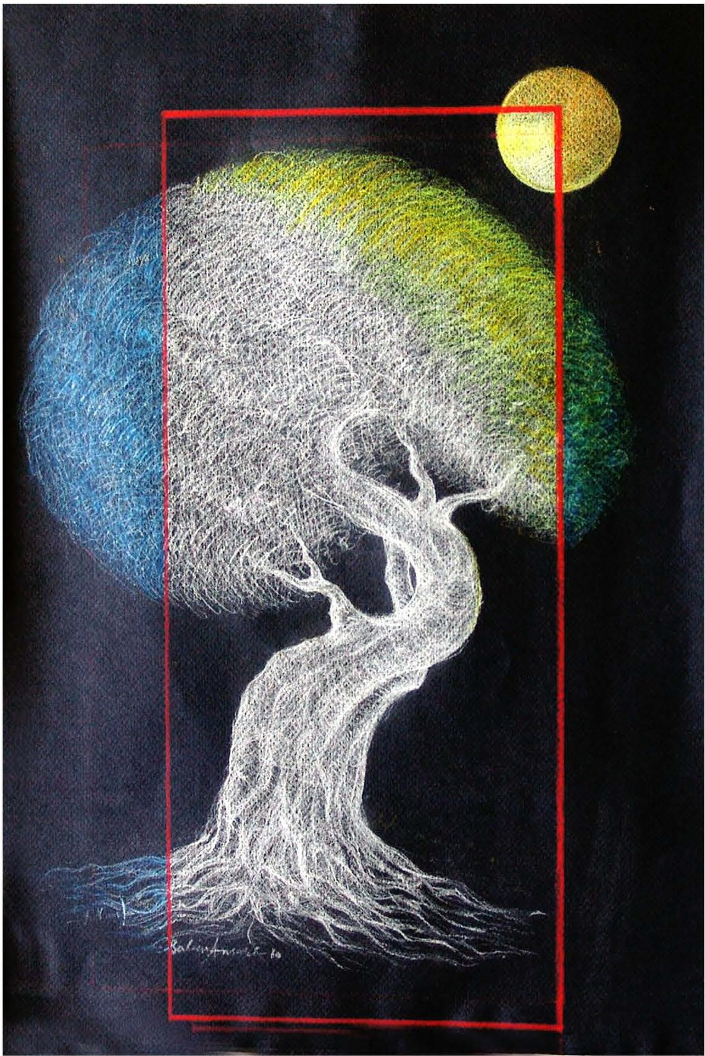

The painting depicts the variety of human moods.It provides us a comprehensive look upon the way how doeshuman mood change in reference to the hopes one has, level of growth one reaches and limitations one faces. The tree symbolizes the growth, moon stands for hope, red frame represents limitations and the variations in color of tree show different moods.

*PAGE42 JANUARY-MARCH 2076* I *VOLUME 13 NUMBER 1*