

**OBITUAR/**

Prof. Dr. Naveed Irfan

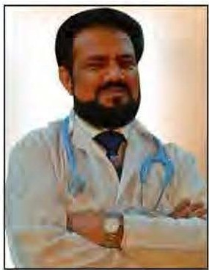**DR EHSAN NAVEED IRFAN DRASIF ZIA BAJWA**

In early hours of 30th April, 2015 Psychiatryin Pakistan lost one of Its most precious anddynamic sons. Dr Naveed lrfan succumbed to acardiac arrest in Abottabad.Hewas just52andin hismostproductive years.Heissurvived bya widow andfourchildren.Justonedayearlier hehad been promotedasProfessor of Psychiatry whichisthehighest rankin themedicalprofession.

His untimely demise haslefta huge vacuum whichhe willalways be feltdeeply.No wonder on that fateful day, thousands of people from across the whole country and even abroad were shocked. These people included eminent professional, colleagues, subordinates, students and thousands of patients. All of whom knew Dr Naveed either as a person as a doctor, teacher and human beihg. All who loved him rushed to Abbottabad/ Mansehra,mdevenhisFacebook wallwasflooded withexpressions ofgrief.

DrNaveed lrfan wasbornin1963in Peshawar in aneducated family.Hisfather wasrenowned psychiatrist andmighthavebeenhisfirstmodeland inspiration.His mother was a house wife. He received his early education in Mansehra and Abottabad. He completed his medical graduation (MBBS) from Ayub Medical College, Abottabad in 1988 with flying colors(13 Gold Medal).He didFCPS from Pakistan.Hewent to London to earn DCNIn Neurologyandafellowshipfromthe American Psychiatric Association.Suchcredentials aredifficult to match.

Married in 1989 andhe hadhappy family life whichis evidence of the well rounded man he was.DrNaveed lrfan was a family man with the true sense of the world.His wife'smemories andcomments are evidence of thisfact.Thecouple livedthrough rainy days and even enjoyed fameand fortunelater on.They had four children,hissonEhsan 28,a daughter Elishba 23,younger daughter Ezza 17and younger sonHassan 14.Dr Naved was fortunate enough to see his son Ehsan and daughter Elishba becoming doctors.His family remembers his preference for Shalwar Kameez over western dress.

Dr Naveed was not uni-dimensional, his intellectual pursuits had a broad horizon. He delved into books which included those on literature, philosophy andevenspiritualism. Infacthealsoexperimented with Wazaaif andspirftual healing.HisfavoritemagazinesUrdudfgest andReader's digestwereeagerly awaited athishome.

Dr Naveed wasamandevoted tohisprofession notonlyasa doctor butalsoasahumblehuman being in work.Dynamic andmobile ashewashe reached out to smaller towns to promote awareness and render his services to the less privilege classesall around his native province.He also ensured thatinformatfonal care be given to hispatients.Heeven usedleaflets written in simple Urdu to benefit patients. Hismethodology in his profession was no doubt very demanding and requiredplenty of mobility.Prof. Dr lrfan wasGod giftedIn these aspects he could work for hours andhoursin asingledayand thatincluded traveling.

So,psychiatry in Pakistan has lost one ofitsmostillustrioussons withtheuntimely death ofDr Naveed lrfan.May Allahbless his soul and give his family the fortitude tobearthisgrief.(Ameen.)

*APRIL·JUNE 2015* I *VOLUME 12 NUMBER 2 PAGE 40*