JPPS 2008; 5(2): 126-126 BOOK REVIEW

BOOK REVIEW

**MCQs and EMIs for MRCPsych Paper 3 Intellectual Signature**

By Dr Saman A. Mushtaq, Dr Imran Mustaq and Dr Imran S Malik

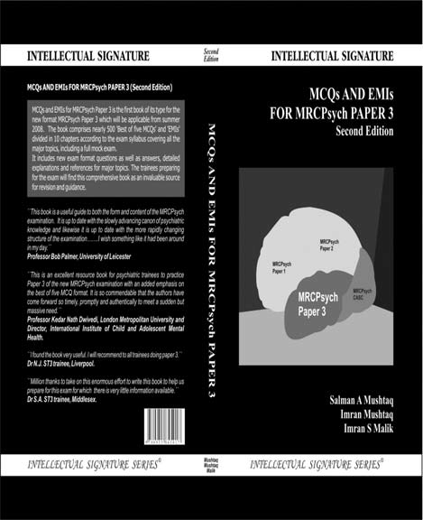

The book is has 10 chapters which address the Royal college of psychiatrist’s syllabus of paper III. The recent revision of the college curriculum has included one third critical appraisal of research evidence and two third clinical topics as well as introduced changes the to

try. The first chapter provides good understanding and appraising of research and the remaining 9 chapters focus on various clinical topics.

The strength of this book is explanatory answers with 500 MCQs and Extended Matches Item. The au- thors have provided the answer with relevant high qual- ity references. The majority of the references are recent and some of the references are of expert s in that field.

This book is definitely a useful tool for trainees who are preparing for paper III of MRCPsych examina- tion. The extended explanations provide basic under- standing of relevant concepts and references will help them to clarify further. The trainees will find it as building block to make progress towards achieving standard of MRCPsych examination and it can also be used to prac- tice for paper III MRCPsych by trainees.

Although this book has been designed for paper III of MRCPsych examination it still has some relevance to Asian countries. Firstly, it is informative and can be used as quick reference by both trainees and qualified specialist. Secondly, the format of presentation similar to some of postgraduate entrance examination and can used a tool to prepare local postgraduate exams. Fi- nally it can be used to prepare for the MRCPsych exami- nation by Asian countries as there is speculation that MRCPsych examination will be also be held in Asian countries in future.

The book has some limitations for example the chapters related to subspecialty and research methods lack input from experts in that field. Although the book is very informative its use may unnecessarily be limited to UK because of excessive emphasis on MRCPsych ex- amination. The authors can consider adding chapters relevant to Asian countries in future edition to make it more attractive for other countries.

the examination format. This book has attempted to

address both these aspects. It has included following chapters: research methods, evidence based practice, statistical and critical appraisal, General adult and Re- hab psychiatry, Liaison psychiatry, Forensic psychiatry, Addiction psychiatry, Learning Disability, Psychotherapy, Old age psychiatry and Child and Adolescent Psychia-

**Dr Bettahalasoor Somashekar,** Consultant Psychiatrist, The Caludon centre, Coventry and Warwickshire partner- ship trust, Coventry CV2 2TE, UK.

**Dr Ashok Kumar Jainer**, Consultant Psychiatrist, The Caludon centre, Coventry and Warwickshire partnership trust, Coven- try CV2 2TE, UK. E-mail: [ashokjainer@hotmail.com](mailto:ashokjainer@hotmail.com)

126