CREATIVE CORNER

# SHORT STORY: DREAMS DIE FIRST SYED HANI

Tossed and turned by the vicissitudes of Life, Abdullah, decides to commit suicide. Originally from the city suburbs, he is alien to the metropolis. He is pursuing a Master’s degree from a local University, and lives in a low-cost apart- ment at the fringes of the city – and indeed at the fringes of the community. Having no roots in this alien culture, he feels estranged. His depression and loneliness have pushed him away from the social limelight, and to make it worse, he has no money to go out and mingle with the hip crowd. He tries his best to make ends meet; working evenings as a sales representative, still bringing in a meager income. There is nothing about his life that qualifies public approval. The girl of his dreams, his long cherished love, has also turned a blind eye to him. Despondent, hopeless and unclear, he is in a constant tussle with studies too. The deadline for submission of his research project is fast approaching, but he has not one idea for his thesis.

When it comes to suicidal ideas – he has ample. He makes a list: hanging himself from the ceiling fan, taking an overdose of insecticide, cutting his wrist, drowning, lying in front of a train-track.

He contemplates each option. He has had a near-drowning experience in a river, accidently, a few years ago. It is very suffocating. This is not usually followed by a mouth-to- mouth resuscitation by a petit damsel, as the movies would have you believe. Generally, a policeman is the first on the scene, in order to register an F.I.R for a criminal investiga- tion. “You cannot die with your own will, let alone live in this country” – he mumbles to himself. It seems very wom- anly to cut his wrist, he thinks. Being a proud son from a respectable family, this seems very unmanly. Insecticide would be very bitter and the way the fraudulent market behaves, the drug would probably not be very effective. No wonder his room is infested with so many rodents. The railway track option is still enticing: “Malir station is not very far”, he thinks to himself. But then he realises how traumatic it would be for his parents to see the mutilated body. Politicians and cronies in the media would not let go of any chance to further their corpse-politics by highlight- ing his gnarly death.

Hanging from the ceiling fan it is then. “I will get even with the KESC too”, he muses. He stands on a chair underneath the fan, slings the rope from it, ties a knot and put his head in the noose. Suddenly images of his parents flash in front of his eyes. He takes his head out, gets down and scribbles, “My parents are not to be blamed for this”. He puts this in his pocket and re-inserts the noose and kicks the chair

CREATIVE CORNER

away. Boom! There is a loud noise. Instead of pressure on his neck, he feels a sharp pain on his head. Still dizzy, he looks around to see what has transpired. The fan has fallen on his head, and he is still living! “Damn”, he says. “Those thieving construction workers”.

He lies listlessly. His mind goes back on his attempts to seek help. He has been to a psychiatrist, who benefited more from this interaction in terms of financial compensa- tion, than himself – so he thought. He was a pill pusher, with no time to listen to people. How can you not listen and prescribe medications for an emotional, lonely and broken heart? Subsequently, he thought of going to a Maulvi, in a hope to find some solace. The Maulvi was more eager to help him with the afterlife then this one. He had a problem with living and this Maulvi was bent on getting him ready to die. Die I will – so he thought.

Just as he was ruminating on these things, his mobile phone rang. It was Shazia – the girl that worked at the same sales-shop where he did. Turns out her father had suffered a heart attack. He looks at the watch, which reads 12:45 am. She was bewildered and confused, with little money at her disposal. In the early hours of the morning, her father had suffered a heart attack and she had no idea where to get the help. She was a quiet girl, working hard to support her elderly parents. He had always admired the character she possessed, though their acquaintance was merely platonic. She had warned him earlier too; ‘make friends in the university, lovers come and go’. A good advice, he thought in hindsight.

After receiving her call he decided to shelf his idea of self-harm. He ran to the basement of his apartment. Look- ing around, he could only find the Bicycle his night watch- man rode. He decided to steal it (read: borrow), thinking end justify means. Her house was not very far. When he reached there she had already taken her father to a private hospital in the vicinity. Upon arriving in the emergency room, he saw Shazia sobbing endlessly. The emergency room front-desk clerk had asked for an initial deposit before initiating acute care. She had no money to offer. Abdullah took out his credit card, made recently on the insistence of one corporate salesman. “Plastic money has its utility” he tells Shazia – who looks reassured. This seems to be a beginning of a new relationship – one full of hope. He forgets about his suicidal plans. Helping others have put meaning in his life.

*PAGE 51 JANUARY – JUNE 2014 VOLUME 11 NUMBER 1*

# PAINTING: MELANCHOLY IN BLUE DR. SYED ALI WASIF

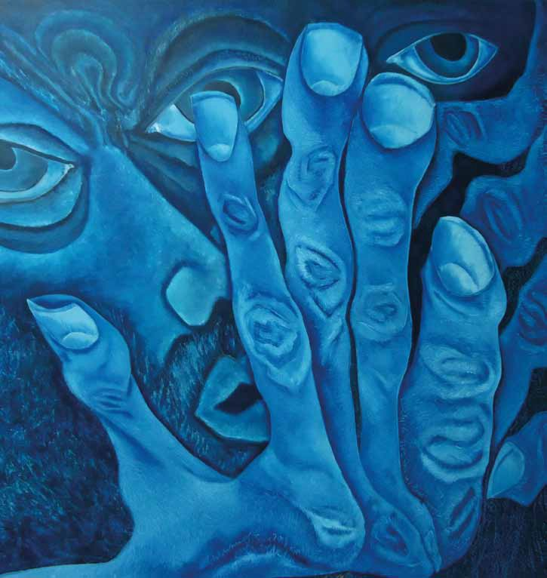

**EDITOR’S NOTE:**

Picture is worth a thousand words. The painting by Dr. Syed Ali Wasif depicts the plight of a common vulnerable man who is stressed out with the dicotomy and disintigration of todays society. The grotesque image speaks volumes in terms of societal perception and stigma associated with mental illnesses. To be moved to draw on a plain canvas requires inspiration and commitment. Inspired by ideas and ideals, one draws parallel to depth of one’s perception. To see abstractions in the course of daily events, to drive meaning from synchronicity, require an attuned mind. The mind which is open to the shades of grey (and white) brings the unseen in to the realm of art-form. The genius in Dr. Wasif has vividly depicted the reality of individuals with distress for those who appreciate the art form.

*JANUARY – JUNE 2014 VOLUME 11 NUMBER 1 PAGE 52*