# □ DEPRESSION, ANXIETY AND STRESS AMONG PRIMARY

**ORIGINA ARTIC f**

# CAREGIVERS OF THALASSEMIA PATIENTS IN HYDERABAD

## AATIR H. RAJPUT', FARIS NADEEM2, VIKRAM KUMAR'

Liaquat University of Medical & Health Sciences, Jamshoro

**RETRACTION NOTICE**

## The article entitled as "Depression, Anxiety and Stress among Primary Caregiver of Thalassemia Patients in Hyderabad" written by "Aatir H. Rajput" is hereby retracted on the grounds of dual submission and publication to an other Journal due to misunderstanding on the part of corresponding author.

**CORRESPONDENCE DETAILS:** E-mail: [aatirh.rajput@gmail.com,](mailto:aatirh.rajput@gmail.com) Contact: 0324-3031413

## ABSTRACT

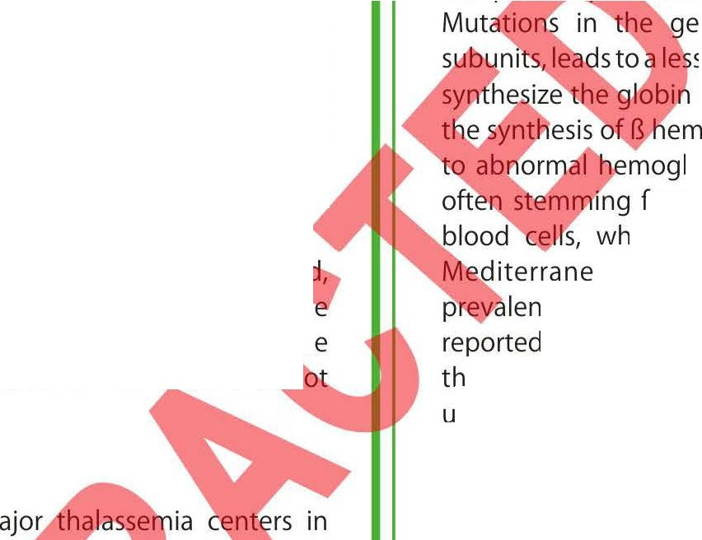

**BACKGROUND**

A chronic genetic disorder; Thalassemia major is a disease, characterized by continuing and severe anemia, bone deformities, hepato-splenomegally and growth retardation. It is a potentially life threatening and serious life-limiting disease that brings about considerable disturbance in all aspects of life. Therapies such as transfusion of blood have enhanced the physical health status of the thalassemia major patients but numerous treatment sessions and alteration in physical appearance effects on the quality of life of the patients and theirfamilies.

## OBJECTIVE

Depression while battling surv1v1ng thalassemia is increasingly ace **pt-ei** , globally. But we hypothesized that psychiatric morbidities aren't Iimite **t** ,th patient, in fact they extend to the caregivers as well. Our study scree **s** the primary caregivers for Depression, Anxiety and Stress which more often tha **n** are the parents.

## METHODS

This observational study encompassed all 3 m

Hyderabad namely; Fatimid foundation, Zainab· id

center. The city-wide survey included 79 care rs

(via convenience sampling) from 1st De was

collected using interview based structu ed the 42

point DAS scale approved by Austr · al Health. The data was analyzed in SPSS v.19

## RESULTS

Moderate levels of Depression Stress (19.11) were all

unearthed in the caregivers. prised of male (60.8%),

educated respondents (78.5° lies (S7%). The caregivers

mainly belonged to lower (35.4°0 .5%) economic class and were forced to miss an average of 2-3 days rweek.

## CONCLUSION

The unending therapeutic process of thalassemia, its cost and impending health problems have adverse effects not only on the patients but on the caregivers as well who spend their time struggling and praying for the patients' health. The mental health of the caregivers should be taken into account and psychiatric consultations should be provided to the caregivers so they may be better able to tend to the patients.

## KEYWORDS

Thalassemia, Caregiver, Depression, Anxiety & Stress.

## INTRODUCTION

B-Thalassemia major, an ailment largely associated with excessive breakage of red blood cells and mal­ production of hemoglobin. Hemoglobin (Hb) is co ubunits, 2 alpha and 2 beta units. ne coding for the protein B

sened or totally missing ability to B-chains, leading to absence of oglobin or, in less severe cases, obin This error leads to anemia rom the abnormal synthesis of red

ich is the hallmark of thalassemia. an region is plagued with a high

ce of thalassemia; the highest incidence is in Italy, the Greek islands and in Asia, where

e peak prevalence of the genetic mutations nderlying thalassemia is reported in the Maldives.'

The conventional treatment comprises of repeated transfusions of blood that maylead to overload of iron in the tissues. Younglings on hyper-transfusion regimens will continue to grow normally probably till puberty. An estimate of the body iron is derived from serum ferritin; levels exceeding 2500 mg/I for over 15 year are thought as a factor increasing the risk for cardiac disease.'Theconcept of health, as explained by WHO, "a state of complete physical, mental, and social well-being, not merely the absence of disease" states clearly importance of mental health. Similar to other long term illnesses, beta-thalassemia burdens not only the individual patient but the entire family which includes (but is not limited to) social and psychological consequences which ultimately affects the wellbeing of the patient.' So it is imperative to study the psychological factors which incorporate, add to distress of the family alongside other factors. Previous studies focused on these points have shown improvement in the quality of life of such patients and their ability to integrate well into their society.'

Parents of children suffering from thalassemia not only worry regarding their children's standard of life, goals and their expectations but, also the influence of the constant realization of disease, repeated treatment

visits to the morbid environment of the hospital on family dynamics and the family's financial, psychological and social stability. Major concerns of the parents regarding the disease are related to the physical outlook of their child, short stature, bone deformities, poor self-image, and hampered fertility, absent or delayed sexual development and other such complications; infections, diabetes, bone and heart disease.'

If viewed from the patient's perspective, it is a worrying and scary experience where they have no choice but to face the mentally tire some psychosocial aspects of thalassemia. In addition to that, their regular visits to the thalassemia centers for blood transfusions and blood tests with iron chelation therapy too are mentally and physically exhaustive. Parents of patients suffering from *{3-* thalassemia have to battle a significant psychological influence, leading to hopelessness, emotional burden and difficulty with social accommodation. They often experience adverse thoughts about their life, heightened anxiety, guilt and lessened self-esteem. If the ability to cope up with painful situations abandons them, they are prey to severe psychosocial problems.

On one or more account, souring of relationship amongst family members, heightened isolation and marginalization too are persistent problems faced by many. Our study aims to focus the mental health in particular and to studies the parents of thalasse **c** patients. This will help us gain insight into the pain and the impair·**d** domains of life (physical health, psychological health and quality o

life). Our study screens the caregivers for Depression, A **iety** and Stress.

### METHODOLOGY

This observational, cross-sectional study e **c**

thalassemia centers in Hyderabad na **ely**

Zainabia center and Sahara hum vey

included 79 caregivers presen· ence

sampling) from 1st Dec 20 ata was

collected using interview es which included the 42 point ian Center for

Posttraumatic Mental rbal informed

consent, respondents proforma's at the clinic. The data was ana nd Ms Excel 2013.

**RESULTS **

The sample population belonged mainly to different localities of Hyderabad representing different gender, ethnic, socio-economic, educational and age groups. A few of these demographics along with the family structure of the respondents is depicted in the Figure

#### tigure 1

|  |  |  |  |  |  |  |
| --- | --- | --- | --- | --- | --- | --- |
| **Care giver demographic spread** | | | | | | |
| 90.00% |  |  |  |  |  |  |
| 80.00% |  |  |  |  |  |  |
| 70.00% | 6I0.80% |  |  |  |  |  |
| 60.00% |  |  |  |  |  |  |
| 50.00% |  |  |  |  |  |  |
| 40.00% |  |  |  |  |  |  |
| 30.00% |  |  |  |  |  |  |
| 20.00% |  |  |  |  |  |  |
| 10.00% |  |  |  |  |  |  |
| 0.00% |  |  |  |  |  |  |
|  | Male | Female | Uneducated | Educated | Joint Family | Nuclear Family |

7

Majority of the caregivers visiting the thalassemia clinic were males (60.8%) owing to our conservative societal values and traditions. Another aspect that can be attributed to our societal trends and traditions is the family structure. S7% of the respondents were a part of joint family set-up while only 43% belonged to nuclear family set­ up. However, a finding defying perceived societal statistical norms is the educational status of the respondents. A vast majority (78.5%) of the respondents were educated while only a meagre 21.5% were uneducated.

Care givers of thalassemic patients poured in at the transfusion centres from varied self-definedage group. The decade long groups startedfrom21 **arsa** dwentabove51 years.Figure2belowfurther

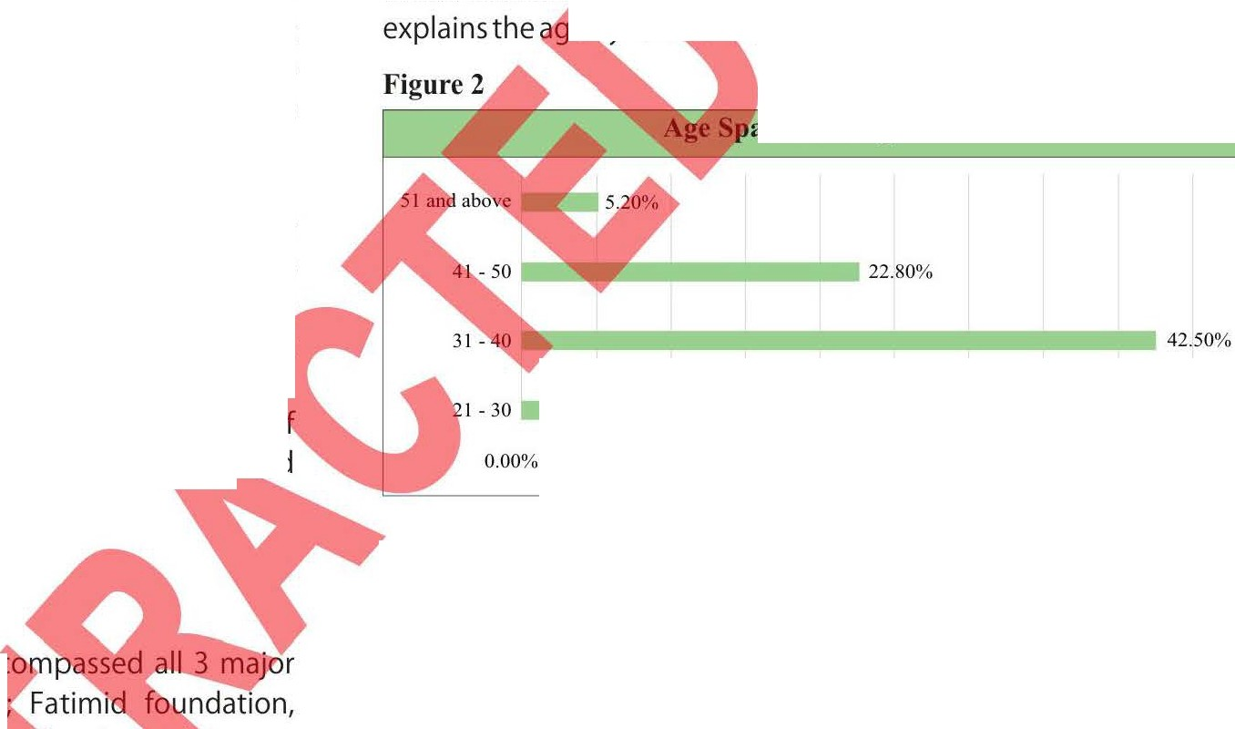

edynan:i"cs· detail.

#### an of Caregivers

30.40%

0.00% 0.00% 0.00% 0.00% 0.00% 0.00% 0.00% 0.00% 0.00%

The greatest proportion (42.5%) of the respondents fell within the age group from 31 to 40 years. The second most common age group, attracting 30.4% of the sample, was 21 to 30 years. The remaining two age groups 41 to 50 years and 51 and above years each contained 22.8% and 5.2% of the sample respectively. The age classification serves as a testimony to the primary assumption that primary care givers are parents since the respondent and early parental age coincide strongly.Depression, Anxiety and Stress were all unearthed in the caregivers. The values are a mean of the values of all respondents. Further detail can be derived from Figure 3.

#### Figure 3

I19.11%

Stress

■10.44%

Anxiety

Depression

15

10

16.06%

I

25

20

**DAS-Score**

The height of the bars indicate individual levels only and no comparison can be drawn with each other since the standard scales and values differ for each. Depression level falls within the moderate range (14-20). Anxiety falls within the moderate range (10-14) and Stress too falls within the moderate range (19-25) defined by the DASS scoring manual.

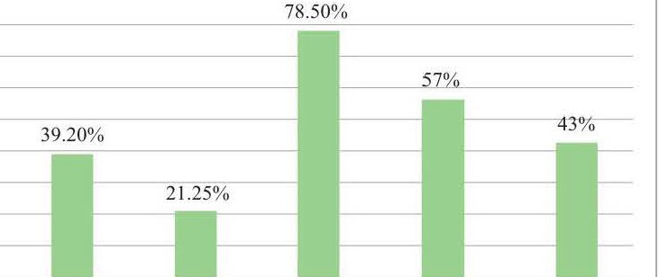



The origins of depression, anxiety and stress aren't always psychological and emotional in origin. We believe that in our modern society, depression, anxiety and stress are often materialistic and financial in origin. The Figure 4 below sheds light on the economic class of the patients and their primary caregivers presenting at the thalassemia centers.

**Figure 4**

**Disease and Economic Class**

□ **Lower economic class Middle economic class**

* **Highereconomic class**

Majority of the respondents belonged to the middle socioeconomic class (54.5%), shortly followed by the lower socioeconomic class (35.4%). Only a small minority of the respondents belonged to the higher socioeconomic class (10.1%).The socioeconomic distribution of synonymous with the national demographics of 2013.

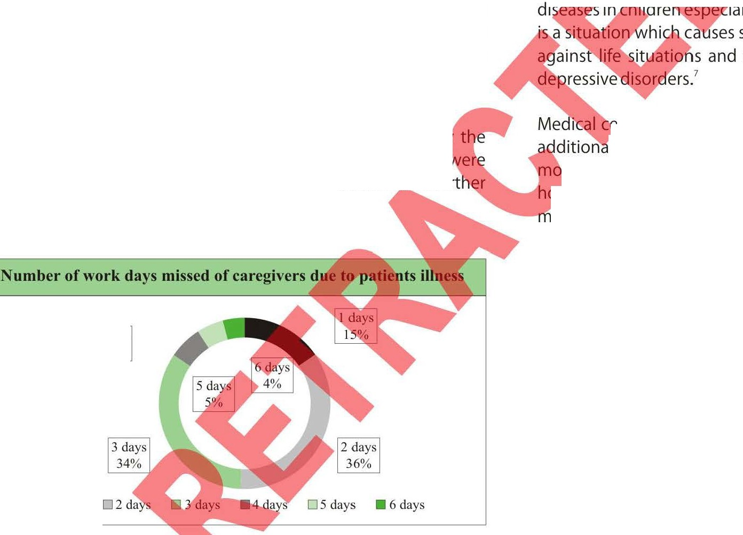

As a consequence of the disease, debility is seen in not onl)/ **t** patients but indirectly in the caregiver as well. Many of whom **ere** forced to miss their work.Figure 5 describes the phenomenon furt **r** below.

**Figure 5**

The battle with beta thalessemia is an unending sojourn and leads to heightened psychological burden to the patients and their families. On numerous accounts. Rao P, Pradhan PV has claimed that the incidence of psychopathological disorders is higher in parents of children with disabling and chronic illnesses (thalassemia) as compared to the normal population.' It is claimed by Deepika Shaligramthat 57% of the caregivers were troubled with psychological distress and had a lessened Quality of Life in as much as 50% of the studied population.

Existing literature also claims that caregivers of thalassemia patients are faced with higher incidence of developing psychological distress as compared to healthy children.'This rate of psychological distress leading to parental stress is higher due to the multiple problems which parents have to tackle while their children undergo the difficult and painful treatment procedures of thalassemia.



Par ues such as the difficulty of psychosocial

adj financial woes, treatment provision,

trav I problems. Existence of long-lasting

* lythose that do not have complete cures tress for mothers and can rile them with make them more prone to suffer from

. nters tending to chronically/seriously ill children, should lly provide psychiatric consultation in an attempt to

nitor and control depressive disorders plaguing mothers. This can opefully aid mothers get through the child's disease in a healthier anner and allow them care for their ill child, and their family,

effectively and efficiently.

* + I day

4 days

**6%**

Low educational status in caregivers may lead to lesser realization of the nature of illness and consequently greater propensity of tumbling into psychological distress. It is likely that the traits of harsher diseases (younger age of onset, frequent transfusions and behavioral problems in the young patient) prompted more apprehensions and psychiatric morbidity in the caregiver. Also, the buffering effect of the nuclear family setup against psychiatric troubles may be because of the protection from societal troubles in ways that are not available to the joint/extended family systems.'

### CONCLUSION

On average, the respondent issed 2 - 3 days of work per week owing to their responsibility *of'G* ring for the patient. On extremes, 15% of the respondents needed miss only 1 work day while 4% of them missed the entire week of work.

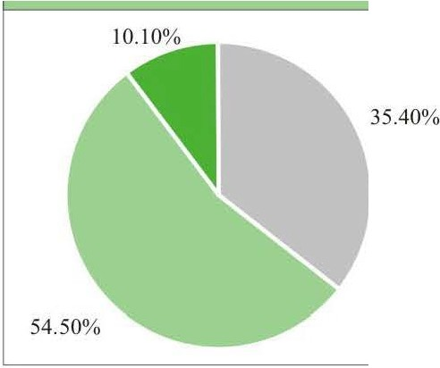

### DISCUSSION

Individuals (children especially) suffering from thalessemia are battling a severe chronic hemolytic anemia that requires transfusions as the sole mode of survival. The long-term illness not only induces psychological distress among the children but their families as well. This often leads to numerous adverse types of behavioral patterns and emotional responses in the family, which influences the relationships of family members with each other and with their surroundings. Long-term diseases of childhood affect the daily life and routine of the patients parents the most and that too at several levels (cognitive levels, emotional level).'

Briefly, this study concludes that the caregivers' concerns pertaining to thalessemia and their own psychiatric problems are worryingly high. The study helped bring to light multiple aspects of psychological distress which might facilitate in designing intervention strategies. The psychological troubles of the caregiver influence many facets of the lives of the caregiver including work. Thus support for the caregiver in the form of mental health intervention, self-help groups and education and medicine should be an essential part of managing thalassemia in order to improve outcomes. Further research in this area with a control group, vaster sample size and repeated evaluations would offer better understanding of the problems that the caregivers are faced with and strengthen the case for a cohesive management approach.



### REFERENCES:

1. Pignatti BC, Rugolotto S, Stefano PD et al.Survival and complications in patients with thalassemia major treated with transfusion and deferoxamine. Haematologica: 2004;89: 1187-1193.
2. Porter J&Davis BA. Monitoring chelation therapy to achieve optimal outcome in the treatment of thalassaemia. Best Pract Res Clin. Haematol:2002;15:329-368.
3. Mazzone L, Battaglia L, Andreozzi F et al. Emotional impact in

beta-thalassaemia major children following cognitive­ behavioural family therapy and quality of life of caregiving mothers. ClinPractEpidemiolMent Health: 2009;5:5.

1. Monastero R, Monastero G, Ciaccio C et al. Cognitive deficits in beta-thalassemia major. ActaNeurolScand:2000;102:162-168.
2. EconomouM, Zafeiriou DI, Kontopoulos E et al. Neurophy­ siologic and intellectual evaluation of beta-thalassemia patients. Brain Dev: 2006;28:l 4-18.
3. Zafeiriou Dl,Economu M, Athanasiou-Metaxa M. Neurological complications in beta-thalassemia.Brain Dev: 2006;28:477-81.
4. Sharghi A, Karbakhsh M, Nabaei Bet al. Depression in mothers of children with thalassemia or blood malignancies: a study from Iran. ClinPrac;tfpidemiolMent Health: 2006;2:27.
5. Shaligra , **Giri aji--SC,**Chaturvedi SK. Quality of life issues in

**t** s with thalassemia. Indian J Pediatr: