□ STRESS AND COPING MECHANISMS AMONG COLLEGE STUDENTS



## MUHAMMAD BILAL SAJID', SAIMA HAMID', FAZAILA SABIH3, AAMNAH SAJID4

'Lecturer, Heavy Industries Taxila Education City-Institute of Medical Sciences HITEC-IMS Taxila

'Associate Professor, Health Services Academy Islamabad, 'Assistant Professor, Islamic International Medical College 'PhD Scholar, Islamic International Medical College

Submitted: May 17, 2016

Accepted: April 30, 2017

**LE:**

**CORRESPONDENCE: DR. M. BILAL SAjlD,** E-mail: [muhammadbilalsajid@hotmail.com](mailto:muhammadbilalsajid@hotmail.com)

## ABSTRACT

**OBJECTIVE**

To determine the most prevalent types of stress among college students in Pakistan as well as to identify the coping strategies to dealwith thestress.

## STUDY DESIGN

Cross-sectional study

## PLACE AND DURATION OF STUDY

The study was conducted in different educational institutionsof Islamabad andduration of study was 6 months fromJuly 2015 to December 2015.

## SUBJECTS AND METHODS

The sample consisted of 120 college students selected through purposive convenient sampling technique. There were 76 males and 46 females in the participants. The Student Life Stress Inventory (SLSI), a self-reported measure was used to assess types and sources of stressand Brief COPE was used to assess coping strategies of students. The information regarding socio-demographic variables was obtained on aseparate sheet.Thedata wasanalyzed through SPSS21.

## RESULTS

The scoresof 98%of the study participants fell between 25% and75%.The top *five* stressors in the respondents were:Self­ Imposed stresses, Emotional stresses, Cognitive Appraisal, Pressures and Changes. The least common stressor reported by respondents was behavioral reactions to stressors. The top five coping mechanisms of our participants were: Religion (6.32+1.68), Active Coping (6.19+1.55), Acceptance

(5.92+1.83), Planning (5.80+1.61) and Positive reframing

(5.66+1.68).

## CONCLUSION

Self-imposed, emotional, cognitive appraisal, pressures and changes weredominant stressors.The most commoncoping behaviors present were using religion, active coping, acceptance of their stresses, planning and positive reframing.Female students were found to react emotionally more than malestudents.

## KEYWORDS

Stress,Coping mechanisms,College Students

## INTRODUCTION

College life is a great time for its charm and challenges. Yet there are so many things that the students have to worryabout.So many stressors are present that affect the students' performance in their academia as well as social interaction. Stress can thus foster unhealthy behaviors like smoking, substance abuse, illegal activities and moral issues. According to the NIH (USA), many students experience the first symptoms of depression during their college years but yet there are no sufficient counseling services available to all of them'. During these years the competition for higher scores and the expectations of family and teachers increased stress levels in students. Every student strives to get ahead of everyone else and has to undergo so many college specific problems and difficulties. College students are specifically more predisposed to stress. Thisis because college is a phase of change from highschoollifeto stressful anddemanding college/university life'.

Stressors that may affect college students can be broadly classified as academic, time or health related, self-imposed and economic'. These stressors do not cause anxiety or tensions by themselves rather stress results from the interaction between these stressors and one's own perception and reaction to these factors'. The past research work has reported that students had difficulties in concentration when under stress. This consequently leads to difficulties in their academic performance. The findings of other studies showed that increased stress levels caused dissatisfaction, poor health, impairment in performance, behavioral, psychological and academic problems in college students' population'· '.

In the USA, a disturbing trend in college student health is the reported increase in student stress nationwide'. According to the Association for University and College Counseling Center of America, about 95% of collegecounseling center directors reported that the number of students with significant psychological problems is growing everyday in their respective University's campuses. Up to 70% of these directors are convinced that the number of students with psychological problems haveincreased drastically in the last year or so'.

In 2008, Stallman conducted a study to find out the prevalence of psychological problems in university students who were patients at the university health service. He reported that more than half of the students that were patients in the university's health service presented mild to high levels of psychological distress in the 6-13 weeks of their respective academic calendars. The study also found out that 22% of the students aged 18and below had very high *levels* of psychological distress and that thisstress affected theirstudies andworklife quite adversely".





Yetagain,in another study conducted in a Karachi medicalcollege by Babar T. Sheikh. et al. (2004), more than 90% of the students under study reported that they had had multiple episodes of stress while in college. 94.1% of males and 91.1% of females maintained this position.It was also noted that females were more prone to fatigue, headaches and episodes of short temperedness as compared with their male counter parts. The top coping behaviors cited by the participants included sleeping, listening to music, playing sports, spending time with friends, isolation, praying, watching movies and online chatting".

Coping behaviors are just as important to be studied. Some students may take to healthy activities such as sports, exercise or creative pathways while others may lean towards smoking, drugs, alcohol abuse and other self-damaging activities. Therefore, it is quite important to find out the various coping activities of college students.

In view of the higher rateof symptoms of stressthe present study was undertaken to find out the most prevalent types of stress in college students of Pakistan as well as to identify the major coping strategies employed by the students to dealwith thestress.

## SUBJECTS AND METHODS

#### Participants

This cross sectional study was carried out in different universities and institutions of Islamabad. The sample of the study consisted of 120 college students selected from Riphah International University, COMSATS University, Bahria University and SKANS School of Accountancy. The purposive convenient sampling technique was used to select the sample. Sample sizecalculationswere made based on this formula:n = Z2 p(l-p)/ e2• According to this formula minimum required samplesize was68.The refusal rate was 14%.

#### Instruments

Data was collected using a close-ended structured questionnaire Student Life Stress Inventory (SLSI). It is a self-reported measure to assess level of stress among college students.The SLSI comprised of 51 items having 9 sections indicating different types of stressors (frustrations, conflicts, pressures, changes, and self-imposed stressors) and reactions to the stressors (physiological, emotional, behavioral, and cognitive). The internal consistency coefficient of this scale was 0.83 indicating that the scale is reliable for the Pakistani student population. The coping strategies were measured through the Urdu Brief COPE (Carver, 1997) comprising of 28 items, categorized into 14 subscale.The response format of the items is a 4- point Likert format (1= Never, 2= Very less, 3= Sometimes and 4= A lot). The high score on each subscale shows more use of that particular coping strategy and vice versa. A demographic information sheet was also used to obtain information regarding background variablespertinent to this study.

#### Procedure

The Proposal was approved by Ethical Review Committee. The potential institutions were identified and contacted. Written

approval was taken from the concerned authorities. Data was collected after the signed consent of the participants of study. The confidentiality of the information was assured to the students. The questionnaires were administered in group setting.The participants were given verbal as well as written instructions. Data was used solely for the purpose of present study. There was no monetary compensation to the study participants. Scores were added individuallyforeach subsection to get atotalscorefor each subscale. There was no overall or total score calculated in this instrument. Each sub scale was independent. For data analysis SPSS software version 21 was used.Then different variableswere computed anddescriptive statistics were applied to the data.The tables and figures were made using Microsoft Office Suite 2011.

**Table I**

Demographic Data of Study Population

|  |  |  |  |
| --- | --- | --- | --- |
| **S.No** | **Variables** | | **Frequency,**  **Percentage, Mean/SD** |
| I | Age±SD | | 21.31±8.13 |
| 2 | Gender | Male | 74(61.7%) |
| **Female** | 46(38.3%) |
| 3 | No. Of siblings | | 3.51±1.54 |
| 4 | No. Of elder siblings | | 1.84±1.27 |
| 5 | **No. Of younger siblings** | | 1.58±1.07 |
| 6 | **Discipline of study** | MBBS | 29(24.2%) |
| BET | 13(10.8%) |
| CA | 66(55.0%) |
| MSc/MPhil | 3(2.5%) |
| BS | 9(7.5%) |
| 7 | Parent City | Punjab | 112(93.3%) |
| **KPK** | 3(2.5%) |
| Sindh | 3(2.5%) |
| **Baluchistan** | 0(0%) |
| Aboard | 2(1.6%) |
| **8** | **Father's Occupation** | Office job | 78(65.0%) |
| **Business** | 34(28.3%) |
| Retired | 8(6.7%) |
| 9 | **Mother's Occupation** | **House wife** | 92(76.7%) |
| Office job | 27(22.5%) |
| Retired | 1(0.8%) |
| 10 | **Father's Educational**  Status | **Primary** | 1(0.8%) |
| Secondary | 11(9.2%) |
| **Intennediate** | 13(10.8%) |
| Bachelors | 43(35.8%) |
| **Masters** | 50(41.7%) |
| PhD | 2(1.7%) |
| II | Mother's **Educational Status** | **Primary** | 1(0.8%) |
| Secondary | 18(15.0%) |
| **Intermediate** | 19(15.8%) |
| Bachelors | 56(46.7%) |
| **Masters** | 26(21.7%) |
| PhD | 0(0%) |
| 12 | Family  **stmcture** | **Nuclear** | 78(65.0%) |
| Combined | 42(35.0%) |

The overall mean score of the inventory was 129.94 ± 28.20. The scoresof 98%of the study sample fell between 25%and75%.The top five stressors in the respondents were: Self-Imposed stresses, Emotional stresses, Cognitive Appraisal, Pressures and Changes.The least common stressor reported by respondents was behavioral





reactions to stressors. The mean scores and percentages of score of the participants both males and females in each of the nine categoriesof the'Student-Life Stress Inventory' aregiven in the Table

1. Women scored more in the emotional stress category than men (Table2).

## RESULTS

One hundred and twenty students voluntarily participated in the current study. The mean age of the participants was 21.31 ± 8.13 years. The mean number of siblings was 3.51 ± .54. There were

61.7% males and 38.3% females enrolled in the present study. Disciplines of study varied fromMBBS (24.2%), BET (10.8%),CA (S5%), MSc/MPhil (2.5%) and BS (7.5%). The respondents hailed from different cities of Punjab. The most common occupation of the fathers of the respondentswasan office job followed by having their own businesses and a small percentage was retired citizens. Most of the mothersof the respondents were housewives i.e.76.7%, followed by having an officejob or retired from service.Regarding educational status of fathers of respondents, 0.8% had primary education, 9.2% had secondary education, 10.8% had intermediate education, 35.8% hadabachelor's degree, 41.7%had a master's degree and 1.7% hada PhD degree. Regarding mothers' educational status, the majority of the mothers (46.7%) had a Bachelor's degree, 21.7% had Master's degree and the rest had primary/secondary education. Sixty five percent of the study sample lived in anuclear family system while the rest were living in a combined family system. The details of the participants' demographic dataaregiveninTable1.

**Table 2**

Mean Percentages of Scores of Participants on SLSI

|  |  |  |
| --- | --- | --- |
| **S.No.** | **Type or stressors** | **Mean percentages** |
| I | **Frustrations** | 43.21% |
| 2 | **Conflicts** | 45.39% |
| 3 | **Pressures** | 58.70% |
| 4 | Changes | 55.61% |
| 5 | SeIr imposed | 76.47% |
| 6 | Physiological | 42.85% |
| 7 | **Emotional** | 68.75% |
| 8 | **Behavioural** | 32.52% |
| 9 | **Cognitive appraisal** | 66.83% |

Table 3 depicts the mean scoresof the participantsaccording to their gender and discipline of study.The mean scores and percentages of scores of the participants according to the discipline of study are

127.86 ± 25.74 for MBBS; 134.08 ± 43.52 for BET; 131.60 ± 26.84 for

CA;123.33 ± 4.72 for MS/M.Phil and 121.22 ± 27.96 for BS. Students

of MBBS andCA reportedly scored higher in the emotional reactions to stresses than students of other disciplines. Mean scores of other disciplines were slightly more than MBBS and CA in the behavioural reactions to stressors. Mean score of the inventory for female was slightly higher than their male counterparts. Mean score of students of BET was higher than students of other disciplines. The coping mechanisms of college students were also explored which are depicted inTable4.

**Table 3**

Mean Scores according to Gender & Discipline of Study

|  |  |  |  |
| --- | --- | --- | --- |
| **S.No** | **Characteristics** | | **Mean scores or the complete Stress Inventory** |
| I | Gender | Male | 127.86 ± 27.75 |
| **Female** | 133.26 ± 28.90 |
| 2 | Discipline of Study | MBBS | 127.86 ± 25.74 |
| BET | 134.08 ± 43.52 |
| CA | 131.60 ± 26.84 |
| MS/M.Phil. | 123.33 ±4.72 |
| BS | 121.22 ± 27.96 |

**Table 4**

Mean Scores of Coping Mechanism

|  |  |
| --- | --- |
| **Coping Mechanisms** | **Study Population(n=l20) Mean ±SD** |
| Self -Distraction | 5.46+1.71 |
| Active-Coping | 6.!9+1.55 |
| **Denial** | 3.93+1.79 |
| Substance Abuse | 2.46+1.20 |
| Use Of EmotionalSupport | 4.99+1.81 |
| Use Of Instrument Support | 5.47+1.76 |
| **Behavioral Disengagement** | 4.00+1.58 |
| **Venting** | 4.38+1.71 |
| Positive Reframing | 5.66+1.68 |
| **Planning** | 5.80+1.61 |
| **Humor** | 3.99+1.92 |
| Acceptance | 5.92+1.83 |
| Religion | 6.32+1.68 |
| Self-Blame | 4.58+1.78 |

## DISCUSSION

Lives of our modern day students are plagued by various stresses which lead to disturbances in their personal as well as academiclives. The present study was carried out not only to find out the most prevalent types of stress in college students' population but also to explore majorcoping mechanisms to deal with the stress.

Past studieshave reported that approximately 75%to 80% of college studentsare moderately stressedand about 10% to 12% are severely stressed. It has been assumed that emerging adulthood, a transitional phase from adolescence into adulthood,augmented the college students' vulnerability to stressl 2. This stress can further cultivate multiple biological as well as psychosocial complexities resulting in detrimental health consequences. Out study also has revealed that unhealthy coping mechanisms such as substance abuse, behavioral disengagement as well self blame are associated with higherlevels of stress.

The findings of the present study revealed that the predominant stressors present in the students were self-imposed stressors, emotional stressors, cognitive appraisal, pressures and changes. Emotional reactions to stressors were present more in females than in men.These findings are in line with previous study carried out by Hyde & Plant in 199513. Another interesting finding in our work has shown gender differences which influence the student stresses and their reactions to such stresses.Female studentsare more often seen to let out their feelings while male students more often hide their

Journal of Pakistan Psychiatric Society

emotions, accept it as such and ignore or try to forget about it. Most importantly, males put in more efforts at problem solving than female students".

In a study done in a private medical college in Karachi, Pakistan, it was found that approximately 70% of the students suffered from anxiety and depression. Most of the students in the study were females". In another similar study done by Shah .et al (2010), moderate to severe stress were found in medical students. Gender difference turned out to be the most important statistically.Females were reported to have higher stress levels than their male counterparts. The most frequent causes of stress reported by the students in this study were, examinations, sleep disorders, vast curriculum, unrealistic expectations of parents, worrying about their futures, loneliness etc". Our results however, measured stress differently than other studies and top stressors were: Self-Imposed stresses, Emotional stresses, Cognitive Appraisal, Pressures and Changes. Our finding also correlate with a study conducted in 2008 by Sajid & Sabih regarding the higher rate of symptoms of anxiety in female students., which found that up to 77% of the students taking part in the study had undergone multiple bouts of stress and extended periods of severe anxiety. Female students reported higher rates of symptoms of anxiety during first year of college life".

The most frequent coping mechanisms used by college students were religious coping, active coping, acceptance, planning and positive reframing. The significant gender differences were also observed regarding coping styles to deal with the stressors. When compared at similar levels of stress, women exhibited stress more overtly than males13. Male students tended to accept their stress more than their female counterparts. High male acceptance compared to femaleswas also consistent with previous studies".

### IMPLICATIONS

This work also provides evidence regarding various stressors affecting the performance of students during their college/university life.This study can be used by the student counseling cells of various colleges, universities and institutions to address this crucial issue. Healthy coping strategies could then be encouraged and a system put into place to support the students to adopt useful coping strategies such as religion, sports, music and other leisure time activities to alleviate their stresses. It is therefore, imperative to establish a student-counseling center in each campus for this purpose. Further studies should be conducted with more disciplines on alargerstudent population in order to get a broader vision of the problem.

Psychology.1991;61(1):841-846.

* 1. Towben L, Cohen L . Chronic stress in the lives of college students. Scale development and prospective prediction of distress.Journal of Youth and Adolescence. 1996; 25:199-217.
  2. Wright J. Environmental stress evaluation in a student

community. The Journal of the American College Health Association.1964; 12(5):325-336.

* 1. Chang E. Life stress and depressed mood among adolescents: Examining a cognitive-affective mediation model. Journal of Social&Clinical Psychology.2001; 20(3):416-429.
  2. Archer J. Stressors on the college campus: A comparison of 1985-1993. Journal of College Student Development. 1996; 37(1):20-28.
  3. Sax L. Health trends among college freshmen. Journal of American College Health.1997;45(6):252-262.
  4. Association for University and College Counseling Center Directors [AUCCCD]. Directors Survey Monograph. (2012). Available from <http://aucccd.org/support/aucccd_directors_> survey_monograph_2012_public.pdf.
  5. Morton S, Amanda Get al. Managing the transition: the role of optimism and self-efficacy for first-year Australian university students. Australian Journal of Guidance and Counseling. 2014;24(1):91-92.
  6. Shaikh Bet al. Students, Stress and Coping Strategies: A Case of Pakistani Medical School. Education for Health. 2004;17(3): 346- 353.
  7. Lumley M, Provenzano, K. Stress management through written

emotional disclosure improves academic performance among college students with physical symptoms. Journal of Educational Psychology. 2003;95(3):641-649.

* 1. Hyde J, Plant E. Magnitude of psychological gender differences: Anotherside of the story. American Psychologist. 1995; 50:159-161.
  2. Khan S,Mehmood S, Badshah A et al.Prevalence of Depression, Anxiety and their associated factors among medical students in Karachi, Pakistan.Journal Of Pakistan Medical Association, 2006; 56(12):583-586.
  3. Shah et al. Perceived Stress, Sources and Severity of Stress among medical undergraduates in a Pakistani Medical School. BMC Medical Education. 201O;10(2).
  4. Sajid W, Sabih F. Stress related emotional ad behavioral problems in medical students. Journal of Islamic International Medical College. 2008;4(2):14-18.
  5. Thomas S, Williams R. Perceived stress, trait anger, modes of anger expression, and health status of college men and women. Nursing Research. 1991;4:303-307.



### REFERENCES

* + 1. USA NIH. Depression and College Students: Answers to college students' frequently asked questions about depression. National Institute of Mental Health: 2012. NIH Publication no. 12-4266.
    2. Archer J. Stressors on the college campus: A comparison of

1985-1993. Journal of College Student Development. 1996; 37(1):20-28.

* + 1. Romano J, D'ZUrilla T, Sheedy J et al. Relation between social problem solving ability and subsequent level of psychological stress in college students. Journal of Personality and Social



# C J:.Af 'VE-CORNE-

**SCHIZOPHERIA**

## AYESHA RAZZAQ

•

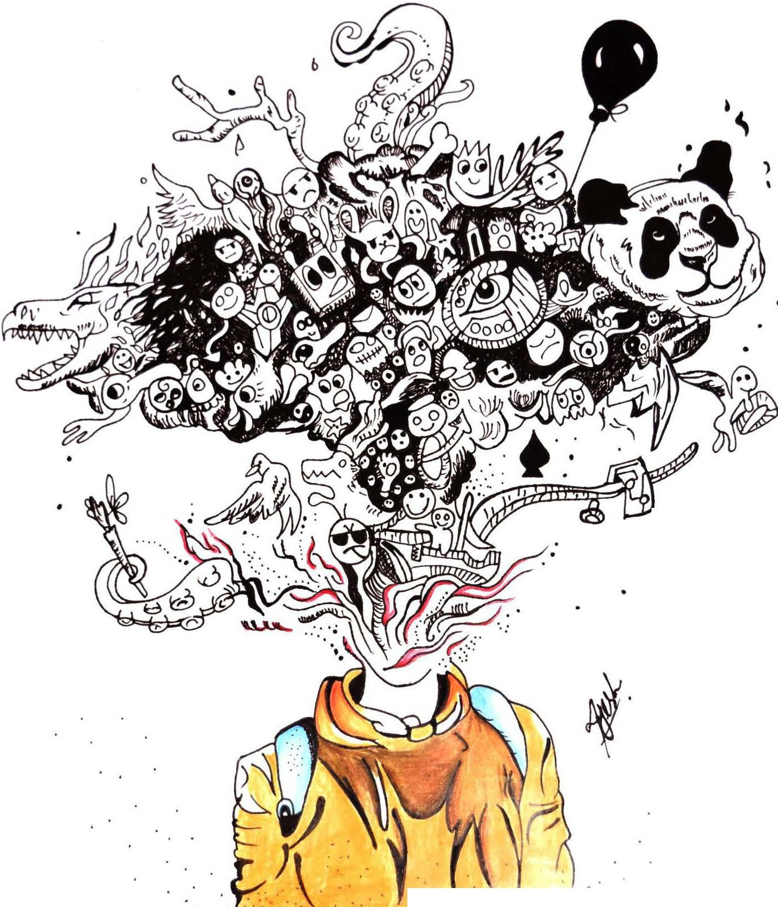

0

0

•

. .

.

.

. .....:.**·.:-/i}- i-** *·',/-•::\/·{}::_:::'.•\: ·-:-•*.·.•.t·t•(''.

Illustration depicts a perfect disorder of thought showing no order in form, disarrangement of ideas and varied unrealistic contents mingled up with some realistic contents. Every thing is spliting out of mind making it hard to distinguish which content belongs to mind and which stands out as external reality.