CREATIVE CORNER

**THE FLOURISHING GLOBAL MINDSET**

**FARRAH ASADULLAH**

Like any catastrophe, the COVID-19 pandemic offers both a challenge and an opportunity to humanity. This crisis has presented a unique monumental opportunity for changing mindset patterns of the past, and for creating a better world for all. The Black Plague transformed Europe's society so deeply, that it gave birth to the Renaissance. Similarly, this pandemic can be a catalyst of global systemic change in the spheres of society, spirituality, arts and science. Our collective approach to the situation will result in how we focus, reflect and react to rebuild a stronger, more resilient global system to combat such disasters in the future.

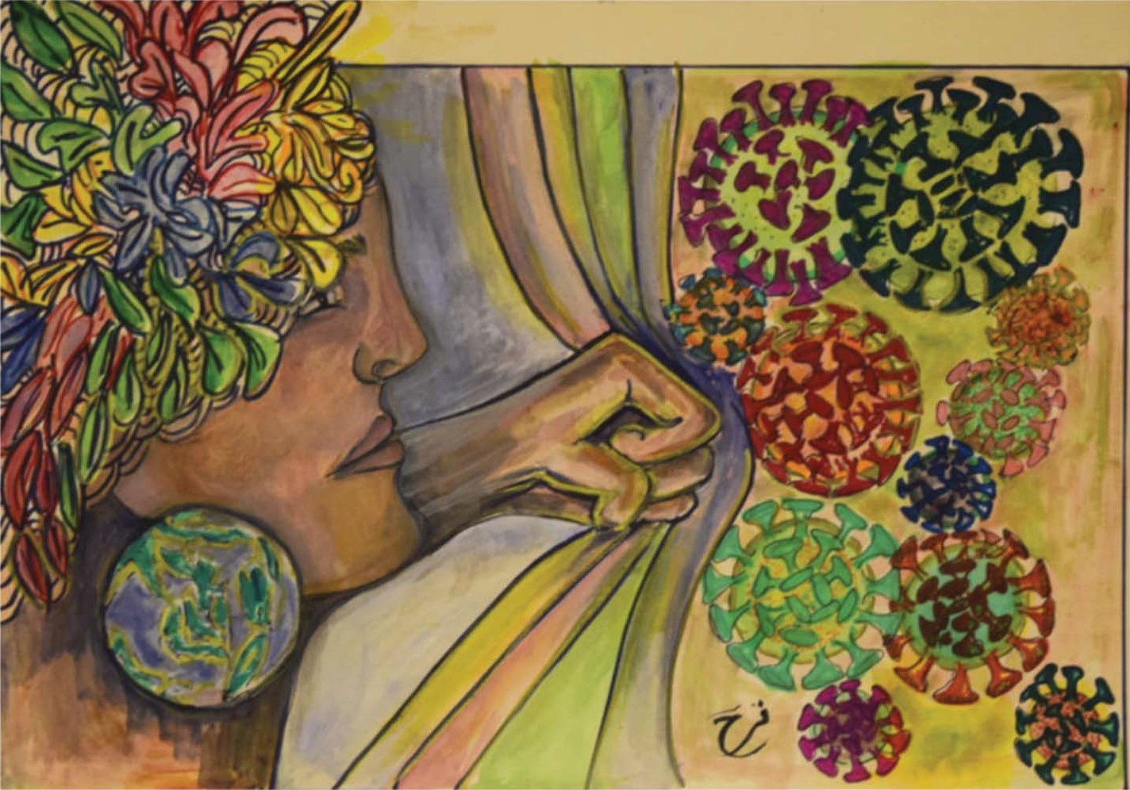

*JULY - SEPTEMBER 2021* ***PAGE 34*** *J Pak Psychiatr Soc VOLUME 18, NUMBER 3*