INFORMATION DOCUMENT
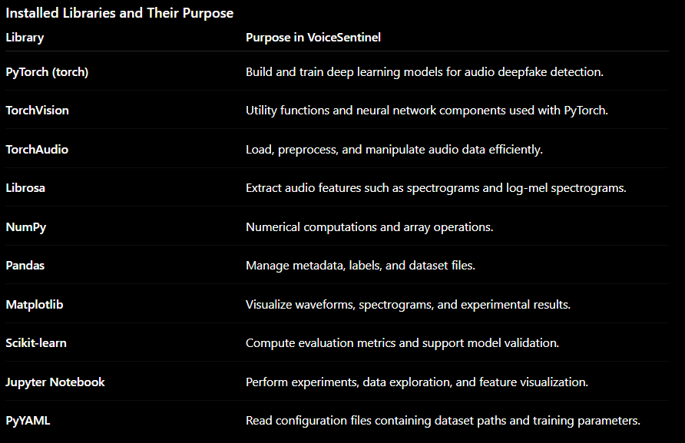During installation, pip automatically downloaded and installed all required supporting packages (dependencies) needed by these libraries, such as SciPy, Pillow, Jinja2, Requests, SoundFile, Numba, and others. These packages enable the installed libraries to function correctly without requiring manual installation.
Dataset: ASVspoof 2019 – Logical Access (LA)
Logical Access means:
Fake speech is injected digitally into the system rather than being played through a speaker.
The fake audio consists of:
- Text-to-Speech (TTS)
- Voice Conversion (VC)

Official Repository: University of Edinburgh – Centre for Speech Technology Research (CSTR)
Official Download Page:
https://datashare.ed.ac.uk/handle/10283/3336
For the project, we are using the following verified Kaggle mirror of the official ASVspoof 2019 dataset.
Dataset Link
https://www.kaggle.com/datasets/awsaf49/asvpoof-2019-dataset/data

Google Colab Dataset Setup
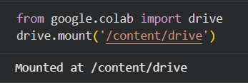
Google Drive was mounted so that the downloaded dataset could be stored permanently.

Install Kaggle Package
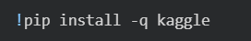
Create Kaggle Legacy API Credentials
Initially, the newer Kaggle Access Token authentication method was tested. Although authentication succeeded, dataset download requests returned 403 Forbidden errors due to compatibility issues with the CLI.
To resolve this, Legacy API Credentials were generated from the Kaggle account settings.
Steps followed:
- Open Kaggle Settings
- Navigate to API Tokens
- Under Legacy API Credentials
- Click Create Legacy API Key
- Download the generated kaggle.json file
- Upload kaggle.json to Google Colab
- The downloaded kaggle.json file was uploaded into the Colab session.
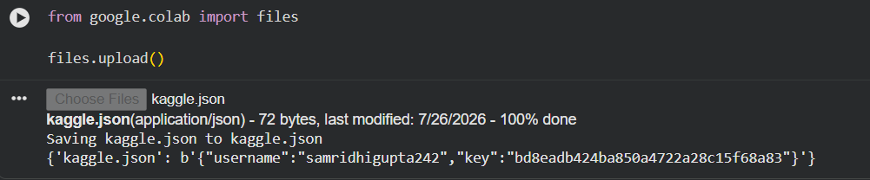
Configure Kaggle API
The uploaded file was moved to the required Kaggle configuration directory and appropriate permissions were assigned.

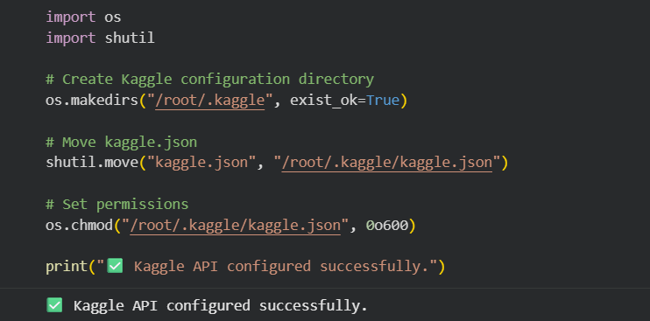

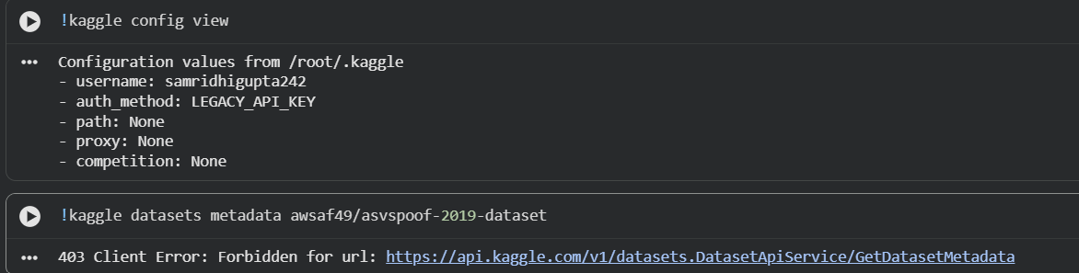

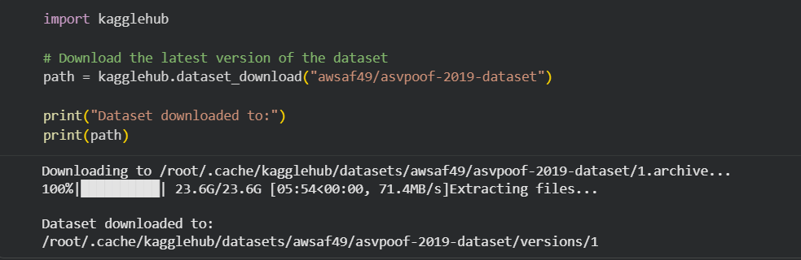
Dataset Download Using KaggleHub
To avoid the authentication issues encountered with the Kaggle CLI (403 Forbidden), the dataset was downloaded using the KaggleHub Python library inside Google Colab. KaggleHub automatically authenticated with the configured Kaggle account and successfully downloaded the complete ASVspoof 2019 Dataset (approximately 23.6 GB, including both the Logical Access (LA) and Physical Access (PA) subsets). After downloading, the dataset was extracted automatically and stored temporarily in the Colab runtime cache.
Downloaded Dataset Path
/root/.cache/kagglehub/datasets/awsaf49/asvspoof-2019-dataset/versions/1
The next step is to copy the downloaded dataset from Colab's temporary storage to Google Drive to ensure persistent storage across future Colab sessions.
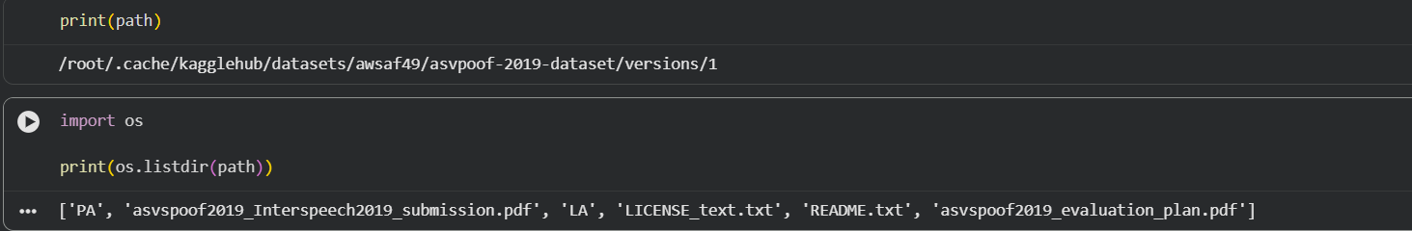
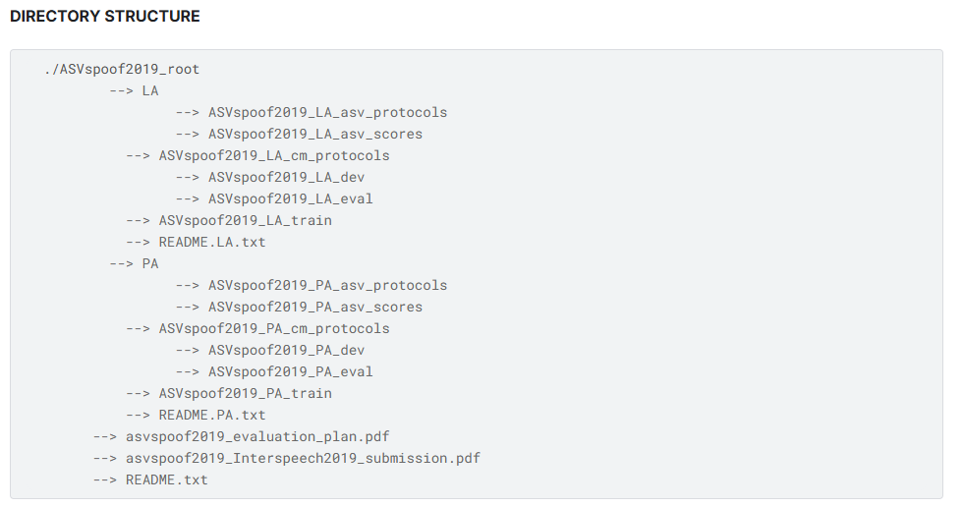

Dataset Interpretation – ASVspoof 2019 (Logical Access)
1. Dataset Selected
Dataset: ASVspoof 2019 – Logical Access (LA)
Source:
https://www.kaggle.com/datasets/awsaf49/asvpoof-2019-dataset/data
The Kaggle dataset was verified as an official mirror by comparing its directory structure, README files, evaluation documents, and protocol files with the official ASVspoof 2019 release.

2. Dataset Structure
The dataset consists of two subsets:
- Logical Access (LA) – AI-generated / synthesized speech (used in this project)
- Physical Access (PA) – Replay attack recordings (not used)
Our project uses only the Logical Access (LA) subset because it is the dataset used by both selected research papers.

3. LA Directory Structure
The LA dataset contains the following components:
- ASVspoof2019_LA_train
- ASVspoof2019_LA_dev
- ASVspoof2019_LA_eval
- ASVspoof2019_LA_cm_protocols
- ASVspoof2019_LA_asv_protocols
- ASVspoof2019_LA_asv_scores
- README.LA.txt
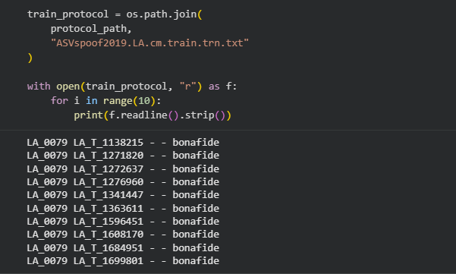

4. Dataset Splits
Split | Purpose
Train | Used for model training
Dev | Used for validation and hyperparameter tuning
Eval | Used for final model evaluation

5. Audio Files
Each dataset split contains a flac folder that stores the audio recordings.
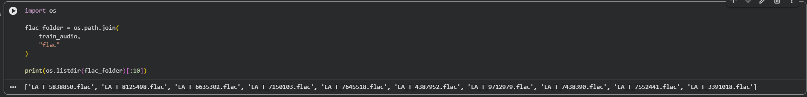
Example:
ASVspoof2019_LA_train
→ LICENSE.txt
→ flac/
→ LA_T_1138215.flac
→ LA_T_1271820.flac
→ ...
All audio samples are stored in FLAC (.flac) format.

6. Protocol Files
The labels are stored separately inside the folder:
ASVspoof2019_LA_cm_protocols
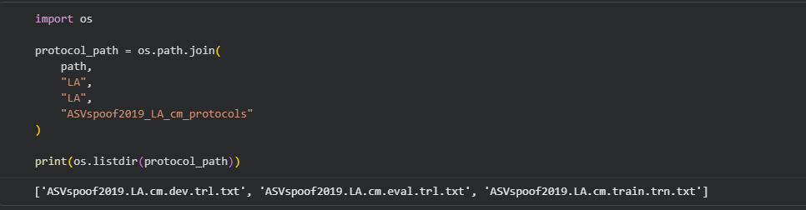
This folder contains:
- ASVspoof2019.LA.cm.train.trn.txt
- ASVspoof2019.LA.cm.dev.trl.txt
- ASVspoof2019.LA.cm.eval.trl.txt
These files contain the ground-truth labels for every audio sample.

7. Protocol File Format
Each row follows the format:
Speaker_ID | Audio_ID | Reserved | Attack_ID | Label
Example:
LA_0079 LA_T_1138215 - - bonafide
Meaning:
Field | Description
Speaker_ID | Speaker identifier
Audio_ID | Audio filename without the .flac extension
Reserved | Unused field
Attack_ID | Spoofing attack ID (- for genuine speech)
Label | bonafide or spoof

8. Audio–Label Mapping
Each protocol entry corresponds to one audio file.
Example:
Audio ID in protocol: LA_T_1138215
Corresponding audio file: LA_T_1138215.flac
Corresponding label: bonafide
During training, the audio ID from the protocol file is matched with the .flac file stored in the appropriate dataset split.

9. Classification Labels
The dataset is a binary classification problem.
Label | Meaning
bonafide | Genuine human speech
spoof | AI-generated or manipulated speech
For spoofed samples, the protocol file also specifies the spoofing attack type (A01–A19).

Dataset Exploration Outcome
During the dataset exploration phase, we:
- Verified that the Kaggle dataset is an official mirror of ASVspoof 2019.
- Explored the overall directory structure.
- Identified the Train, Dev, and Eval dataset splits.
- Located the Countermeasure (CM) protocol files.
- Understood the format of the protocol files.
- Verified the mapping between protocol entries and .flac audio files.
- Understood the binary classification labels (bonafide and spoof).
- Established the complete data loading workflow that will be implemented in the custom ASVspoofDataset class.

File Structure Overview
The ASVspoof 2019 Logical Access (LA) dataset is organized into dedicated folders for audio recordings, protocol files, and evaluation resources. Each component serves a specific role in the deepfake detection pipeline.
Folder/File | Description | Used in VoiceSentinel
ASVspoof2019_LA_train | Contains training audio recordings (.flac) used to train the model. | ✅
ASVspoof2019_LA_dev | Contains development (validation) audio recordings used for model validation and hyperparameter tuning. | ✅
ASVspoof2019_LA_eval | Contains evaluation audio recordings used for final performance testing. | ✅
ASVspoof2019_LA_cm_protocols | Contains protocol files with the ground-truth labels (bonafide / spoof) and attack information for each audio file. | ✅
ASVspoof2019_LA_asv_protocols | Contains protocol files for the Automatic Speaker Verification (ASV) task. | ❌
ASVspoof2019_LA_asv_scores | Contains baseline ASV system scores provided by the challenge organizers. | ❌
README.LA.txt | Official documentation describing the LA dataset, directory structure, and usage guidelines. | 📖 Reference

Components Used in This Project
For the VoiceSentinel framework, only the following components are required:
- ASVspoof2019_LA_train – Training dataset
- ASVspoof2019_LA_dev – Validation dataset
- ASVspoof2019_LA_eval – Evaluation dataset
- ASVspoof2019_LA_cm_protocols – Ground-truth labels and attack metadata
The remaining folders (ASVspoof2019_LA_asv_protocols and ASVspoof2019_LA_asv_scores) are intended for the Automatic Speaker Verification (ASV) task and are not required for the audio deepfake detection pipeline implemented in VoiceSentinel.

Phase 3
Step 1: Designing the Dataset Loader
Before implementing the dataset loader, we identified what information the ASVspoofDataset class should receive and what responsibilities it should have. This design-first approach ensures the class is modular, reusable, and easy to maintain.
Inputs to the Dataset Class
When creating the dataset object, the following information should be provided:
- Dataset Root Path – Location of the ASVspoof2019 LA dataset.
- Dataset Split – Specifies whether the loader should use the train, dev, or eval subset.
- Transform (Optional) – Used later for feature extraction or data augmentation.

Core Methods
The dataset class will implement three standard PyTorch methods:
- __init__() – Initializes the dataset by reading paths and protocol information.
- __len__() – Returns the total number of samples.
- __getitem__() – Loads and returns a single audio sample along with its label.

