VoiceSentinel: Robust & Stereo-Aware Audio Deepfake Detection Framework
Abstract
Recent advances in Text-to-Speech (TTS) and Voice Conversion (VC) have enabled the generation of highly realistic synthetic speech, increasing the risk of voice impersonation, biometric spoofing, and misinformation. This project presents VoiceSentinel, a modular deep learning framework for audio deepfake detection built using the ASVspoof 2019 Logical Access (LA) benchmark dataset.
VoiceSentinel implements an end-to-end detection pipeline comprising dataset processing, audio preprocessing, acoustic feature extraction, model training, evaluation, and deployment. Inspired by recent research on robust feature learning and stereo-aware audio analysis, the framework provides four configurable detection modes for evaluating different feature representations and model architectures within a unified pipeline.
The framework is implemented in PyTorch and deployed through a Gradio-based web interface, enabling real-time audio deepfake detection while supporting future research and model extensions.
1. Introduction
Advances in Text-to-Speech (TTS) and Voice Conversion (VC) technologies have enabled the generation of highly realistic synthetic speech. While these technologies have applications in accessibility, virtual assistants, and speech synthesis, they also introduce significant security risks, including voice impersonation, biometric spoofing, and misinformation.
Detecting AI-generated speech has therefore become a critical research problem. Existing approaches often rely on a single feature representation or model architecture, limiting their ability to generalize across unseen spoofing attacks and diverse recording conditions.
To address these challenges, this project presents VoiceSentinel, a modular audio deepfake detection framework that integrates multiple detection strategies within a unified pipeline. Built using the ASVspoof 2019 Logical Access (LA) dataset, the framework supports standardized preprocessing, configurable detection modes, model evaluation, and real-time deployment through an interactive web interface.

2. Problem Statement
The increasing realism of AI-generated speech has reduced the effectiveness of conventional audio authentication systems. Existing detection methods often struggle with unseen spoofing attacks, varying recording conditions, and limited adaptability due to their reliance on a single detection strategy.
This project addresses these limitations by developing VoiceSentinel, a modular framework that supports multiple detection pipelines, standardized preprocessing, reproducible evaluation, and real-time audio deepfake detection within a unified system.

3. Objectives
The objectives of VoiceSentinel are to:
- Develop an end-to-end framework for audio deepfake detection.
- Utilize the ASVspoof 2019 LA dataset for training and evaluation.
- Implement robust preprocessing and acoustic feature extraction.
- Integrate multiple detection strategies inspired by recent research.
- Enable comparative evaluation through modular detection modes.
- Support real-time inference through an interactive Gradio interface.

4. Literature Review
Recent advances in audio deepfake detection have focused on improving model robustness through enhanced feature representations, data augmentation techniques, and spatial modeling of speech signals. This project is primarily inspired by two research works that address complementary aspects of audio spoof detection: stereo-aware representation learning and robust feature learning through data augmentation.

4.1 Paper 2: Betray Oneself: A Novel Audio DeepFake Detection Model via Mono-to-Stereo Conversion
Paper Link:
https://arxiv.org/abs/2305.16353
Objective
The paper introduces a stereo-aware audio deepfake detection framework based on the observation that synthetic speech generated in the mono domain often lacks the natural spatial characteristics of genuine speech. It proposes exploiting stereo representations to capture spatial inconsistencies that are difficult to identify using conventional mono-based approaches.
Key Contributions
- Introduces a Mono-to-Stereo (M2S) conversion framework for audio deepfake detection.
- Explores stereo representations to capture spatial artifacts in synthesized speech.
- Employs a dual-branch architecture for learning channel-specific information.
- Demonstrates improved detection performance over conventional mono-based methods on the ASVspoof2019 benchmark.
Implementation in VoiceSentinel
VoiceSentinel incorporates the concept of stereo-aware processing through dedicated detection pipelines that investigate spatial representations as an additional source of discriminative information for detecting synthetic speech.

4.2 Paper 4: A Study On Data Augmentation In Voice Anti-Spoofing
Paper Link:
https://arxiv.org/abs/2110.10491
Objective
This paper investigates the effectiveness of data augmentation techniques in improving the robustness and generalization of voice anti-spoofing systems. It demonstrates that carefully designed augmentations and spectrogram-based feature representations significantly improve performance under unseen spoofing attacks and real-world recording conditions.
Key Contributions
- Evaluates multiple data augmentation techniques for audio spoof detection.
- Introduces SpecAverage, a spectrogram-based augmentation strategy.
- Demonstrates the effectiveness of Log-Spectrogram representations for anti-spoofing.
- Improves model robustness against unseen attacks and channel variations through data-centric preprocessing.
Implementation in VoiceSentinel
VoiceSentinel adopts the concepts of robust preprocessing, spectrogram-based feature extraction, and augmentation-inspired processing to improve model robustness and enable comparative evaluation across multiple detection pipelines.

5. Dataset Analysis
5.1 ASVspoof 2019 Logical Access (LA) Dataset
VoiceSentinel is developed and evaluated using the ASVspoof 2019 Logical Access (LA) dataset, one of the most widely used benchmark datasets for audio deepfake and voice spoofing detection. The dataset was introduced as part of the ASVspoof 2019 Challenge to evaluate the robustness of automatic speaker verification (ASV) systems against synthetic and manipulated speech.
Official Dataset Website:
https://www.asvspoof.org/index2019.html
Evaluation Plan:
https://www.asvspoof.org/asvspoof2019/asvspoof2019_evaluation_plan.pdf
The Logical Access (LA) subset focuses on logical attacks, where spoofed audio is generated using Text-to-Speech (TTS) and Voice Conversion (VC) systems. Unlike the Physical Access (PA) subset, which considers replay attacks, the LA dataset specifically targets synthetic speech generation, making it well suited for developing audio deepfake detection models.
5.2 Dataset Composition
The dataset consists of three predefined subsets that support model development, validation, and evaluation.
Dataset Split | Purpose
Training Set | Used for model training and parameter optimization.
Development Set | Used for hyperparameter tuning and model validation.
Evaluation Set | Used for final performance evaluation on unseen spoofing attacks.

Each audio sample is accompanied by a protocol file containing metadata such as the speaker ID, file name, spoofing attack ID, and ground-truth label

5.3 Class Labels
The dataset is formulated as a binary classification problem with two classes:
Label | Description
Bonafide | Genuine human speech recordings.
Spoof | Speech generated using TTS or Voice Conversion systems.
The objective of VoiceSentinel is to correctly classify each audio recording into one of these two categories.

5.4 Audio Format
The audio files are provided in FLAC format with a sampling rate of 16 kHz. During preprocessing, all recordings are standardized before feature extraction to ensure consistent input dimensions for deep learning models.
The preprocessing pipeline includes:
- Audio loading
- Waveform normalization
- Padding or truncation to a fixed length
- Feature extraction for model training

6. VoiceSentinel Framework
6.1 Overview
VoiceSentinel is a modular deep learning framework for audio deepfake detection developed using PyTorch. It provides a unified pipeline for dataset processing, audio preprocessing, feature extraction, model training, evaluation, and real-time inference. The framework supports multiple configurable detection modes, enabling systematic comparison of different detection strategies within a consistent workflow.

6.2 Framework Architecture
VoiceSentinel follows a modular workflow comprising the following stages:
- Dataset Loading: Parses the ASVspoof 2019 LA dataset and corresponding protocol files.
- Audio Preprocessing: Standardizes audio through waveform loading, normalization, and fixed-length processing.
- Feature Extraction: Generates acoustic representations such as LFCC and Log-Spectrograms.
- Detection Mode: Processes the extracted features using one of the four configurable detection modes (Mode A–D).
- Model Inference: Classifies the input audio as Bonafide or Spoof.
- Evaluation & Deployment: Evaluates model performance and enables real-time inference through a Gradio interface.

6.3 Core Components
VoiceSentinel is organized into the following modules:
- Dataset Module: Loads the dataset, parses protocol files, and prepares the train, development, and evaluation splits.
- Preprocessing Module: Performs waveform normalization and fixed-length audio processing.
- Feature Extraction Module: Extracts LFCC and Log-Spectrogram features for model training.
- Detection Module: Implements the four configurable detection modes.
- Training & Evaluation Module: Handles model training, checkpointing, and performance evaluation.
- Deployment Module: Provides a Gradio-based interface for real-time audio deepfake detection
7. Methodology
VoiceSentinel follows a structured pipeline for audio deepfake detection, beginning with dataset preparation and ending with real-time inference. The methodology comprises six key stages: dataset preparation, audio preprocessing, feature extraction, model training, evaluation, and deployment.

7.1 Dataset Preparation
The ASVspoof 2019 Logical Access (LA) dataset serves as the primary benchmark for training and evaluation. Protocol files are parsed to obtain audio paths, speaker information, attack identifiers, and ground-truth labels. The processed metadata is then used to construct PyTorch datasets and data loaders for the training, development, and evaluation splits.

7.2 Audio Preprocessing
All audio recordings are standardized before feature extraction to ensure consistent model inputs. The preprocessing pipeline includes:
- Audio loading
- Waveform normalization
- Padding or truncation to a fixed length
- Conversion to a uniform input format
This standardization enables efficient batch processing and stable model training.

7.3 Feature Extraction
Raw waveforms are transformed into acoustic representations suitable for deep learning models. Depending on the selected detection mode, VoiceSentinel extracts:
- LFCC (Linear Frequency Cepstral Coefficients): Used for frequency-domain speech representation.
- Log-Spectrograms: Capture time-frequency information for robust spectral analysis.
The extracted features serve as inputs to the corresponding detection models.

7.4 Model Training
The extracted features are used to train the selected detection model using supervised learning. The training pipeline includes:
- Batch-wise data loading
- Forward propagation
- Loss computation
- Backpropagation
- Model optimization
- Checkpoint generation
Model performance is continuously monitored using the development set to select the best-performing checkpoint.

7.5 Model Evaluation
The trained models are evaluated using the development and evaluation datasets. Performance is measured using standard classification metrics along with Equal Error Rate (EER), the primary evaluation metric for audio spoofing detection.
The evaluation pipeline includes:
- Accuracy
- Precision
- Recall
- F1-Score
- Equal Error Rate (EER)

7.6 Deployment
The final trained models are integrated into a Gradio-based web application that supports real-time audio deepfake detection. Users can upload an audio sample, select a detection mode, and obtain prediction results through an interactive interface.

8. VoiceSentinel Detection Modes
VoiceSentinel provides four configurable detection modes, each designed to evaluate a different approach to audio deepfake detection. While all modes share a common preprocessing and evaluation pipeline, they differ in the feature representations and model architectures employed.
Mode | Description | Feature Representation | Model Architecture
Mode A | Baseline detection pipeline using conventional acoustic analysis for binary classification. | LFCC | ResNet34
Mode B | Robust detection pipeline that employs spectrogram-based features and augmentation-inspired preprocessing to improve generalization. | Log-Spectrogram | ResNet34
Mode C | Stereo-aware detection pipeline that explores spatial information through mono-to-stereo conversion and graph-based feature learning. | Mono-to-Stereo Representation | SincNet + ResNet + GAT
Mode D | Comprehensive detection pipeline that combines stereo-aware processing with robust spectral representations for enhanced detection performance. | Stereo Log-Spectrogram | Stereo-aware ResNet34

9. Project Structure
VoiceSentinel follows a modular project structure to improve code organization, maintainability, and extensibility. The project is divided into independent modules responsible for data processing, feature extraction, model implementation, training, evaluation, and deployment.
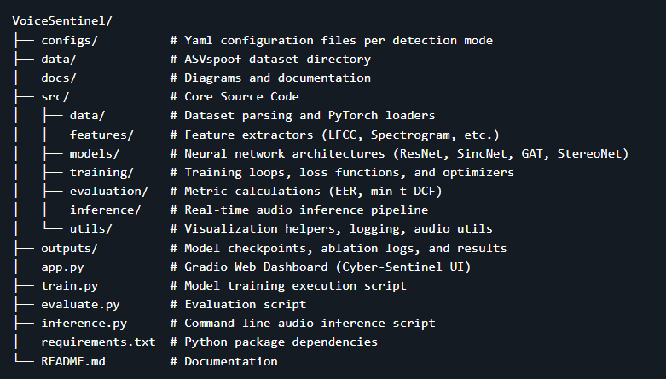
Directory Description
Directory / File | Description
configs/ | Stores configuration files for different detection modes and experiments.
data/ | Contains the ASVspoof 2019 LA dataset used for training and evaluation.
docs/ | Includes project documentation, diagrams, and supporting materials.
src/data/ | Implements dataset parsing, protocol processing, and PyTorch data loaders.
src/features/ | Implements acoustic feature extraction modules such as LFCC and Log-Spectrograms.
src/models/ | Contains the neural network architectures used across different detection modes.
src/training/ | Implements the training pipeline, optimization, and checkpoint management.
src/evaluation/ | Provides evaluation metrics and performance analysis utilities.
src/inference/ | Implements the inference pipeline for audio prediction.
src/utils/ | Contains utility functions for logging, visualization, and common operations.
outputs/ | Stores trained model checkpoints, logs, and experimental results.
app.py | Launches the Gradio-based web application for real-time inference.
train.py | Entry point for training the detection models.
evaluate.py | Evaluates trained models on the validation and evaluation datasets.
inference.py | Performs inference on individual audio files using trained models.
requirements.txt | Lists the Python dependencies required to run the project.
README.md | Provides project overview, setup instructions, and usage guidelines.

10. System Workflow
VoiceSentinel follows a complete end-to-end workflow for audio deepfake detection. An input audio recording is first processed through the preprocessing pipeline, where it is standardized for further analysis. The preprocessed audio is then transformed into the appropriate acoustic representation based on the selected detection mode. The extracted features are passed to the corresponding deep learning model, which performs binary classification and predicts whether the input audio is Bonafide or Spoof. The prediction, along with the associated confidence score, is then presented to the user through the web interface.

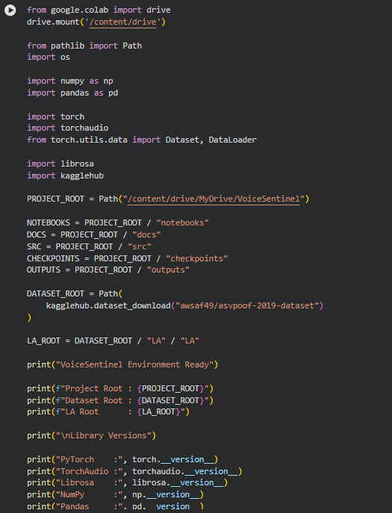

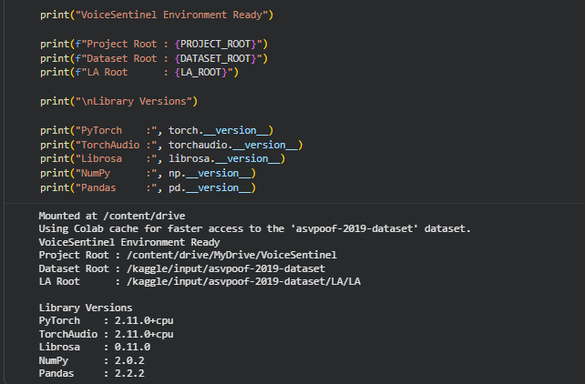
Environment & Dataset Initialization
- Mounted Google Drive and connected the Voice_Sentinel project.
- Imported all required libraries (PyTorch, Torchaudio, Librosa, NumPy, Pandas, KaggleHub).
- Defined the project root and key project directories.
- Downloaded/located the ASVspoof2019 LA dataset using KaggleHub.
- Defined the dataset root (LA_ROOT).
- Created paths for:
  - Protocol files (Train, Dev, Eval)
  - Audio directories (Train, Dev, Eval)
- Verified that all dataset paths are valid and accessible.
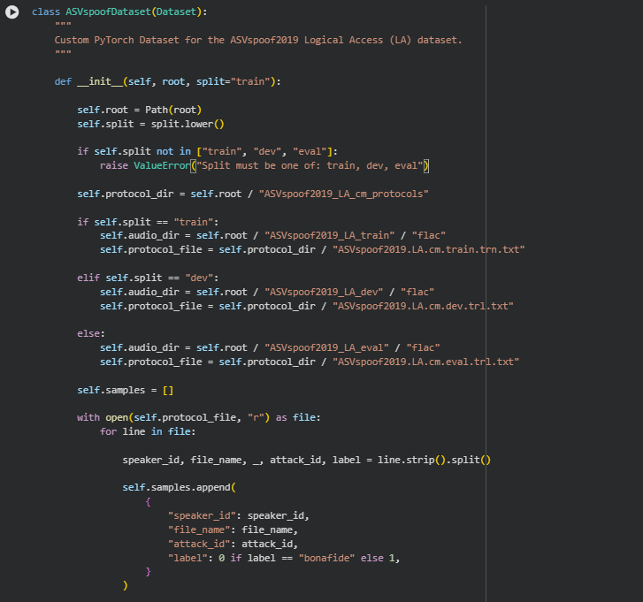
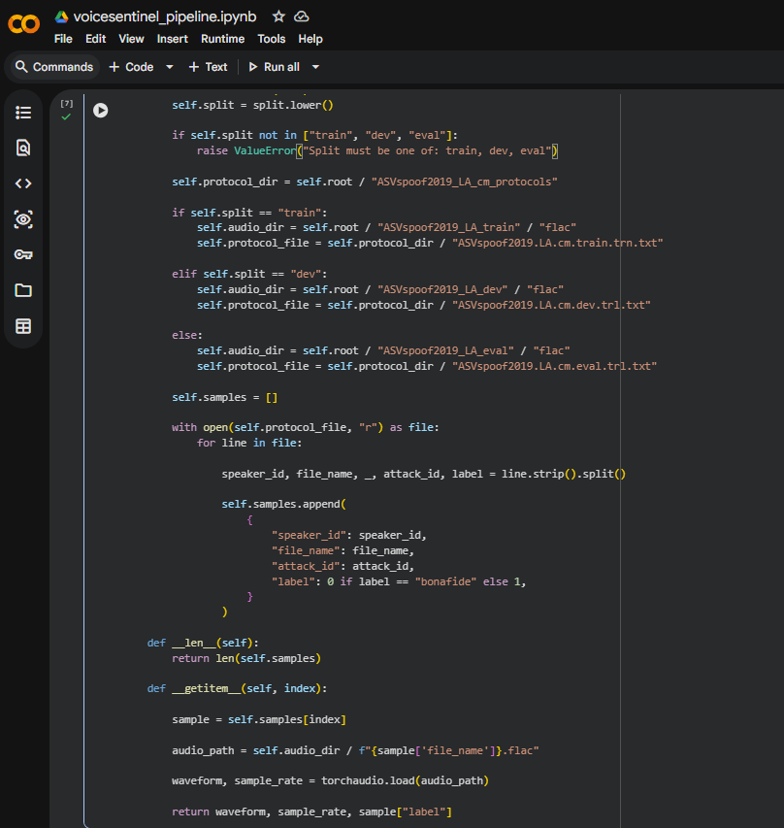
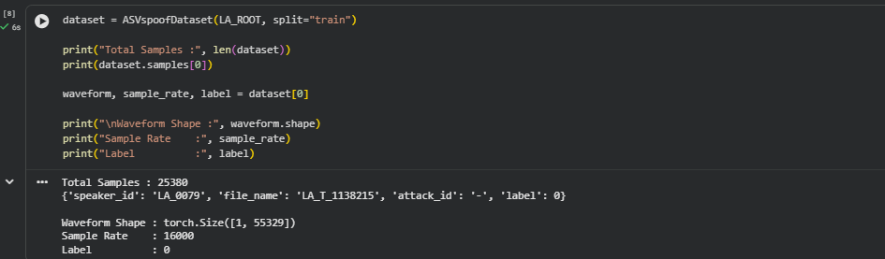

11. Demonstration
VoiceSentinel has been developed as a complete end-to-end audio deepfake detection framework and deployed through an interactive web application. The project enables users to upload an audio recording, select one of the available detection pipelines, and perform real-time authenticity analysis. The implementation, source code, and deployment are publicly accessible for reproducibility and demonstration purposes.

11.1 Project Repository
The complete implementation of VoiceSentinel, including dataset processing, feature extraction, deep learning models, training, evaluation, and deployment modules, is available on GitHub.
GitHub Repository:
🔗 https://github.com/justsamridhi/Voice_sentinel

11.2 Live Demonstration
The framework is deployed using Gradio, providing an interactive interface for real-time audio deepfake detection. Users can upload an audio sample, choose a detection mode (Modes A–D), and obtain prediction results along with acoustic feature visualizations and confidence scores.
Live Demo:
🔗 https://4ce19085bf6b1617b6.gradio.live/

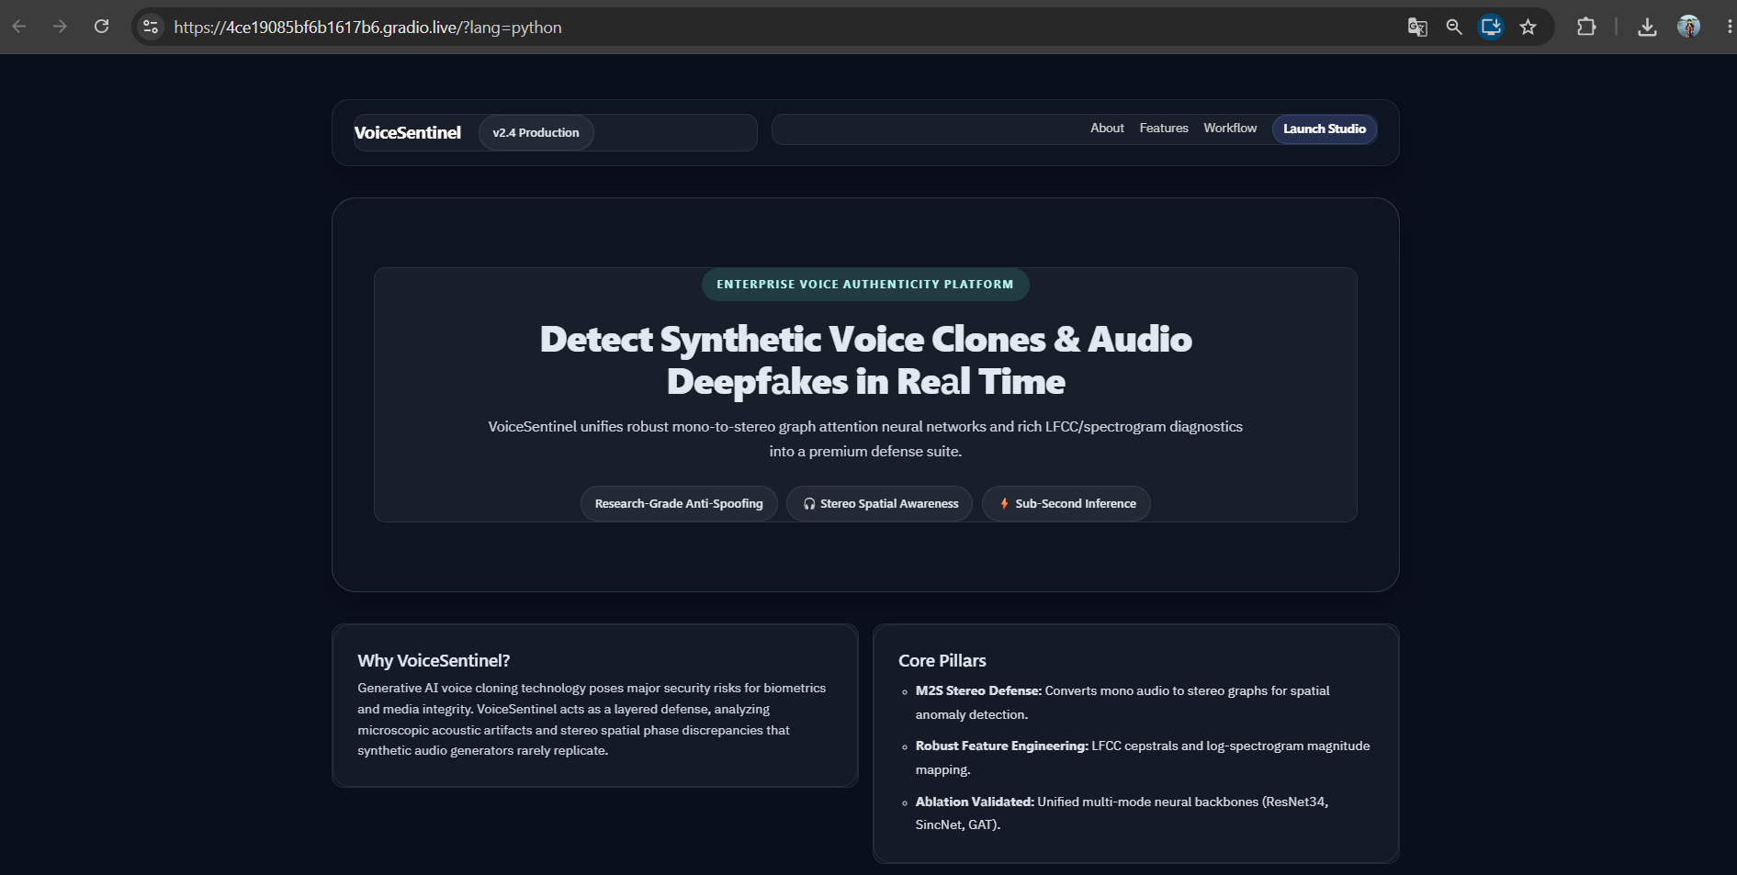
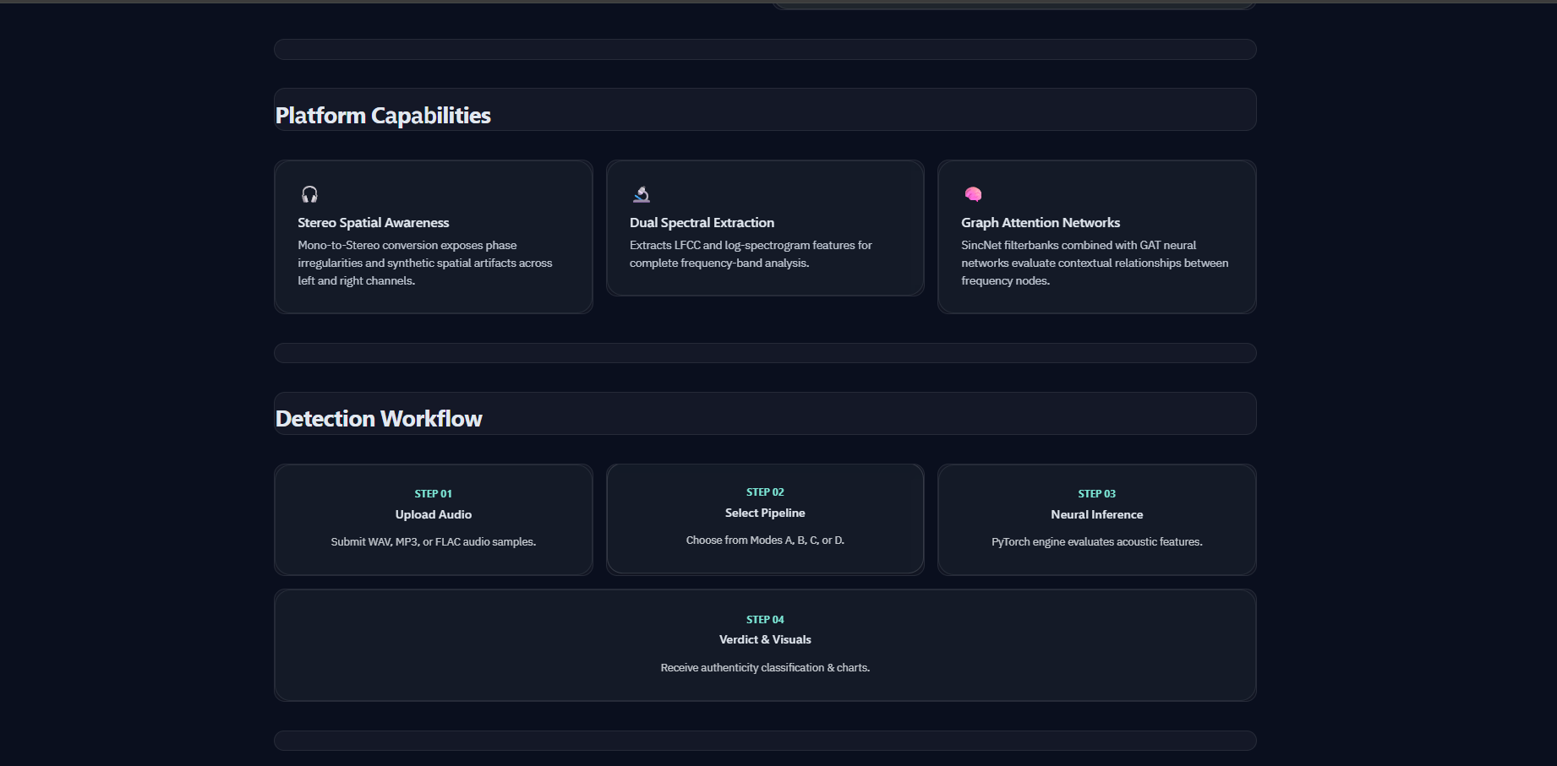
Figure : VoiceSentinel web interface highlighting the platform capabilities and end-to-end detection workflow. The application supports stereo-aware feature analysis, spectral feature extraction, graph-based deep learning, and provides a streamlined pipeline from audio upload and model selection to real-time inference and prediction visualization.
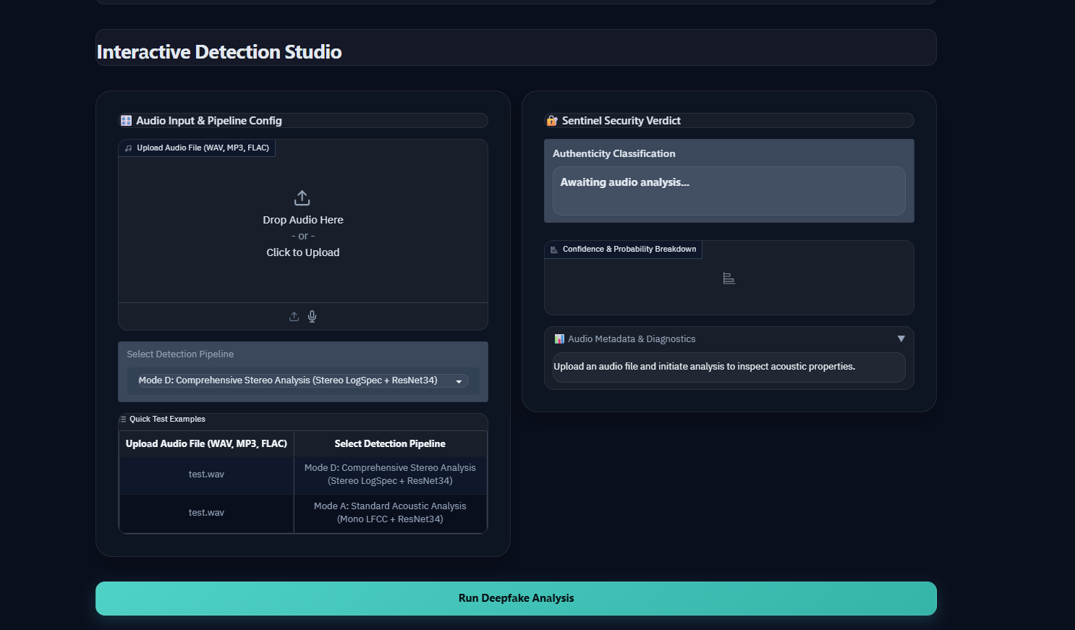
Figure : Interactive Detection Studio of VoiceSentinel illustrating the audio upload interface, selection of detection pipelines (Modes A–D), and the real-time analysis workflow. The interface allows users to configure the desired detection mode before initiating inference.
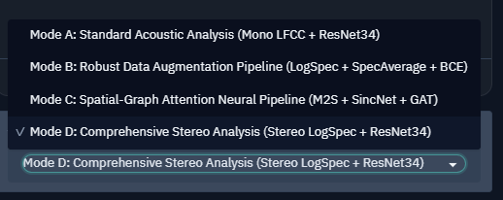
Figure : Detection pipeline selection menu showing the four configurable modes available in VoiceSentinel: Mode A (Standard Acoustic Analysis), Mode B (Robust Data Augmentation), Mode C (Spatial-Graph Attention), and Mode D (Comprehensive Stereo Analysis). This modular design enables comparative evaluation of multiple deepfake detection strategies within a unified framework.

Figure : VoiceSentinel interface showcasing the integrated acoustic feature visualization module and research validation benchmarks. The dashboard provides waveform, FFT, spectrogram, and LFCC visualizations while highlighting the ASVspoof 2019 LA benchmark dataset and the research foundations adopted from Paper 2 (M2S-ADD) and Paper 4 (Robust Data Augmentation).

SAMPLE IMPLEMENTATION
Demo Audio
For demonstration and validation, the audio sample spongebob-fail.mp3 was used as the test input. The clip has a duration of 3.38 seconds, a sampling rate of 48 kHz, and consists of stereo (2-channel) audio. The sample was analyzed using Mode A (Standard Acoustic Analysis), and VoiceSentinel successfully classified it as Bona Fide (Real Speech) with 100% prediction confidence, while simultaneously generating waveform, FFT, log-spectrogram, and LFCC visualizations for acoustic analysis

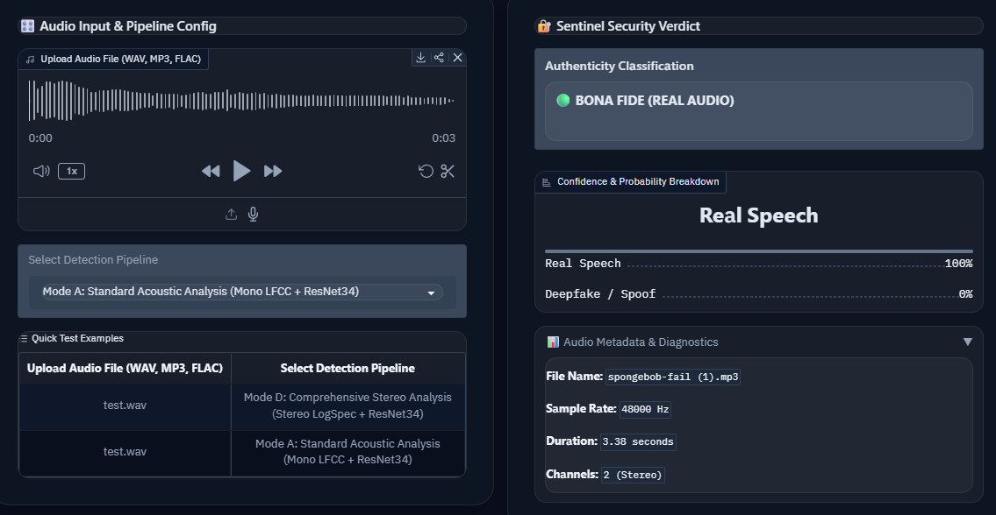
Detection Result
VoiceSentinel analysis of the sample audio spongebob-fail.mp3 (3.38 s, Stereo, 48 kHz) using Mode A (Standard Acoustic Analysis). The system classified the recording as Bona Fide (Real Speech) with 100% confidence. The interface also displays prediction probabilities and audio metadata, demonstrating the framework's capability for real-time audio authenticity verification.

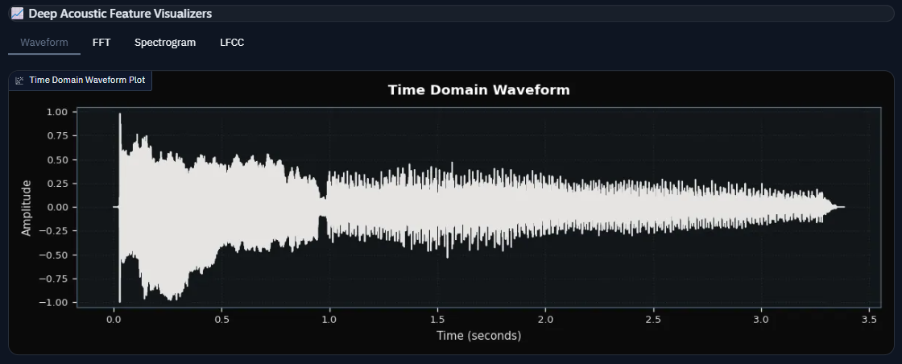
Time-Domain Waveform
Time-domain waveform of the input audio spongebob-fail.mp3. The waveform represents variations in signal amplitude over time and provides an initial visualization of the temporal characteristics of the speech signal before feature extraction and neural network inference.

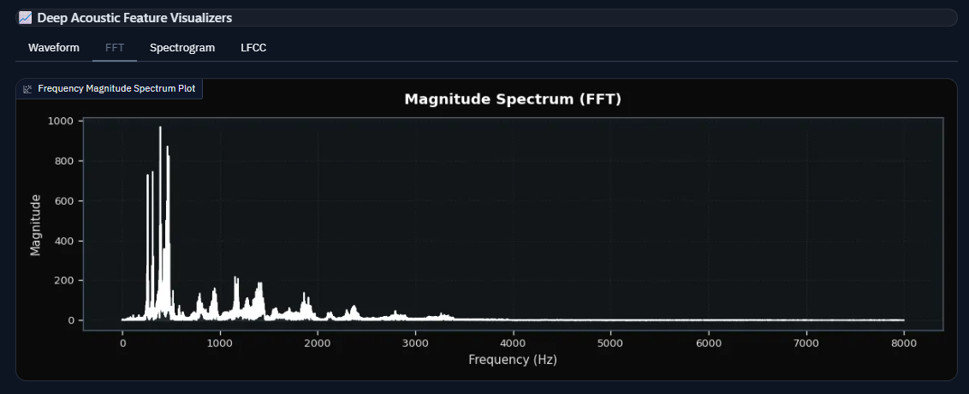
Frequency Spectrum (FFT)
Fast Fourier Transform (FFT) of the input audio showing the distribution of signal energy across frequency components. The dominant low-frequency peaks correspond to the primary speech harmonics, while higher-frequency components exhibit lower energy, representing the spectral characteristics used during acoustic analysis.

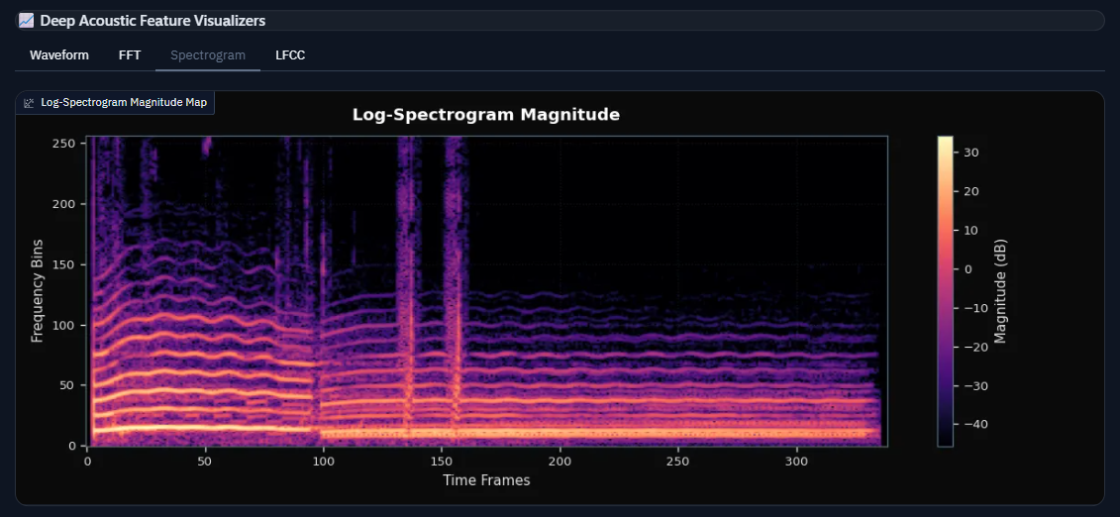
Log-Spectrogram
Log-spectrogram representation of the input audio illustrating the variation of spectral energy across time and frequency. Bright regions indicate dominant speech frequencies, while temporal transitions capture changes in phonetic content. This time-frequency representation forms one of the primary inputs for convolutional feature extraction.

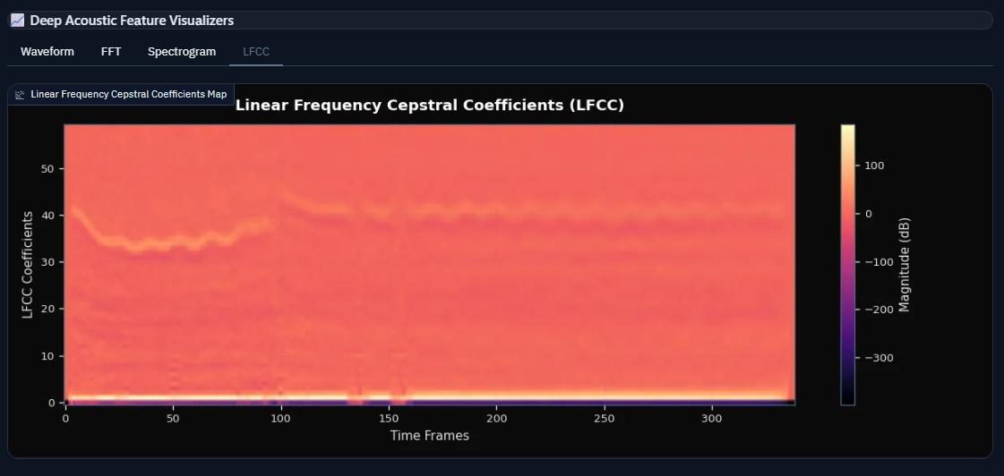

LFCC Feature Map
Linear Frequency Cepstral Coefficient (LFCC) representation extracted from the input audio. LFCC features encode the spectral envelope of the speech signal and effectively capture discriminative acoustic patterns used by VoiceSentinel for distinguishing bona fide and spoofed speech. These features serve as the primary input to the ResNet34-based detection pipeline in Mode A.

Result
The demonstration successfully validated the end-to-end functionality of the VoiceSentinel framework. The input audio sample spongebob-fail.mp3 (3.38 s, 48 kHz, Stereo) was processed using Mode A (Standard Acoustic Analysis). The framework correctly classified the sample as Bona Fide (Real Speech) with a prediction confidence of 100%.
In addition to the classification result, VoiceSentinel generated multiple acoustic feature visualizations, including the time-domain waveform, FFT spectrum, log-spectrogram, and LFCC feature map. These visualizations provide interpretable insights into the temporal, spectral, and cepstral characteristics of the input signal, supporting both prediction and acoustic analysis.
The successful execution of the complete inference pipeline demonstrates that VoiceSentinel integrates audio preprocessing, feature extraction, deep learning-based classification, and interactive visualization into a unified, real-time audio deepfake detection system

