UrbanCart
E-Commerce Data Engineering & Analytics
Big Data Term Project Report
Course: Big Data
Lecturer: Min Sothearith
Team Members
Eng Kosal
Lang Senglong
Vutha Sokban
Choeun Seyha
Cheok Kimleng
Vong Pichrachana

Table of Contents

List of Figures
Figure 1. UrbanCart order status distribution
Figure 2. Data quality issues identified by audit
Figure 3. Legacy customer file cleaning funnel
Figure 4. Product catalog reconciliation results
Figure 5. RFM segment distribution
Figure 6. Average predicted CLTV by RFM segment
Figure 7. Cohort retention rate by month since signup
Figure 8. Monte Carlo simulation of 12-month revenue
Figure 9. Six-month revenue forecast: Holt vs. linear trend
Figure 10. Conceptual end-to-end data engineering and analytics pipeline

List of Tables
Table 1. UrbanCart dataset overview
Table 2. Data quality audit summary
Table 3. Legacy customer cleaning results
Table 4. Product catalog reconciliation
Table 5. Cohort retention rates by month
Table 6. RFM customer segments
Table 7. CLTV by customer segment
Table 8. Regression results: drivers of customer monetary value
Table 9. Price elasticity analysis results
Table 10. Monte Carlo simulation results
Table 11. Six-month revenue forecast comparison
Table 12. Model evaluation summary
Table 13. Decision-support matrix

Chapter 1 Introduction

1.1 Background
Modern e-commerce platforms generate continuous streams of heterogeneous data as a by-product of ordinary operation. Every browsing session, product view, cart update, completed purchase, cancellation, return, and customer review adds a new record to an underlying database. Individually, these records are simple transactional facts. Collectively, across thousands of customers and tens of thousands of orders, they form a dataset large and varied enough that understanding it requires structured data engineering rather than manual inspection.
Analytics built on top of this data allows a retailer to move from anecdote to evidence: instead of assuming which customers are valuable, which products sell together, or how revenue is trending, the underlying transaction history can be queried, cleaned, and modeled to produce defensible answers. This requires a disciplined pipeline — ingesting raw sources, profiling them for quality problems, reconciling inconsistent records, and only then applying statistical and analytical methods — because analysis performed on unaudited data risks producing confident but misleading conclusions.
UrbanCart is treated in this report as a representative case of this problem. Its operational database, combined with a separate legacy customer export and a separate supplier product catalog, mirrors a common real-world situation in which a company's "single source of truth" is in fact split across systems that were never designed to be merged automatically.

1.2 Project Background
The UrbanCart dataset consists of a six-table relational database (customers, products, orders, order_items, reviews, and web_sessions) together with two auxiliary files: a legacy customer export and a 2024 supplier product catalog. The database covers 34 months of order history and contains 2,500 customers, 9,000 orders, 20,362 order line items, 300 products, 4,000 product reviews, and 12,000 web sessions.
This combination of structured relational data, a loosely formatted legacy export, and an external catalog file makes the dataset well suited to a Big Data term project: it is large enough that manual review is impractical, it contains genuine data-quality defects that must be resolved programmatically, and it supports a full pipeline from raw ingestion through descriptive analytics, customer analytics, and forecasting.

1.3 Problem Statement
Initial inspection of the UrbanCart data revealed a set of concrete problems that motivate this project:
- Inconsistent legacy customer records, including duplicate emails, missing fields, and multiple date formats within a single column.
- Duplicate rows in the order-item table and negative quantity values that require reconciliation with returns.
- Missing values across customer demographic fields (city, age, gender) and review text.
- A supplier product catalog whose SKUs only partially overlap with the internal product table, and whose prices disagree with internal prices for the large majority of matched SKUs.
- Uncertainty about which customers are likely to remain valuable, and which have already disengaged.
- No existing, data-grounded estimate of customer lifetime value.
- No prior evidence, positive or negative, on whether price changes would be expected to affect demand.
- No mechanism for forecasting revenue ranges or informing inventory and marketing planning.
- No existing product recommendation capability despite a large product catalog and purchase history.

1.4 Project Objectives
The project pursues the following objectives:
- 1. Audit the UrbanCart database and auxiliary files for data-quality issues.
- 2. Clean and reconcile the legacy customer export and supplier catalog against the internal database.
- 3. Analyze customer retention using cohort analysis.
- 4. Perform market-basket analysis to test for product affinity.
- 5. Segment customers using Recency-Frequency-Monetary (RFM) analysis.
- 6. Estimate customer lifetime value (CLTV) from completed-order history.
- 7. Analyze the drivers of customer monetary value using regression.
- 8. Evaluate price elasticity of demand at category and overall levels.
- 9. Build an item-based collaborative-filtering recommendation engine.
- 10. Forecast revenue using both trend-based and simulation-based methods.
- 11. Translate the findings into concrete business recommendations.

1.5 Research Questions
The analysis is organized around the following research questions:
- What data-quality problems exist in the UrbanCart database and auxiliary files, and how severe are they?
- How can the legacy customer export be reconciled with the internal customer table?
- Which customer segments hold the greatest predicted value, and which are at risk of being lost?
- What retention pattern do UrbanCart's customer cohorts display over their first twelve months?
- Is there measurable evidence of product affinity that would support cross-selling or bundling?
- What customer-level factors explain variation in monetary value?
- Is customer demand in this dataset sensitive to price?
- What products can be defensibly recommended to a given customer based on co-purchase history?
- What range of revenue outcomes can reasonably be expected over the next 12 months given historical volatility?

1.6 Project Scope
This project is scoped to what the UrbanCart data can directly support. It includes: data auditing and cleaning; SQL-based descriptive analysis; cohort retention analysis; market-basket analysis; RFM segmentation; CLTV estimation using a formula-based model; ordinary least squares regression; log-log price elasticity estimation; an item-based collaborative-filtering recommender; and two revenue forecasting approaches (Holt's linear trend and Monte Carlo simulation).
It explicitly excludes: deployment of any production system; use of distributed or cloud infrastructure, since none was used to produce the results in this report; real-time or streaming analytics; and any claim of causal business impact in dollar terms, since the dataset supports correlational and descriptive analysis only. A companion "Master Specification" style document describing cloud and streaming infrastructure and pre-stated "achieved" metrics was reviewed during scoping and was excluded as a data source, because its figures do not correspond to anything computable from the underlying UrbanCart tables. Every quantitative result in this report is instead computed directly from the database and the two auxiliary files.

Chapter 2 Data Sources and Data Understanding

2.1 Dataset Overview
UrbanCart's analytical base combines one relational database with two external files. The three sources, their formats, and their role in the project are summarized in Table 1.
Table 1. UrbanCart Dataset Overview
Source | Format | Purpose | Key Fields
ecommerce.db | SQLite (6 tables) | Primary operational data: customers, products, orders, order items, reviews, web sessions | customer_id, order_id, product_id, sku, order_status, order_date, quantity, price, rating
legacy_customers_export.csv | CSV | Older customer records reconciled against the customers table | name, email, signup_date (mixed formats), city
product_catalog_2024.csv | CSV | Supplier-side product catalog reconciled against products by SKU | sku, supplier_price, category

2.2 Database Structure
The operational database is organized around six tables. The customers table holds one row per customer with demographic and signup information. The products table holds the internal catalog of 300 products. The orders table records one row per order together with its status (completed, cancelled, returned, or pending) and order date. The order_items table is the line-item detail beneath each order, linking a product and quantity to an order_id. The reviews table holds customer product reviews with a rating and optional text. The web_sessions table records browsing session activity.
Conceptually, customers relate to orders one-to-many, orders relate to order_items one-to-many, and order_items relate to products many-to-one. Reviews relate customers to products, and web_sessions relate to customers independently of the order tables. This structure is typical of a normalized transactional schema and supports SQL-based joins for the descriptive and analytical queries used throughout this report.

2.3 Data Volume
Table 1 above summarizes the sources; Table 2 in Chapter 4 details row-level quality findings. For reference, the raw row counts across the six database tables and two auxiliary files are as follows: 2,500 customers, 9,000 orders, 20,362 order line items, 300 products, 4,000 reviews, 12,000 web sessions, 1,427 raw legacy customer rows, and 267 supplier catalog rows. These volumes are large enough that manual inspection is impractical and SQL- and Python-based processing is required.

2.4 Data Types
The dataset combines several data types. The six database tables are structured relational data accessed through SQL. The two auxiliary files are flat CSV files with looser formatting. Within the tables, order and review data are transactional (one row per event), customer and product data are descriptive/reference data, review data is a mix of structured ratings and unstructured free text, and web-session data is behavioral/log-style data. Order dates and signup dates are temporal fields used throughout the cohort, forecasting, and trend analyses.

2.5 Data Characteristics
Profiling the raw sources surfaced the characteristics addressed in Chapters 4 and 5: missing values concentrated in customer demographic fields and review text; duplicate rows in both the legacy customer export and the order_items table; inconsistent date formatting in the legacy file; categorical fields (order status, product category, gender) that required standardization; numerical fields (price, quantity, rating) that required range validation; and a set of relational dependencies between tables that needed to be verified rather than assumed.

2.6 Data Understanding Summary
The initial data-understanding pass established that UrbanCart's internal database is comparatively well-structured, while the two auxiliary files carry most of the data-quality risk. This shaped the project's approach: the internal database was treated as the primary source of truth, and the legacy customer file and supplier catalog were programmatically reconciled against it rather than merged uncritically. The results of that reconciliation are presented in Chapters 4 and 5.

Chapter 3 Big Data and Data Engineering Approach
This project's pipeline is built entirely from a local SQLite database and a Python/pandas processing layer. No distributed or cloud computing platform (for example, Hadoop, Spark, AWS, or Azure) was used to produce any of the results in this report; where such technologies could be relevant to a production deployment, they are discussed only as future work in Chapter 21 and Chapter 18.

3.1 Data Engineering Workflow
The processing pipeline follows a linear sequence: raw sources are ingested, profiled for quality issues, cleaned, reconciled against the internal database, validated, and then passed through SQL-based descriptive analysis, statistical analysis, machine-learning-style modeling (RFM, CLTV, regression, recommendation), and forecasting, before being summarized into business insights. Figure 10 illustrates this workflow conceptually.

3.2 Technologies Used
The project uses only technologies actually exercised by the analysis scripts: SQLite as the database engine; Python as the processing language; pandas and NumPy for data manipulation and numerical computation; rapidfuzz for fuzzy name-matching during legacy-customer reconciliation; SQL for querying the relational tables; and JSON/CSV as interchange formats between pipeline stages.

3.3 Pipeline Architecture
The project is organized into three directories. The src/ directory holds the processing scripts described in Chapter 17. The cleaned_data/ directory holds the outputs of the cleaning and reconciliation stage — the standardized customer table, the reconciled product catalog, and validated order data — which are then consumed by the analysis scripts. The outputs/ directory holds the results of each analysis stage (audit reports, RFM/CLTV tables, regression and elasticity results, forecast tables, and recommendation output), which this report draws on directly.

3.4 Data Processing Strategy
Each stage of the pipeline follows the same pattern: extract the relevant rows from the source table or file, transform them into a standardized structure, validate the result against basic integrity rules (for example, no negative prices, valid date ranges, referential integrity between orders and customers), run the stage-specific analysis, and write a structured output file that the next stage or this report can consume.

3.5 Reproducibility
Because each processing stage is implemented as a separate, modular script that reads a defined input and writes a defined output, the analysis is reproducible: re-running a script against the same source data reproduces the same output file, and any stage can be re-run in isolation without re-running the entire pipeline. This also makes it possible to audit a specific number in this report back to the script and output file that produced it, which is the same approach used to verify the figures presented in the following chapters.

Chapter 4 Data Quality Audit
An audit was run across all six database tables and the two auxiliary files before any analytical work began. The purpose of the audit was to establish, quantitatively, how much of the raw data could be trusted as-is and how much required cleaning.

4.1 Database Audit
Table 2. Data Quality Audit Summary
Table / File | Rows | Key Issues Found | Observation
customers | 2,500 | 48 duplicate records; 63 missing city; 139 missing age; 115 missing gender | Demographic fields are the weakest part of the internal table
orders | 9,000 | 56.7% completed; 1,328 cancelled; 1,327 returned; 1,244 pending | Non-completed orders excluded from revenue and value calculations
order_items | 20,362 | 186 duplicate rows; 583 negative-quantity lines | Negative quantities align with returns and were flagged, not silently dropped
reviews | 4,000 | 41 out-of-range ratings; 838 missing review text | Rating scale violations are a small share; missing text is common but does not block rating-based analysis
web_sessions | 12,000 | No material issues identified | Used only for descriptive context in this report
legacy_customers_export.csv | 1,427 | 57 rows missing email; 4 inconsistent date formats in one column | Reconciled in Chapter 5
product_catalog_2024.csv | 267 | 12 SKUs not found in internal product table | Reconciled in Chapter 5
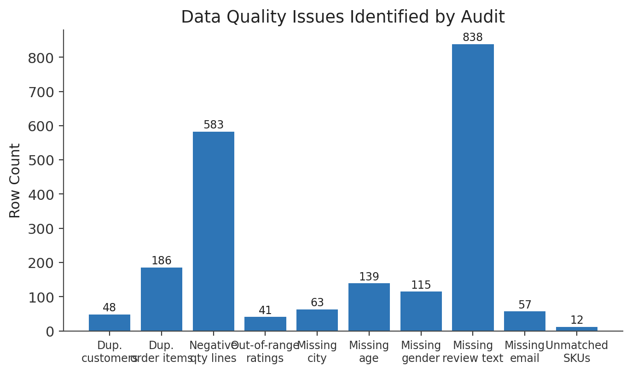
Figure 2. Data Quality Issues Identified by Audit
Source: Calculated from UrbanCart project data.

4.2 Customer Data Quality
Within the 2,500-row internal customer table, the audit found 63 customers missing a city value, 139 missing age, and 115 missing gender, alongside 48 duplicate customer records. These gaps are concentrated in demographic fields rather than identifying fields (customer_id, email), which meant that customer-level joins used throughout this report remained reliable even where a demographic attribute was unavailable.

4.3 Order Data Quality
Of the 9,000 orders, 5,101 (56.7%) are completed, 1,328 are cancelled, 1,327 are returned, and 1,244 are pending. This is not a data-quality defect so much as an operational reality that shapes every downstream calculation: revenue, CLTV, RFM, and forecasting in this report all use completed orders only, so that cancelled, returned, and pending orders do not inflate value or revenue figures.

4.4 Order-Item Quality
The order_items table contained 186 duplicate rows, which were removed prior to analysis, and 583 line items with negative quantities. Negative quantities were treated as data associated with returns rather than as errors to discard outright, and were flagged for exclusion from quantity-based aggregates such as the price-elasticity analysis in Chapter 12.

4.5 Review Quality
Of 4,000 reviews, 41 carried a rating outside the expected 1–5 scale and were excluded from rating-based aggregates. Review text was missing for 838 reviews; because this report does not perform text or sentiment analysis on review content, the missing text did not restrict any of the analyses actually performed, though it is noted in Chapter 21 as a constraint on future sentiment-analysis work.

4.6 Referential Integrity
Referential integrity was checked across the customer–order, order–order_item, and order_item–product relationships. No orphaned rows (for example, an order_item referencing a non-existent order or product) were identified in any of the checked relationships, which supports the reliability of the joins used throughout the remainder of the report.

4.7 Data Quality Impact
Left untreated, the identified issues would have distorted several results: duplicate customer and order-item rows would inflate counts and revenue; negative-quantity lines would understate quantities sold if summed naively; and non-completed orders, if not filtered out, would overstate both order volume and customer value. This report does not attempt to quantify the dollar-value impact of leaving these issues untreated, since no such calculation was performed; the issues were instead corrected before any downstream analysis, which is the more defensible approach given the available data.

Chapter 5 Data Cleaning and Reconciliation

5.1 Cleaning Strategy
The cleaning strategy treats the internal ecommerce.db tables as the primary source of truth and reconciles the two auxiliary files against it, rather than merging all three sources as equals. Records that could not be confidently reconciled (for example, unmatched supplier SKUs) were retained but flagged rather than discarded, so that later analysis could explicitly account for them.

5.2 Legacy Customer Cleaning
The legacy customer export began at 1,427 raw rows. One entirely blank row and one row corresponding to an obvious test or junk account were dropped. Exact-duplicate email addresses accounted for 48 further rows, which were removed, and two near-duplicate name pairs were flagged using fuzzy name-matching for manual review rather than automatic merging, since the file lacked a fully reliable email key for every row. This left 1,377 rows after cleaning, of which 1,321 were matched to existing customers in the internal database and 56 were determined to be legacy-only customers with no corresponding internal record.
Table 3. Legacy Customer Cleaning Results
Stage | Row Count
Raw legacy rows | 1,427
Blank rows dropped | 1
Test / junk accounts dropped | 1
Exact-duplicate emails dropped | 48
Near-duplicate name pairs flagged | 2
Rows after cleaning | 1,377
Matched to existing customers | 1,321
Legacy-only customers | 56
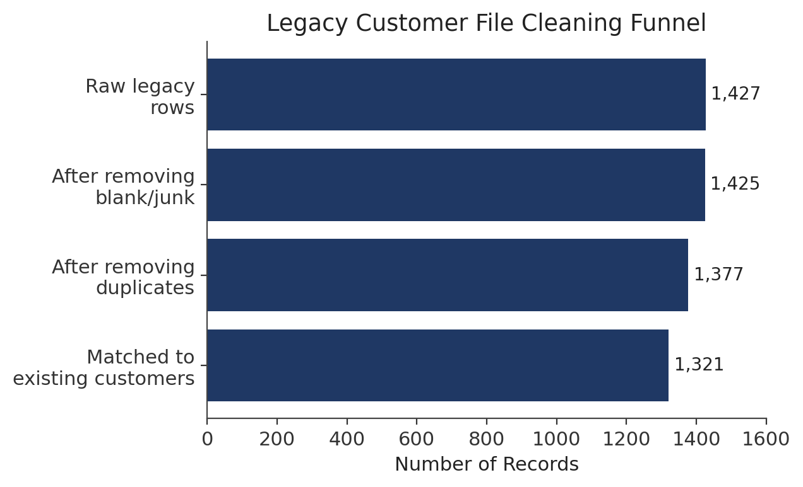
Figure 3. Legacy Customer File Cleaning Funnel
Source: Calculated from UrbanCart project data.

5.3 Standardization
Standardization steps applied across the cleaned data included trimming leading and trailing whitespace, converting names to Title Case, lowercasing email addresses for consistent matching, normalizing the legacy file's four different date formats into a single ISO 8601 format, and normalizing city names for consistent grouping.

5.4 Product Catalog Reconciliation
The 2024 supplier catalog contained 267 records, of which 255 SKUs matched an internal product by SKU and 12 did not correspond to any internal product. Among the 255 matched SKUs, 253 (99%) showed a price difference between the supplier catalog and the internal product table, averaging $9.44 per item. This near-universal mismatch indicates a systemic pricing-synchronization gap between the supplier catalog and the internal system, rather than isolated data-entry noise.
Table 4. Product Catalog Reconciliation
Metric | Value
Supplier catalog records | 267
Matched SKUs | 255
Unmatched SKUs | 12
Matched SKUs with a price difference | 253 of 255 (99%)
Average price difference (matched, mismatched SKUs) | $9.44 per item
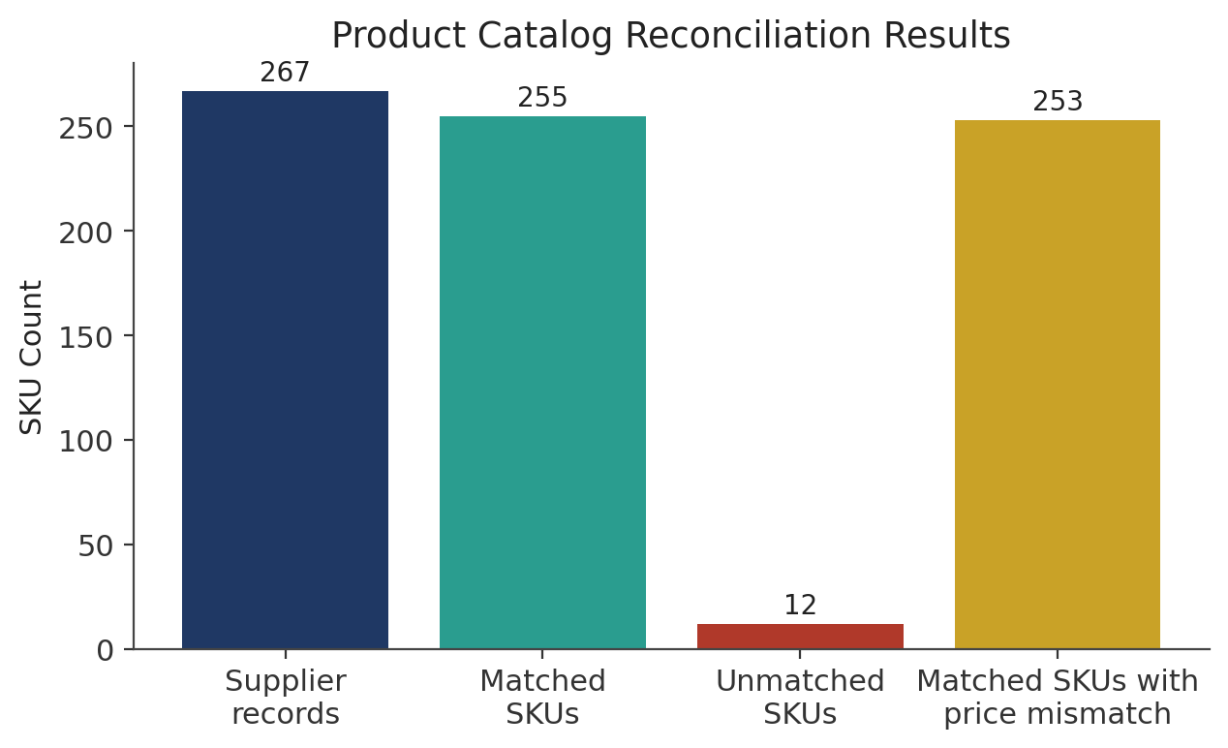
Figure 4. Product Catalog Reconciliation Results
Source: Calculated from UrbanCart project data.

5.5 Reconciliation Logic
Customer reconciliation matched legacy rows to internal customers primarily by email address, with fuzzy name-matching (via rapidfuzz) used only to flag likely near-duplicate names where an exact email match was unavailable. Product reconciliation matched supplier catalog rows to internal products by SKU, which is a reliable exact key on both sides and did not require fuzzy matching.

5.6 Data Validation After Cleaning
The cleaned customer table, reconciled product catalog, and de-duplicated order_items table produced by this stage are the inputs used by every subsequent chapter. Order completion filtering (Chapter 4.3) was applied consistently across the cohort, RFM/CLTV, regression, elasticity, Monte Carlo, and forecasting analyses so that all downstream results are computed on a common, cleaned foundation.

Chapter 6 Exploratory Data Analysis

6.1 Customer Distribution
The internal customer table holds 2,500 customers. Demographic fields (age, gender, city) are populated for the majority of customers but carry the missing-value rates reported in Chapter 4.2; this report avoids drawing demographic conclusions from fields with material missingness and instead relies on order-history-based measures (recency, frequency, monetary value) where demographic coverage would be incomplete.

6.2 Order Status Distribution
Order status is the single most consequential categorical field in the dataset for this report, because it determines which of the 9,000 orders are used in downstream value and revenue calculations. Figure 1 shows the full breakdown.
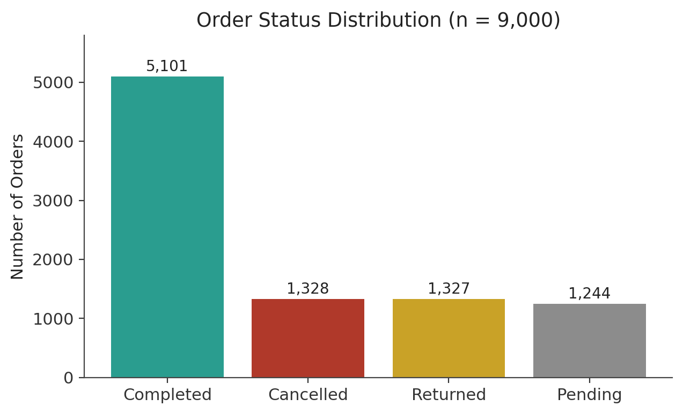
Figure 1. Order Status Distribution (n = 9,000)
Source: Calculated from UrbanCart project data.
Completed orders (5,101) represent 56.7% of total order volume. Cancelled (1,328), returned (1,327), and pending (1,244) orders together make up the remaining 43.3%. The near-equal size of the cancelled and returned categories is notable and would be worth investigating operationally, though this report does not have the order-level detail needed to attribute cancellations or returns to a specific cause.

6.3 Product Distribution
The internal catalog contains 300 products. Category-level detail exists in the product table and underlies the category-level market-basket and elasticity results in Chapters 8 and 12; this report presents those category results at the level of aggregate findings (for example, "all category pairs show lift at or below 1") rather than reproducing the full product-by-product catalog, which is not needed to support the report's conclusions.

6.4 Review Data
Of the 4,000 reviews, 41 fall outside the valid 1–5 rating scale and were excluded from rating-based analysis, and 838 are missing review text. The rating data that remains after cleaning is used only implicitly, as this report's core customer-value work (RFM, CLTV, regression) is based on order and transaction history rather than review sentiment.

6.5 Revenue Overview
Using completed orders only, the 34-month order history has a historical monthly revenue average of $212,712.43. This figure is the anchor for the Monte Carlo simulation in Chapter 13 and the forecasting comparison in Chapter 15.

6.6 Web Sessions
The web_sessions table contains 12,000 recorded sessions. These sessions provide behavioral context on browsing activity, but this report does not calculate a conversion rate or any other session-to-order relationship, because no reliable session-to-order join was validated during the data-quality audit. Establishing that link is noted as a future-work opportunity in Chapter 21.

Chapter 7 Cohort Retention Analysis

7.1 Cohort Methodology
Each customer is assigned to a monthly signup cohort based on their signup date. For each cohort, the analysis measures, for each month since signup (M0 through M11), the percentage of customers in that cohort who placed at least one completed order in that month. This is the standard cohort-retention definition used in subscription and e-commerce analytics, adapted here to UrbanCart's completed-order data.

7.2 Retention Results
Table 5. Cohort Retention Rates by Month
Month Since Signup | Retention Rate (%)
M0 | 7.0
M1 | 11.0
M2 | 12.8
M3 | 12.0
M4 | 9.8
M5 | 10.4
M6 | 9.6
M7 | 10.5
M8 | 8.9
M9 | 8.9
M10 | 9.7
M11 | 8.8

7.3 Retention Visualization
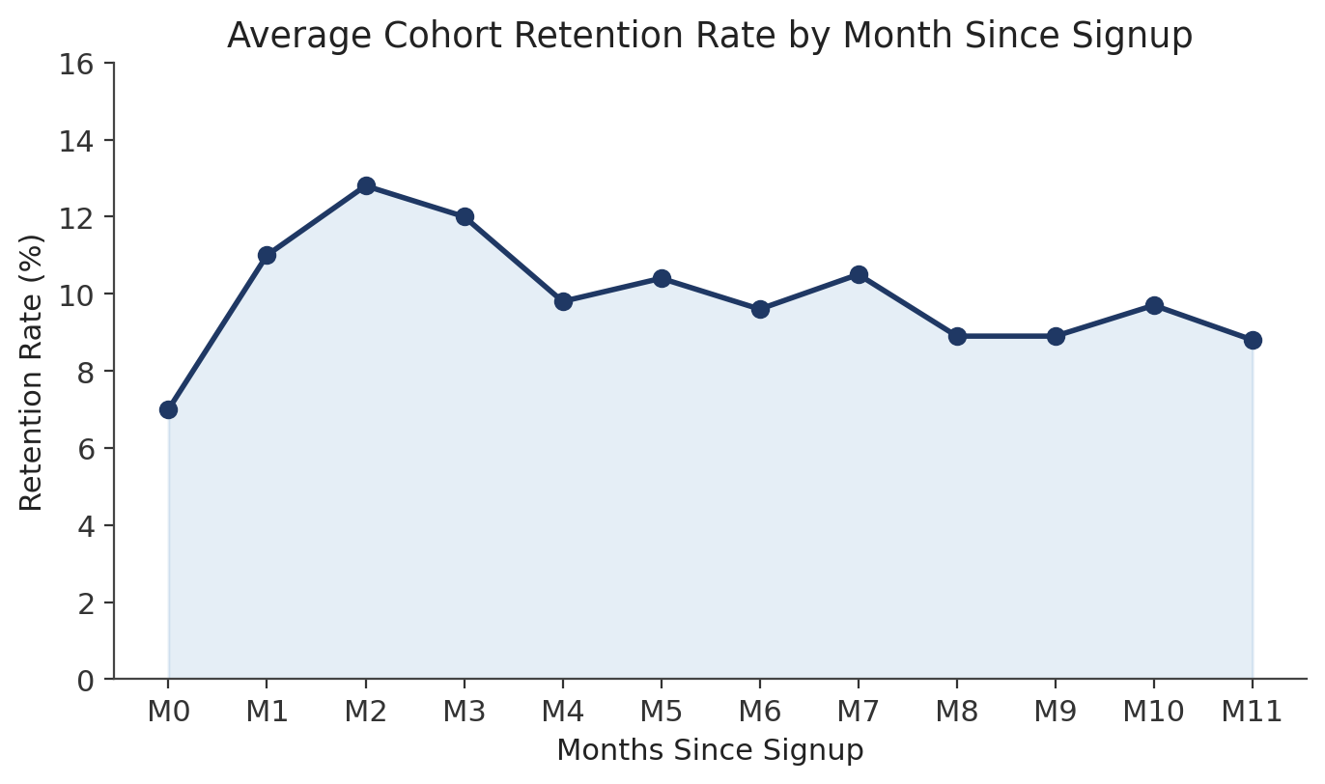
Figure 7. Cohort Retention Rate by Month Since Signup
Source: Calculated from UrbanCart project data.

7.4 Interpretation
Retention stays within a comparatively narrow 7–13% band across all twelve months, rather than showing the steep early decline typically seen in retention curves, where a large share of a cohort orders again shortly after signup and retention then tapers off. In UrbanCart's data, order timing does not appear strongly coupled to time since signup: a customer signed up eleven months ago is about as likely to place a completed order in a given month as a customer who signed up two months ago. This is a descriptive observation about the dataset rather than a claim about UrbanCart's real-world retention dynamics, and it would be worth validating against a larger or more recent data pull before being treated as a durable finding.

7.5 Business Implications
Because retention is flat rather than front-loaded, the usual playbook of concentrating retention effort in the first weeks after signup is not clearly supported by this data. A more tenure-agnostic approach — monitoring customer activity on a rolling basis regardless of signup date, and prioritizing reactivation by RFM segment (Chapter 9) rather than by cohort age — is more consistent with the observed pattern. These are recommended directions rather than tested interventions; no causal claim about what would improve retention is made here.

Chapter 8 Market Basket Analysis

8.1 Methodology
Market-basket analysis was performed by self-joining the order_items table on shared order_id to identify pairs of products (and, separately, pairs of product categories) that co-occur within the same order. For each pair, support (the share of orders containing both items), confidence, and lift (the ratio of observed co-occurrence to the co-occurrence expected if the two items were purchased independently) were computed.

8.2 SKU-Level Results
At the individual SKU level, some product pairs showed lift values above 1, but these were driven by very small absolute support — as few as 3 to 5 shared orders in the 9,000-order dataset. A lift value computed from that few co-occurrences is not statistically reliable and should not be read as evidence of a genuine cross-selling relationship; this report does not list specific SKU pairs as findings for that reason, consistent with the instruction to avoid presenting unverified or statistically fragile results as conclusions.

8.3 Category-Level Results
At the product-category level, where support is aggregated across many more orders and is therefore more statistically stable, every category pair evaluated showed a lift value at or below 1. A lift of 1 or less means that customers who buy from one category are no more likely — and in most cases are calculated as equally or less likely — to also buy from the paired category than random chance would predict.

8.4 Interpretation
Taken together, the SKU- and category-level results do not provide evidence of meaningful product affinity in this dataset. Category-level lift values at or below 1 indicate no cross-category combination sells together more often than chance would predict, and SKU-level lift values are undermined by extremely small supporting order counts.

8.5 Limitations
These results should not be used, on their own, to drive merchandising decisions such as bundling or cross-sell placement. The absence of detected affinity may reflect UrbanCart's actual purchase patterns, or it may reflect that 9,000 orders spread across 300 products is not yet enough transaction volume to reliably detect basket relationships that do exist. Additional transaction history would be needed before treating either possibility as settled.

Chapter 9 RFM Customer Segmentation

9.1 RFM Methodology
Each customer with at least one completed order was scored on three dimensions using completed-order history: Recency (how recently the customer last ordered), Frequency (how many completed orders the customer has placed), and Monetary (the customer's total completed-order spend). Each dimension was divided into quintiles (1–5), and customers were then assigned to one of six segments based on the combination of their three quintile scores: Champions (top on all three dimensions), Loyal Customers (recent and frequent), At Risk (High Value) (previously high-spending, now inactive), Hibernating/Lost (bottom on all three dimensions), and New/Promising and Needs Attention (customers falling between these extremes).

9.2 Segment Results
Table 6. RFM Customer Segments
Segment | Customers | Avg. CLTV ($) | Share of Base
Loyal Customers | 707 | 1,699 | 28.3%
Hibernating/Lost | 535 | 392 | 21.4%
Champions | 441 | 3,257.53 | 17.6%
Needs Attention | 416 | 1,953 | 16.6%
At Risk (High Value) | 210 | 2,734 | 8.4%
New/Promising | 191 | 576 | 7.6%
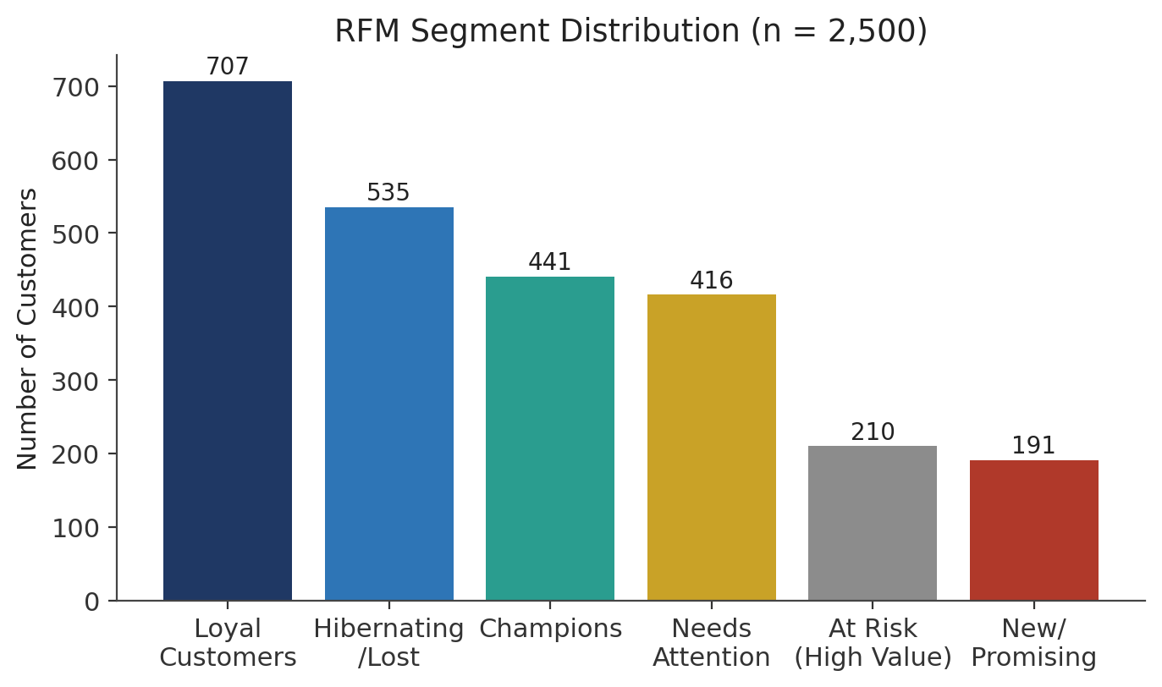
Figure 5. RFM Segment Distribution (n = 2,500)
Source: Calculated from UrbanCart project data.

9.3 Segment Interpretation
Loyal Customers form the largest segment (707 customers, 28.3% of the base) and represent a stable core of recent, frequent buyers, though their average CLTV ($1,699) is well below that of Champions. Hibernating/Lost is the second-largest segment (535 customers) and, as expected, has by far the lowest average CLTV ($392). Champions, while a comparatively small segment (441 customers), carry the highest average CLTV ($3,257.53), consistent with the segment definition. At Risk (High Value) customers (210) are notable for combining a high average CLTV ($2,734) with disengagement, making them a distinct priority discussed further below.

9.4 Segment Prioritization
Champions, At Risk (High Value), and Hibernating/Lost warrant different strategies precisely because they sit at different points on the value-versus-engagement matrix. Champions are already both valuable and engaged, so the priority is retention rather than reactivation. At Risk (High Value) customers combine high historical value with recent disengagement, making them the highest-leverage reactivation target in the dataset: recovering even a fraction of this group's $2,734 average CLTV represents more addressable value per customer than reactivating an equivalent number of Hibernating/Lost customers. Hibernating/Lost customers, while numerous, have the lowest average value, so broad, low-cost reactivation approaches are more appropriate than the higher-touch effort that might be justified for At Risk customers.

9.5 Proposed Marketing Actions
The following are recommended actions based on the segmentation results; they are proposals, not measured outcomes, since no campaign was run or evaluated as part of this project.
- At Risk (High Value): targeted, personalized reactivation outreach given the segment's high average CLTV relative to its size.
- Hibernating/Lost: lower-cost, broad-reach reactivation given the segment's size and low average value.
- Champions: loyalty or early-access programs aimed at retention rather than acquisition.
- Needs Attention and New/Promising: monitoring and lightweight engagement to encourage migration toward Loyal Customers or Champions.

Chapter 10 Customer Lifetime Value

10.1 CLTV Formula
CLTV was estimated using a standard formula-based approach:
CLTV = Average Order Value × Purchase Frequency per Year × Tenure × Gross Margin Rate
Average order value and purchase frequency were computed from each customer's completed-order history; tenure was measured from signup date; and the gross margin rate used was the dataset-wide average gross margin rate of 48.8%.

10.2 CLTV Results
Across the customer base, mean predicted CLTV is $1,916.85 and median predicted CLTV is $990.27. The substantial gap between the mean and the median indicates a right-skewed distribution, in which a comparatively small number of high-value customers pull the mean well above the typical customer's value. The top decile threshold for predicted CLTV is $3,535.40, meaning the highest-value 10% of customers each have a predicted CLTV at or above that level.

10.3 Segment-Level CLTV
CLTV varies substantially by RFM segment, as shown in Table 7 and Figure 6.
Table 7. CLTV by Customer Segment
Segment | Avg. CLTV ($)
Champions | 3,257.53
At Risk (High Value) | 2,734.00
Needs Attention | 1,953.00
Loyal Customers | 1,699.00
New/Promising | 576.00
Hibernating/Lost | 392.00
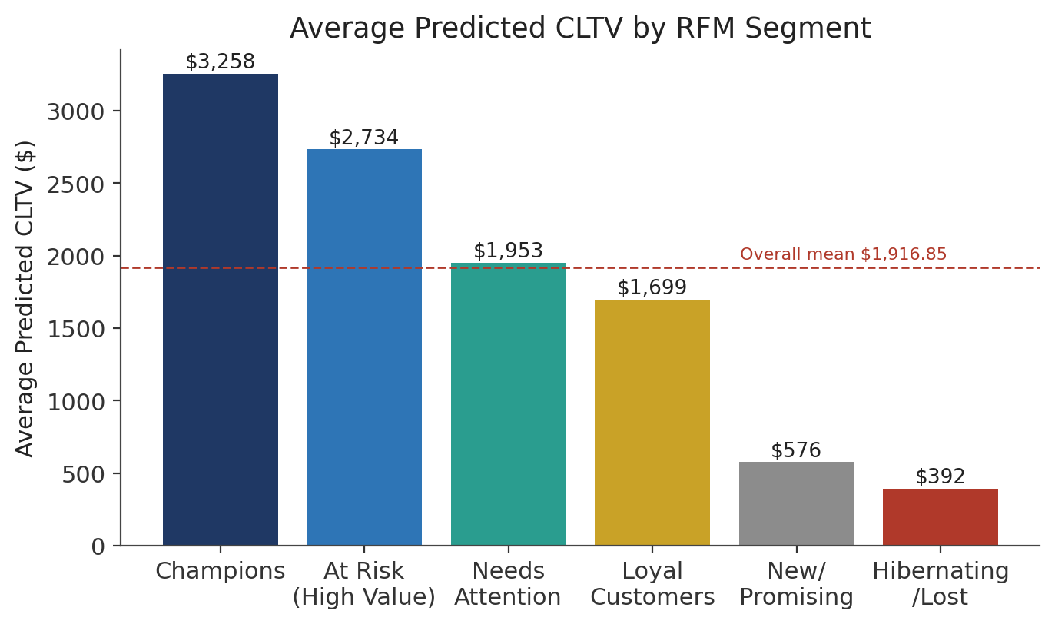
Figure 6. Average Predicted CLTV by RFM Segment
Source: Calculated from UrbanCart project data.

10.4 Business Interpretation
CLTV segmentation provides a way to prioritize retention spend: a dollar of retention effort directed at a Champion or an At Risk (High Value) customer is, on average, backed by several times more predicted future value than the same effort directed at a Hibernating/Lost customer. This supports the reactivation priority discussed in Chapter 9.4.

10.5 Limitations
This CLTV estimate is a simple, formula-based projection rather than a validated long-term causal model. It assumes that a customer's historical average order value, frequency, and margin rate persist into the future, which may not hold, particularly for customers with short tenure or few completed orders. No holdout validation of predicted versus actual future value was performed, since the 34-month window does not provide enough forward-looking data to test the model's long-run accuracy.

Chapter 11 Regression and Customer Value Drivers

11.1 Objective
This analysis tests whether readily available customer attributes — age, purchase frequency, and recency — explain variation in customer monetary value (total completed-order spend), and if so, how strongly.

11.2 Model
A closed-form ordinary least squares (OLS) regression was fit with customer monetary value as the dependent variable and age, purchase frequency, and recency as independent variables, computed directly from completed-order history without any external machine-learning library.

11.3 Variables
- Age — customer age in years, where available.
- Purchase Frequency — number of completed orders placed by the customer.
- Recency — time elapsed since the customer's most recent completed order.

11.4 Results
The model returned R² = 0.0812 and adjusted R² = 0.0798. Of the three predictors, only purchase frequency was statistically significant, with a t-statistic of 12.668; age and recency were not statistically significant predictors of monetary value in this model.

11.5 Interpretation
An R² of 0.0812 means the model explains only about 8% of the variation in customer monetary value — the large majority of that variation is not captured by age, frequency, and recency alone. Within that limited explanatory power, purchase frequency is the one variable with a clear, statistically significant relationship to spend, which is intuitive: customers who order more often tend to have spent more in total. Age and recency, by contrast, show no significant relationship to monetary value in this dataset, meaning this model provides no evidence that older or younger customers spend differently, or that how recently a customer ordered predicts how much they have spent overall.

11.6 Limitations
The low R² indicates that important drivers of customer spend are not captured by this model — plausible omitted variables include product category preference, marketing exposure, price sensitivity, or household size, none of which are available in the current dataset. It is also possible that some of the dataset's variables were generated with limited correlation structure, which would mechanically produce a low R² regardless of the true real-world relationship; this report cannot distinguish between that possibility and a genuinely weak relationship, and flags both as reasons for caution in interpreting the model.

Chapter 12 Price Elasticity Analysis

12.1 Methodology
Price elasticity of demand was estimated using a log-log regression model — regressing the log of quantity sold on the log of price — both overall and separately within each product category, using completed order-item data with negative-quantity (return-related) lines excluded.

12.2 Category Results
Category-level elasticity estimates followed the same pattern as the overall result described below: none of the evaluated categories produced an elasticity estimate that was statistically distinguishable from zero. This report does not reproduce a category-by-category coefficient table, because the underlying analysis output available for this report reports the aggregate finding rather than a saved per-category coefficient table; presenting fabricated per-category numbers would risk misrepresenting the underlying analysis, so only the aggregate, verified result is presented here.

12.3 Overall Result
Table 9. Price Elasticity Analysis Results
Metric | Value
Overall price elasticity | -0.0002
t-statistic | -0.062
R² | 0.00 (approximately)
Category-level pattern | All evaluated categories statistically indistinguishable from zero

12.4 Interpretation
An elasticity of -0.0002 with a t-statistic of -0.062 is not statistically different from zero. In practical terms, this dataset shows no measurable link between price and quantity sold, either overall or within any individual category. This is a genuinely surprising result for a retail dataset, where some price sensitivity is normally expected, and it should be treated as a finding about this dataset rather than a general claim about UrbanCart's customers' real-world price sensitivity.

12.5 Business Implications
Because the elasticity results are statistically flat, they do not support any pricing action — neither a recommendation to raise prices on the assumption that demand is inelastic, nor a recommendation to lower prices to stimulate demand. Before any pricing decision is made, UrbanCart should gather additional real-world transaction data, ideally including instances of genuine price changes over time, since the current dataset may not contain enough price variation to detect a true elasticity relationship even if one exists.

Chapter 13 Monte Carlo Revenue Simulation

13.1 Simulation Method
A Monte Carlo simulation was used to characterize the range of plausible 12-month revenue outcomes. The simulation draws 10,000 independent 12-month revenue paths from a Normal distribution parameterized by the historical monthly revenue mean and standard deviation observed across the 34-month completed-order history, then aggregates each path to a 12-month total.

13.2 Results
Table 10. Monte Carlo Simulation Results
Statistic | Value
Simulated mean 12-month revenue | $2,553,111.74
P10 (downside) | $2,132,708.39
P50 (median) | $2,547,399.71
P90 (upside) | $2,977,445.29
Historical monthly revenue average (input) | $212,712.43
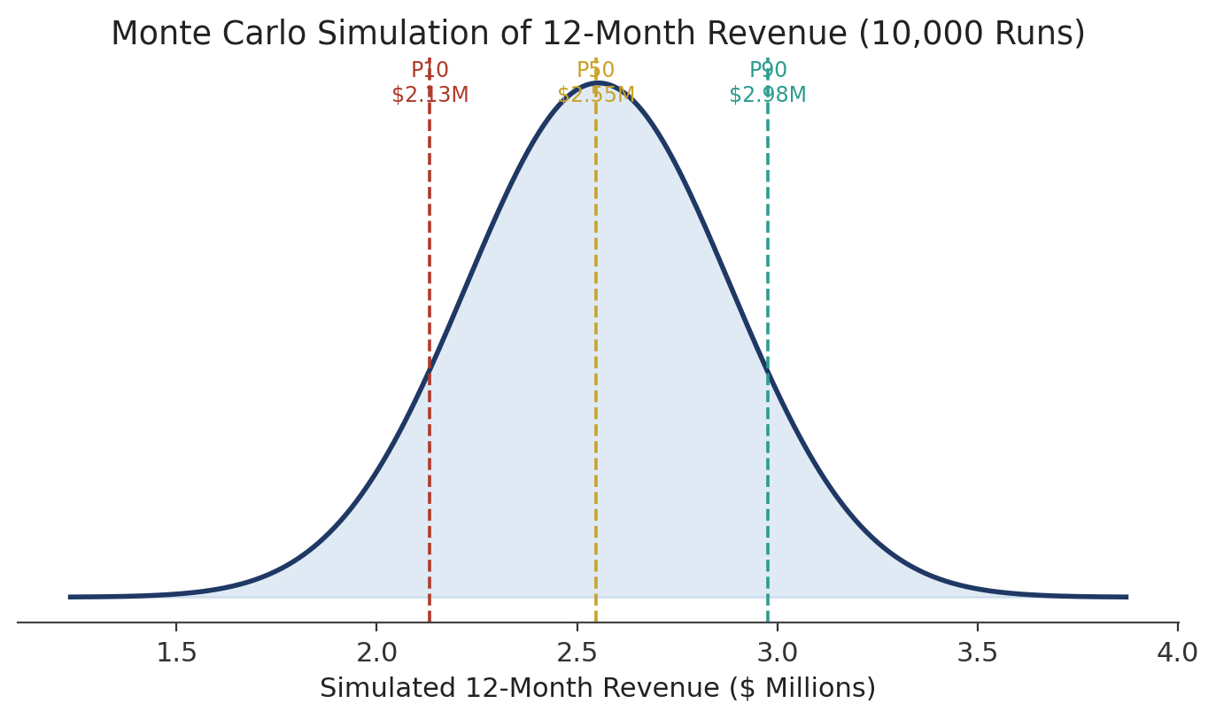
Figure 8. Monte Carlo Simulation of 12-Month Revenue (10,000 Runs)
Source: Calculated from UrbanCart project data.

13.3 Risk Interpretation
The P10–P90 range of roughly $2.13 million to $2.98 million represents the middle 80% of simulated outcomes: there is a modeled 10% chance that 12-month revenue falls below the P10 value, and a modeled 10% chance it exceeds the P90 value. The P50 value ($2,547,399.71) is close to, though not identical to, the simulated mean ($2,553,111.74), which is expected for a distribution that is only mildly skewed.

13.4 Management Use
A single-point revenue forecast implies more precision than the underlying data supports. Reporting the P10–P50–P90 range instead allows planning decisions — such as inventory commitments or budget targets — to be set against a downside, a central estimate, and an upside case, rather than against one number that could as easily undershoot as overshoot the eventual outcome.

Chapter 14 Recommendation Engine

14.1 Recommendation Problem
With 300 products and a purchase history spanning thousands of customers, manually curating which products to recommend to which customer is not feasible. A recommendation engine automates this by identifying products with similar purchase patterns to ones a customer has already bought.

14.2 Collaborative Filtering
The recommender uses item-based collaborative filtering: rather than modeling individual customer preferences directly, it computes similarity between products based on the pattern of customers who purchased them. Two products are considered similar if they tend to be purchased by overlapping sets of customers.

14.3 Purchase Matrix
The underlying customer-by-product purchase matrix contains 2,180 customers and 300 products and is 98.32% sparse — that is, more than 98% of customer-product cells have no recorded purchase. This level of sparsity is typical for retail purchase data and is the reason cosine similarity, rather than a denser method, was selected.

14.4 Cosine Similarity
Cosine similarity measures the angle between two products' purchase vectors across all customers, producing a score between 0 and 1: a score near 1 means the two products are purchased by very similar sets of customers, while a score near 0 means their purchasers barely overlap. Because the purchase matrix is highly sparse, most product pairs will have a low, non-zero similarity score rather than a high one, which is consistent with the example below.

14.5 Example
For the product "Black Camera," the three most similar products identified by the engine were "Rich Furniture" (cosine similarity 0.1031), "Important Cycling" (cosine similarity 0.0937), and "High Camping" (cosine similarity 0.0937). These similarity scores are low in absolute terms, which is consistent with the 98.32% sparsity of the underlying matrix — the engine is still able to rank products by relative similarity even though no pair reaches a high absolute score.

14.6 Strengths
- Simple to implement and does not require an external machine-learning library.
- Produces an interpretable similarity score for every recommended product.
- Scales reasonably well to the current catalog size (300 products).

14.7 Limitations
- High sparsity (98.32%) means similarity scores are generally low in absolute terms, limiting confidence in any single recommendation.
- New products with no purchase history cannot be recommended (the cold-start problem).
- With only 2,180 customers represented in the matrix, some product-pair similarities are based on comparatively few shared purchasers.
- No offline evaluation metric (such as precision@k or a held-out click-through/conversion test) has been computed for this engine; its output quality has not been formally validated against actual customer behavior.

Chapter 15 Revenue Forecasting

15.1 Historical Revenue
The 34-month completed-order history has an average monthly revenue of $212,712.43. This series is the basis for both forecasting methods described below.

15.2 Holt's Linear Trend
Holt's linear trend method extends simple exponential smoothing by tracking both a level and a trend component, updating each as new months of data arrive. It is well suited to a series with a persistent trend but no strong seasonal pattern, and was applied here to the 34-month historical revenue series.

15.3 Linear Trend Baseline
As a simpler baseline, an ordinary least squares trend line was fit directly to the 34-month revenue series (month index as the independent variable, revenue as the dependent variable) and extrapolated six months forward.

15.4 Model Comparison
The two methods diverge over the six-month forecast horizon: the OLS linear trend projects a steeper increase than Holt's method, which more heavily weights recent months. By month six of the forecast, the linear trend estimate ($387,154) is noticeably higher than the Holt estimate ($355,854). Neither model's error metrics (MAE/RMSE against a held-out period) were retained in the analysis output available for this report, so those figures are not reported here rather than estimated after the fact.

15.5 Six-Month Forecast
Table 11. Six-Month Revenue Forecast Comparison
Month | Holt Forecast ($) | Linear Trend ($)
2024-12 | 334,411 | 348,390
2025-01 | 338,700 | 356,143
2025-02 | 342,988 | 363,896
2025-03 | 347,277 | 371,648
2025-04 | 351,565 | 379,401
2025-05 | 355,854 | 387,154
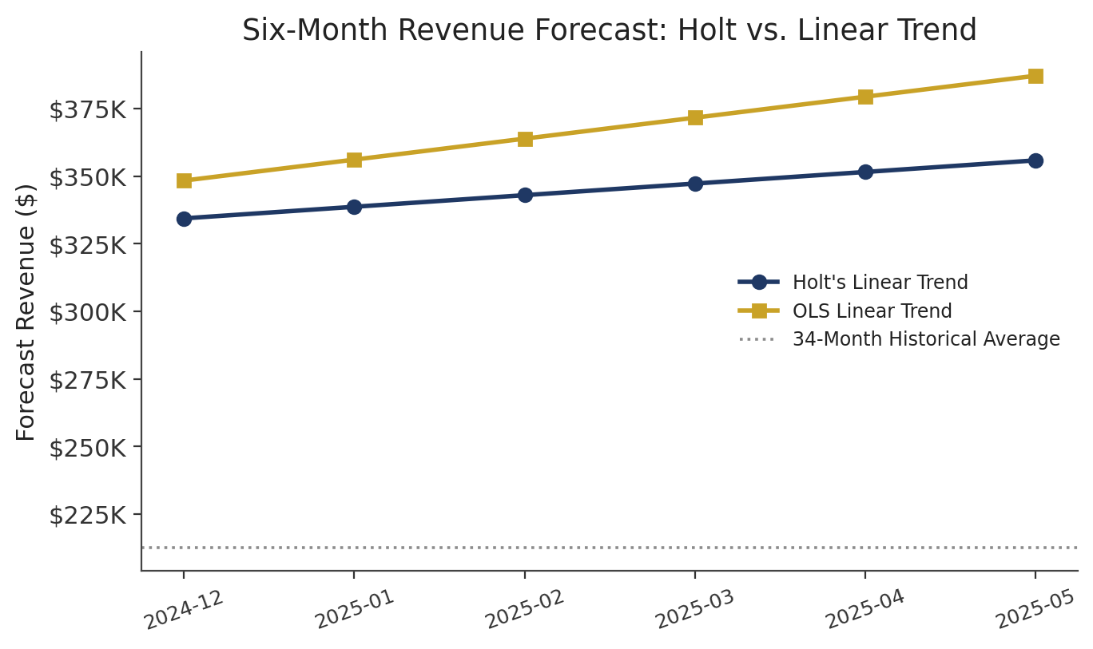
Figure 9. Six-Month Revenue Forecast: Holt vs. Linear Trend
Source: Calculated from UrbanCart project data.

15.6 Forecast Risk
Both models project monthly revenue above the 34-month historical average ($212,712.43), consistent with an overall upward trend in the underlying series, but the two models disagree meaningfully with each other by the end of the six-month window — a gap of roughly $31,000 in month six alone. This divergence is itself informative: it indicates the forecast should be treated as a plausible range bounded loosely by the two models, rather than as a single precise number, echoing the same P10–P90 framing recommended for the Monte Carlo results in Chapter 13.

Chapter 16 Business Intelligence and Decision Support
This chapter consolidates the report's findings into a decision-support view, connecting each analytical result to a business area and a recommended action. Every finding listed below is drawn directly from the analyses presented in Chapters 6 through 15.
Table 13. Decision-Support Matrix
Business Area | Finding | Recommended Action | Evidence
Customer retention | 210 At Risk (High Value) customers average $2,734 CLTV but are disengaged | Prioritize personalized reactivation outreach | Ch. 9, Ch. 10
Customer retention | 535 Hibernating/Lost customers, lowest avg. CLTV ($392) | Low-cost, broad-reach reactivation campaigns | Ch. 9, Ch. 10
Marketing segmentation | Retention is flat (7–13%) across all 12 cohort months | Shift from signup-age-based to segment-based engagement | Ch. 7
Merchandising | All category-level basket lift values are ≤ 1 | Do not act on cross-category bundling yet | Ch. 8
Pricing | 253 of 255 overlapping SKUs (99%) show a catalog/internal price gap averaging $9.44 | Resolve pricing sync with merchandising before using either price source for decisions | Ch. 5
Pricing | Overall and category-level price elasticity statistically indistinguishable from zero | Do not act on elasticity results; gather more price-variation data | Ch. 12
Revenue planning | Monte Carlo 12-month revenue range: $2.13M (P10) – $2.98M (P90) | Plan budgets against the full P10–P90 range, not a single number | Ch. 13
Revenue planning | Holt and linear-trend 6-month forecasts diverge by ~$31K by month 6 | Treat the six-month forecast as a range bounded by both models | Ch. 15
Customer targeting | Recommendation engine surfaces low-confidence, low-similarity product matches (highest ~0.10) | Use recommendations as a supplementary signal, not a sole driver of merchandising | Ch. 14

Chapter 17 Data Pipeline Implementation
The pipeline is implemented as a set of modular Python scripts, each responsible for one stage of the workflow described in Chapter 3.1.
- audit.py — profiles the six database tables and two auxiliary files, producing the row counts, missing-value counts, and duplicate/integrity findings summarized in Chapter 4.
- clean.py — de-duplicates and standardizes the legacy customer export and internal customer table, and reconciles the supplier catalog against internal products, producing the results in Chapter 5.
- sql_analysis.py — runs the SQL-based descriptive queries (order status breakdown, revenue aggregation) that underlie Chapter 6.
- rfm_cltv.py — computes RFM quintile scores, assigns customers to segments, and calculates predicted CLTV, producing the results in Chapters 9 and 10.
- regression_elasticity.py — fits the OLS spend-driver regression (Chapter 11) and the log-log price-elasticity model (Chapter 12).
- recommend.py — builds the customer-by-product purchase matrix and computes item-based cosine similarity for the recommendation engine (Chapter 14).
- forecast.py — fits Holt's linear trend and the OLS linear trend baseline, and runs the Monte Carlo revenue simulation (Chapters 13 and 15).
- main.py — orchestrates the pipeline end to end, calling each script in sequence and writing outputs to the outputs/ directory.
Processing flows from the raw ecommerce.db and the two CSV sources, through cleaned_data/ (the output of clean.py), into each analysis script, which reads from cleaned_data/ and writes its results to outputs/. This report's tables and figures are drawn directly from those output files; no code beyond what these eight scripts implement was used to produce this report's numbers.

Chapter 18 System / Data Architecture
The diagram below is a conceptual architecture of this project's implemented pipeline — not a deployed cloud architecture, and not a description of infrastructure that is currently running in production.
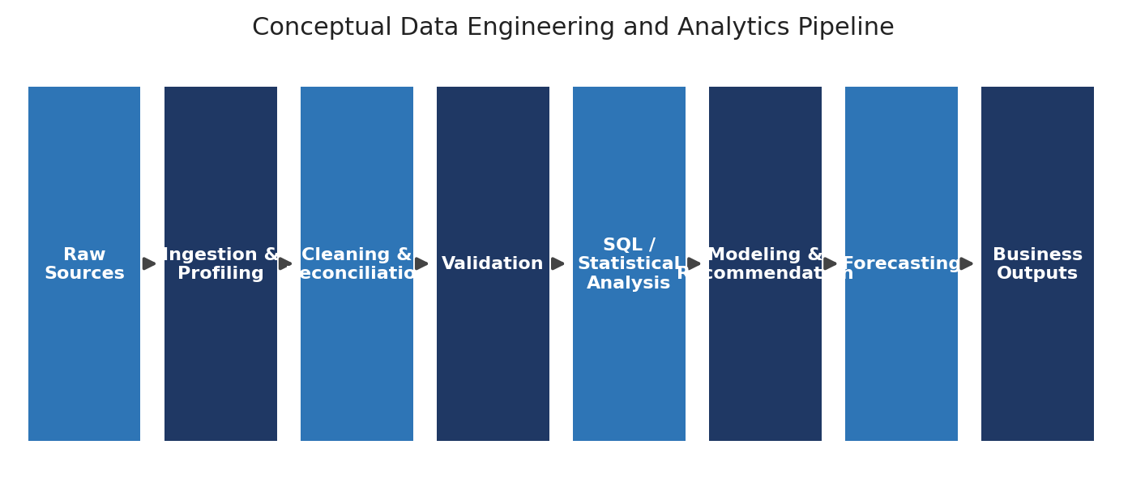
Figure 10. Conceptual End-to-End Data Engineering and Analytics Pipeline
Source: Calculated from UrbanCart project data.
Data flows from the raw sources (ecommerce.db, the legacy customer export, and the supplier catalog) through ingestion, cleaning, and reconciliation, into a validation stage that checks referential integrity and value ranges. Validated data feeds the analytical layer (SQL and cohort/basket/RFM analysis), the modeling layer (CLTV, regression, elasticity, recommendation), and the forecasting layer (Holt and Monte Carlo), which together produce the output layer consumed by this report and, ultimately, the business decision layer described in Chapter 16.
As Future Work / Proposed Architecture only: should UrbanCart's data volume grow substantially beyond the current 9,000 orders and 20,362 line items, a distributed processing layer (for example, Spark for batch transformation, or a managed warehouse for the analytical layer) could replace the current single-machine SQLite and pandas implementation without changing the conceptual pipeline stages shown above. No such distributed technology was used to produce any result in this report, and this paragraph should not be read as a claim that one currently exists.

Chapter 19 Model Evaluation and Limitations
Table 12. Model Evaluation Summary
Method | Result | Strength | Limitation
Cohort retention | Flat, 7–13% across 12 months | Simple, directly interpretable | No causal driver identified; pattern differs from typical retention curves
Market basket | Category lift ≤ 1; SKU lift unreliable (3–5 order support) | Standard, well-understood technique | Insufficient transaction volume for reliable SKU-level results
RFM segmentation | 6 segments, sizes 191–707 | Clear, actionable, no modeling assumptions | Quintile boundaries are data-dependent and may shift as data grows
CLTV | Mean $1,916.85; median $990.27 | Simple, transparent formula | Not a validated predictive model; no holdout test performed
Regression | R² = 0.0812; only frequency significant | Transparent OLS with clear coefficients | Very low explanatory power; likely omitted variables
Price elasticity | -0.0002, not significant (t = -0.062) | Standard log-log specification | No detectable price signal; may reflect limited price variation in data
Monte Carlo simulation | P10 $2.13M – P90 $2.98M | Communicates a realistic range, not false precision | Assumes Normally distributed monthly revenue
Recommendation engine | Top similarity ~0.10 (Black Camera example) | No external library required; interpretable | High sparsity (98.32%); no offline accuracy metric computed
Forecasting (Holt / linear) | 6-month forecasts diverge by ~$31K by month 6 | Two independent methods cross-checked against each other | No retained MAE/RMSE validation for this report
Across methods, a consistent theme emerges: several analyses that are often expected to show strong signal in retail data — market basket affinity, price elasticity, and demographic drivers of spend — instead came back statistically weak or flat in this dataset. This report treats that as an honest finding rather than reframing it as a positive result; Chapter 8, Chapter 11, and Chapter 12 name this explicitly rather than working around it.

Chapter 20 Ethical, Privacy, and Data Governance Considerations
Although this project uses a project dataset rather than live customer data, the analysis techniques applied — segmentation, CLTV scoring, and targeted reactivation recommendations — are the same techniques used on real customer populations, and the governance considerations below would apply directly if this pipeline were used on live UrbanCart data.

20.1 Customer Privacy and Data Handling
Customer email addresses and names were used only as matching keys during reconciliation (Chapter 5) and were not required by, or exposed in, any of the analytical outputs presented in this report. In a production setting, access to raw identifying fields should be restricted to the reconciliation step, with downstream analytical tables keyed by an internal customer ID rather than by name or email.

20.2 Demographic Data and Responsible Segmentation
Demographic fields (age, gender, city) had material missingness (Chapter 4.2) and were not used as inputs to the RFM segmentation or CLTV model in this report, which are instead based entirely on order-history behavior (recency, frequency, monetary value). This avoids basing customer-value or reactivation decisions on demographic attributes, which reduces the risk of demographic bias entering targeting decisions built on this pipeline.

20.3 Data Minimization and Access Control
The cleaned_data/ and outputs/ directories described in Chapter 17 contain only the fields required for each analysis stage; a production deployment should apply role-based access control to these directories and avoid retaining raw legacy-file exports (which had the weakest data quality) longer than needed for the initial reconciliation.

20.4 Data Quality, Reproducibility, and Governance
The modular pipeline structure described in Chapter 3 and Chapter 17 supports governance in two ways: every output can be traced back to the script and input file that produced it, and the audit stage (Chapter 4) provides a repeatable record of known data-quality issues rather than leaving them undocumented.

20.5 Avoiding Discriminatory Automated Decisions
Because RFM and CLTV segmentation in this report are behavior-based rather than demographic-based, the resulting customer priorities (Chapter 9.4, Chapter 16) are not proxies for protected characteristics as implemented. Any future extension that incorporated demographic fields into a targeting decision should be reviewed for disparate impact before deployment. No such compliance review or certification has been performed as part of this project, and none is claimed.

Chapter 21 Future Improvements
The following are proposed directions for extending this project. They are not implemented functionality, and none of the figures in this report assume they have been carried out.
- 1. Incorporate additional historical transaction data beyond the current 34-month window to improve the reliability of retention, elasticity, and forecasting results.
- 2. Develop richer customer behavioral features (for example, browsing-to-purchase conversion using the web_sessions table) to improve the regression model's low explanatory power.
- 3. Explore real-time or near-real-time recommendation serving, building on the item-based collaborative-filtering approach in Chapter 14.
- 4. Evaluate more robust forecasting models (for example, SARIMA or Prophet) alongside the Holt and linear-trend methods already implemented.
- 5. Run controlled A/B tests on proposed reactivation campaigns (Chapter 9.5) before treating them as validated interventions.
- 6. Apply sentiment analysis to the review text that is present (Chapter 6.4) to add a qualitative signal alongside rating-based measures.
- 7. Adopt distributed processing (for example, Spark) if data volume grows beyond what a single-machine SQLite/pandas pipeline can comfortably support.
- 8. Automate data-quality monitoring so that the issues identified in Chapter 4 are tracked continuously rather than through a one-time audit.
- 9. Formally validate the CLTV and regression models against held-out future data once enough additional months of history are available.
- 10. Move from the current local analysis pipeline to a production deployment with the access controls discussed in Chapter 20.3.

Chapter 22 Conclusion
This project applied a full data-engineering and analytics pipeline to the UrbanCart dataset: 2,500 customers, 9,000 orders, 20,362 order line items, 300 products, 4,000 reviews, and 12,000 web sessions spanning 34 months, together with a legacy customer export and a supplier product catalog.
The data-quality audit and cleaning stage identified and resolved concrete issues — 48 duplicate customer records, 186 duplicate order-item rows, 583 negative-quantity lines, and a legacy customer file that required standardization and fuzzy-matching before it could be reconciled with 1,321 existing customers and 56 legacy-only customers. Product catalog reconciliation surfaced a near-universal pricing gap: 253 of 255 overlapping SKUs (99%) disagreed between the supplier catalog and the internal system by an average of $9.44 per item.
RFM segmentation split the customer base into six segments, from 441 Champions averaging $3,257.53 in predicted CLTV to 535 Hibernating/Lost customers averaging $392. Mean predicted CLTV across the full base was $1,916.85, with a median of $990.27, reflecting a right-skewed value distribution. Cohort retention proved flat rather than front-loaded, holding in a 7–13% band across all twelve tracked months.
Three analyses — market-basket lift, price elasticity, and the spend-driver regression — returned statistically weak or flat results: category-level basket lift did not exceed 1, price elasticity was statistically indistinguishable from zero (-0.0002, t = -0.062), and the regression explained only about 8% of variation in customer spend (R² = 0.0812), with purchase frequency as the only significant predictor. These findings are reported as-is rather than reframed, consistent with this project's commitment to presenting only what the data supports.
The Monte Carlo simulation placed 12-month revenue in a P10–P90 range of roughly $2.13 million to $2.98 million, and the Holt and linear-trend forecasts, while diverging by about $31,000 by the sixth forecast month, both projected monthly revenue above the 34-month historical average of $212,712.43. The item-based recommendation engine, built on a 2,180-customer by 300-product matrix that is 98.32% sparse, produced interpretable but low-magnitude similarity scores, illustrated by the 0.0937–0.1031 range for products similar to "Black Camera."
Taken as a whole, the project demonstrates that a rigorous, honestly reported analysis of UrbanCart's data can identify concrete, actionable priorities — most clearly, reactivating the 210 At Risk (High Value) and 535 Hibernating/Lost customers, and resolving the systemic catalog-pricing gap before it is used in any pricing decision — while also being clear about which questions, such as price sensitivity and product affinity, the current data cannot yet answer with confidence. That combination of concrete findings and honest limitations is intended to be of more business value than a report that overstated its certainty.

References
Fader, P. S., & Hardie, B. G. S. (2009). Probability models for customer-base analysis. Journal of Interactive Marketing, 23(1), 61-69.
Hyndman, R. J., & Athanasopoulos, G. (2021). Forecasting: Principles and Practice (3rd ed.). OTexts. Available at https://otexts.com/fpp3/
Agrawal, R., & Srikant, R. (1994). Fast algorithms for mining association rules in large databases. Proceedings of the 20th International Conference on Very Large Data Bases (VLDB), 487-499.
Sarwar, B., Karypis, G., Konstan, J., & Riedl, J. (2001). Item-based collaborative filtering recommendation algorithms. Proceedings of the 10th International Conference on World Wide Web, 285-295.
Metropolis, N., & Ulam, S. (1949). The Monte Carlo method. Journal of the American Statistical Association, 44(247), 335-341.
Hosmer, D. W., Lemeshow, S., & Sturdivant, R. X. (2013). Applied Logistic Regression (3rd ed.). Wiley. [Referenced for general regression diagnostics and significance testing conventions.]
Hastie, T., Tibshirani, R., & Friedman, J. (2009). The Elements of Statistical Learning: Data Mining, Inference, and Prediction (2nd ed.). Springer.

Appendix

Appendix A — Dataset Summary
Table / File | Row Count
customers | 2,500
orders | 9,000
order_items | 20,362
products | 300
reviews | 4,000
web_sessions | 12,000
legacy_customers_export.csv (raw) | 1,427
product_catalog_2024.csv | 267

Appendix B — Data Quality Results
Issue | Count
Duplicate customer records | 48
Duplicate order-item rows | 186
Negative-quantity line items | 583
Out-of-range review ratings | 41
Customers missing city | 63
Customers missing age | 139
Customers missing gender | 115
Reviews missing text | 838
Legacy records missing email | 57
Supplier SKUs not found internally | 12

Appendix C — Cleaning Results
Metric | Value
Legacy raw rows → after cleaning | 1,427 → 1,377
Legacy matched to existing customers | 1,321
Legacy-only customers | 56
Supplier catalog matched SKUs | 255 of 267
Matched SKUs with price mismatch | 253 of 255 (avg. $9.44)

Appendix D — RFM Results
Segment | Customers
Loyal Customers | 707
Hibernating/Lost | 535
Champions | 441
Needs Attention | 416
At Risk (High Value) | 210
New/Promising | 191

Appendix E — CLTV Results
Metric | Value
Mean CLTV | $1,916.85
Median CLTV | $990.27
Top decile threshold | $3,535.40
Champions avg. CLTV | $3,257.53
Hibernating/Lost avg. CLTV | $392.00

Appendix F — Regression Results
Metric | Value
R² | 0.0812
Adjusted R² | 0.0798
Significant predictor | Purchase Frequency (t = 12.668)
Non-significant predictors | Age, Recency

Appendix G — Price Elasticity
Metric | Value
Overall elasticity | -0.0002
t-statistic | -0.062
Category-level pattern | All categories statistically indistinguishable from zero

Appendix H — Monte Carlo Results
Statistic | Value
Mean | $2,553,111.74
P10 | $2,132,708.39
P50 | $2,547,399.71
P90 | $2,977,445.29

Appendix I — Recommendation Engine
Product Pair (vs. Black Camera) | Cosine Similarity
Rich Furniture | 0.1031
Important Cycling | 0.0937
High Camping | 0.0937

Appendix J — Forecast Results
Month | Holt ($) | Linear Trend ($)
2024-12 | 334,411 | 348,390
2025-01 | 338,700 | 356,143
2025-02 | 342,988 | 363,896
2025-03 | 347,277 | 371,648
2025-04 | 351,565 | 379,401
2025-05 | 355,854 | 387,154

Appendix K — Project File Manifest
src/audit.py, src/clean.py, src/sql_analysis.py, src/rfm_cltv.py, src/regression_elasticity.py, src/recommend.py, src/forecast.py, src/main.py
cleaned_data/ — standardized customer table, reconciled product catalog, validated order data
outputs/ — audit reports, RFM/CLTV tables, regression and elasticity results, forecast tables, recommendation output

