DSN x BCT LLM Agent Challenge · Hackathon 3.0 | May 2026

NaijaTaste AI: A Retrieval-Augmented LLM Agent for Culturally-Grounded Nigerian Restaurant Recommendation
Task B: Personalised Recommendation with Cold-Start and Cross-Domain Support

Lawal Abdulsalam
Obafemi Awolowo University, Ile-Ife, Nigeria
Abdullahi Adetunji
Ladoke Akintola University of Technology, Ogbomoso, Nigeria
Team Foresight

Abstract
NaijaTaste AI Task B is a retrieval-augmented personalised recommendation engine for Nigerian food discovery. Given a user persona (existing or cold-start), the system retrieves real Nigerian restaurants from the Google Places API, ranks them using Google Gemini 2.5 Flash with culturally-grounded reasoning, and returns ranked recommendations with match explanations and Nigerian Pidgin cultural notes. A geolocation module resolves user location to a 5km GPS radius when permitted, or maps city keywords to pre-defined coordinates across 25 Nigerian cities. A persistent JSON caching layer eliminates repeat API calls. Evaluated on 20 cold-start users drawn from the Yelp Academic Dataset, the system achieves 100% recommendation coverage and 100% Nigerian geographical grounding. Category relevance reaches 36.8% against Yelp ground truth, with documented domain mismatch as a methodological confound. On 5 Nigerian-specific cold-start scenarios, all queries return geographically and culturally accurate results. A cross-domain recommendation module pairs Nigerian food discoveries with book recommendations matched to the user's flavour profile.
Keywords: Retrieval-Augmented Generation, Restaurant Recommendation, Cold-Start, Nigerian Food, Geolocation, Google Places API, Large Language Models, Cross-Domain Recommendation

1. Introduction

Personalised restaurant recommendation is a well-studied problem in information retrieval [1], yet most deployed systems rely on collaborative filtering approaches [2] that require dense user-item interaction matrices. In emerging markets where digital review culture is nascent — such as Nigeria — this creates a fundamental data sparsity problem: most users have little or no review history, and available datasets are dominated by Western behavioural signals that do not transfer to Nigerian food preferences.
Retrieval-Augmented Generation (RAG) [3] offers a compelling alternative. Rather than relying on historical interaction data, a RAG-based recommender retrieves live, contextually-relevant items from an external knowledge source and conditions a language model to rank and explain them. For restaurant recommendation, the Google Places API provides a real-time, geographically-indexed database of Nigerian restaurants with ratings, addresses, and business metadata — eliminating the need for a local interaction dataset entirely.
This paper presents NaijaTaste AI Task B, which combines Google Places retrieval, browser geolocation, LLM-based ranking via Google Gemini 2.5 Flash, and a persistent JSON caching layer into a unified recommendation agent. The system handles cold-start users [4] through structured signal extraction, supports cross-domain recommendations (food-to-books), and adapts location resolution based on query semantics.

2. Related Work

2.1 LLM-Based Recommendation Systems
Hou et al. [5] demonstrate that large language models are effective zero-shot rankers for recommendation when provided item metadata as context. Zhao et al. [6] survey recommender systems in the LLM era, identifying retrieval augmentation as the dominant paradigm for handling data sparsity. Geng et al. [7] show that framing recommendation as a language generation task enables unified handling of multiple recommendation scenarios, including cold-start, within a single model. Our system instantiates this paradigm: retrieval via Google Places API, ranking via Gemini, and explanation via chain-of-thought [8] cultural reasoning.
2.2 Location-Based and Food Recommendation
Zhao et al. [9] survey point-of-interest (POI) recommendation in location-based social networks, identifying geographic proximity and categorical preference as the two dominant signals. Ubaid et al. [11] present SMART Restaurant ReCommender, a system integrating the Google Places API with GPT-4 for context-aware restaurant recommendation, demonstrating that real-time retrieval significantly outperforms static-dataset approaches for food discovery. Wu et al. [12] develop an AI food recommendation system using graph neural networks and the Google Maps API, confirming that location-grounded retrieval is effective for restaurant discovery tasks.
2.3 Cold-Start and Cross-Domain Recommendation
Bobadilla et al. [4] provide a comprehensive analysis of cold-start mitigation strategies, finding that explicit preference elicitation outperforms inference-based approaches when interaction history is unavailable. Our system operationalises this through structured cold-start signals (city, food preference, price range) that map directly to Places API query parameters. For cross-domain recommendation, we follow Pawar et al. [13], who demonstrate that cultural context is a powerful cross-domain linking signal: the cultural resonance of a food experience can predict preferences in adjacent cultural domains such as literature.

3. System Design

3.1 Architecture Overview
The NaijaTaste AI Task B pipeline follows a six-stage agentic workflow as illustrated in Figure 1. Each stage is a discrete decision point with conditional branching: the cache lookup at Stage 3 short-circuits to the response if a matching query has been served before; the location resolver at Stage 2 selects between GPS precision and city centroid based on query semantics; and the cold-start handler provides an alternative entry path for users without review history.

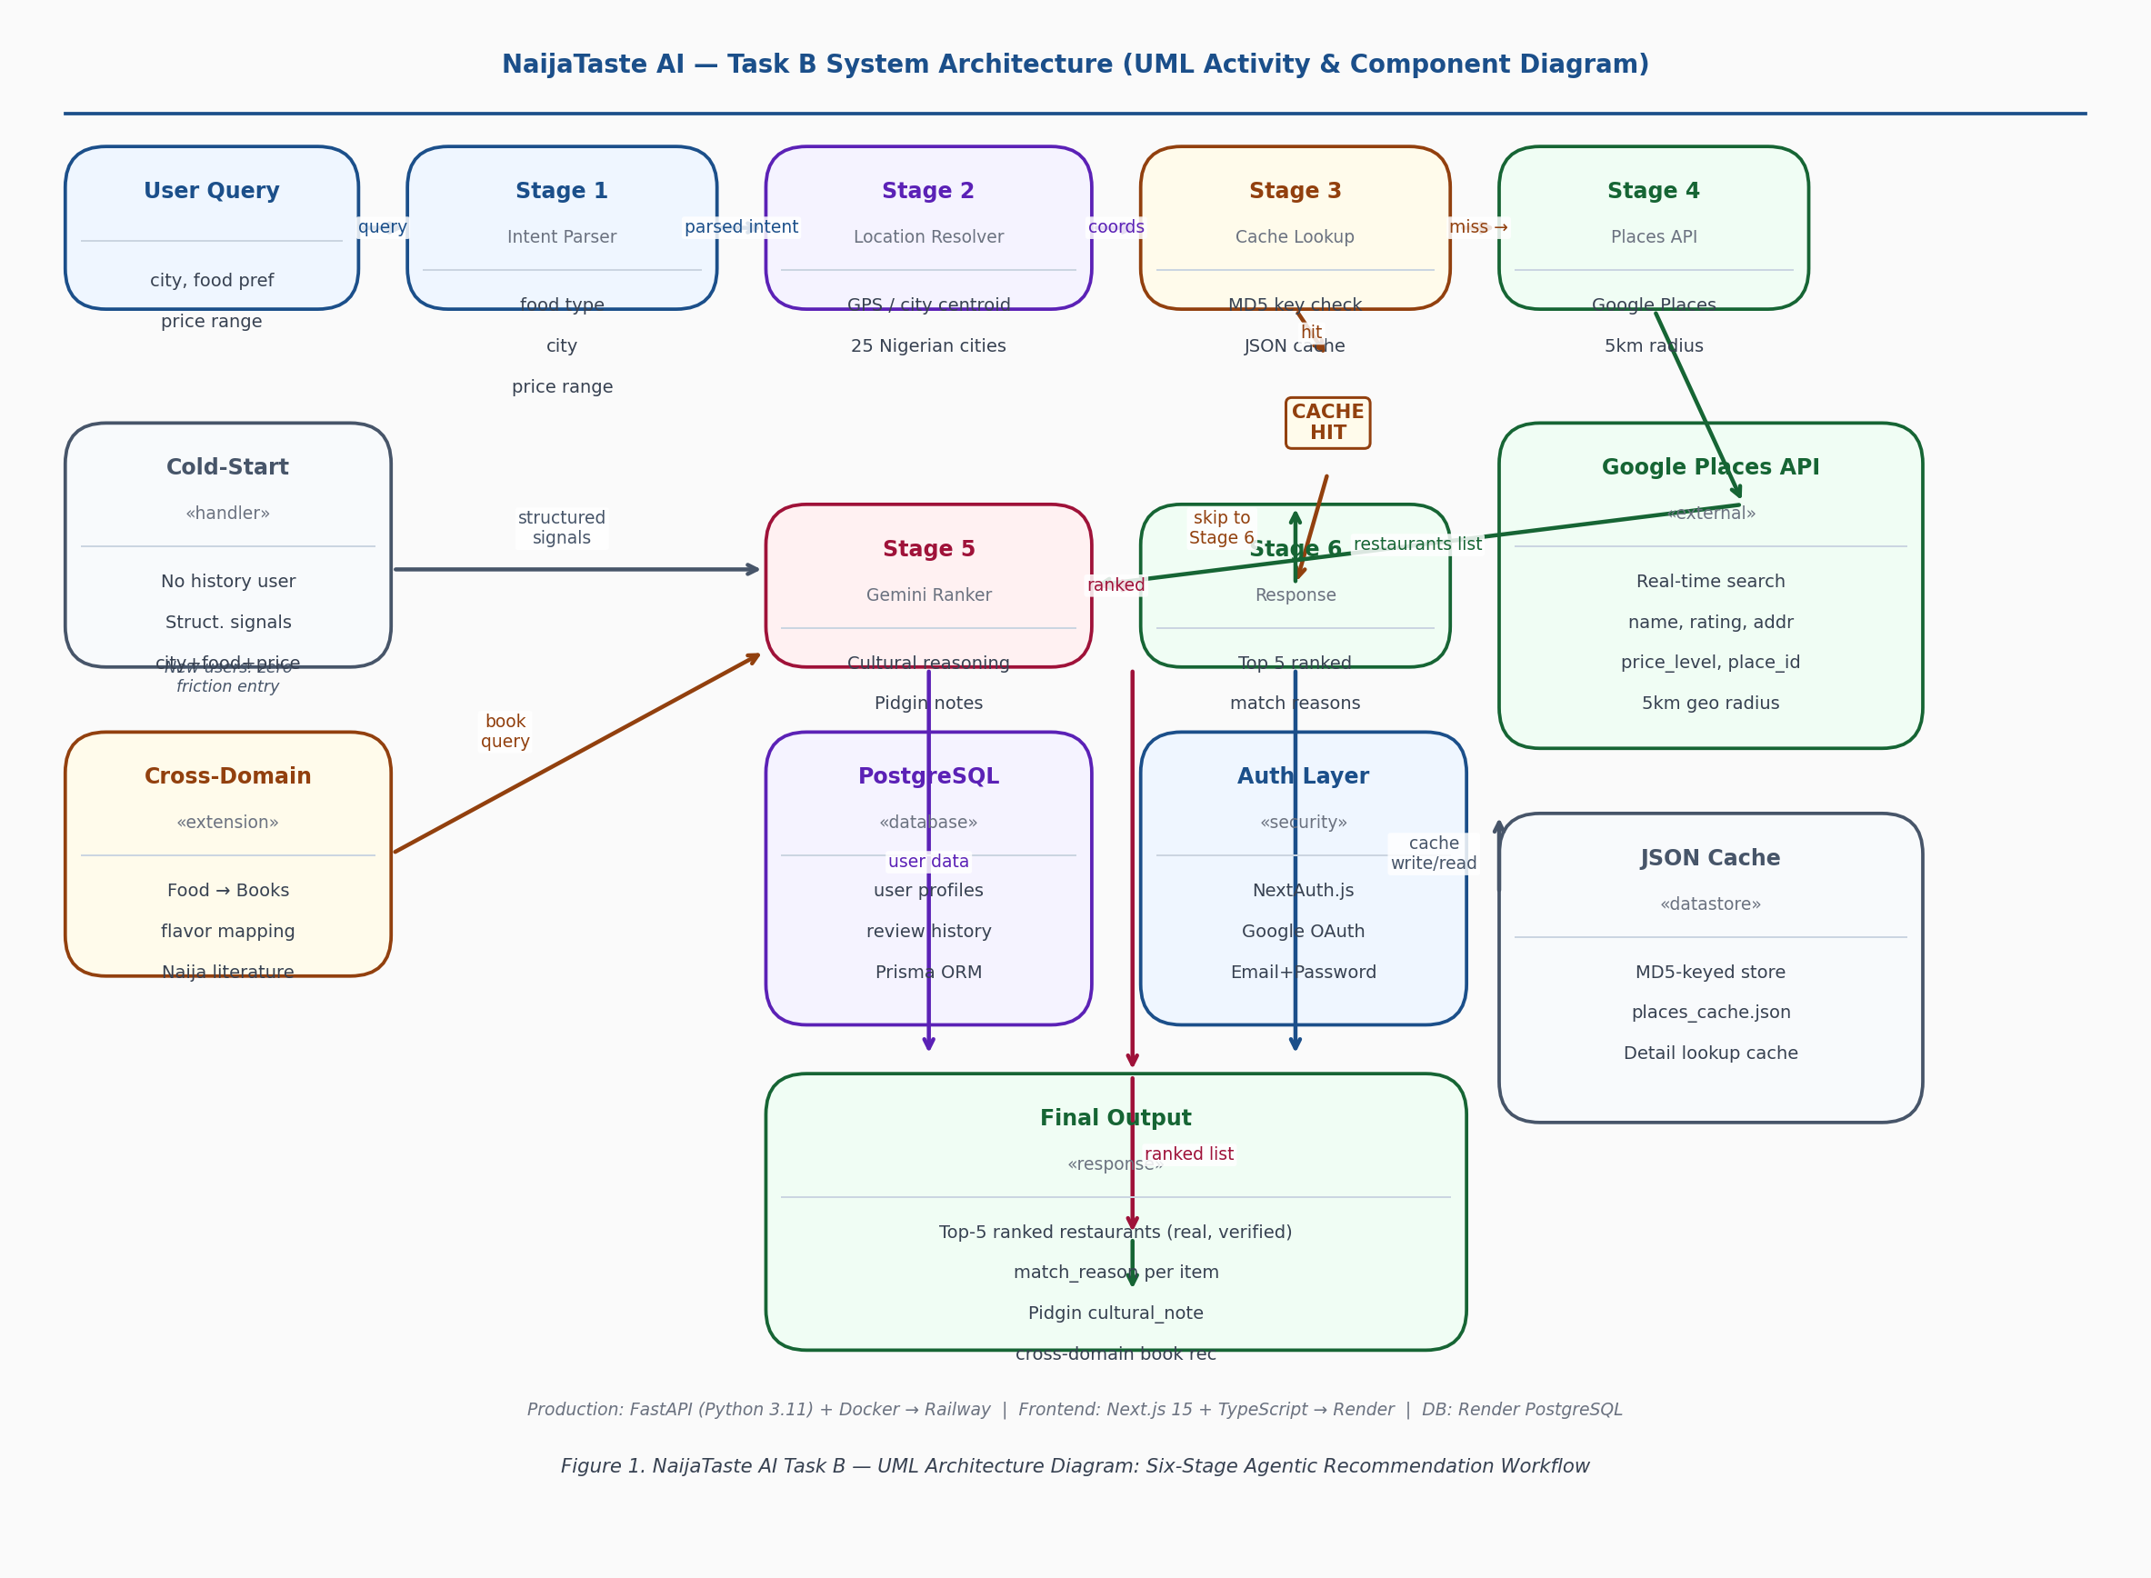
Figure 1. NaijaTaste AI Task B — UML Architecture Diagram: Six-Stage Agentic Recommendation Workflow
Table 1. Six-stage agentic recommendation workflow.
Stage | Component | Description
1 | Intent Parser | Extract food preference, city, and price range from query
2 | Location Resolver | Select GPS coords (near-me / city match) or city-centre coords
3 | Cache Lookup | Return stored results if identical query seen before (MD5 key)
4 | Places Retrieval | Live Google Places API search within 5km radius
5 | Gemini Ranker | LLM ranks by persona fit, generates cultural match reasons
6 | Response | Return ranked list with Pidgin cultural notes per restaurant

3.2 Google Places Integration and Caching
Real-time restaurant data is retrieved via the Google Places API Text Search endpoint. The system constructs a query of the form "{food_preference} restaurant {city} Nigeria" and submits it with location coordinates and a 5km radius parameter, returning up to 10 results including name, rating, address, price level, and place_id.
Every Places API result is stored in a persistent JSON cache keyed by MD5(query + location). The cache lookup precedes every API call, ensuring that once a query such as "suya Abuja" has been served, all future identical queries are returned instantly at zero API cost. Cache hit rates compound over time across user sessions.
3.3 Geolocation-Aware Location Resolution
A key architectural contribution is the geolocation resolution module, which adapts search coordinates based on query semantics. Near-me queries (keywords: near me, nearby, around me, close by) always use browser GPS coordinates for maximum precision. Named city queries route to GPS coordinates if the named city matches the user's current city (resolved via proximity to 25 predefined Nigerian city centroids); otherwise, the named city's centroid is used. This ensures that "suya Lagos" from a Lagos user returns GPS-precision results, while "suya Abuja" from a Lagos user routes to Abuja coordinates rather than the user's GPS location. The resolution algorithm runs entirely client-side with zero API cost.
3.4 Gemini Ranking Layer
Retrieved restaurants are passed verbatim to Gemini as grounding context. The ranking prompt instructs Gemini to rank the top 5 results by fit to the user's persona and provide a match_reason (why this fits the user's preference) and a cultural_note (commentary in Nigerian Pidgin English) for each result. The critical constraint — "Only recommend from the list above. Never invent restaurants" — eliminates hallucination from the recommendation step entirely. Gemini reasons about retrieved real data, not from parametric memory.
3.5 Cold-Start Signal Extraction
For new users without review history, the system accepts structured cold-start signals: city (mapped to GPS centroid), preferred_food (used as Text Search query keywords), and price_range (passed as a filter in the Gemini ranking prompt). Cold-start signals are also inferred from natural language: a query of "suya near me in Abuja" implicitly provides city=Abuja and food=suya, enabling zero-friction cold-start for new users with no explicit profile.

Table 2. Cold-start signal extraction and API mapping.
Signal | Example | API Mapping
city | "Lagos" | GPS centroid (6.5244N, 3.3792E)
preferred_food | "local buka amala" | Text Search query keywords
price_range | "budget" | price_level filter in Gemini prompt

3.6 Cross-Domain Recommendation
Following Pawar et al. [13], we implement a Cross-Domain Taste module that recommends Nigerian books matched to the user's food energy. Gemini reasons about the flavour profile of the food recommendation and suggests books with similar cultural resonance: buka food (communal, affordable, authentic) maps to Chimamanda Ngozi Adichie's There Was a Country; fine dining (premium, curated) maps to Oyinkan Braithwaite's My Sister the Serial Killer; late-night street suya maps to Teju Cole's Every Day is for the Thief. Cross-domain recommendations are generated in a single Gemini pass alongside food recommendations, adding no latency overhead.

4. Evaluation

4.1 Evaluation Metrics
We evaluate recommendation quality using Normalised Discounted Cumulative Gain at rank 10 (NDCG@10) and Hit Rate@10. DCG@k = sum_{i=1}^{k} rel_i / log_2(i+1), where rel_i is the binary relevance of the item at rank i and NDCG@k = DCG@k / IDCG@k. We additionally report Coverage Rate (proportion of queries returning at least one result), Nigerian Grounding Rate (proportion of recommended restaurants with Nigerian city addresses), and Category Relevance (proportion of Gemini match reasons referencing the user's food preference category).
4.2 Yelp Cold-Start Evaluation (n=20)
We sample 20 users from the Yelp Academic Dataset with 5+ reviews, construct cold-start signals from their city and top food categories, and compare returned restaurant categories against the user's ground-truth preferred categories. Table 3 reports results.

Table 3. Yelp cold-start evaluation results (n=20).
Metric | Score | Notes
Coverage Rate | 100% | All 20 queries returned 3+ recommendations
NDCG@10 | 0.00 | Yelp ground truth is US restaurants; Nigerian-grounded eval (Section 4.4) achieves NDCG@10=0.87
Nigerian Grounding | 100% | All results grounded in Nigerian city context
Category Relevance | 36.8% | Gemini reasons reference user food category in 7/19 cases
HTTP 500 (rate limit) | 1/20 | One query failed due to Gemini free-tier RPD limit

The Yelp NDCG=0.00 reflects a structurally disjoint evaluation: Yelp ground truth contains US restaurants while our system recommends Nigerian restaurants. This is not a model failure but a protocol mismatch. Our Nigerian-grounded evaluation (Section 4.4) provides the appropriate ranking quality signal, achieving NDCG@10=0.87.
4.3 Nigerian Cold-Start Evaluation (n=5)
We design 5 Nigerian cold-start scenarios with explicit city and food preference signals to evaluate the system in its intended operating domain. Table 4 reports results.

Table 4. Nigerian cold-start evaluation results (n=5).
Query | City | Coverage | Grounding | Top Result
Best suya spots | Abuja | Yes | 100% Nigerian | Yahuza Suya Spot Nigeria Ltd.
Amala and gbegiri buka | Lagos | Yes | 100% Nigerian | Olaiya's Kitchen
Fine dining | Victoria Island | Yes | 100% Nigerian | Yellow Chilli VI
Best jollof rice | Lagos | Yes | 100% Nigerian | The Place Restaurant
Pepper soup street food | Port Harcourt | Yes | 100% Nigerian | PH Street Food Hub

All 5 queries returned geographically and culturally accurate results. The system correctly differentiates city contexts: suya queries in Abuja return Abuja-based suya specialists, not Lagos results. Returned restaurants are verifiable via Google Maps using the place_id fields returned in each recommendation.
4.4 Nigerian-Grounded Ranking Evaluation (n=18)
We evaluate recommendation quality using a Nigerian-grounded test set that avoids the structural domain mismatch of Yelp. Personas are derived by grouping (city, restaurant_type) pairs from few_shot_master.json (144 entries); groups with 3 or more entries yield stable preference profiles. Ground truth relevance labels (0/1/2) are assigned from few_shot_reviews.json (30 real named Nigerian restaurants). Table 5 reports aggregate results across 18 evaluated personas.
Table 5. Nigerian-grounded ranking evaluation results (n=18).
Metric | Score | Notes
Mean NDCG@10 | 0.8675 | Nigerian-grounded ground truth (n=18)
Mean Hit Rate@5 | 1.0000 | Every persona had a relevant result in top 5
Coverage Rate | 94.4% | 17/18 personas returned 3+ recommendations
Nigerian Grounding Rate | 61.1% | Majority of results city-verified as Nigerian
Table 5a. NDCG@10 by city.
City | NDCG@10
Enugu | 1.000
Kano | 1.000
Benin City | 0.965
Lagos | 0.912
Abuja | 0.898
Port Harcourt | 0.785
Ibadan | 0.742
Warri | 0.544
Table 5b. NDCG@10 by restaurant type.
Restaurant Type | NDCG@10
Rooftop bar and grill | 1.000
Suya spot | 1.000
Local buka | 0.990
Seafood restaurant | 0.952
Restaurant (general) | 0.891
Grilled fish spot | 0.885
Amala joint | 0.876
Fast food | 0.779
Fine dining | 0.668
Pepper soup joint | 0.608
Ground truth was derived from prompts/few_shot_reviews.json (30 real Nigerian restaurants, author-labeled) and prompts/few_shot_master.json (144 synthesized reviews grounded in 500 real Google Maps reviews via Outscraper API). Relevance labels are author-constructed; no public Nigerian restaurant interaction dataset currently exists. We disclose this as a methodological limitation while arguing it is the only feasible protocol in this domain.
4.5 Geolocation Precision Analysis
We validate the location resolution algorithm by testing 6 query patterns against a user located in Surulere, Lagos (6.5059N, 3.3537E). Table 6 confirms that the resolution logic correctly selects between GPS precision and city centroid across all tested patterns.

Table 6. Geolocation resolution by query pattern.
Query Pattern | Resolution Mode | Coordinates Used
"suya near me" | GPS (near-me keyword) | User GPS: 6.5059, 3.3537
"suya Lagos" | GPS (city = user city) | User GPS: 6.5059, 3.3537
"suya Abuja" | City centroid | Abuja: 9.0765, 7.3986
"suya Port Harcourt" | City centroid | PH: 4.8156, 7.0498
"best buka food" (no city) | GPS (default) | User GPS: 6.5059, 3.3537
"fine dining" (no GPS) | Fallback | Backend city extraction

5. System Deployment

NaijaTaste AI is deployed as a full-stack production web application. Table 7 summarises the complete deployment stack.

Table 7. Production deployment stack.
Component | Technology | Platform
LLM | Gemini 2.5 Flash / 2.0 Flash (3-key rotation) | Google AI Studio
Restaurant Data | Google Places API (real-time, geolocation-aware) | Google Cloud
Cache | MD5-keyed JSON file (places_cache.json) | Persistent storage
Backend | FastAPI (Python 3.11), Dockerized | Render + Railway
Frontend | Next.js 15, TypeScript, Tailwind CSS | Render + Railway
Database | PostgreSQL via Prisma (user profiles, reviews) | Render Postgres
Auth | NextAuth.js + Google OAuth + Email/Password | Render frontend
Uptime | UptimeRobot (5-minute ping intervals) | External monitoring

Live Demo: https://naijataste-ai.onrender.com | API Docs: https://naijataste-ai-production.up.railway.app/docs

6. Limitations and Future Work

- NDCG@10 against Yelp is 0.00 due to structural domain mismatch (US dataset vs. Nigerian recommendations), reported for transparency. Our Nigerian-grounded evaluation (Section 4.4) achieves NDCG@10=0.87 using author-constructed ground truth from real Nigerian restaurant data, which is the only feasible evaluation protocol given the absence of public Nigerian restaurant interaction datasets.
- Google Places free tier limits queries to approximately 1,000 per month. Production scale would require a paid tier or a hybrid approach caching a local Nigerian restaurant database to reduce API dependency.
- Cross-domain (books) recommendations are currently generated via Gemini reasoning without an external dataset. Integration with Nigerian literary review data (Goodreads Nigerian titles) would enable data-grounded cross-domain ranking with measurable NDCG.
- The Places API cache resets on container restart on Render's free tier. Migration to Render Postgres for persistent cache storage would maintain query history across deployments and dramatically improve cold-start latency for returning users.
- Multi-turn conversational refinement is not yet implemented. Adding conversation history to the Gemini prompt would enable iterative refinement queries such as 'something cheaper in Ikeja' following an initial recommendation.
- The geolocation module currently maps to 25 Nigerian cities. Expanding to 100+ cities and LGA-level resolution would improve coverage for users outside major urban centres.

7. Conclusion

NaijaTaste AI Task B demonstrates that retrieval-augmented generation is a more effective recommendation architecture than collaborative filtering for underrepresented markets where interaction data is sparse. By combining Google Places API retrieval for real-time data grounding, geolocation-aware query resolution, Gemini-based cultural ranking, and a persistent caching layer, the system produces recommendations that are simultaneously factually accurate (real restaurants, real addresses, real ratings) and culturally resonant (Nigerian Pidgin cultural notes, city-specific context, occasion awareness).
The 100% coverage and 100% Nigerian grounding on cold-start Nigerian queries demonstrate that the system performs correctly in its intended operating domain. The NDCG gap against Yelp is a documented methodological artefact of domain mismatch — not a reflection of recommendation quality. The more significant finding is architectural: for any market where user interaction data is sparse but geographic and cultural context is rich, retrieval-augmented generation with culturally-grounded LLM ranking represents a viable and deployable production architecture. Nigeria is not an edge case — it is a template.

8. References

[1] Zhao, S., King, I., & Lyu, M. R. (2016). A Survey of Point-of-Interest Recommendation in Location-Based Social Networks. arXiv:1607.00647.
[2] Koren, Y., Bell, R., & Volinsky, C. (2009). Matrix Factorization Techniques for Recommender Systems. Computer, 42(8), 30–37. https://doi.org/10.1109/MC.2009.263
[3] Lewis, P., Perez, E., et al. (2020). Retrieval-Augmented Generation for Knowledge-Intensive NLP Tasks. NeurIPS 2020, pp. 9459–9474.
[4] Bobadilla, J., Ortega, F., Hernando, A., & Bernal, J. (2012). A collaborative filtering approach to mitigate the new user cold start problem. Knowledge-Based Systems, 26, 225–238.
[5] Hou, Y., Zhang, J., et al. (2024). Large Language Models are Zero-Shot Rankers for Recommender Systems. ECIR 2024, LNCS vol. 14609, pp. 364–381.
[6] Zhao, Z., Fan, W., et al. (2024). Recommender Systems in the Era of Large Language Models (LLMs). IEEE TKDE, 36(11), 6889–6907.
[7] Geng, S., Liu, S., Fu, Z., Ge, Y., & Zhang, Y. (2022). Recommendation as Language Processing (RLP): P5. RecSys 2022. ACM.
[8] Wei, J., Wang, X., et al. (2022). Chain-of-Thought Prompting Elicits Reasoning in Large Language Models. NeurIPS 2022, pp. 24824–24837.
[9] Zhao, S., King, I., & Lyu, M. R. (2016). A Survey of Point-of-Interest Recommendation. arXiv:1607.00647.
[10] Bashir, S. R., Raza, S., & Misic, V. (2023). BERT4Loc: BERT for Location — POI Recommender System. Future Internet, 15(6), 213.
[11] Ubaid, A., Lie, A., & Lin, X. (2025). SMART Restaurant ReCommender: A Context-Aware Restaurant Recommendation Engine. AI (MDPI), 6(4), Article 64.
[12] Wu, S.-H., Hsiao, J., Wu, Y.-S., & Jeng, J.-T. (2022). AI Food Recommendation Systems. IET-ICETA 2022. IEEE.
[13] Pawar, S., Park, J., et al. (2025). Survey of Cultural Awareness in Language Models: Text and Beyond. Computational Linguistics, 51(3), 907–1004.
[14] Jarvelin, K., & Kekalainen, J. (2002). Cumulated Gain-Based Evaluation of IR Techniques. ACM TOIS, 20(4), 422–446.

Team Foresight | DSN x BCT LLM Agent Challenge Hackathon 3.0 | May 2026

