# Customers

# Where are the customers located?

**By state**

Unsurprisingly, the three states with the highest population had the most sales. Sao Paulo, Rio de Janeiro, and Minas Gerais had the largest number of orders, respectively. There was a large drop-off between these 3 states and the rest. I also made a graph of the sales on a per capita basis. Sao Paulo and Rio de Janeiro were still in the top 2, but the Distrito Federal, a relatively small state, jumped into the top 3. A cluster of 5 other states, including Minas Gerais, was right below those 3.

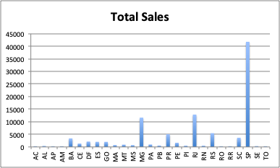

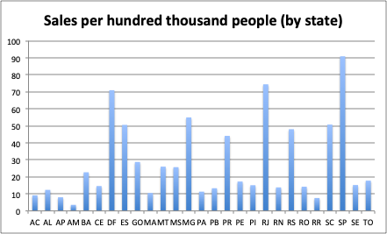

**By city**

The top 4 cities were Sao Paulo, Rio de Janeiro, Belo Horizonte, and Brasilia. Brasilia is in the Distrito Federal, which explains why that state had such a high per capita. Belo Horizonte is in Minas Gerais. These are four out of the six most populous cities in Brazil.

One potential city for improvement is Fortaleza, which is the fifth most populated city in Brazil, but isn’t anywhere in the top 10 of sales.

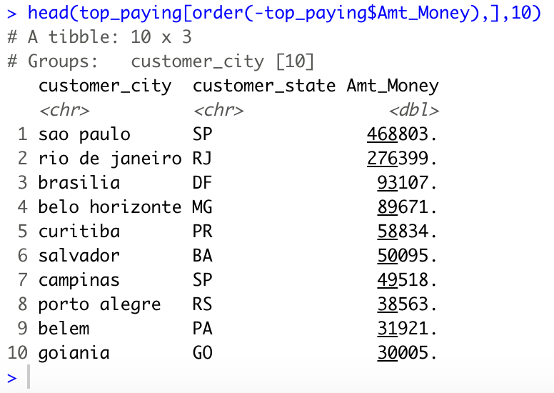

**By zip code**

There were too many zip codes to make a histogram of, so I looked at the top 10 zip codes. The top 5 were all in Rio de Janeiro, in fact, Rio had 6 of the top 10 zip codes. The others were in Espirito Santo, Minas Gerais (twice), and Sao Paulo.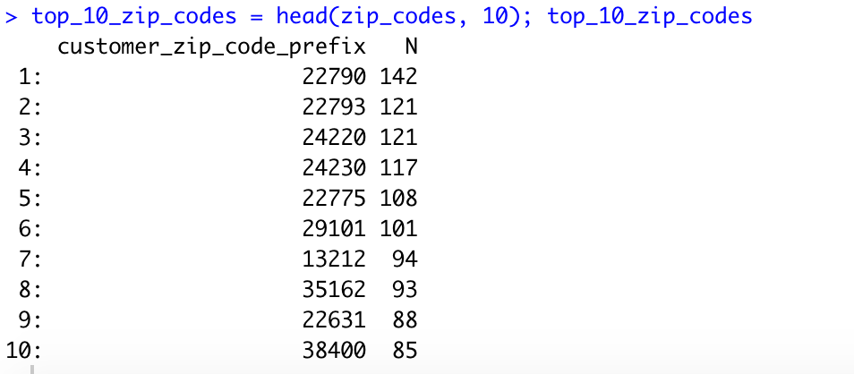

# What type of areas are the zip codes in?

I had to do this manually. I looked up a couple of the top 10 zip codes. Most of the zip codes in Rio (22790, 22793, 22775, and 22631) are from around the Barra de Tijuca, which seems to be an upscale living area. Two others from Rio (24220 and 24230) are from the Guanabara Bay, near Icarai, a beach area.

Map of Rio, with most popular zip codes circled (from mapsland.com)

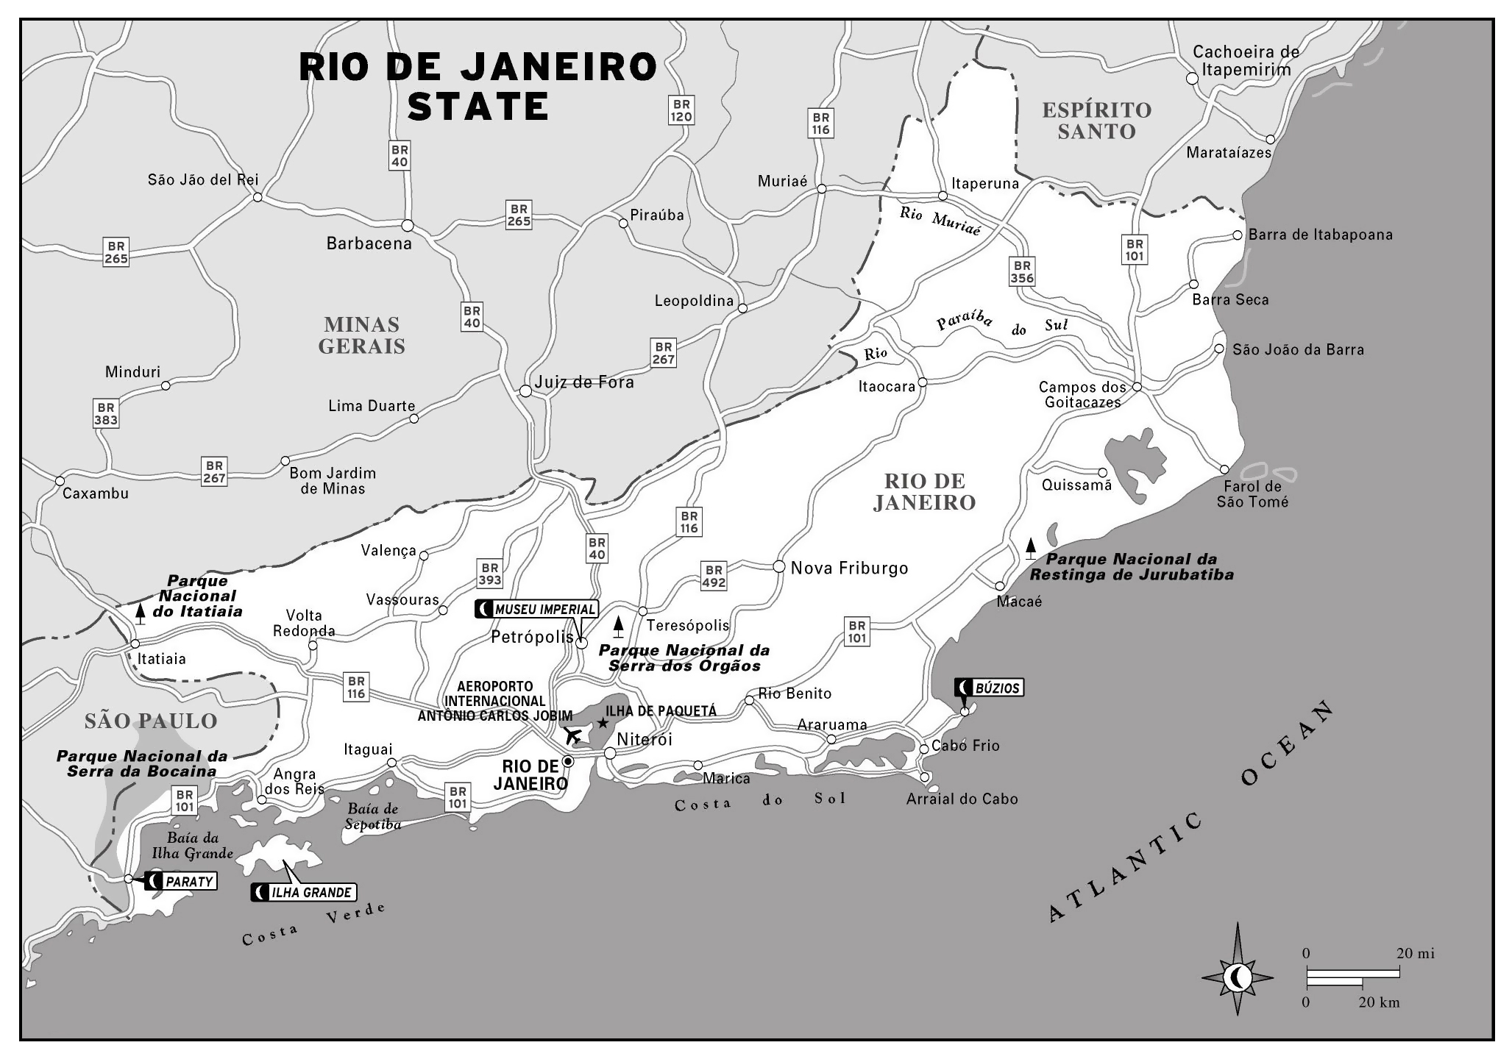

Barra de Tijuca

Icarai

# How many are returning customers?

Initially I did an analysis based on the customer ID. I counted how many times each customer ID showed up in the data. I have two histograms for that.

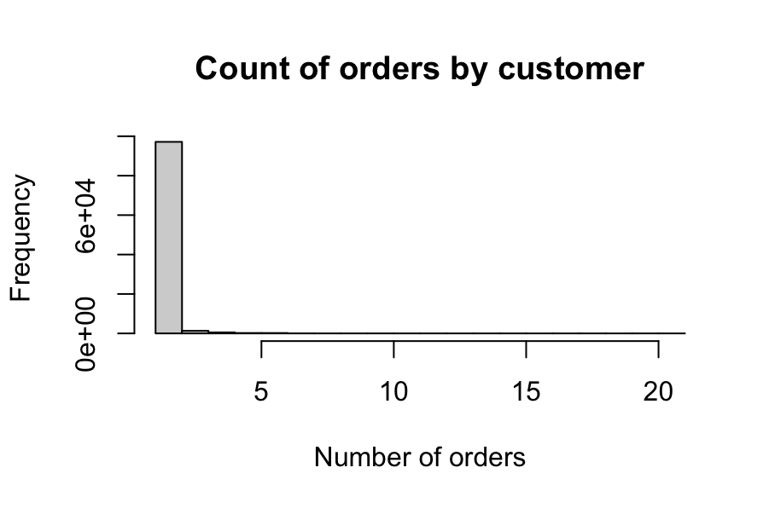

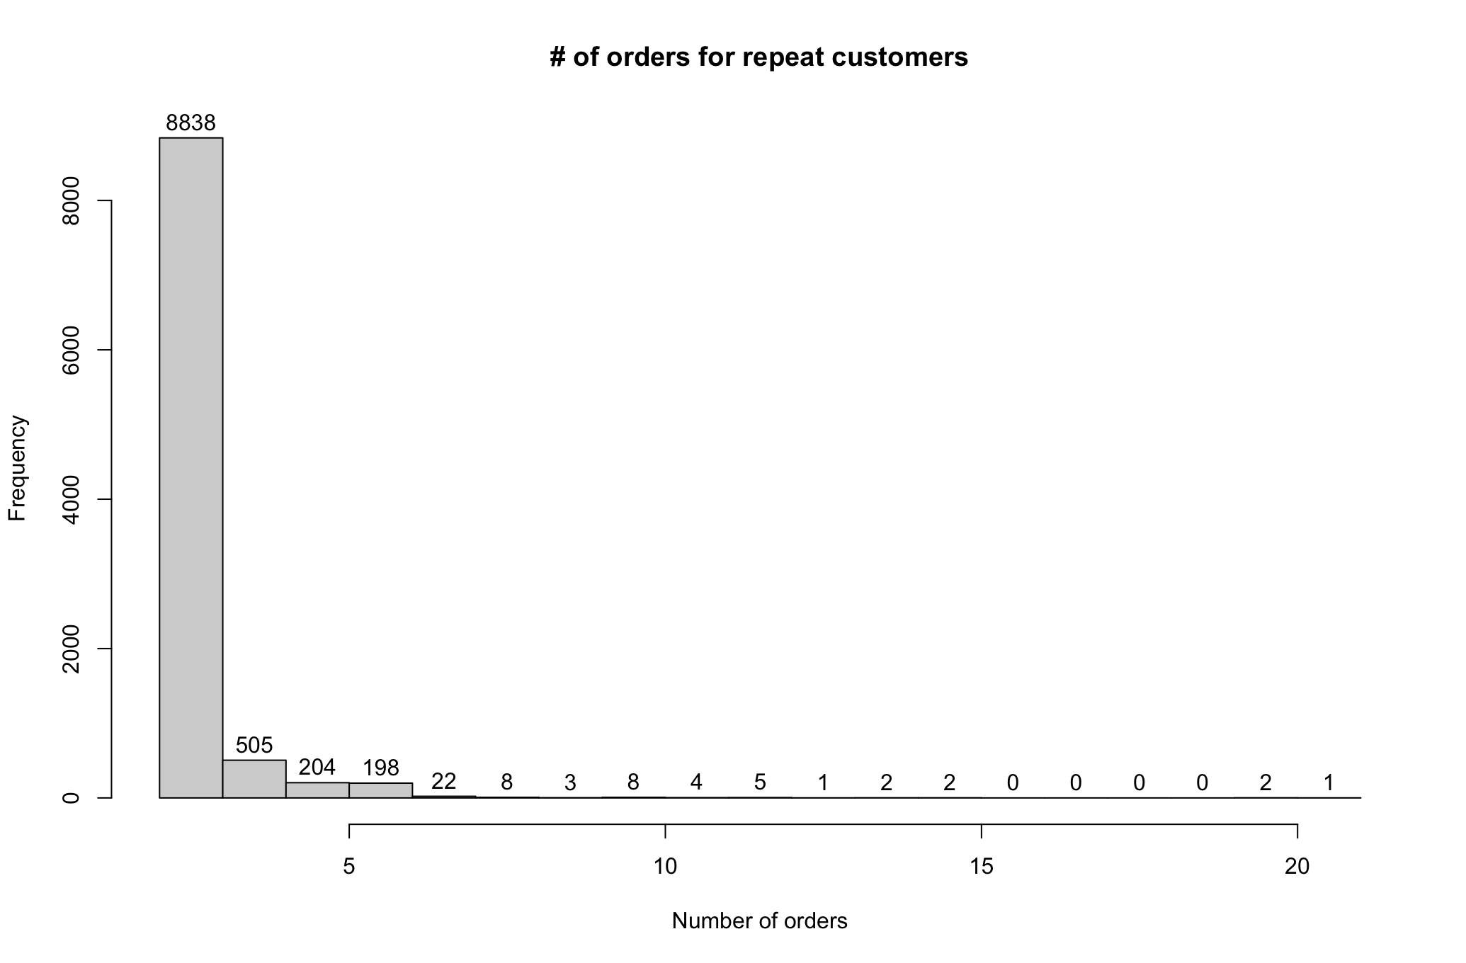

However, when I looked closer at the repeat customers, I saw that there was a new row in the data table for every item purchased. When I summed up the numbers, no customer was a repeat customer.

# Who are the customers that haven’t purchased in the longest time?

This is hard to answer because there are no repeat customers. However, 119 customers had orders on 9/9/2017, which were the first orders in the database.

# Who are the top customers?

The top 5% of customers in terms of money paid more than $379.90. They were mostly from the top four cities Sao Paulo, Rio de Janeiro, Belo Horizonte, and Brasilia. 95% of the customers only bought 1 item.

This is the percentile table for transaction price.

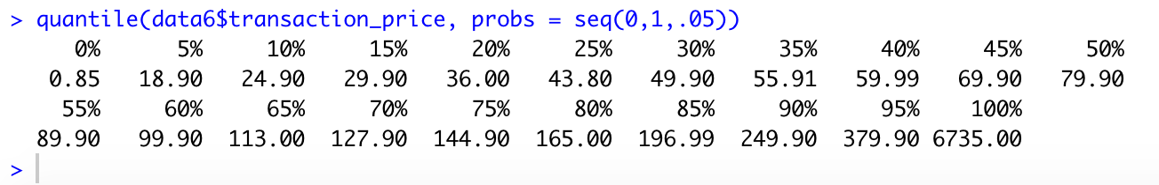

This is the percentile table for the items bought per customer.

# Macintosh HD:private:var:folders:nq:qjj_l7c10nj_j3368s7vsckc0000gn:T:TemporaryItems:Screen Shot 2020-11-02 at 11.01.52 PM.png