BLOGGING

1. When writing a blog post with affiliate links or something, Show a result or prove of evidence that will cause others to click on your links:

Eg: Example of Lomash your friend showing how he earned his first $100 in affiliate marketing.

He said:

A month ago, I got an email from one the tools’ affiliate program that mentioned on the post which says,

***“You Earned a Referral!”***and the whole email looks like this:

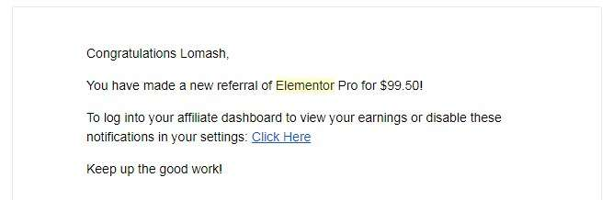

Bloggers To Learn From:

https://passiveincomesuperstars.com/

bloggerspassion.com/

matthewwoodward.co.uk/

makingsenseofcents.com/

What is Working For Me

1. Target long tail keyword and forget about short keywords it hard to rank for.
2. Build backlinks to the homepage if you want to increase domain authority
3. High length world blog post works like magic