Bootstrap

**Grid System**

The grid system is a way of structuring your webpage layout into columns or rows. They add up to 12 columns, that’s all the column numbers you specify in your row should not be greater than 12. But not always require to be equal to 12. Each row should be in <div> of class “container” or “container-fluid”

Example:

  <!--"container-fluid" ==full width of 100% But "container"==center width define by boostrap-->

    <div class="container-fluid">

        <!--you can use flexBox justify-content, align-itmes values here to see how the colums are spaced out-->

        <div class="row">

            <div class="col-6 col-md-2" style="background-color: yellow;">d</div>

            <!--use offset to set left margins for coloms base on number of colums it should take as margin-->

            <div class="col-6 col-md-4 offset-md-5" style="background-color: aqua;">d</div>

        </div>

    </div>

**Offset**

You can use offset to give a column the number of left margin it should have. The concept is that, it takes the number of columns as it margin. So if you say that offset-md-2 then that column will have a left margin that’s equal to the width of 2 columns on medium screen like tablet.

The format is this: offset-screenType-numberOfColumAsMargins

Example: the below second 11th colom has been given a left margin that takes the width of 2 columns

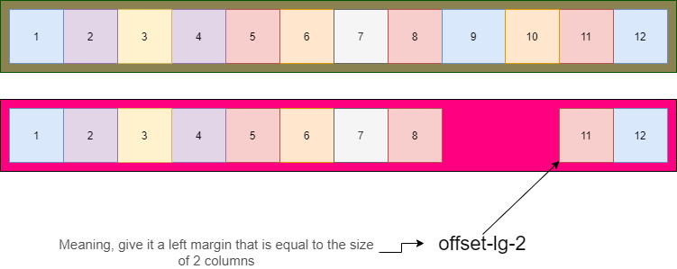

Order

You can use the “order” class to determine which column should a specific column jump into base on specific screen view.

 <div class="container-fluid">

        <div class="row">

            <!--"order-md-2" will make this column take the second colmn position-->

            <div class="col-6 order-md-2" style="background-color: yellow;">d</div>

           <!--"order-md-1" will make this column take the first column position-->

            <div class="col-6 order-md-1" style="background-color: aqua;">d</div>

        </div>

    </div>

== =================

**ALERT**

Alert are nice way to show message to the user without it showing as a modal. It is a normal text that should be displayed when something happen.

Normally, you will use JavaScript to set the “display” alert dom element to block when something happen to show the alert.

Example of alert that will be called when the page load:

      <!--wraping it inside a container so that it will be at the center-->

    <div class="container">

        <!--the div-->

        <div class="alert alert-warning alert-dismissible fade show" role="alert">

            <!--message to display in the alert-->

            <strong>Holy guacamole!</strong> You should check in on some of those fields below.

            <!--button to hide or remove the alert from the dom-->

            <button type="button" class="btn-close" data-bs-dismiss="alert" aria-label="Close"></button>

        </div>

    </div>

The result is below image, when the user clicks on the “X” button, the alert will be removed from the dom or page

C:\Users\Justice Ankomah\Downloads\Screenshot_2021-04-18 Document.png

===================

===vector, svg resource====

https://dev.to/surajondev/40-useful-resources-for-mastering-web-1i0h