**23CCE284**

**Database Management System Laboratory**

**Project Report**

**INVENTORY MANAGEMENT**

Submitted By:

Aditya Varma - CB.EN.U4CCE23004

Suraj Rajeev – CB.EN.U4CCE23057

Tarun Srivathsan – CB.EN.U4CCE23058



**Department of Electronics and Communication Engineering,**  **Amrita School of Engineering,** **Amrita Vishwa Vidyapeetham, Coimbatore,** **India -641112** .

**Abstract**

The Inventory Management System is a user-friendly application developed using Python, with MySQL for data storage and Tkinter for the graphical user interface. This system streamlines inventory operations by enabling customers to browse available products, select required items, choose sellers, and place orders with secure payment options. Additionally, it facilitates the addition of new suppliers and products. The primary objective of this project is to create a fully automated system that ensures efficient stock management by maintaining optimal inventory levels while preventing overstocking and stockouts. Key features include user registration and authentication, stock and product management, product availability tracking, secure transactions, and an administrative panel. The system enhances data integrity, user privacy, scalability, and security, ensuring seamless inventory control. By automating processes and enabling real-time tracking, it minimizes manual errors, inefficiencies, and operational costs, while also preventing theft, procurement issues, and wastage.

**Motivation**

In today's fast-paced world, businesses require efficient inventory management solutions to streamline operations and improve productivity. Traditional inventory tracking methods often lead to errors, inefficiencies, and increased costs. With the rise of digital technology and the growing preference for convenience, there is a significant need for a robust online platform that enables users to effortlessly order products from their devices. This project aims to bridge the gap between businesses and customers by providing an automated system that simplifies inventory management while enhancing user experience. Furthermore, it saves customers time by reducing the need for in-person shopping, making the process more efficient and accessible. By integrating real-time tracking, automated stock management, and secure transactions, this system ensures accuracy, reduces operational overhead, and enhances overall efficiency for both businesses and customers.

**Objectives**

An Inventory Management System helps businesses track, manage, and optimize inventory efficiently while ensuring seamless operations. Traditional methods often lead to errors, inefficiencies, overstocking, and increased costs. This project aims to develop a fully automated, user-friendly system that streamlines inventory tracking, reduces manual effort, and enhances decision-making. The key objectives are:

1. **Efficient Stock Management:**

The system ensures businesses maintain the right inventory levels to meet demand while avoiding overstocking or shortages. By implementing real-time tracking and automated alerts, businesses can optimize stock levels, prevent wastage, and improve overall supply chain efficiency.

1. **Automation and Error Reduction:**

Manual inventory tracking is prone to human errors, leading to discrepancies and financial losses. This system automates data entry, stock updates, and order processing, minimizing errors and enhancing accuracy. Additionally, automation reduces the need for manual intervention, saving time and resources.

1. **User-Friendly Interface for Seamless Operations:**

A well-designed, intuitive interface simplifies inventory management for users, regardless of technical expertise. The system provides easy navigation for stock monitoring, product selection, supplier management, and order processing, ensuring smooth business operations.

1. **Secure Transactions and Payment Integration:**

The system integrates a secure payment gateway for seamless transactions, ensuring customers and suppliers can safely complete financial transactions. This enhances trust, protects sensitive data, and streamlines payment processing.

1. **Comprehensive Database Management:**

A structured database efficiently stores and manages product details, supplier records, stock levels, sales transactions, and order histories. This allows businesses to retrieve data quickly, maintain records systematically, and ensure smooth inventory operations.

1. **Data-Driven Decision Making and Business Growth:**

The system provides detailed insights through reports and analytics, helping businesses make informed decisions about demand forecasting, stock replenishment, and sales trends. These insights contribute to strategic planning, cost reduction, and overall business growth.

By fulfilling these objectives, the Inventory Management System enhances efficiency, accuracy, security, and scalability, ultimately improving the overall management of inventory operations.

**ER Diagram**

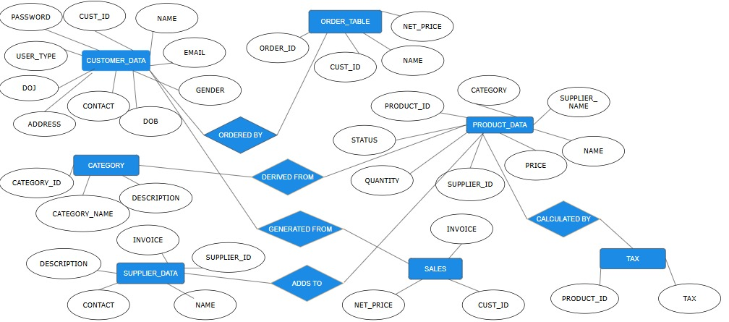

**Schema Diagram**

