# 1. KPI Issue

## a. Iran IOT(inteference over thermal)

is KPI design issue the design: taking the lowest interference detected as thermal noise is wrong

## b.STC collision (shall be contention) kpi issue is kpi design issue.

the local ask why TDD's collision rate is higher than FDD, even its value bigger than 100%.

firstly, it is a KPI formula issue.

secondly, designer don't understand the contention, just regarding it as collision

at last, there contention rach rate is normal,the local team shall check the FDD's contention free rach is so high, too much HOs???? .

## c. many kpi issue indicate HW/SW issue, e.g. RRC SR rate is maybe RP3 failure, mabye EPC configuration, RACH related issue(such as timeoffset configuration)

then the Philippines sw commit that there is race condition: the timeoffset value may changed via 2 process,process 1 set as value according to configuration, process 2 set it as RRU type's default value.

I ask him to add some process mute or sync mechanism. but he said that he don't understand.

## d.

# 2. hw/sw issue

## a. the sichuan system module failure issue,

local team: sw upgrade issue; hw team: known hw issue, just aging. No clear proof from local team.

## b.stc system module failure issue,

LFS team said that it is hw issue and hw commited.

but from TI datasheet, and open source code of LFS, it is a LFS issue.

# 3. HW issue

a. FPFD can't power on FZNC issue.

b. FZHJ can't detect tonyu RET issue.

# 4. other issue

e.g. Cargon mircowave backhual shaping issue

hw PTN backhual issue(configurtion in CMCC side)

# 5. easy issue,

configuration issue:

sw issue: e.g. cell id (1,2, 102, 3, 103) can't startup

root cause: the O&M configure the route according cell id, but the method used for string comparison has some problem. So regard 102 =2, 103=3

# 6, other team's issue

measurement can't transfer: TRS ISSUE.

7. theoretical issue:

IPsec support: just support via studying the open source strongSwan (becuse TRS team just porting it)

protocol overview:

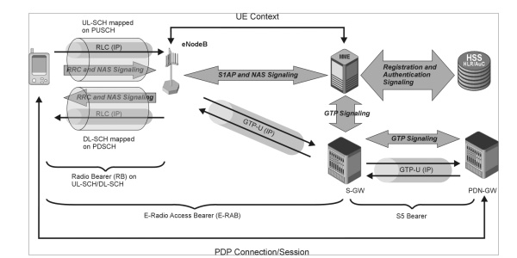

**Why is GTP used in LTE?**

* It provides mobility. When UE is mobile, the IP address remains same and packets are still forwarded since tunneling is provided between PGW and eNB via SGW
* Multiple tunnels (bearers) can be used by same UE to obtain different network QoS
* Main IP remains hidden so it provides security as well
* Creation, deletion and modification of tunnels in case of GTP-C

GTP Interfaces in LTE In LTE, version 2 is used for GTP-C and version 1 is used for GTP-U In simple LTE network implementation, GTP-v2 is used on S5 and S11 interfaces and GTPv1 is used on S1-U.

besides the tunnel management functionality, the GTP control plane protocol also offers functions and messages for:

• Path management.• Mobility management.• CS fallback.• Non-3GPP-related access.• Trace management

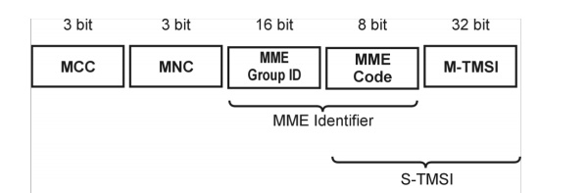

GUTI

**attach:**

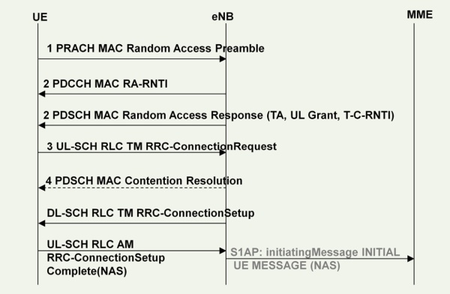

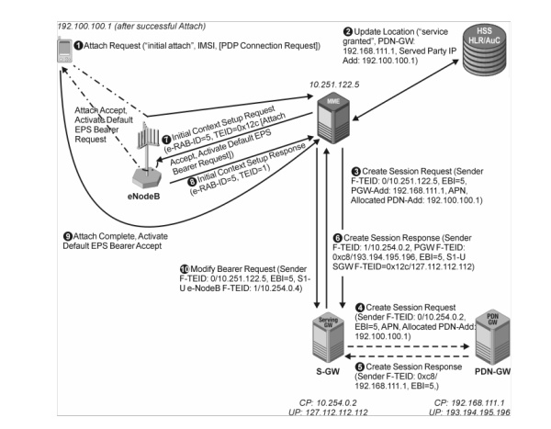

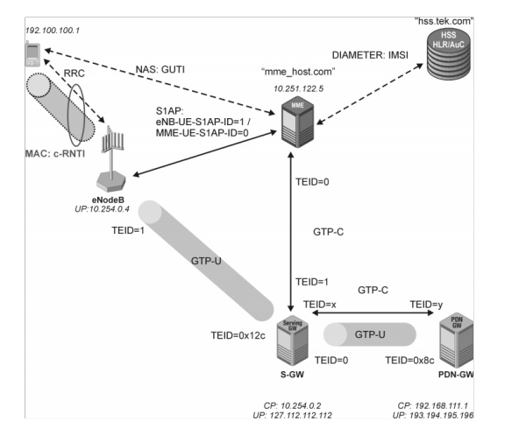

**intra cell HO**

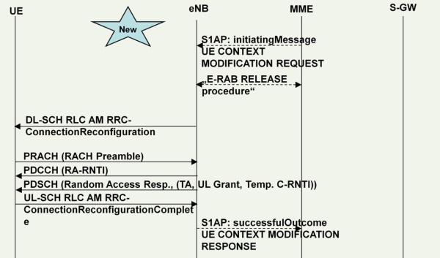

**x2 HO:**

一对消息是 HO request <---->HO request ack

如涉及到 MME, 上述消息在 mme<---> target enb 间交互,而mme 回给source enb的是HO command.

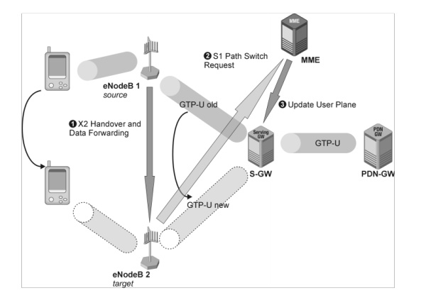

**s1 setup:**

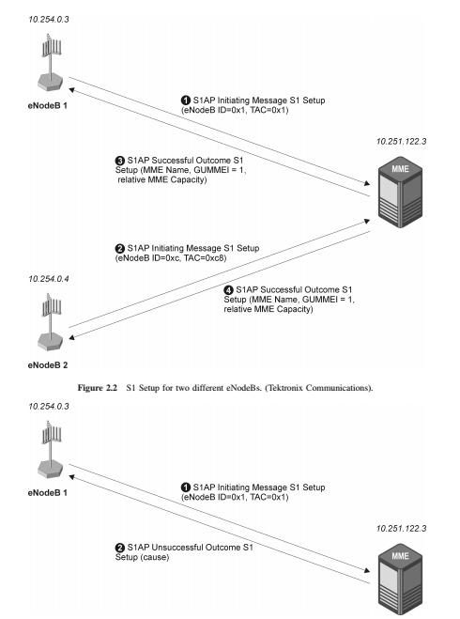

attach:

