Games in C++ – Assignment Exercise 1 – Planning Evidence document  
Recreating ‘Pong’  
Dominik Heiler - 23015707

For our first main assignment in the ‘Games in C++’ module, we were tasked with coding our own version of the arcade game ‘Pong’, using C++ and the accompanying SFML code library.

**Github Username:** DominikHHH

**Link to Source Code:** <https://github.com/UWEGames-GiC/pong-23-24-DominikHHH>

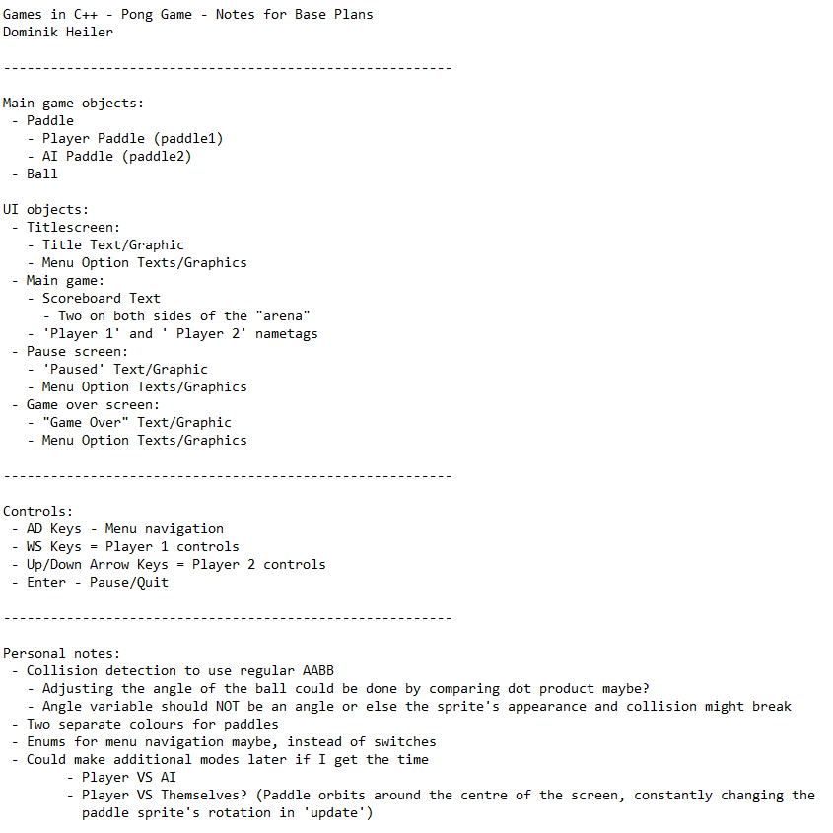Presented below are some of the planning materials that I made for myself while coding the actual game assets themselves.

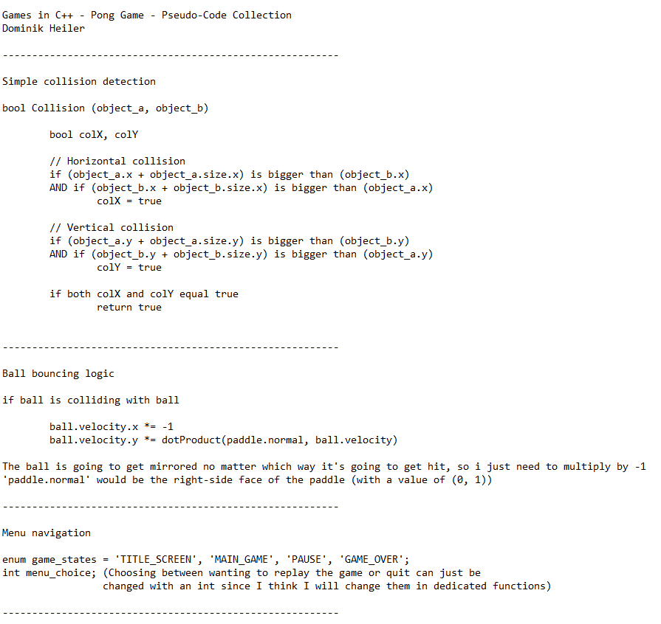

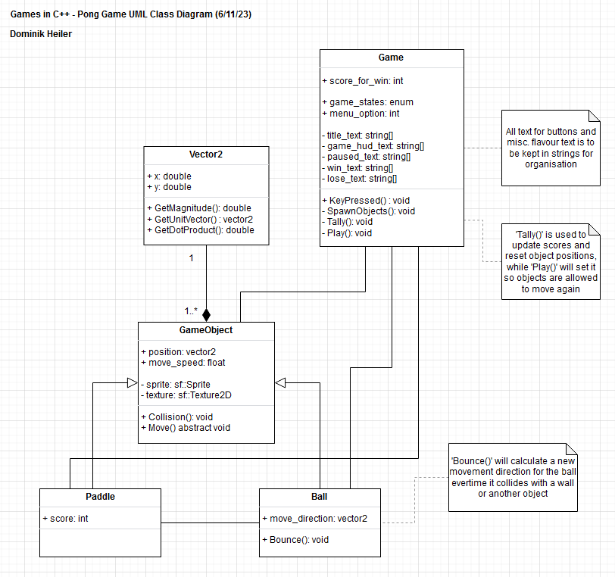(Above: screenshots of my notes, pseudo-code snippets, and doodles that I made for myself at the start of, and during, the project’s development, having used ‘Notepad’ and ‘MSPaint’ for future ease of access. The doodles, in particular, were made just for myself as a way to keep track of what I needed to work on, so they are quite rough and quickly-produced)

(Above: the main UML class diagram that I made for myself using ‘draw.io’, having planned out all the main object classes that I will use in my game)

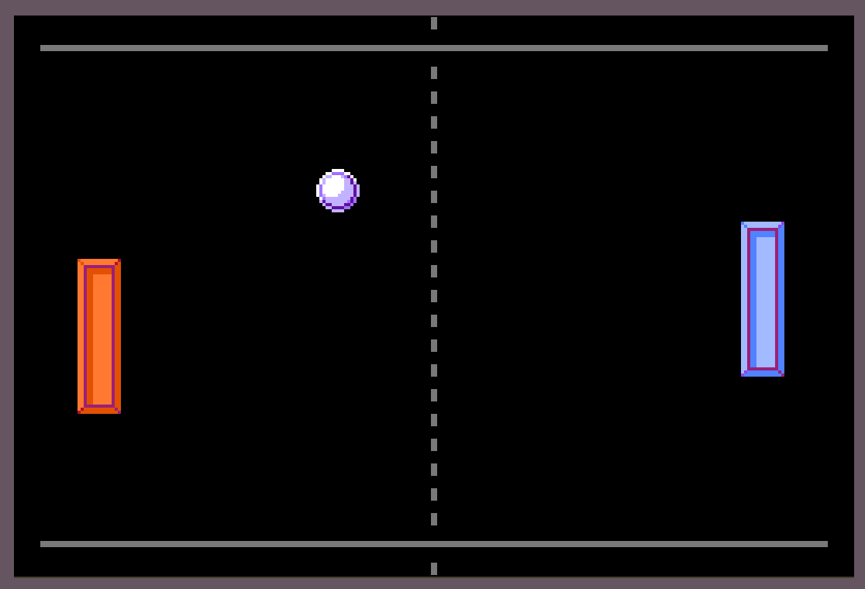

(Above: a basic mock-up featuring some simple visuals that I drew in ‘Aseprite’)

C++ code and graphical assets made by Dominik Heiler

Software used: CLion, Gitkraken Aseprite, draw.io

‘Press Start 2P Font’ by codeman38 (<https://www.fontspace.com/press-start-2p-font-f11591>)