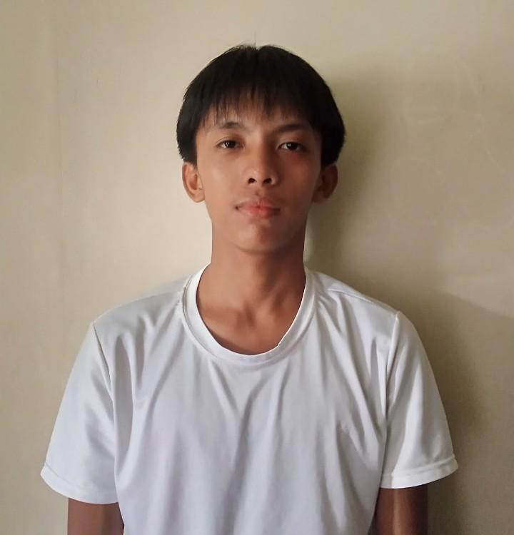
Justin Jade Yare

Zone 6B -Bulao Iponan

09535181590

justinyare7@gmail.com
_____________________________________________________________________________________
ENTHUSIASTIC AND QUICK-TO-LEARN INDIVIDUAL WITH A STRONG INTEREST IN IT. READY TO APPLY MY SKILLS AND GAIN IHANDS-ON EXPERIENCE WHILE CONTRIBUTING TO A TEAM.
_____________________________________________________________________________________
EDUCATIONAL BACKGROUND:

Tertiary
Phinma Cagayan de Oro College - Cagayan de Oro
Bachelor in Science-Information Technology (2025-Present)

Secondary
Iponan National High School. -Cagayan de Oro
Information and Communication Technology Strand
With Honor Award

Bulao Elementary School
Loyalty Award
_____________________________________________________________________________________
SKILLS:

Networking
Server Configuring
Dissassimbling and Assembling
Microsoft Office (Word, Excel, PowerPoint)

_____________________________________________________________________________________
ADDITIONAL INFORMATION:
Language: English. Fillipino
_____________________________________________________________________________________
REFERENCES:
Kagawad Joel Obsioms

