GroundStation Simulation Tool

1. Topic

GroundStation is a simulation tool controlling Husar Moonrover with keyboard and USB joystick. It visualizes its position on the Lunarena, robot's velocity, arm position, the weight of moon regolith in cylinder and angular velocities on each wheel.

2. Structure

Program consists of 3 modules: Robot simulation (class Robot), Control System (class MainWindow) and SCADA (class SCADA).

2.1 Robot

Robot consists of Driving System and Digging System. The first first includes 4 wheels with engines, the latter arm with the cylinder. Robot also has its position on the map, which is depends on linear and angular velocity of the robot. This class can simulate the robot's movement and features like digging the material and unloading it to the LunaBin.
Every change of the rover's values emits the signals which leads to visualize the robot's current state.

2.2 SCADA

Two pictures - pixmaps – side and up of the robot showing the values of linear and angular velocity, mass of the regolith and arm position. Used : QPainter which provides highly optimized functions to do most of the drawing GUI programs require. It can draw aligned text, pixmaps and much more.

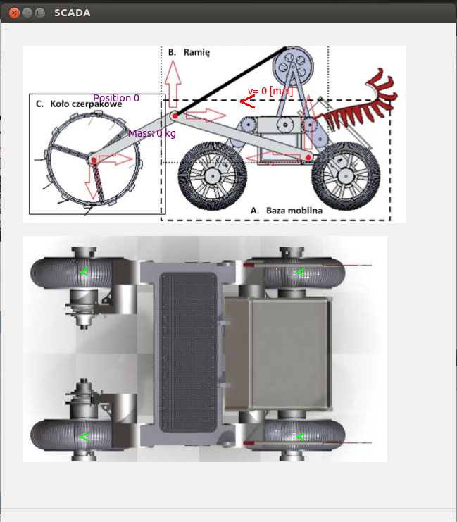

Fig 1. The SCADA window with zero values

The first pixmap, showing the Husar from the side, visualizes the arm position and mass in the cylinder. The values changes while digging and unloading the regolith. What is more, the current speed is shown by value and lenght of the arrow (picture below).

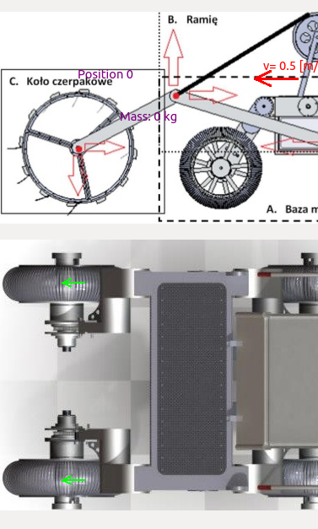

Fig 2. The SCADA showing a robot driving forward

2.3 MainWindow

The MainWindow allows to control the robot by keyborard and joystick. It shows robot's position on the map, text browser with logs and IP camera streaming (not available at the moment). Pressing the keys (standard WSAD and Q,E to dig/drop) corresponds with driving forward, turning left/right and digging/dropping the regolith. Joystick is used indirectly via program QJoypad which inputs from a gamepad or joystick and translates it into key strokes or mouse actions.

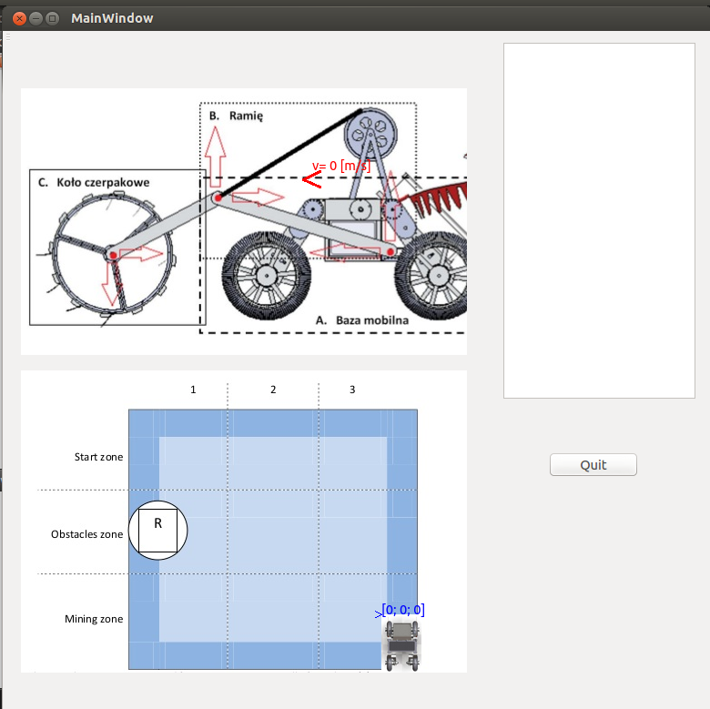

Fig 3. The MainWindow before launching

The robot's velocity is showed on the map as an arrow which lenght is specified by robot's current speed and angle by rover's angle. Every action is described in the browser on the right to be up-to-date with Husar's state.

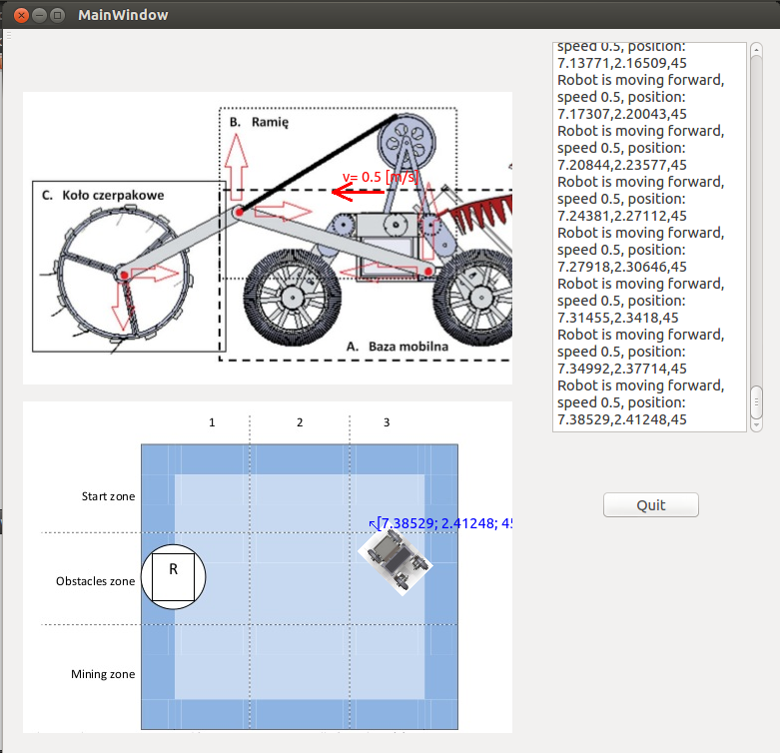

Fig 4. The sight of robot's current speed and position

3. System Requirements

- Unix OS (advised Ubuntu 12.10)
- Qt 4.8 or higher (qt-project.org/)
- QJoyPad 4.1 (qjoypad.sourceforge.net)
- USB Joystick with drivers
- 3DConnexion driver (http://www.3dconnexion.com/service/drivers.html)
- 3DConnexion Software Development Kit (http://www.3dconnexion.com/service/software-developer.html)
- Visualisation ToolKit (http://www.vtk.org) with proper configuration (http://www.vtk.org/Wiki/VTK/3DConnexion_Devices_Support)

4. Control System

W – drive forward (joystick: up arrow)
A – turn left (joystick: left arrow)
D – turn right (joystick: right arrow)
Q – dig (joystick button 1)
E – drop (joystick button 2)

5. Software development

The later versions of GroundStation will have following features:

- Communication via TCP/IP with PLC driver – frames including the function number, arguments and correction control
- extended control system – commands like : halt,, setting electromagnets to be turned off/on
- extended SCADA : each engine voltage, streaming from IP camera, animated arm and cylinder
- further optimalisation of the code

