**Professionals by Sport**

**MLB**

**NBA**

**NFL**

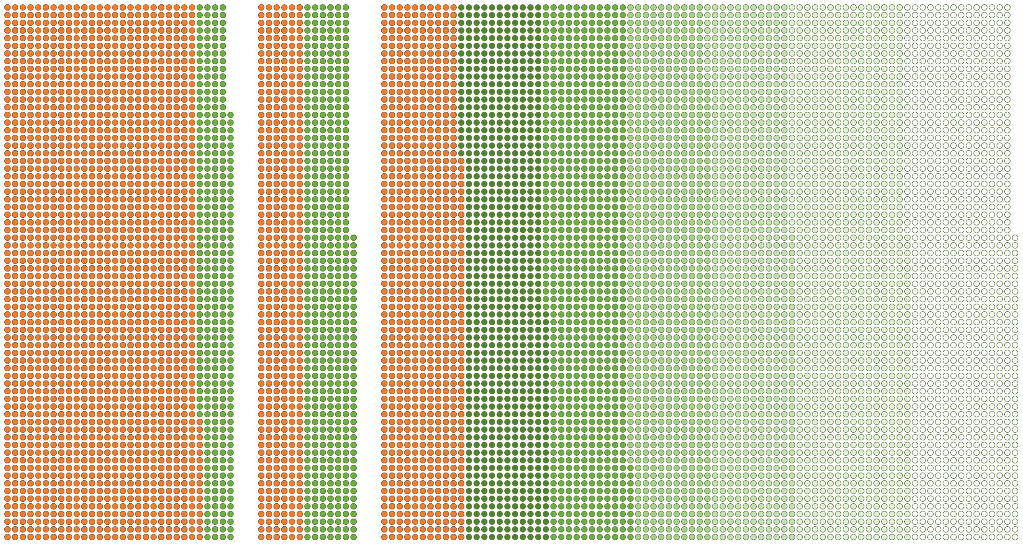

Rookie

A

Low-A

Advanced-A

Double-A

Triple-A

MLB

NFL

Scout Team

G-League

NBA