**EXP.1: Downloading and installing Hadoop, Understanding different Hadoop modes, Startup scripts, Configuration files.**

**AIM:**

To Download and install Hadoop, Understanding different Hadoop modes, Startup scripts, Configuration files.

**PROCEDURE:**

1. **Install Java 8:** Download Java 8 from the link: <http://www.oracle.com/technetwork/java/javase/downloads/jdk8-downloads-2133151.html>
   1. Set environmental variables:
      1. User variable:
         * Variable: JAVA_HOME
         * Value: C:/java
      2. System variable:
         * Variable: PATH
         * Value: C:/java/bin
   2. Check on cmd, see below:

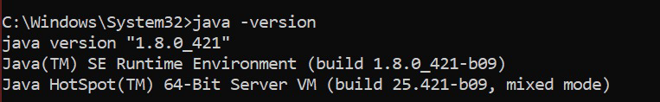

1. **Download Hadoop-2.7.0** : download Hadoop 2.7.0 from the link: [http://www.apache.org/dyn/closer.cgi/hadoop/common/hadoop-2.7.0/hadoop-2.7.0.tar.gz](http://www.apache.org/dyn/closer.cgi/hadoop/common/hadoop-3.3.6/hadoop-3.3.6.tar.gz)
   1. Put extracted Hadoop-2.7.0 files into C drive. Note that do not put these extracted files into C drive, where you installed your Windows.
   2. **Download “*hadoop-common-2.7.0-bin-master***” from the link: [https://github.com/amihalik/hadoop-common-2.7.0-bin/tree/master/bin](https://github.com/amihalik/hadoop-common-3.3.6-bin/tree/master/bin). You will see 11 files there. Paste all these files into the “bin” folder of Hadoop-2.7.0.
   3. Create a “data” folder inside Hadoop-2.7.0, and also create two more folders in the “data” folder as “data” and “name.”
   4. Create a folder to store temporary data during execution of a project, such as “D:/hadoop/temp.”
   5. Create a log folder, such as “D:/hadoop/userlog”
   6. Go to Hadoop-2.7.0 →etc → Hadoop and edit four files:
      1. core-site.xml
      2. hdfs-site.xml
      3. mapred-site.xml
      4. yarn-site.xml

**core-site.xml:**

<?xml version="1.0" encoding="UT F-8"?>

<?xml-stylesheet type="text/xsl" href="configuration.xsl"?>

<configuration>

<property>

<nam e>fs.defaultFS</nam e>

<value>hdfs://localhost:9000</value>

</property>

</configuration>

**hdfs-site.xml:**

<?xml version="1.0" encoding="UTF-8"?>

<?xml-stylesheet type="text/xsl" href="configuration.xsl"?>

<configuration>

<property>

<name>dfs.replication</name>

<value>1</value>

</property>

<property>

<name>dfs.namenode.name.dir</name>

<value>file:///C:/hadoop-2.7.0/data/namenode</value>

</property>

<property>

<name>dfs.datanode.data.dir</name>

<value>file:///C:/hadoop-2.7.0/data/datanode</value>

</property>

</configuration>

**mapred-site.xml:**

<?xml version="1.0"?>

<?xml-stylesheet type="text/xsl" href="configuration.xsl"?>

<configuration>

<property>

<name>mapreduce.framework.name</name>

<value>yarn</value>

</property>

</configuration>

**yarn-site.xml:**

<?xml version="1.0"?>

<configuration>

<property>

<name>yarn.nodemanager.aux-services</name>

<value>mapreduce_shuffle</value>

</property>

</configuration>

* 1. Go to the location: “Hadoop-2.7.0→etc→hadoop,” and edit “hadoop-env.cmd” by writing set JAVA_HOME=C:/java/jdk1.8.0_202
  2. Set environmental variables: Do: My computer → Properties → Advance system settings →

Advanced → Environmental variables

* + 1. User variables:
* Variable: HADOOP_HOME
* Value: C:/hadoop-2.7.0

1. System variable
   * Variable: Path
   * Value: C:/hadoop-2.7.0/bin

C:/hadoop-2.7.0/sbin

C:/hadoop-2.7.0/share/hadoop/common/*

C:/hadoop-2.7.0/share/hadoop/hdfs

C:/hadoop-2.7.0/share/hadoop/hdfs/lib/*

C:/hadoop-2.7.0/share/hadoop/hdfs/*

C:/hadoop-2.7.0/share/hadoop/yarn/lib/*

C:/hadoop-2.7.0/share/hadoop/yarn/*

C:/hadoop-2.7.0/share/hadoop/mapreduce/lib/* C:/hadoop-2.7.0/share/hadoop/mapreduce/*

C:/hadoop-2.7.0/share/hadoop/common/lib/*

1. Check on cmd; see below.

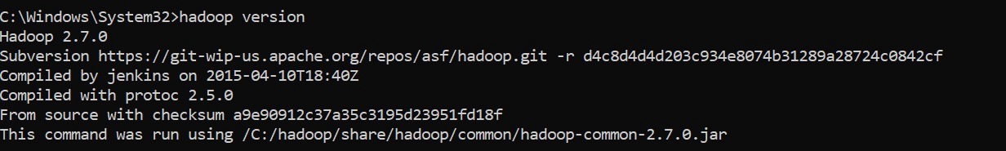

1. **Format name-node**: On cmd go to the location “Hadoop-2.6.0→bin” by writing on cmd “cd hadoop-2.6.0.\bin” and then “hdfs namenode –format”
2. Start Hadoop. Go to the location: “D:\hadoop-2.6.0\sbin.” Run the following files as administrator “start-all.cmd”.
3. Go to your web browser and search “localhost:9870” to access Hadoop NameNode. For Resource Manager, search “localhost:8088”.

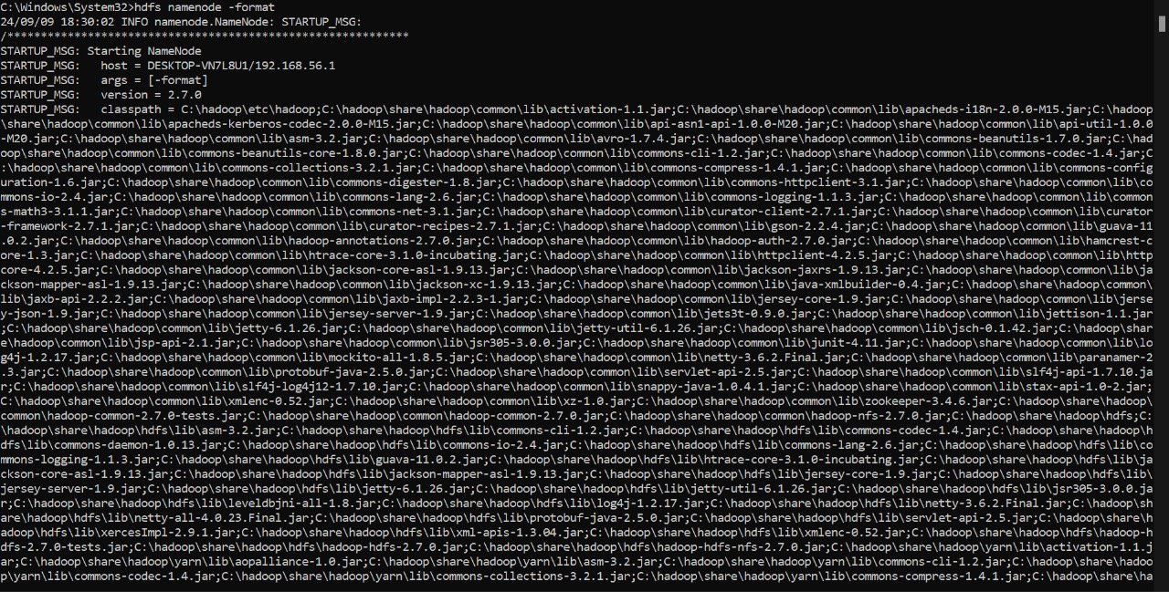

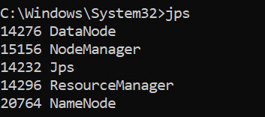

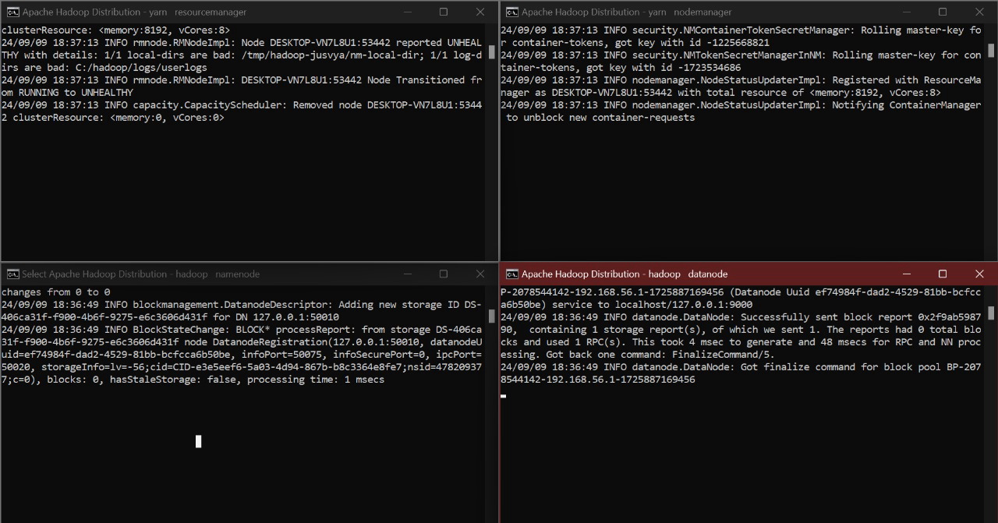

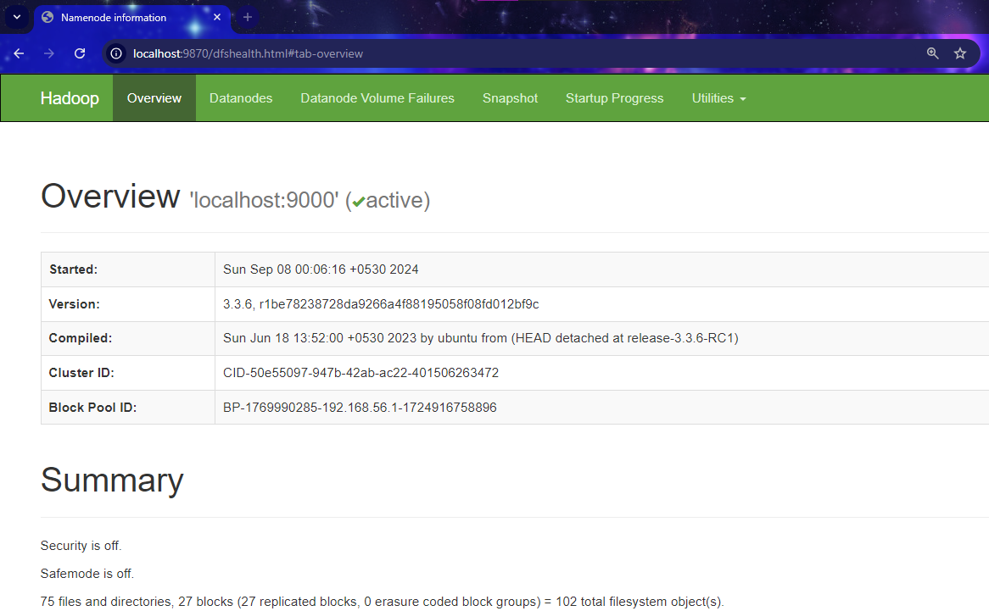

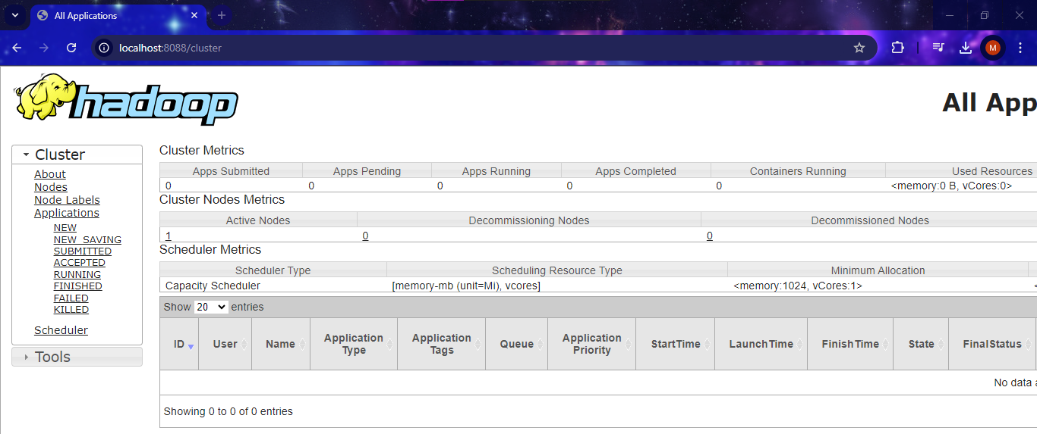

**RESULT:**

The step-by-step installation and configuration of Hadoop on Windows system have been successfully completed.