

**American International University-Bangladesh (AIUB)**

**Faculty of Science and Technology (FST)**

**Department of Computer Science (CS)**

**SDPM Group Project, Spring 2023**

**Project Title: eLearnify: Online Learning Management System**

**Section: D**

**Submitted by**

|  |  |
| --- | --- |
| Name | ID |
| Atunu Paul | 20-43227-1 |
| Jafrin Sultana Juthi | 20-43281-1 |

**1.0 Introduction:**

This document's goal is to serve as a project plan for creating an online learning management system (LMS). The project team, stakeholders, and anybody else involved in the creation and execution of the system are the target audience for this document. This document's purposes are to outline the project's scope, objectives, deliverables, and deadlines.

**2.0 Project Title:**

"eLearnify: Online Learning Management System."

**3.0 Objectives:**

The main goal of eLearnify is to offer an online platform for instructors, students, and educational institutions to support distance learning. The system's specific objectives are:

* To give teachers and students a user-friendly interface for managing and accessing course materials, assignments, tests, and grades.
* To give teachers the ability to design and administer courses, including adding course materials, creating tests and assignments, and controlling forums and announcements.
* To make it possible for students to submit assignments and exams, see course materials, register for courses, and monitor their progress.
* To make it easier for instructors and students to communicate through message boards, messaging, and email notifications.
* To produce statistics and reports on student participation, course progress, and system usage.

**4.0 Justification:**

In response to the COVID-19 pandemic, eLearnify was created to meet the rising demand for online education. The system will help educational organizations, teachers, and students by offering a convenient and adaptable platform for distance learning. Educational institutions may continue to offer students a high-quality education regardless of their location or schedule thanks to eLearnify. Students may access course materials and keep track of their progress from any location with an internet connection, while instructors can effortlessly develop and manage courses. Additionally, eLearnify will offer analytics and statistics to aid lecturers and educational institutions in tracking student participation and enhancing course outcomes.

**5.0 Systems Overview:**

eLearnify is an online learning management system designed to facilitate remote learning for educational institutions, instructors, and learners. The system consists of three main user types: administrators, instructors, and learners. Administrators are responsible for managing the overall system and user accounts. Instructors are responsible for creating and managing courses, while learners are responsible for registering for courses and accessing course materials.

**eLearnify includes the following features and functions:**

* User registration and login: Users can register for an account and login to the system.
* Course creation and management: Instructors can create and manage courses, including adding course content, setting up quizzes and assignments, and managing discussions and announcements.
* Course registration and access: Learners can register for courses, access course materials, submit assignments and quizzes, and track their progress.
* Communication tools: eLearnify includes discussion forums, messaging, and email notifications to facilitate communication between instructors and learners.
* Reports and analytics: The system generates reports and analytics on course progress, learner engagement, and overall system usage.
* System administration: Administrators can manage user accounts, system settings, and overall system performance.

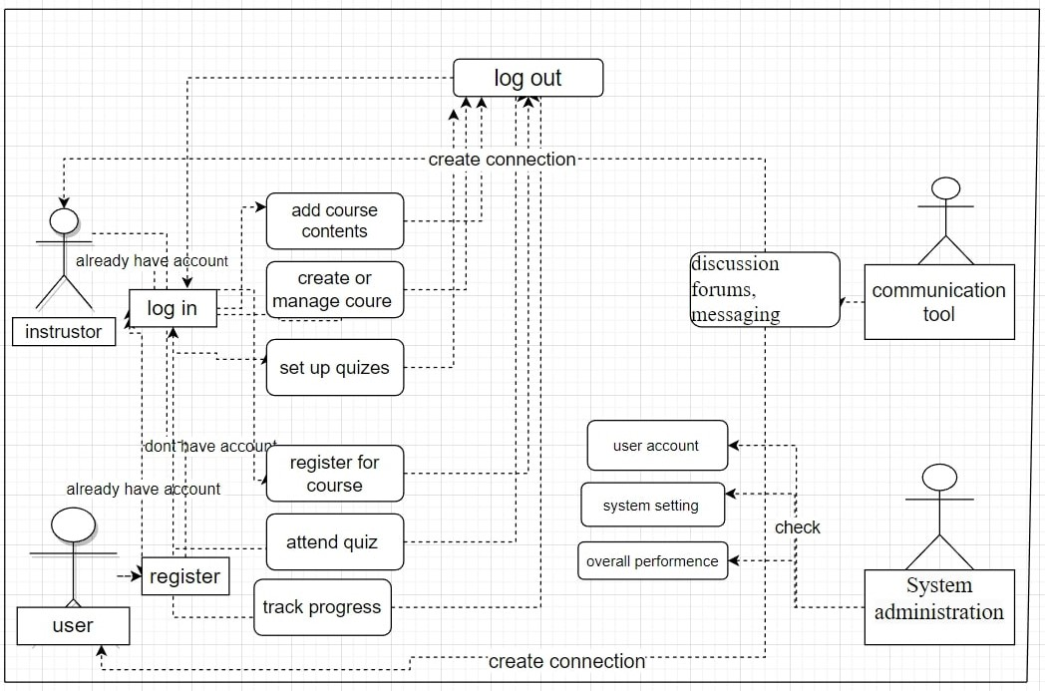

**Figure: Use case diagram**

**6.0 Stakeholder Analysis:**

**Internal stakeholders:**

1. Instructors (Positive): The people responsible for creating courses, teaching and grading.
2. Administrators (Positive): The individuals responsible for managing our platform like maintenance, costs, workers etc.
3. Course designers (Positive): The individuals who make the course fun and usable to all people with attractive graphical work.
4. Investors (Positive): The persons or organization who invest in eLearnify by looking at the possibility of financial approach.

**External stakeholders:**

1. Students (Positive): They will be the eLearnify platform's main users, accessing course materials, turning in assignments, and interacting with peers and instructors.
2. Educational institutions (Positive): Organizations who may work with eLearnify in partnership to offer their students online courses or to use the platform for professional development.
3. Parents/guardians (Positive): If there are students under 12 and currently under courses in eLearnify then they may be monitoring their assessments.
4. Employers (Positive): Employers who utilize eLearnify for corporate training or professional development may be stakeholders interested in monitoring their employees' progress and evaluating the program's efficacy.
5. Regulatory bodies (Negative): Regulatory organizations may need to make sure that the platform complies with particular requirements if eLearnify is used for courses that call for accreditation or certification.
6. Competitors (Negative): Other companies or organizations that offer similar online learning platforms.

**7.0 Feasibility Study:**

**Technical Feasibility:**

eLearnify's technical viability is essential to the project's success. The following elements must be considered to ensure technical viability:

1. Infrastructure: To guarantee that the eLearnify platform is accessible to students and teachers around-the-clock without downtime or sluggish performance, a strong infrastructure is needed. To ensure that the platform can handle huge levels of traffic, server hardware, cloud-based services, and a high-speed internet connection must all be used.
2. Software development: To build the platform, build and maintain the database, and guarantee the system runs smoothly, eLearnify will need a team of knowledgeable software professionals. To guarantee that the product is delivered on time and within budget, a project management framework like Agile approach should be employed.
3. Security: To safeguard students' personal information and instructional materials, eLearnify must put in place stringent security measures. To guarantee the security and integrity of the data, the platform must be constructed with encryption, multi-factor authentication, and access controls.

**Financial Feasibility:**

eLearnify's financial viability is essential in establishing whether the project can be carried out within the allocated budget. The following elements must be considered to maintain financial viability:

1. Funding: The eLearnify platform must have enough money to be developed and maintained. This comprises the price of the infrastructure, labor, software, and hardware.
2. Revenue sources: The platform may generate income by charging educational institutions for access or by charging students for certain courses or services. Sponsorships, marketing, and software licensing are further potential money sources.
3. ROI: The success of the eLearnify project depends in large part on return on investment. To make sure the project produces a profit, the estimated ROI should be assessed, and a business plan should be created.

**8.0 System Components:**

1. User Interface: This element oversees the system's visual interface and user-user communication. The eLearnify website, dashboard, and course pages are all included in its design.
2. Authentication and Security: This part is in charge of making sure that only authorized users can access the system and that it is secure. Access restriction, user authentication, and data encryption are all included.
3. Course Management oversees producing, revising, and archiving courses as well as managing the various courses that are made available on the platform. Manage course materials, assignments, and exams are also included in it.
4. Collaboration and Communication: This part is in charge of fostering interactions between students and teachers that promote communication and collaboration. It has functions including messaging, message boards, and video conferencing.
5. Content Management: This component is responsible for managing the different types of content available on the platform, including multimedia content such as videos, audio recordings, and images.
6. Reporting and Analytics: This part is in charge of giving information about how the system is used and how well the pupils are doing. It has attributes like dashboards, reports, and analytics.
7. System administration: This part oversees maintaining the system, which includes user administration, system backups, and software updates.
8. Mobile Support: In charge of making sure that the eLearnify platform is usable on mobile devices. It encompasses mobile device optimization, mobile app development, and responsive design.
9. Payment and Billing: This section is in charge of overseeing the platform's payment and billing procedures for students and educational institutions. It has functions including billing, subscription management, and payment gateways.
10. APIs and integration: This part oversees making it possible to integrate with other programs and systems. It incorporates webhooks, APIs, and connection with external programs like student information systems (SISs) and learning management systems (LMSs).

**9.0 Process model to be followed:**

**Agile Software Development Model**

A well-liked process paradigm for software development is the Agile software development model. It places a strong emphasis on incremental and iterative development, as well as regular feedback loops and ongoing improvement. The use of the Agile software development paradigm for creating the eLearnify system is justified as follows:

1. Flexibility: The Agile methodology is very adaptable and is simple to adjust. This is crucial for a system like eLearnify that may need frequent upgrades and modifications to meet the changing needs of its users.
2. Delivering software in tiny, testable chunks that stakeholders can examine and evaluate is a key component of the Agile paradigm. This guarantees that the system is constantly improving and fulfilling the needs of the users.
3. Collaboration: It is a key component of the Agile model between the development team, stakeholders, and end users. This guarantees that the system was developed with the requirements of the users in mind.
4. Rapid feedback loop: The Agile methodology fosters frequent user feedback, which helps the development team find and address problems fast. This guarantees that the system is advancing constantly and fulfilling the needs of the users.
5. Reduced Risk: Risk is decreased thanks to the Agile model's division of the development process into manageable chunks that can be tested and evaluated. As a result, the likelihood of a project failing is decreased because concerns are detected and dealt with early in the development process.

**10.0 Effort Estimation:**

The average KLOC (thousand lines of code) for completing the system is200.

We will use the COCOMO approach to determine the number of person-months required for the project.

We have,

Coefficient = 2.4 (as per organic project)

KLOC = 20,000

P = 1.05

PM = Coefficient (Effort Factor) X (KLOC/1000) ^ P

=2.4 X (50,000/1000) ^ 1.06

= 151.74 ~ 152 person months

According to Rational Unified Process:

|  |  |  |
| --- | --- | --- |
| **Task** | **Time (Days)** | **Person Month** |
| Requirement Analysis | 2 | 16 |
| Planning | 3 | 24 |
| Requirement Planning | 2 | 16 |
| System Design | 4 | 32 |
| Object Design | 1 | 8 |
| Unit Test | 5 | 40 |
| Integration & System Testing | 2 | 16 |

Every single engineer works = 8 Hours per day (5 Days per week)

The overall length of the project = 20 working days.

DM = 2.50 X (PM) ^T

= 2.50 X 152 ^ 0.4

= 14.5 months

Required number of people = PM/DM

= 152/14.5

= 10.48 ~ 10 peoples

The project's estimated total cost is:

* 152 person months are needed to complete it;
* 14.5 months are needed for development;
* 10 individuals needed overall.

**11.0 Activity Diagram:**

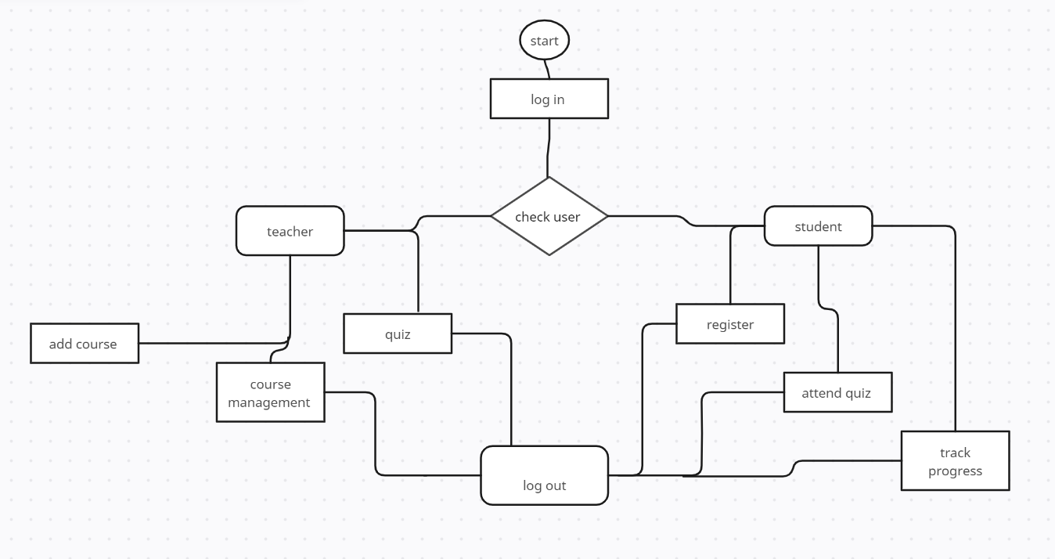

**12.0 Risk Analysis:**

|  |  |  |  |  |
| --- | --- | --- | --- | --- |
| **Risks** | **Probability** | **Impact** | **Rating** | **RMMM** |
| Technical challenges | 20% | 3 | Medium | R-1 |
| Compatibility issues | 30 | 4 | low | R-2 |
| System crash | 50% | 1 | high | R-3 |
| Budget constraints | 40% | 4 | Low | R-4 |
| Budget constraints | 30% | 3 | Medium | R-5 |
| Late delivery | 50% | 3 | Medium | R-6 |
| User adoption challenges: | 30% | 4 | Low | R-7 |

**13.0 Budget for the project:**

Website launch (hosting) = 15,000 BDT

Laptop/Computer = 50,000 BDT

Office Rent = 25,000 BDT

Maintenance cost (1 year) = 30,000BDT

Developers fee = 2,00,000 BDT

Total cost is = 3, 20,000 BDT