

American International University-Bangladesh (AIUB)  
**Department of Computer Science  
Faculty of Science & Technology (FST)**

**Centralized Medical Application**

A Software Requirement Engineering Project Submitted

By

|  |  |  |  |  |
| --- | --- | --- | --- | --- |
| **Semester: Spring_22_23** | | **Section:** | **Group Number:** | |
| SN | Student Name | Student ID | Contribution (CO1+CO2) | Individual Marks |
| 19 | Abu Shaleh Md. Kaium | 20-42475-1 |  |  |
| 25 | Thouhida Tasnim | 20-43051-1 |  |  |
| 28 | Shariar Nihal | 20-43220-1 |  |  |
| 29 | Jafrin Sultana Juthi | 20-43281-1 |  |  |

The project will be Evaluated for the following Course Outcomes

|  |  |  |
| --- | --- | --- |
| Evaluation Criteria | Total Marks (50) | |
|  | |
| Revision History, Test Plan Identifier, Reference Materials, Problem Background, Solutions | [10 Marks] |  |
| Requirements Specification (System feature, Quality Attributes, System Interface, Project Requirements) | [10 Marks] |  |
| Item Not to be tested, Testing approach (Testing levels, tools, meetings), Test cases | [10 Marks] |  |
| Item pass/fail criteria, Test deliverables, Staffing and Training, Responsibilities, Scheduling, Risk | [10 Marks] |  |
| Approval, Format, Submission, and Defense | [10 Marks] |  |

Software Test Plan

for

Centralized Medical Application

Version 2.0 approved

Prepared by

Abu Shaleh Md. Kaium

Thouhida Tasnim

Shariar Nihal

Atunu Paul

Organization: Rise up Tech Ltd.

Date

29-04-2023

Table of Contents

Revision History 3

1. TEST PLAN IDENTIFIER: AT-TP01.3 4

2. REFERENCES 4

3. INTRODUCTION 4

3.1 Background to the Problem 4

3.2 Solution to the Problem 4

4. REQUEIREMNT SPECIFICATION 4

4.1 System Features 4

4.2 System Quality Attributes 5

4.3 System Interface 5

4.4 Project Requirements 5

5. FEATURES NOT TO BE TESTED 5

6. TESTING APPROACH 5

6.1 Testing Levels 5

6.2 Test Tools 6

6.3 Meetings 6

7. TEST CASES/TEST ITEMS 7

8. ITEM PASS/FAIL CRITERIA 7

9. TEST DELIVERABLES 7

10. STAFFING AND TRAINING NEEDS 8

11. RESPONSIBILITIES 8

12. TESTING SCHEDULE 8

13. PLANNING RISKS AND CONTINGENCIES 9

14. APROVALS 9

# Revision History

|  |  |  |  |
| --- | --- | --- | --- |
| Revision | Date | Updated by | Update Comments |
| 0.1 | 2023.02.01 | Thouhida Tasnim | First Draft [Update solution of problem] |
| 0.2 | 2023.02.30 | Abu Shaleh Md. Kaium | Second Draft [Update system features] |
| 0.3 | 2023.03.15 | Atunu Paul | Third Draft [Update UI/UX design] |
| 0.4 | 2023.03.27 | Shariar Nihal | Fourth Draft [Update Testing Level] |
| 0.5 | 2023.04.10 | Thouhida Tasnim | Fifth Draft [Update Test Case] |
| 0.6 | 2023.04.18 | Abu Shaleh Md. Kaium | Final Draft [Revised full document and finalized] |

# TEST PLAN IDENTIFIER: CMA-001T

# REFERENCES

1. System Design Document (SDD)
2. User Manual
3. Test Strategy Document
4. Defect Report

# INTRODUCTION

## Background to the Problem

## Every citizen must go to the doctor lots of times throughout their lifetime. Also, scheduling an appointment to see the doctor and have the tests done takes a lot of time and presents difficulties for a variety of reasons. The citizen must manually make an appointment and then wait a long time for his meeting time. When a patient visits a doctor and the doctor prescribes him medicines or a test, the information is kept on hard paper that is easily lost or damaged. And the result of this is that we must go back to the doctor or have the subsequent tests done again, which is costly and time-consuming. These difficulties can be removed simultaneously by a digital web-based solution, which will save time and money.

## Solution to the Problem

People frequently struggle with the decision of whether or not to go to the hospital when they consider the inconvenience of seeing a doctor. Today, getting a serial in a government hospital is significantly more challenging. More than an hour must be spent waiting in line. Then, after receiving the serial, some people engage in political maneuvering to meet the doctor early. Again, taking tests and other tasks are challenging. Also, the sufferer will endure great suffering if they lose their previous paperwork. Sometimes, doctors and hospital administrators overcharge patients for prescriptions, medications, procedures, etc. These problems can be solved by standardizing these rates. At that time, they go for a test and consult with the doctor.

These problems can be carefully resolved by a web-based application. It will help people do their tasks more quickly and reduce their worry of getting health care. At the same time, it will also decrease discrimination regarding the cost of medical care, scheduling appointments with physicians, etc. The existing paper-based process takes a long time, causes a lot of issues, and causes citizens to be treated differently depending on their needs. The web-based solution will get rid of all the hassles and give people an effective means to get the care they need. Citizens will be able to use this method to diagnose mild illnesses without seeing a doctor. With the help of this system, discrimination between social classes will be eliminated, and everyone will receive equal treatment.

There are a few independent applications, including DIMS, DocTime, Arogga, SeekMed, and others. Each of them has unique qualities and was created to fulfill particular requirements. Also, they provide some unique features and offers, but these are insufficient to address these problems. We require a health application that will be created to address each of the issues mentioned.

# REQUEIREMNT SPECIFICATION

## System Features

**1.User Registration:**

**Functional Requirements:**

* 1. User needs to register in this system first by giving a valid email address or phone number

and password.

1.2 A user also needs to provide valid information to get the right suggestions from the system.

1.3 The user must verify their email or phone number to complete the registration.

1.4 The user can add previous medical history (if any).

**Priority Level:** High

**Precondition:** User have valid NID card and phone number.

**Cross reference:** N/A

**2. Doctor Appointment**

**Functional Requirements:**

2.1 The system will recommend a doctor to the user based on their specific diseases.

2.2Additionally, a user can search for doctors manually by name.

2.3 The user will then be able to view the doctor's name, degree, specialty, and

Qualifications and appointment time.

2.4 The user may book an appointment with any doctor by clicking "Book" next to the

doctor name.

2.5 The user can also find information about hospitals and their doctors on this site.

**Priority Level:** High

**Precondition:** user must log in with valid id and password.

**Cross reference**: 1.1, 1.2, 1.3, 1.4,4.1,4.2,4.3,4.4

**3.Doctor’s View:**

**Functional Requirements:**

3.1 Can view patient list who are requested for appointment.

3.2 Can check patient’s old medical history and reports.

* 1. Can communicate with patients if necessary.

**Priority Level:** Medium

**Precondition:** user must log in with valid id and password.

**Cross reference**: 1.1, 1.2, 1.3, 1.4, 2.3, 2.4, 2.5

1. **Disease Prediction**

**Functional Requirements:**

**4.1** Disease prediction requires inputs from the user, such as blood pressure and pulse.

**4.2** The user must select the checkbox next to the disease symptoms.

**4.3** The user is required to fill out the 'Duration' and 'Disease State' columns for any

symptoms for which the checkbox has been selected.

**4.4** The user must then select "Submit" for disease prediction, after which doctors will be

suggested based on the disease prediction.

**Priority Level:** Medium

**Precondition:** The user must accurately enter all required information.

**Cross-reference:** 2.3, 2.4, 2.5

1. **Custom Exercise Guide to Patients**

**Functional Requirements:**

5.1 In this option, a doctor may advise the patient to engage in physical activity.

5.2 The doctor can provide the patient with the necessary documents or videos.

5.3 Patients can download or verify the available documents and videos.

5.4 Additionally, the user can communicate with the doctor in real-time via live

chatting, and the doctor is able to monitor the patient's progress.

**Priority Level:** Medium

**Precondition:** The user must log in with their valid email and password and must have

doctor’s consultation subscription.

**Cross-reference:** 1.4, 2.3, 2.4, 2.5,4.1,4.3

## System Quality Attributes

**QA 1- Availability:** The system must be 97% available during 8 p.m. to 8 a.m. hours and 99% available between the hours of 8 a.m. and 8 p.m. local time.

**Priority Level:** High

**Precondition:** The users must have enough internet connection.

**Cross-reference:** N/A

**QA 2- Testability:** Software must have the ability to recognize when a system is in danger of failing. There shouldn't be any cyclomatic complexity greater than 15.

**Priority Level:** High

**Precondition:** N/A

**Cross-reference:** QA1**,** QA-4, QA-5

**QA 3- Portability**: The web-based platform shall be used to run the system. Using a web browser on any device, the user can access the system.

**Priority Level:** Medium

**Precondition:** N/A

**Cross-reference:** QA-2, QA-4, QA-5

**QA 4 – Maintainability:** It shouldn't take more than two hours for a maintenance programmer to make changes to an existing form. Any system problem must be fixed effectively by the maintenance programmers in less than three hours of manual effort.

**Priority Level:** High

**Precondition:** The system should detect any errors.

**Cross-reference:** QA-1, QA-2, QA-5

**QA 5–Flexibility:**The operation of this system will be easy and straightforward. If anything has to be added or updated, a maintenance programmer may work on the software and generate a new version, including code modifications and testing, in less than 3-4 hours of labor.

**Priority Level:** High

**Precondition:** System should identify an error.

**Cross-reference:** QA-2, QA-3

**QA 6-Performance:** The system must be able to handle a large number of concurrent users without performance issues, with an average response time of two seconds and at least 1000 simultaneous users without crashing or slowing down.

**Priority Level:** High

**Precondition:** Thesystem must be functional and stable, with all components integrated.

**Cross Reference:** N/A

**QA 7**-**Efficiency:** The system should be designed to use resources efficiently and quickly to ensure an optimal user experience. It should be able to handle a large number of simultaneous users without slowing down or crashing. Performance metrics should be measured and optimized regularly to ensure peak efficiency.

**Priority Level:** High

**Precondition:** All of the parts of the system have to work together smoothly and reliably.

**Cross-reference:** QA-1, QA-2, QA-3, QA-5.

**QA 8- Security:** The system should have a well-defined authorization system to control user access to various system resources and restrict access to sensitive information.

**Priority Level:** High

**Precondition:** The system must have an effective authentication mechanism and well-defined user classifications and access levels.

**Cross-reference:** N/A

**QA 9- Reliability:** The system must be reliable, meaning that it should perform its functions correctly and consistently. It must be able to handle errors, prevent data loss, and recover quickly from any failure. The system must have a meantime between failures of at least 10,000 hours, and the meantime to repair must not exceed four hours.

**Priority Level:** High

**Precondition:** The system must be designed with redundancy and fault tolerance mechanisms in place.

**Cross-reference:** QA1, QA2, QA4, QA5, QA6, QA7

**QA 10- Usability:** The system must have a simple and understandable user interface. It needs to be simple to use, provide helpful feedback when something goes wrong, and be accessible to people with different abilities. Standardized usability testing requires a system usability score of 80% or above.

**Priority:** High

**Precondition:** The system must be fully functional, with all features implemented and tested.

**Cross reference:** QA-1, QA-3, QA-5

**QA 11- Reusability:** The system should be built so that its parts can be simply reused and incorporated into other programmers. For maximum reusability, the system should be developed using common practices in the field, such as object-oriented design and the separation of concerns.

**Priority:** Medium

**Precondition:** The system must have a clear and well-documented architecture with standardized APIs and data formats.

**Cross reference:** QA-2, QA-4, QA-5

**QA 12- Interoperability:** The system must be compatible with common data formats and protocols so that it can share information with other applications. Data import/export functionality and compatibility with other widely used applications and platforms are essential features.

**Priority:** Medium

**Precondition:** The system must have a well-defined data model and API, with clear documentation and support for standard data formats.

**Cross reference:** QA-3, QA-4, QA-5, QA-11

## System Interface

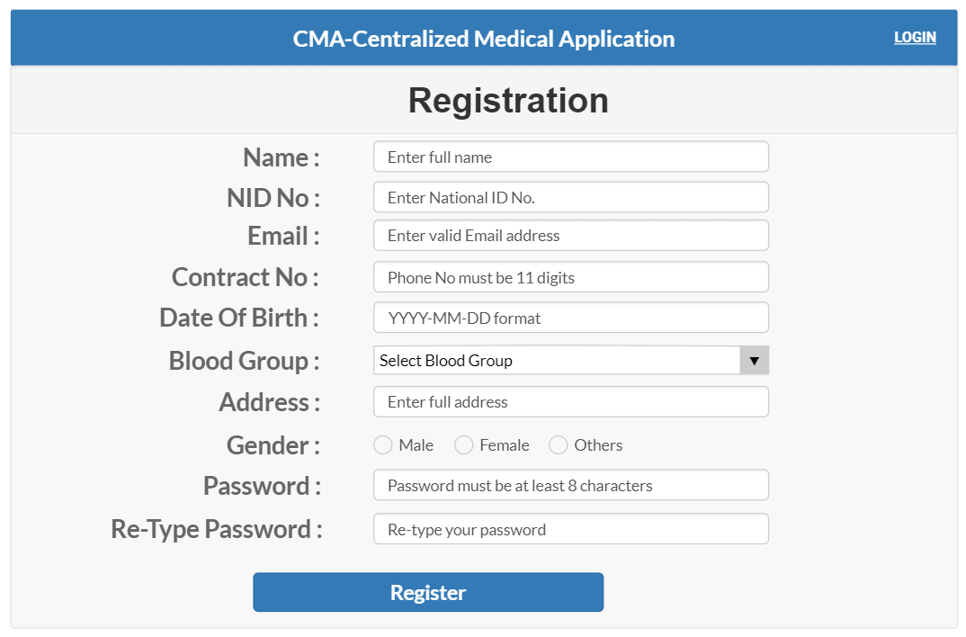**UI/UX design:**

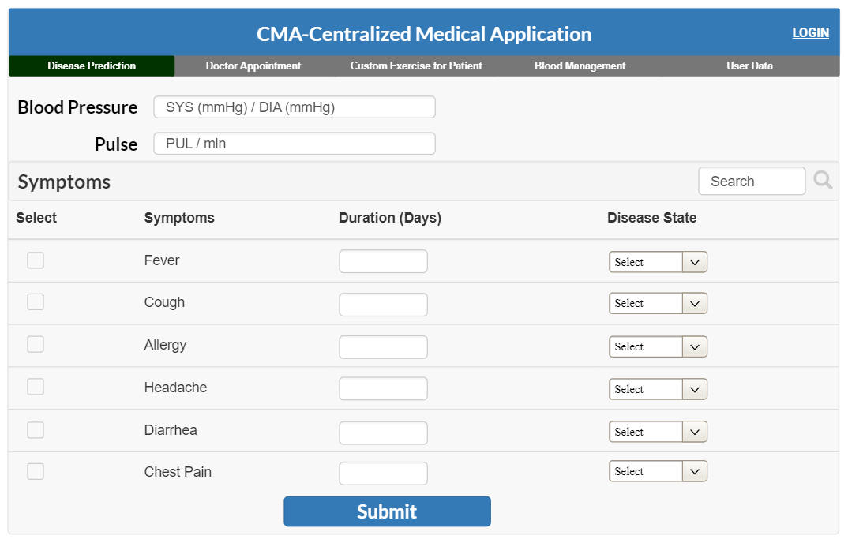

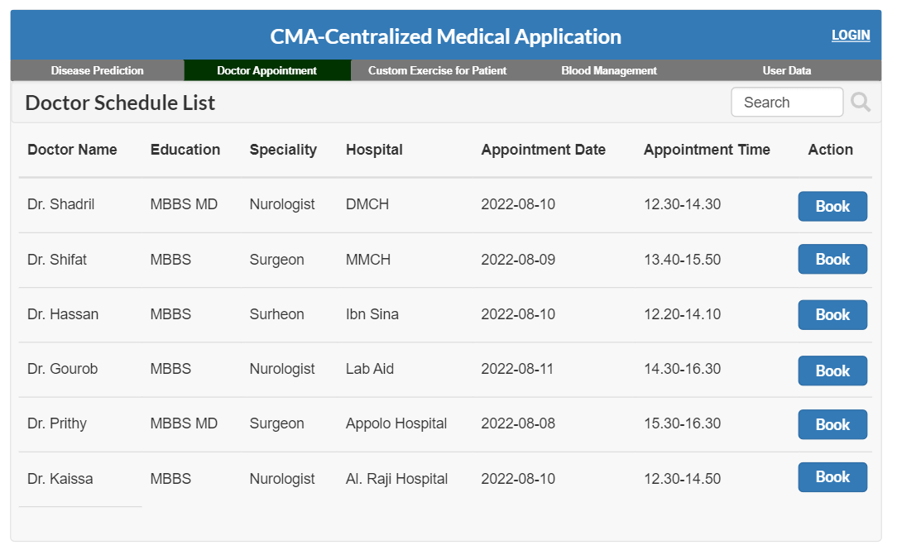

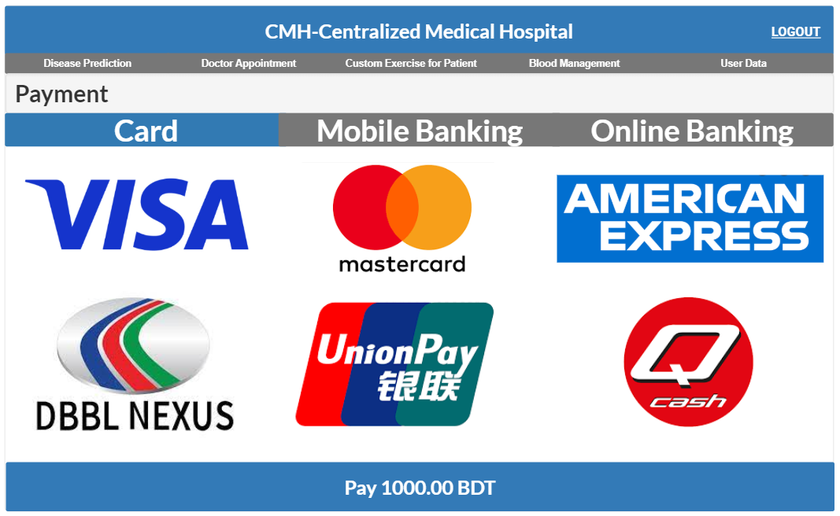

## 

## Project Requirements

**Time:**

Constructive Cost Model:

* Project type : Organic (Basic COCOMO Model)
* Coefficient<effort factor>  : 2.40 [P=1.05, T=0.38]
* SLOC :10000 Lines
* Effort : (2.40* 101.05) = 26.93
* Dev. time, DM : (2.50* 26.930.38) = 8.74 = 9 Months = 2160 WH

**Budget:**

Required People, ST: Effort/DM = 26.93/8.74 = 3.80 = 4

Developer & Tester Salary in 9 months:

Per Developer salary Per working Hour = 700 Taka

Total Developer salary = 700*2160 = 15,12000 Taka

Requirement Analysis:

Time Needed: 5 weeks (25 working days = (25*12) =300 WH)

Req Analyst Person’s Hourly wage = 300 Taka

Total Req. Analyst salary = 300*300= 90,000 Taka

Resource Expense Estimation: 100000 Taka

Rent Expense:

Office space per Month = 50,000 Taka

Total in 9 Months = 450,000 Taka

Total Utilities in 9 Months (including miscellaneous): 20,000 Taka

Maintenance (Till 2 years after Delivery):

Expense per Hour: 1000 Taka

Total Estimated Time needed for Maintenance 2400 Hours

Total Estimated Maintenance Expense = 2400*1000 = 2400,000 Taka

Advertisement Marketing Cost (Annual) :

Package that includes a total of 30 minutes advertisement 3,00,000Taka

Social Media Sponsored Post:

Facebook/Instagram sponsored post cost per month 25,000Taka

Sponsored post cost in 9 months = 25,000 * 8 = 225,000/-

Total Estimated Expense:

1512000 + 90000 + 100000 + 450,000 + 20,000 + 2400,000 + 300,000 + 225,000 = 50,97,000Taka

Profit:

Reverse Expense = 15%*50,97,000 = 764,550 Taka

**Project Budget:**

50,97000 + 764,550 = **58,61,550 Taka**

**Resources:**

|  |  |  |
| --- | --- | --- |
| **Hardware/Software** | **Resources** | **Quantity** |
| Hardware | Server | 2x rack-mounted servers |
| Hardware | Workstations | 10x desktop computers, 2x laptops |
| Hardware | Network equipment | 1x router, 2x switches, 1x firewall |
| Hardware | Printers | 1x laser printers, 1x inkjet printer |
| Software | Operating system | 10x Windows 10 licenses, 2x Linux licenses |
| Software | Database | 1x MySQL database |
| Software | Web servers | 2x Apache web servers |
| Software | Development tools | 5x Visual Studio licenses |
| Software | Testing tools | 1x Selenium, 1x Postman, 1x LoadRunner, 1x Visual Studio Test Professional |

**Environment:**

**Development environment:** Software developers use a development environment as a tool to create, test, and debug new software prior to its release.

**Testing environments:** They should be similar to the production environment, but with reduced data volumes to avoid impacting the production environment. Examples include testing new software releases before they are deployed to production.

**Production environments:** They must be stable and reliable to protect end-users and the business, as any issues could lead to lost revenue and damage.

# FEATURES NOT TO BE TESTED

# Notification: When a patient request for appointment or a doctor accept appointments, Notification goes to their account. These features are not much important. So, this feature are not need to test right that version.

# Custom exercise for patient: Here, a user can see about heath related advice. Since that feature is not much important , so it’s not necessary for testing.

# TESTING APPROACH

## Testing Levels

## ● Unit Testing: Our project now still in the implementation phase so we assume that we will do the Unit Testing during our system development. In this testing we will tests individual software modules and see whether the individual system module has error or not. This testing methodology is done by the software developers and QA staff. This testing goal is to ensure that each unit of software code works as intended. In this step, we will follow “White Box Testing” technique.

● **Integration Testing:** Our project now still in the implementation phase so we assume

that in this integration testing we will make sure that all the software modules are

integrated logically and tested as a group and working correctly. The goal of this level

of testing is to find flaws in the way various software modules interact when they're

integrated. In this step, we will follow the “Bottom-up Integration” technique.

● **System Testing:** Our project now still in the implementation phase so we assume that

through the system testing we will test of full-featured, fully integrated system. Then

we will verify if it meets all the requirement. Black-box testing falls under this

condition. So, in this level, we will follow “Black Box Testing” technique.

● **Acceptance Testing:** Our project now still in the implementation phase so we assume

that we will do this acceptance testing for checking the acceptability of our product.

This test will be done to check whether any defect missed during the functional

testing phase. In this level, we will follow the “Black Box Testing” technique. After

that, we may run unit tests again.

## Test Tools

**Selenium:** It is an open-source tool that is used for automating web browsers. It allows a tester to write tests in various programming languages and run them on multiple browsers.

**Postman:** It is an API testing tool that is used for testing RESTful APIs. It allows a tester to test APIs without writing any code.

**LoadRunner:** It is a performance testing tool that is used to test the performance and scalability of applications.

**Visual Studio Test Professional:** It is a testing tool that is used for manual and automated testing of applications developed using Microsoft technologies.

**6.3 Meetings**

We will meet once after every one or two days through MS Teams to evaluate progress to date

and to identify error trends and problems as early as possible. Our test team leader will meet with

development and the project manager once after every two days as well. These two meetings will

be scheduled on different days. Additional meetings can be called as required for emergency

situations.

# TEST CASES/TEST ITEMS

|  |  |  |  |  |  |
| --- | --- | --- | --- | --- | --- |
| Project Name: Centralized Medical Application -CMA | | | Test Designed by: Abu Shaleh Md. Kaium | | |
| Test Case ID: FR_1 | | | Test Designed date: 19-Apr-2023 | | |
| Test Priority : High | | | Test Executed by: | | |
| Module Name: User Registration | | | Test Execution date: | | |
| Test Title: Registration with valid phone number/NID number | | | | | |
| Description: Test website login page. | | | | | |
| Precondition: The user must have a registered account. | | | | | |
| Test Steps | Test Data | Expected Results | | Actual Results | Status (Pass/Fail) |
| 1. Go to the  website  2. Enter a  valid information which is required for registered.  3. Click submit | Username: kaium985  Phone number: 01755555555  Password: jdh34@j  Blood group: B+  Address: Dhaka  Date of birth: 20-04-1995 | Create a new user id if phone number/NID is unique. | | As  Expected. | Pass |
| Post Condition: The user account has been successfully registered with the provided information and is now accessible for login to the CMA system. | | | | | |

|  |  |  |  |  |
| --- | --- | --- | --- | --- |
| Project Name: Centralized Medical Application -CMA | | | Test Designed by: Abu Shaleh Md. Kaium | |
| Test Case ID: FR_2 | | | Test Designed date: 19-Apr-2023 | |
| Test Priority : High | | | Test Executed by: | |
| Module Name: Login Session | | | Test Execution date: | |
| Test Title: Verify login with valid username and password | | | | |
| Description: Test website login page. | | | | |
| Precondition: The user must have a registered account. | | | | |
| Test Steps | Test Data | Expected Results | Actual Results | Status (Pass/Fail) |
| 1. Go to the  website  2. Enter a  username  3. Enter the  password  4. Click submit | Username:  02020202  Password: 321 | Users should log in to  the application | As  Expected. | Pass |
| Post Condition: The user is validated with the database and successfully logs in to the account. The account session details are logged in the database. | | | | |

|  |  |  |  |  |
| --- | --- | --- | --- | --- |
| Project Name: Centralized Medical Application -CMA | Test Designed by: Abu Shaleh Md. Kaium | | | |
| Test Case ID: FR_3 | Test Designed date: 19-Apr-2023 | | | |
| Test Priority : Medium | Test Executed by: | | | |
| Module Name: Disease prediction | Test Execution date: | | | |
| Test Title: Verify diseases prediction by suggesting doctor. | | | | |
| Description: Test website disease prediction page. | | | | |
| Precondition: The user must accurately enter all required information in the disease prediction page. | | | | |
| Test Steps | Test Data | Expected Results | Actual Results | Status (Pass/Fail) |
| 1. Go to the diseases   prediction option.   1. Enter Blood pressure and pulse. 2. Check option of symptoms. 3. Enter duration days. 4. Enter disease state.   Click on submit. | Blood pressure:120/80  Pulse: 70  Symptoms: Check Fever  Duration: 7  Disease state: High | The interface should suggest some doctors for that disease. | As  Expected. | Pass |
| Post condition: User’s must need to log in with their valid ID and Password. | | | | |

|  |  |  |  |  |  |
| --- | --- | --- | --- | --- | --- |
| Project Name: Centralized Medical Application - CMA | | | Test Designed by: Thouhida Tasnim | | |
| Test Case ID: FR_4 | | | Test Designed date: 19-Apr-2023 | | |
| Test Priority: High | | | Test Executed by: | | |
| Module Name: Blood Management | | | Test Execution date: | | |
| Test Title: Verify Blood Management | | | | | |
| Description: Test web Blood Management | | | | | |
| Precondition: The user needs to log in to the system | | | | | |
| Test Steps | Test Data | Expected Results | | Actual Results | Status (Pass/Fail) |
| 1. Navigate to the website and login using valid credentials. 2. Click on the "Blood Management" tab in the menu. 3. Click on search box. 4. Give desired blood group and location. 5. Click on action button. | Username: "Piash@123" Password: "123@iL".  Blood group type: "O-".  Location: "Dhaka".  Action: Click on action button. | The system should display a list of relevant blood donors based on the entered location and blood group. The displayed information should be accurate, and the contact information of the selected donor should be correct. | | As  Expected. | Pass |
| Post Condition: The system should display a list of relevant blood donors based on the entered location and blood group. | | | | | |

|  |  |  |  |  |
| --- | --- | --- | --- | --- |
| Project Name: Centralized Medical Application - CMA | | Test Designed by: Abu Shaleh Md. Kaium | | |
| Test Case ID: FR_5 | | Test Designed date: 19-Apr-2023 | | |
| Test Priority: High | | Test Executed by: | | |
| Module Name: Doctor Appointment | | Test Execution date: | | |
| Test Title: Verify Doctor Appointment | | | | |
| Description: Test web Doctor Appointment | | | | |
| Precondition: The user needs to log in to the system. | | | | |
| Test Steps | Test Data | Expected Results | Actual Results | Status (Pass/Fail) |
| 1. Go to website and click on doctor appointment.  2. Click on search option.  3. Type a doctor’s name or select from suggested doctors list.  4. Check doctors name, specialty, appointment date, hospital name, available time.  5. Click on book option. | **For search option-**  Doctor’s name: Dr. Shadril.  Specialty : Neurologist  Action: **Click on Book** | Go to payment option successfully. | As  Expected. | Pass |
| Post Condition: This user's time slot will be reserved on database. | | | | |

|  |  |  |  |  |
| --- | --- | --- | --- | --- |
| Project Name: Centralized Medical Application - CMA | | | Test Designed by: Abu Shaleh Md. Kaium | |
| Test Case ID: NFR_1 | | | Test Designed date: 06-Aug-22 | |
| Test Priority: High | | | Test Executed by: | |
| Module Name: Maintainability | | | Test Execution date: | |
| Test Title: Verify the responsiveness of System to solve problem within 3 hours | | | | |
| Description: Test if system can solve the problem within 3 hours. | | | | |
| Precondition: User must Login with valid username and password. | | | | |
| Test Steps | Test Data | Expected Results | Actual Results | Status (Pass/Fail) |
| 1.Go to the application and login.  2.Click on Doctor’s appointment.  3. click on Book for taking appointment of a doctor. | **For search option-**  Doctor’s name: Dr. Shadril  Specialty: Neurologist.  Action: **Click on Book** | Doctor’s appointment problem should be solved within 2 hours or less. | As  Expected. | Pass |
| Postcondition: N/A | | | | |

|  |  |  |  |  |
| --- | --- | --- | --- | --- |
| Project Name: Centralized Medical Application- CMA | | | Test Designed by: Abu Shaleh Md. Kaium | |
| Test Case ID: NFR_2 | | | Test Designed date: 06-Apr-2022 | |
| Test Priority: High | | | Test Executed by: | |
| Module Name: Availability | | | Test Execution date: | |
| Test Title: Verify the availability of the system | | | | |
| Description: Test the availability of the system between 8:00 a.m. to 8:00 p.m. | | | | |
| Precondition: User must login to the system | | | | |
| Test Steps | Test Data | Expected Results | Actual Results | Status (Pass/Fail) |
| 1. Go to the website and click on disease prediction. 2. Use the system from 8:00 a.m. to 8:00 p.m. For 10000 times with automated software. | **Blood pressure:**120/80mmHg  **Pulse:** 70  **Symptoms:** Fever  **Duration:** 7  **Disease state:** Medium | The system must be 99% available between 8.00 a.m. and 8:00 p.m. local time | As  Expected. | Pass |
| Post Condition: The system should be able to handle 10000 requests from the automated software without any downtime or performance issues. | | | | |

|  |  |  |  |  |
| --- | --- | --- | --- | --- |
| Project Name: Centralized Medical Application - CMA | | | Test Designed by: Thouhida Tasnim | |
| Test Case ID: NFR_3 | | | Test Designed date: 27-Apr-23 | |
| Test Priority: High | | | Test Executed by: | |
| Module Name: Usability | | | Test Execution date: | |
| Test Title: Verify the usability of the CMA application | | | | |
| Description: Test the usability of the CMA application to ensure that users can perform tasks efficiently and effectively | | | | |
| Precondition: User must be logged in to the CMA application. | | | | |
| Test Steps | Test Data | Expected Results | Actual Results | Status (Pass/Fail) |
| 1.Login to the CMA application and look for “Find a doctor” feature  2.Search for doctor by entering a valid specialty or name and verify the result  3. Select doctor and book an appointment and verify booking process  4.Logout from the CMA application | UserId: Thouhida  Password: 1234  **For search option-**  Doctor’s name: Dr. Authoi  Specialty: Neurologist.  Action: **Click on Book** | The login process should be quick and easy, the "Find a Doctor" feature should be prominently displayed, the search functionality should be accurate, and the booking process should be straightforward and intuitive. | As  Expected. | Pass |
| Postcondition: N/A | | | | |

|  |  |  |  |  |
| --- | --- | --- | --- | --- |
| Project Name: Centralized Medical Application - CMA | | | Test Designed by: Thouhida Tasnim | |
| Test Case ID: NFR_4 | | | Test Designed date: 27-Apr-23 | |
| Test Priority: High | | | Test Executed by: | |
| Module Name: Portability | | | Test Execution date: | |
| Test Title: Verify the portability of the CMA application | | | | |
| Description: Test the portability of the CMA application to ensure that it can be run on different platforms and environments | | | | |
| Precondition: N/A | | | | |
| Test Steps | Test Data | Expected Results | Actual Results | Status (Pass/Fail) |
| 1.Install the CMA application on windows 10, launch the application and verify that it runs without any error.  2. Install the CMA application on Android phone, launch the application and verify that it runs without any error.  3. Install the CMA application on iOS phone, launch the application and verify that it runs without any error. | N/A | The CMA application should be installed successfully on Windows 10, Android, and iOS phones to launch without errors. It should also be installed successfully on an iOS phone to launch without errors. | As  Expected. | Pass |
| Postcondition: N/A | | | | |

|  |  |  |  |  |
| --- | --- | --- | --- | --- |
| Project Name: Centralized Medical Application - CMA | | | Test Designed by: Thouhida Tasnim | |
| Test Case ID: NFR_5 | | | Test Designed date: 27-Apr-23 | |
| Test Priority: High | | | Test Executed by: | |
| Module Name: Testability | | | Test Execution date: | |
| Test Title: Verify the testability of the CMA application | | | | |
| Description: Test the testability of the CMA application to ensure that users can perform tasks efficiently and effectively | | | | |
| Precondition: User must be logged in to the CMA application. | | | | |
| Test Steps | Test Data | Expected Results | Actual Results | Status (Pass/Fail) |
| 1.Review the requirements documentation and identify the functional and non-functional requirements that have been specified.  2.Identify the test cases that have been developed for the CMA application. 3. Review the test results to identify any defects or issues that were identified during testing. | N/A | The requirements should be clear and complete, well defined, should provide actual information to guide the testing process and the defects or issues should be well-defined, and should provide proper information to allow developers to address them. | As Expected. | Pass |
| Postcondition: N/A | | | | |

|  |  |  |  |  |
| --- | --- | --- | --- | --- |
| Project Name: Centralized Medical Application - CMA | | | Test Designed by: Thouhida Tasnim | |
| Test Case ID: NFR_6 | | | Test Designed date: 27-Apr-23 | |
| Test Priority: High | | | Test Executed by: | |
| Module Name: Flexibility | | | Test Execution date: | |
| Test Title: Evaluate the flexibility of the CMA application | | | | |
| Description: Test the flexibility of the CMA application to ensure the CMA application’s ability to adapt the changing requirements | | | | |
| Precondition: The CMA application is installed and running on the target hardware. | | | | |
| Test Steps | Test Data | Expected Results | Actual Results | Status (Pass/Fail) |
| 1.Install the CMA application on a different devices and launch the application on each device.  2.Verify that the application is displayed and run smoothly on each device. | **Screen size:**  10-inch  **Operating system:**  Ubuntu Linux | The CMA application should run and display smoothly on all tested devices with different configurations | As  Expected. | Pass |
| Postcondition: N/A | | | | |

|  |  |  |  |  |
| --- | --- | --- | --- | --- |
| Project Name: Centralized Medical System | | | Test Designed by: Shariar Nihal | |
| Test Case ID: NFR_7 | | | Test Designed date: 19 April 2023 | |
| Test Priority: High | | | Test Executed by: | |
| Module Name: Interoperability | | | Test Execution date: | |
| Test Title: Verify interoperability between the software and Payment Gateway | | | | |
| Description: Test the ability of the software to work with a payment method system. | | | | |
| Precondition (If any): User must be logged in to the CMA application. | | | | |
| Test Steps | Test Data | Expected Results | Actual Results | Status (Pass/Fail) |
| 1. Start the software and go to the payment module  2. Enter the payment gateway system.  3. Perform a basic operation, such as pay Doctor fees.  4. Enter amount and click pay.  5. Enter credit card details or mobile baking (Bkash) number.  6. Submit the payment. | Bkash number-  017xxxxxxxx  Transaction id- 11Ohwoxx001 | The software should be able to communicate with the payment gateway system and process the payment successfully.  The payment confirmation page should be displayed to the user indicating the payment has been successful. | As expected | Pass |
| Post Condition: User is validated with database and successfully login to account. The account session details are logged in the database. | | | | |

|  |  |  |  |  |
| --- | --- | --- | --- | --- |
| Project Name: Centralized Medical System | | | Test Designed by: Shariar Nihal | |
| Test Case ID: NFR_8 | | | Test Designed date: 19 April 2023 | |
| Test Priority (Low, Medium, High): Medium | | | Test Executed by: | |
| Module Name: Efficiency | | | Test Execution date: | |
| Test Title: Evaluate efficiency of the CMA Application | | | | |
| Description: Test the efficiency of the CMA application in terms of processing time, memory usage, and system resources. | | | | |
| Precondition (If any): A set of input values for each part of the software must be prepared. | | | | |
| Test Steps | Test Data | Expected Results | Actual Results | Status (Pass/Fail) |
| 1. Input the first set of data and perform the operation.  2. Measure the memory usage and system resources used during the operation using a performance monitoring tool.  3. Measure the processing time | Usage % of Ram- 40% | The software should be able to process data efficiently within an acceptable timeframe. | As expected | Pass |
| Post Condition: N/A | | | | |

|  |  |  |  |  |
| --- | --- | --- | --- | --- |
| Project Name: Centralized Medical System | | | Test Designed by: Atunu Paul | |
| Test Case ID: NFR_9 | | | Test Designed date: 19 April 2023 | |
| Test Priority: High | | | Test Executed by: | |
| Module Name: Security | | | Test Execution date: | |
| Test Title: Verification and validation. | | | | |
| Description: Testing the security of the CMA application . | | | | |
| Precondition (If any): The CMA application is installed and user must be logged in to the CMA application. | | | | |
| Test Steps | Test Data | Expected Results | Actual Results | Status (Pass/Fail) |
| 1.Enter a valid username and password and log in to the CMA application  2.Input wrong username and password | Username: Paul  Password: 321  Username: Ashik  Password: xyz | 1.The user should be able to log in successfully if he inputs correct username and password  2.The user should not be able to log in with invalid username and password and should receive an error message. | As expected | Pass |
| Post Condition: User is validated with database and successfully login to account. | | | | |

|  |  |  |  |  |
| --- | --- | --- | --- | --- |
| Project Name: Centralized Medical Application | | | Test Designed by: Atunu Paul | |
| Test Case ID: NFR_10 | | | Test Designed date: 20 April 2023 | |
| Test Priority: High | | | Test Executed by: | |
| Module Name: Performance | | | Test Execution date: | |
| Test Title: Evaluate the performance of the CMA application | | | | |
| Description: Test the performance of the CMA application to ensure that it works properly under stress | | | | |
| Precondition (If any): The CMA application should be installed | | | | |
| Test Steps | Test Data | Expected Results | Actual Results | Status (Pass/Fail) |
| 1.Log in to the CMA application and go to a page that needs significant processing.  2.Use a load testing tool to simulate a certain number of current users.  3.Measure the response time of the page under different levels of load. | Valid username and password.  Load testing tool configured to simulate a certain level of current users. | The page should load within the time limit even if the load increases. | As expected, | Pass |
| Post Condition: N/A. | | | | |

|  |  |  |  |  |
| --- | --- | --- | --- | --- |
| Project Name: Centralized Medical Application | | | Test Designed by: Abu Shaleh Md. Kaium | |
| Test Case ID: NFR_11 | | | Test Designed date: 20 April 2023 | |
| Test Priority: High | | | Test Executed by: | |
| Module Name: Reliability | | | Test Execution date: | |
| Test Title: Verify the reliability of the CMA application | | | | |
| Description: Test the reliability of the CMA application to ensure that it performs consistently and reliably under different conditions. | | | | |
| Precondition: User must be logged in to the CMA application. | | | | |
| Test Steps | Test Data | Expected Results | Actual Results | Status (Pass/Fail) |
| 1.Use the system for a continuous 24-hour period, simulating 500 concurrent users making requests at random intervals. | **Test data:** generic test data | The system should be able to handle 500 concurrent users without any downtime or performance issues, with a response time of less than 5 seconds for 95% of the requests. | As expected, | Pass |
| Postcondition: The system should be able to handle a high volume of requests and perform consistently and reliably under varying conditions. | | | | |

|  |  |  |  |  |
| --- | --- | --- | --- | --- |
| Project Name: Centralized Medical Application | | | Test Designed by: Abu Shaleh Md. Kaium | |
| Test Case ID: NFR_12 | | | Test Designed date: 20 April 2023 | |
| Test Priority: High | | | Test Executed by: | |
| Module Name: Reusability | | | Test Execution date: | |
| Test Title: Verify the reusability of the CMA application | | | | |
| Description: Test the reusability of the CMA application to ensure that the code can be easily reused in other projects or modules. | | | | |
| Precondition: The CMA application must be installed and running. | | | | |
| Test Steps | Test Data | Expected Results | Actual Results | Status (Pass/Fail) |
| 1.Verify that the new project or module functions correctly with the integrated code. | N/A | The new project or module should function correctly and without errors. | As expected, | Pass |
| Postcondition: The code should be easily reusable and well-suited for integration into other projects or modules. | | | | |

# ITEM PASS/FAIL CRITERIA

* When a user completes the registration process, the data provided may be reliable.
* Mobile number/NID number might be valid.
* Must enter the one-time password (OTP) sent to the mobile phone, or registration will fail.
* User id must be in numbers.
* Page transaction and overall system experience should be smooth.
* Test case should be documented properly.
* As we know complete testing is not possible for any software but at least 90% test

cases should be passed only then the software will be accepted.

# TEST DELIVERABLES

* **Acceptance Test Plan:** It is a document that details everyone on the team's roles and duties during the Acceptance Testing phase.
* **System/Integration Test Plan:** This document details the strategy for testing the system and the integration.
* **Unit Test Plans/Turnover Documentation:** This document describes the unit testing strategy and includes the unit testing documentation to be turned over to the client.
* **Screen Prototypes:** These prototypes represent system displays and their corresponding user interfaces.
* **Report Mock-ups:** These are the visual representations of the reports generated by the system.
* **Defect/Incident Reports and Summaries:** This document contains a record of all major and minor incidents that occurred during testing.
* **Test Logs and Turnover Reports:** These documents contain detailed information about the tests performed and their results.

# STAFFING AND TRAINING NEEDS

To ensure proper testing, it is recommended to have a full-time tester assigned to the project during the system/integration and acceptance testing phases. At the start of the project, a person should be assigned part-time to participate in reviews, and after approximately three months into the project, they should be assigned full-time. If there is no dedicated tester available, the project manager or test manager can take on the role.

Training should be provided in the following areas to ensure complete and proper testing:

* The developers and testers need to be trained on the basic operations of the EDI (Electronic Data Interchange) interface.
* The operations staff will also require complete training on the EDI communications process prior to the final acceptance of the project.
* The sales administration staff will require training on the new screens and reports.

# RESPONSIBILITIES

|  |  |  |  |  |  |
| --- | --- | --- | --- | --- | --- |
|  | TM | PM | Dev. Team | Test Team | Client |
| Acceptance test Documentation & Execution | X | X |  | X | X |
| System/Integration test Documentation & Exec. | X | X |  | X |  |
| Unit test documentation & execution | X |  | X | X |  |
| System Design Reviews | X | X | X | X | X |
| Detail Design Reviews | X | X | X | X |  |
| Test procedures and rules | X | X |  | X |  |
| Screen & Report prototype reviews | X | X | X | X | X |
| Change Control and registration testing | X | X | X | X | X |

# TESTING SCHEDULE

A testing schedule is essential for ensuring testing activities are completed on time and within budget. Regular monitoring and updating are essential to identify and mitigate risks, optimize resource allocation, and improve overall testing effectiveness.

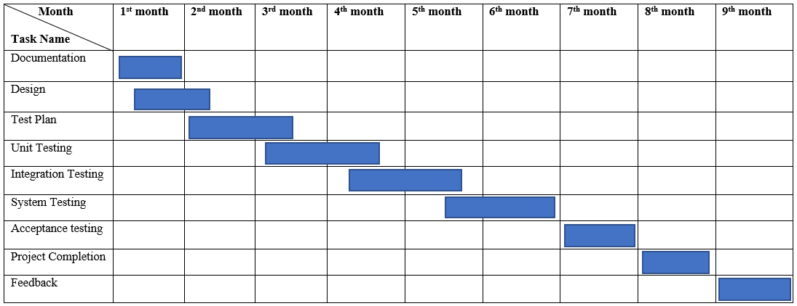

# PLANNING RISKS AND CONTINGENCIES

There could be multiple risk and contingencies during project time-

* If the number of defects and bugs is higher than the tester team expected, then more time and money will be needed to fix them.
* It may take a few more days to finish the task if a team member quits in the middle of the project.
* If customers aren't happy with the product's performance, it could cause a delay in shipping while the issues are resolved.

# APROVALS

|  |  |
| --- | --- |
| Project Sponsor – “A” |  |
| Development Management- “B” |  |
| EDI Project Manager- “C” |  |
| RS Test Manager- “D” |  |
| RS Development Team Manager- “E” |  |
| Reassigned Sales – “F” |  |
| Order Entry EDI Team Manager – “H” |  |