**Triangulum**

1. **Sprint 1**
   1. **Objectives**

The objective for this sprint was to learn cloud9, AWS CDK, lambda function, S3 bucket, command for Ubuntu, GitHub, Leetcode and implement a lambda function which can monitor the availability and latency of websites.

* 1. **Technologies Used**

1. Cloud9
2. Lambda
3. S3 Bucket
   1. **Sprint breakdown**

The sprint was divided into 3 tasks.

1. **Create cloud9 environment**

Created a Cloud9 environment, set python 3.6 as default version and updated the AWS cli

1. **implement Hello world lambda function**

Created a CDK app and implemented hello world Lambda function

1. **Web-Health monitoring lambda function**

Monitor the availability and latency of a website. For this [www.skipq.org](http://www.skipq.org) is used and a lambda function is used to do it.

1. **Periodic invocation of lambda function**

A scheduler was set to invoke the web health lambda function every minute to check the availability and latency of the website

1. **Create S3 bucket and monitor the health of two websites**

Creates an S3 bucket, uploaded and downloaded the file from bucket and fetch url from the downloaded file check the web health of that resource.

* 1. **Errors and Solutions**

During the implementation error I faced numerous error some of them resolved

1. **Storage Issue**

There was an error that the device is running of low space, so I increased the storage of my cloud9 instance from 10GB to 20GB.

1. **No module named aws-cdk and amazonzq**

These errors appeared because of the packages that are not installed properly. So, I uninstalled the packages and reinstalled and the error was resolved.

* 1. **Output**

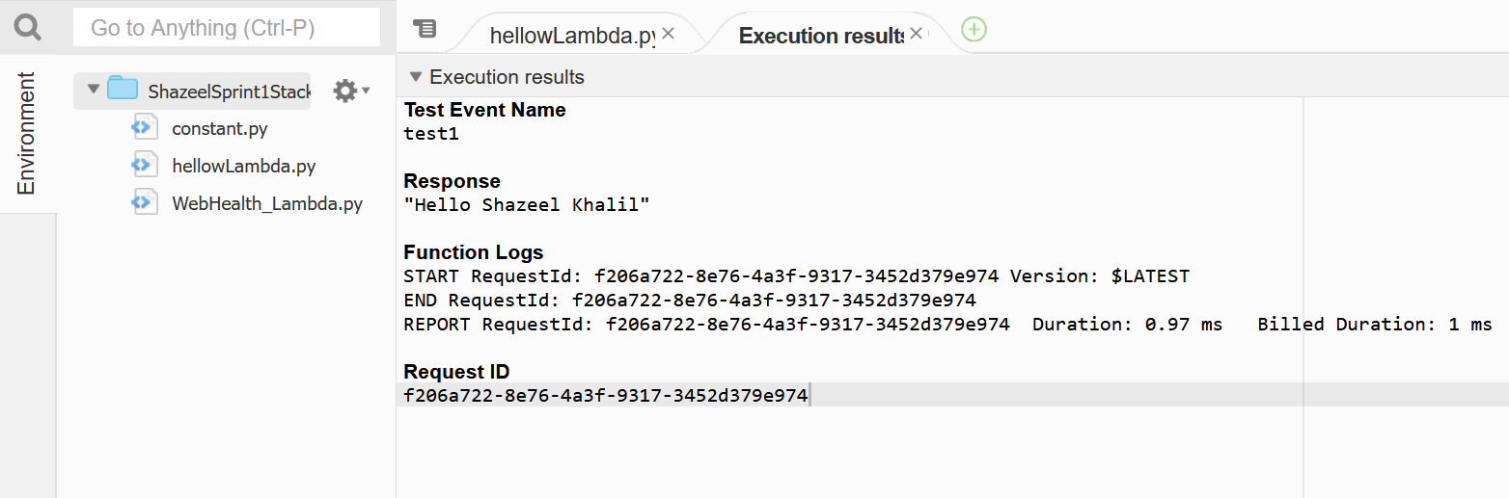

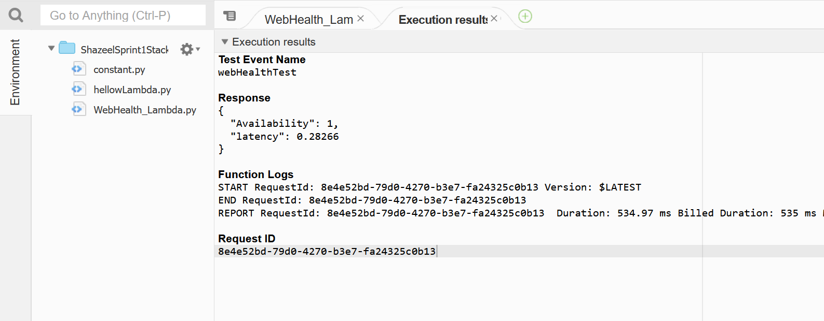

* 1. **Function documentation**

**def create_lambda(self, id, asset, handler):**

**Description:**

This function is used to setup the lambda function.

**Parameters:**

The function takes three parameters id is the name of the function, asset (will be the path of lambda file) and handler is the name of the function lambda will execute.

**Return value:**

The function returns a function.

**def get_availability(url):**

**Description:**

calculates the availability of given URL.

**Parameters:**

The function takes the url of the website as parameter to calculate the availability.

**Return value:**

The function returns 1.0 if the website is up and 0.0 if the website is down.

**def get_latency(url):**

**Description:**

calculates the latency of given URL.

**Parameters:**

The function takes the url of the website as parameter to calculate the latency.

**Return value:**

The function returns the time in second the website took to respond.

**def create_bucket(bucketName):**

**Description:**

Creates the s3 bucket.

**Parameters:**

This function takes the name of the bucket as parameter i.e., shazeelskipq

**Return value:**

This function will return a bucket

* 1. **References**

<https://stackoverflow.com/questions/59135352/write-s3-objects-with-cdk>

<https://www.youtube.com/watch?v=ne89_atwygE>

<https://boto3.amazonaws.com/v1/documentation/api/1.9.42/reference/services/s3.html#S3.Bucket.download_file>

<https://boto3.amazonaws.com/v1/documentation/api/1.9.42/reference/services/s3.html#S3.Bucket.download_file>

<https://boto3.amazonaws.com/v1/documentation/api/latest/guide/credentials.html>