**VUEJS**

Es un framework de JavaScript que facilita la creación de interactive and reactive web frontends (browser-side web aplications) easier.

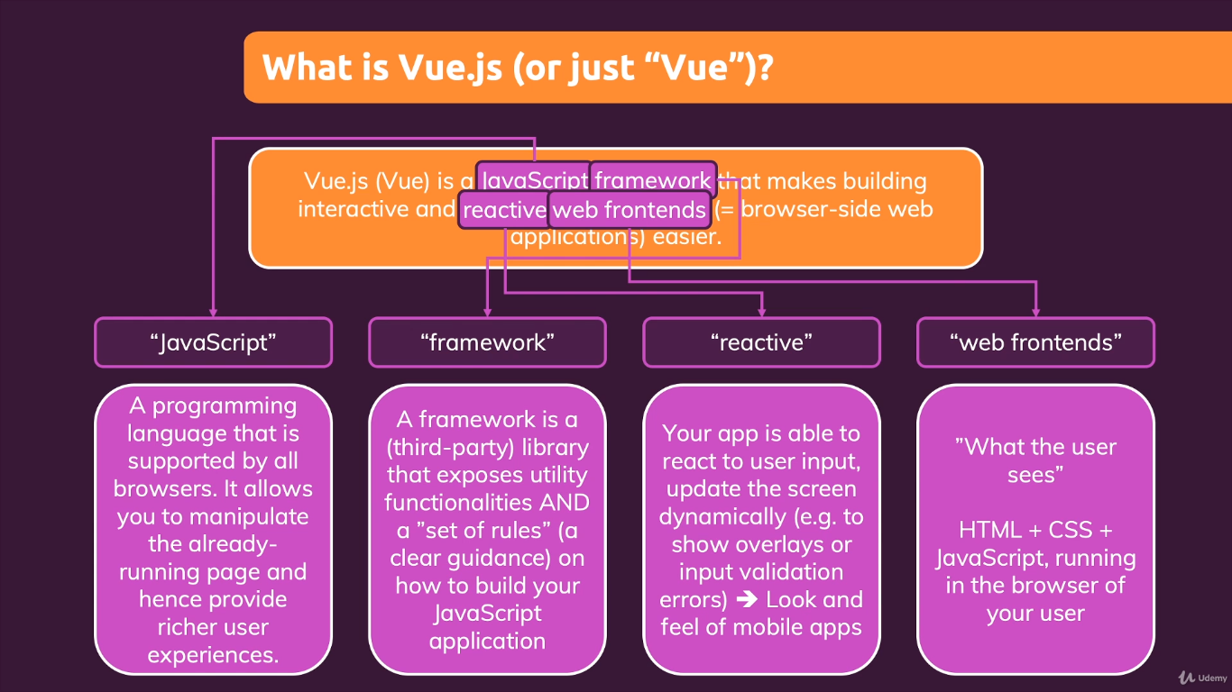 Reactive: Your app i sable to react to user input, update the screen dynamically.

