Kontrolltöö

create procedure SeeAllStudents

as

select \* from dbo.Student

go; 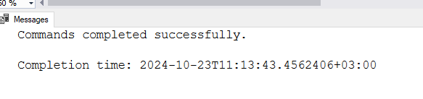

insert into dbo.Student(LastName, ClassId, StudentId, FirstName, ParentPhone)

values('hunt', 1, 2, 'pavel', '513222'),

('koer', 2, 3, 'tiiu', '51622'),

('kana', 3, 4, 'aet', '822'),

('kukk', 4, 5, 'mari', '51992'),

('hani', 5, 6, 'mark', '511999922'),

('haigur', 6, 7, 'vasja', '458222'),

('kobras', 7, 8, 'teet', '31974'),

('hüljes', 8, 9, 'tiit', '56492'),

('elukas', 9, 10, 'jüri', '5874562'),

('part', 10, 11, 'valmar', '596651');

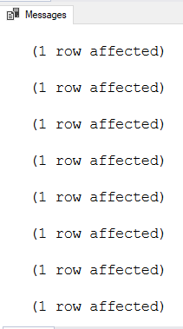

insert into dbo.Class (Id, ClassName, ClassId)

values(1,'chemistry', 1)

insert into dbo.Class (Id, ClassName, ClassId)

values(2,'physics', 2)

insert into dbo.Class (Id, ClassName, ClassId)

values(3,'cs', 3)

insert into dbo.Class (Id, ClassName, ClassId)

values(4,'english', 4)

insert into dbo.Class (Id, ClassName, ClassId)

values(5,'management', 5)

insert into dbo.Class (Id, ClassName, ClassId)

values(6,'economy', 6)

insert into dbo.Class (Id, ClassName, ClassId)

values(7,'more chemistry', 7)

insert into dbo.Class (Id, ClassName, ClassId)

values(8,'sample', 8)

insert into dbo.Class (Id, ClassName, ClassId)

values(9,'cooking', 9)

insert into dbo.Class (Id, ClassName, ClassId)

values(10,'hairdresser', 10)



insert into dbo.Coupons(StudentId)

values (1)

insert into dbo.Coupons(StudentId)

values (2)

insert into dbo.Coupons(StudentId)

values (3)

insert into dbo.Coupons(StudentId)

values (4)

insert into dbo.Coupons(StudentId)

values (5)

insert into dbo.Coupons(StudentId)

values (6)

insert into dbo.Coupons(StudentId)

values (7)

insert into dbo.Coupons(StudentId)

values (8)

insert into dbo.Coupons(StudentId)

values (9)

insert into dbo.Coupons(StudentId)

values (10)



insert into dbo.Groups(FirstName, LastName, Email, Phone, ClassId)

values ('ants','juust','aa@aa.c', 515185, 1)

insert into dbo.Groups(FirstName, LastName, Email, Phone, ClassId)

values ('bob','piim','ab@aa.c', 515146, 2)

insert into dbo.Groups(FirstName, LastName, Email, Phone, ClassId)

values ('rob','koer','ac@aa.c', 515119, 3)

insert into dbo.Groups(FirstName, LastName, Email, Phone, ClassId)

values ('man','kana','ad@aa.c', 515134, 4)

insert into dbo.Groups(FirstName, LastName, Email, Phone, ClassId)

values ('woman','lind','ae@aa.c', 515166, 5)

insert into dbo.Groups(FirstName, LastName, Email, Phone, ClassId)

values ('mart','vares','af@aa.c', 515185, 6)

insert into dbo.Groups(FirstName, LastName, Email, Phone, ClassId)

values ('tõnu','siga','ag@aa.c', 515189, 7)

insert into dbo.Groups(FirstName, LastName, Email, Phone, ClassId)

values ('valmar','kukk','ah@aa.c', 515147, 8)

insert into dbo.Groups(FirstName, LastName, Email, Phone, ClassId)

values ('aet','hunt','ai@aa.c', 515112, 9)

insert into dbo.Groups(FirstName, LastName, Email, Phone, ClassId)

values ('mari','sink','aj@aa.c', 515165, 10)



insert into dbo.Kitchen(Food, CouponId)

values ('burger', 1)

insert into dbo.Kitchen(Food, CouponId)

values ('cheese', 2)

insert into dbo.Kitchen(Food, CouponId)

values ('ham', 3)

insert into dbo.Kitchen(Food, CouponId)

values ('salad', 4)

insert into dbo.Kitchen(Food, CouponId)

values ('soup', 5)

insert into dbo.Kitchen(Food, CouponId)

values ('ice cream', 6)

insert into dbo.Kitchen(Food, CouponId)

values ('sandwich', 7)

insert into dbo.Kitchen(Food, CouponId)

values ('fruit', 8)

insert into dbo.Kitchen(Food, CouponId)

values ('jam', 9)

insert into dbo.Kitchen(Food, CouponId)

values ('fish', 10)



insert into dbo.School(SchoolName, SchoolAddress)

values('normal','street 1')

insert into dbo.School(SchoolName, SchoolAddress)

values('good','street 2')

insert into dbo.School(SchoolName, SchoolAddress)

values('better','street 3')

insert into dbo.School(SchoolName, SchoolAddress)

values('best','street 4')

insert into dbo.School(SchoolName, SchoolAddress)

values('worse','street 5')

insert into dbo.School(SchoolName, SchoolAddress)

values('worst','street 6')

insert into dbo.School(SchoolName, SchoolAddress)

values('most normal','street 7')

insert into dbo.School(SchoolName, SchoolAddress)

values('even worse','street 8')

insert into dbo.School(SchoolName, SchoolAddress)

values('tthk','street 9')

insert into dbo.School(SchoolName, SchoolAddress)

values('tpl','street 10')



select \* from dbo.Student

left join dbo.Groups on dbo.Student.FirstName = dbo.Groups.FirstName;

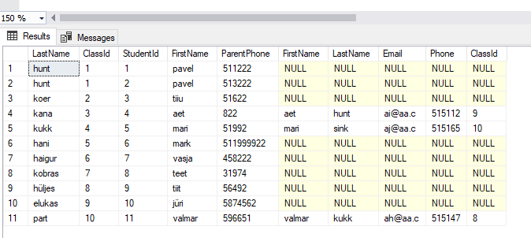

select \* from dbo.Student

right join dbo.Groups on dbo.Student.FirstName = dbo.Groups.FirstName;

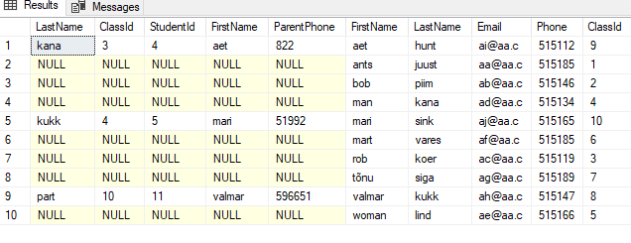

select \* from dbo.Student

full join dbo.Groups on dbo.Student.FirstName = dbo.Groups.FirstName;

