**CMSC 150 GENERIC SOLVER USER MANUAL**

About

This is user manual is to help you navigate through the unfortunately incomplete Generic Solver for Polynomial Regression, Quadratic Spline Interpolation, and Simplexes.

How to Use This

Requirements:

> Make sure that the .csv files are properly formatted (e.g. extra newline at the end of the file)

> Make sure you have everything listed in the INSTALL.txt file

Running the App:

> Navigate to the project folder and run RUNME.sh on your terminal using ./RUNME.sh

The resulting app window should look like this when it opens in your browser:

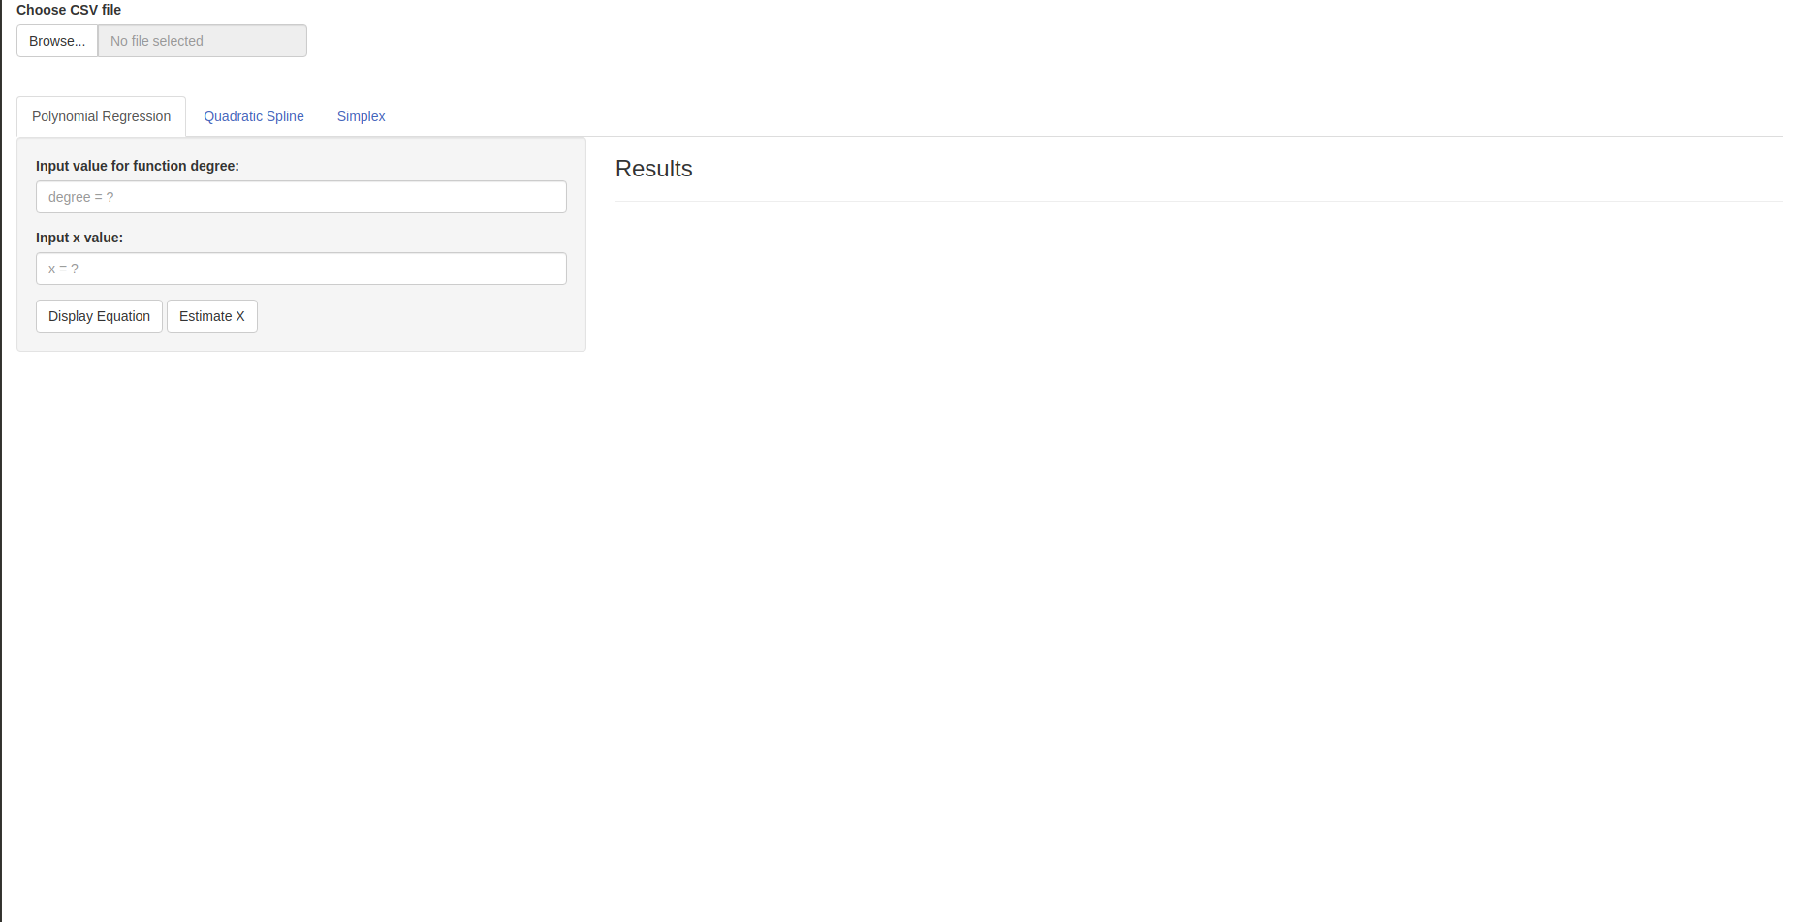

Select a .csv file using the “Browse” button before you begin. Afterwards, you can navigate the solvers by clicking on their respective tabs.

Polynomial Regression

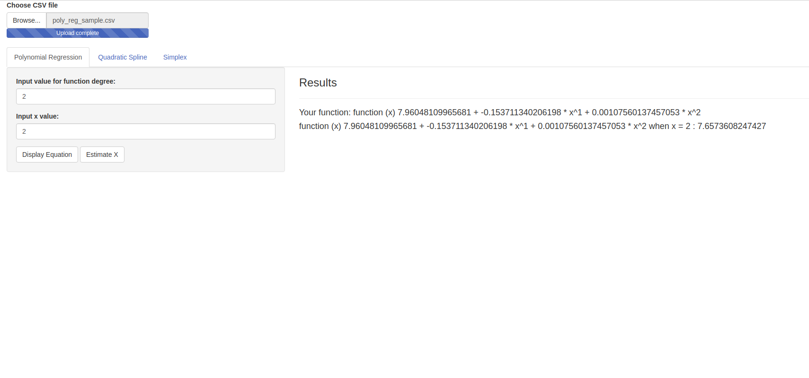 Here you can solve for the nth order function that will model your given data and the estimate of f(x).

1. Insert your desired function degree in its respective input box

2. Insert you desired value of x in its respective input box

3. Click the “Display Equation” button to see your equation

4. Click the “Estimate X” button to see the function value given your desired value of x

5. If you want to read data from a different .csv file, select it using the “Browse” button and start over at Step 1

Quadratic Spline

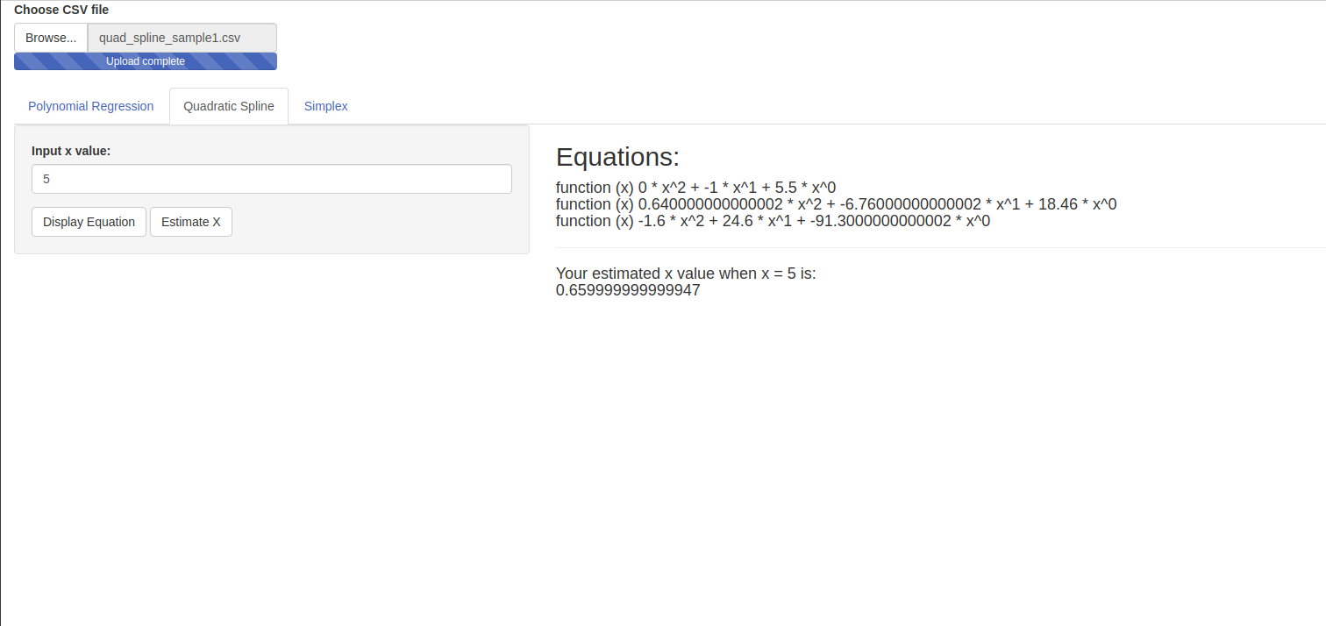

Here you can solve for the function per interval and the estimate of f(x).

1. Insert you desired value of x in its respective input box

2. Click the “Display Equation” button to see the equations for each interval

3. Click the “Estimate X” button to see the value of the function given your desired value of x

4. If you want to read data from a different .csv file, select it using the “Browse” button and start over at Step 1

Simplex

Here you should have been able to find the answer to the optimization problem but unfortunately it wasn’t finished in time.