Technical Documentation for a SQLite3 based scraper.
As the object of our scraper we have chosen the site with recipes - delish.com. The reason why - it doesn't have any encoding for a query, also it is scrapeable by BeautifulSoup4. 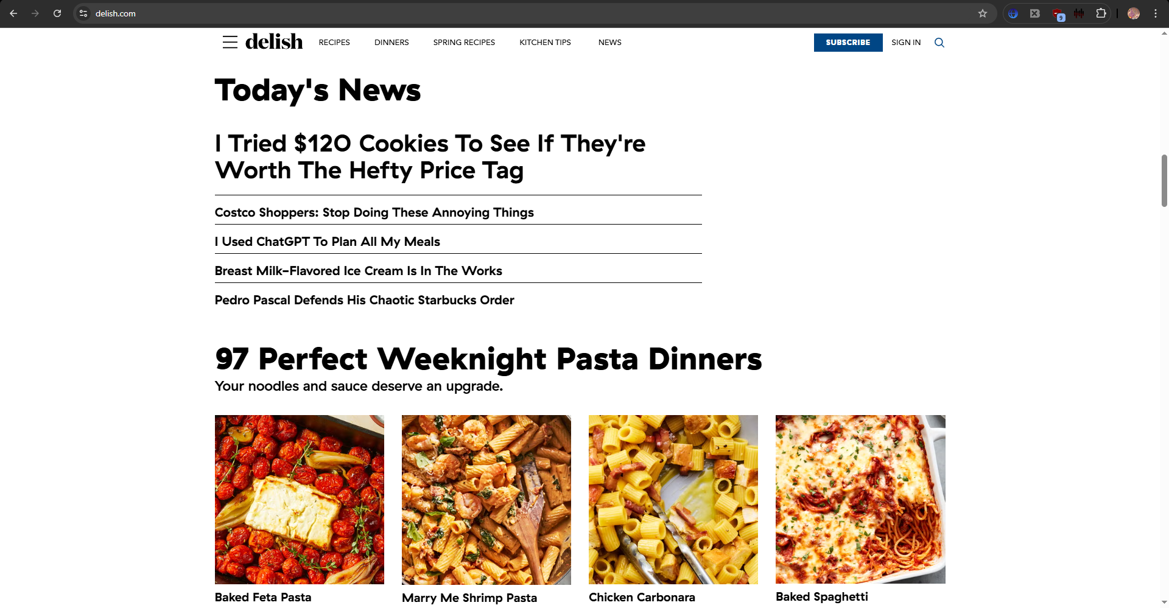
To see how this site processes a query, we search for a recipe with 1 word - let it be "curry":
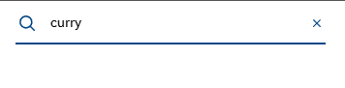
There we have to select "Recipe" from a dropdown menu.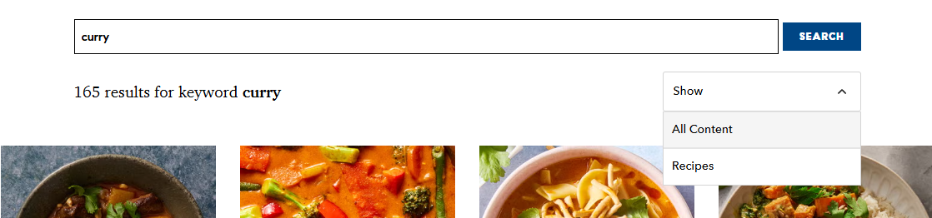
And now we have what we wanted to know - the URL for a recipe search:
This is how it looks for a multiply search query:
Now we need to look at the tags so we know where to parse from. The ingredients are in the 'li' tag, class - 'css-s5yyyu3 e12sb1171'.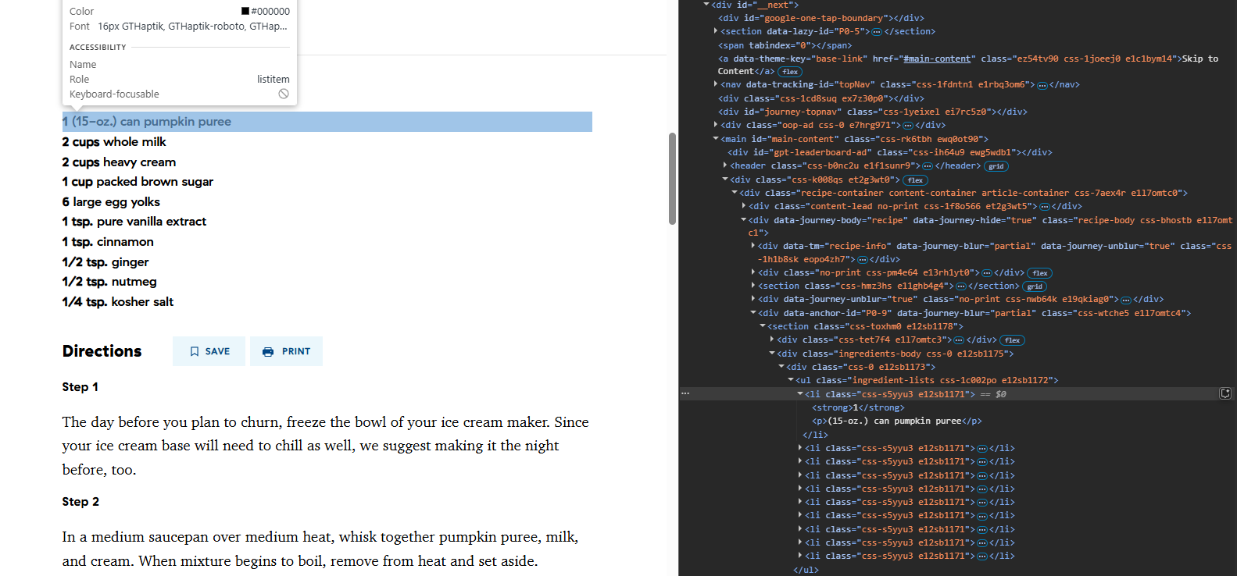
The steps for the tutorial are in class="css-21v28f e1241r8m3".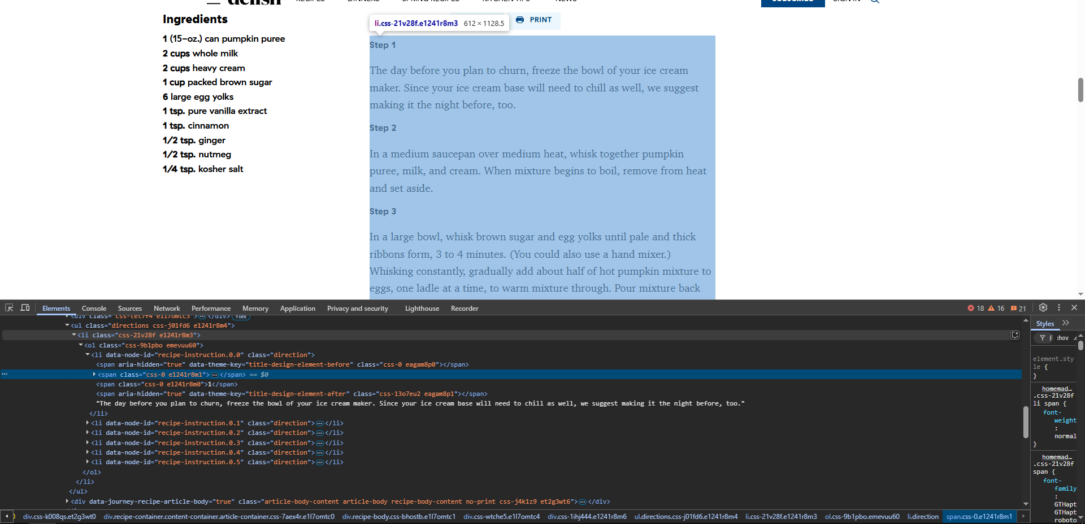
And the photo for this guide in the 'img' tag, class="css-0 e1g79fud0"