Demandware: Automated Emails

1. Welcome email on successful registration
2. Email product to a friend
3. Email wish list to a friend
4. Order confirmation email
5. Order despatched/unable to fulfil email
6. Order cancellation email
7. Order returned email
8. Forgot password email
9. New password confirmation email (after password reset)
10. Email with purchased e-gift card details
11. Email with returned e-gift card details

1. Welcome email on successful registration🡪 Email Template: newAccount

Subject line: You’ve successfully registered at Seafolly

Subject line: Te has registrado exitosamente a Maaji 🡪 Hecho

1). ‘newsletter-header’ – Contains logo

Imagen que contiene objeto

Descripción generada con confianza alta

2). ‘[newaccount-newsletter-body](https://dev05-shop-avenue32.demandware.net/on/demandware.store/Sites-Site/default/ViewLibraryContent_52-Start?ContentUUID=bcFJaiaaiuH46aaadnHXAmgK6p)’

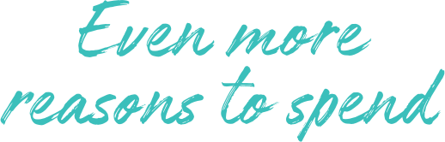

Aún más razones para disfrutar (letrero)

Hola [First Name], ¡Felicitaciones por crear tu cuenta Maaji - Mermaid!

Ahora puedes disfrutar todos los beneficios de ser un socio registrado.

* Recibe noticias de nuestras ofertas exclusivas y productos.
* Guarda tu historial de órdenes.
* Agiliza tu proceso de pago guardando tu dirección de facturación y envío. 🡪 Hecho

Hi [First Name], congratulations on creating your Maaji - Mermaid account!

You now get to enjoy all the benefits of being a registered customer.

* Receive news about exclusive offers and products.
* Save your order history.
* Speed up the checkout by storing billing & shipping info.

**

*Included four category static images, name and link*

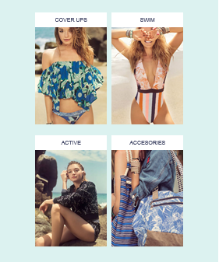

3). emailComponent - ‘newsletter-footer’ 🡪 Content Asset – ‘newsletter-footer’

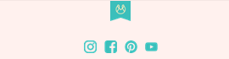

Email Template structure:

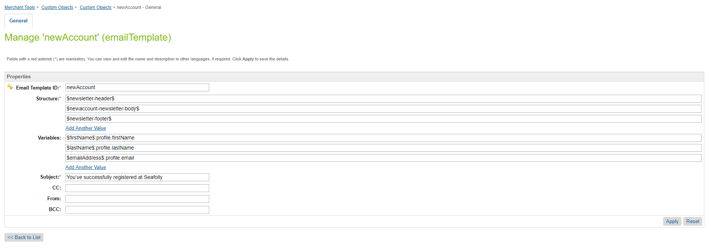

Email component:

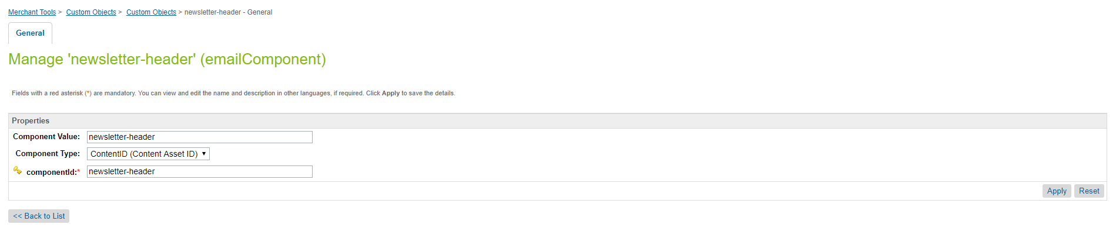

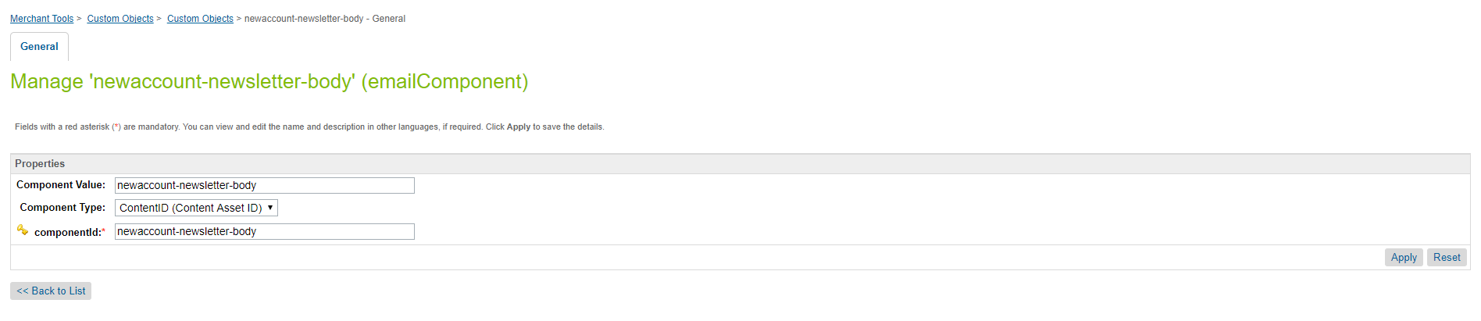

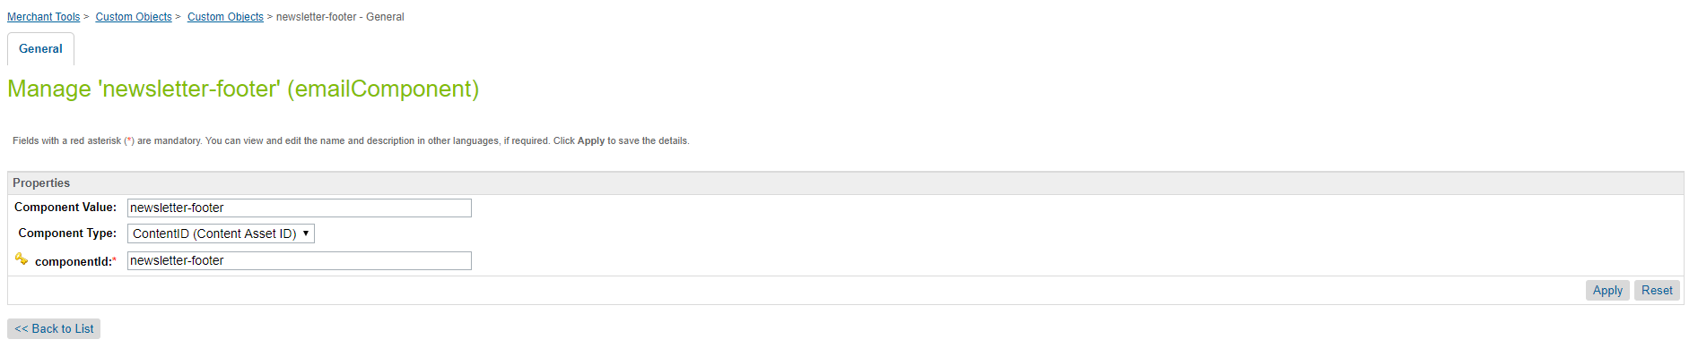

2. Email product to a friend🡪 Email Template: sendToFriend

Subject line: [NAME] has sent you a style suggestion from Seafolly

Subject line: [NAME] te ha enviado un estilo que de Maaji que te puede gustar 🡪 Hecho

1). ‘newsletter-header’ – Contains logo

Imagen que contiene objeto

Descripción generada con confianza alta

2). ‘send-to-friend-body-customer-msg’



¡Mira lo que encontré!

De: [Friend’s Name]

[Sender’s Email]

[Sender’s Message]

From: [Friend’s Name]

[Sender’s Email]

[Sender’s Message]

3). Custom object emailComponent: ‘send-to-friend-body-product-info’

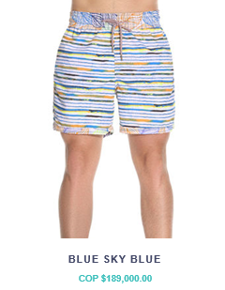



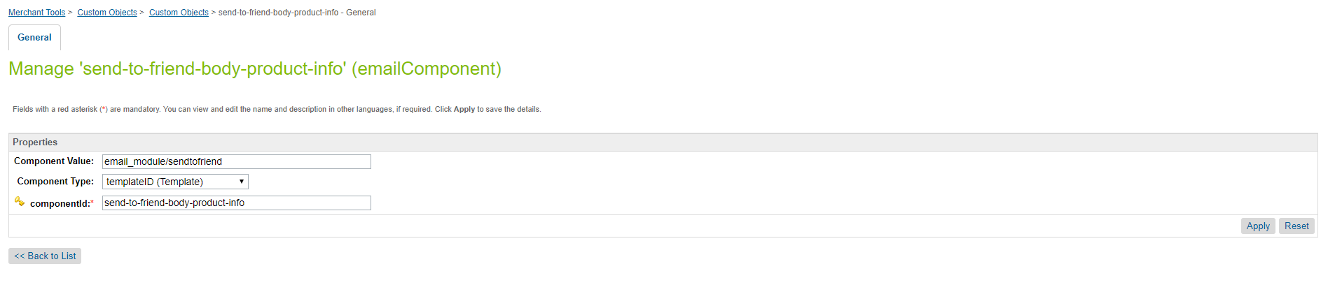

4). emailComponent - ‘newsletter-footer’ 🡪 Content Asset – ‘newsletter-footer’



3. Email wish list to a friend🡪 Email Template: wishList

Subject line: [NAME] has sent you their Seafolly wish list

Subject line: [NAME] te ha enviado su lista de deseos de Maaji 🡪 Hecho

1). ‘newsletter-header’ – Contains logo

Imagen que contiene objeto

Descripción generada con confianza alta

2). ‘wish-list-body-customer-msg’



Mi lista de deseos

From: [Friend’s Name]

[Sender’s Email]

[Sender’s Message]

De: [Friend’s Name]

[Sender’s Email]

[Sender’s Message]

CTA: [SEE THE WISH LIST]

https://development-ap01-seafolly.demandware.net/on/demandware.static/-/Library-Sites-MaajiSharedLibrary/default/dw5ec3d37f/images/maaji_email_images/btn_view_my_wishlist.png

3). emailComponent - ‘newsletter-footer’ -> Content Asset – ‘newsletter-footer’



4. Order confirmation email🡪 Email Template: orderConfirmation

Subject line: Confirmation of your order [Order Number]

Subject line: Confirmación de tu orden [Order Number] 🡪 Hecho

1). ‘newsletter-header’ – Contains logo

Imagen que contiene objeto

Descripción generada con confianza alta

2) ‘order-confirmation-body’



¡Gracias¡

Hi [firstName], we've received your order and will have it ready for you soon.  
You'll receive an email once it has shipped.

Hola [firstName], hemos recibido tu orden y queríamos contarte que la tendremos preparada para su envío próximamente. Espera un nuevo correo electrónico tan pronto te la enviemos. 🡪 Hecho

https://development-ap01-seafolly.demandware.net/on/demandware.static/-/Library-Sites-MaajiSharedLibrary/default/dw09a03a54/images/maaji_email_images/btn_order_details.png

3) Custom object emailComponent: ‘order-details’ 🡪email template: email\_module/orderconfirmation

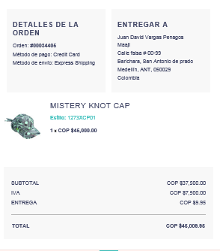

4). emailComponent - ‘newsletter-footer’ -> Content Asset – ‘newsletter-footer’



5. Order dispatched/unable to fulfil email🡪 Email Template: dispatchedOrderEmail

Subject line: Your order is on its way

Subject line: Tu orden va en camino 🡪 Hecho

1). ‘newsletter-header’ – Contains logo

Imagen que contiene objeto

Descripción generada con confianza alta

2). ‘dispatched-email-content-msg’

C:\Users\Dinu\AppData\Local\Microsoft\Windows\INetCache\Content.Word\onthis-way.png

¡En camino¡

Dear [First Name], your order has been shipped and on its way!

[First Name], ¡tu orden ha sido enviada y la estarás recibiendo prontamente¡

C:\Users\Vibin\AppData\Local\Microsoft\Windows\INetCache\Content.Word\order-detail.png

3) Custom object emailComponent: ‘order-details’ 🡪email template: email\_module/orderconfirmation

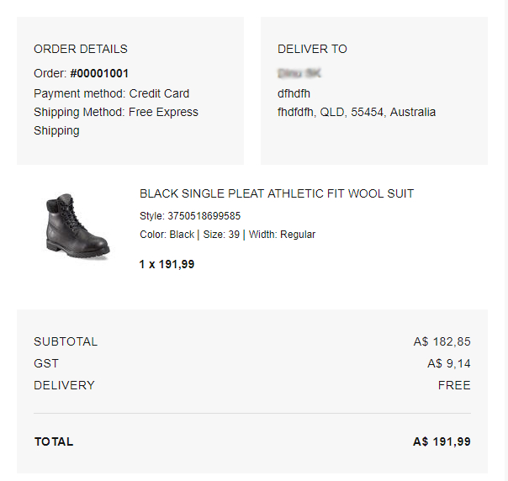

4). emailComponent - ‘newsletter-footer’ -> Content Asset – ‘newsletter-footer’



6. Order cancellation email🡪 Email Template: cancelledOrderEmail

Subject line: Your order has been cancelled

Subject line: Tu orden ha sido cancelada 🡪 Hecho

1). ‘newsletter-header’ – Contains logo

C:\Users\Dinu\AppData\Local\Microsoft\Windows\INetCache\Content.Word\seafolly-logo-email.png

2). ‘cancelled-email-content-msg’

Dear [First Name], Unfortunately we haven’t been able to process your order on this occasion. Order [INSERT ORDER NUMBER] has been cancelled and no payment has been taken from your account.

[First Name], Infortunadamente no fue possible procesar tu orden en esta ocasión. La orden INSERT ORDER NUMBER] ha sido cancelada y no se realizó ningún cobro a tu cuenta. 🡪 Hecho

3) Custom object emailComponent: ‘order-details’ 🡪 email template: email\_module/orderconfirmation

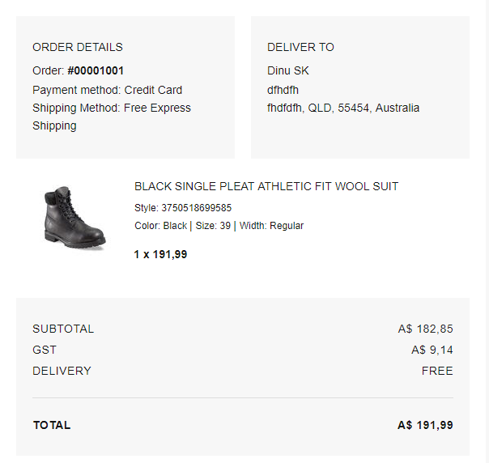

4). emailComponent - ‘newsletter-footer’ -> Content Asset – ‘newsletter-footer’



7. Order returned email🡪 Email Template: orderReturnedEmail

Subject line: We’ve received your return

Subject line: Hemos recibido tu devolución 🡪 Hecho

1). ‘newsletter-header’ – Contains logo

C:\Users\Dinu\AppData\Local\Microsoft\Windows\INetCache\Content.Word\seafolly-logo-email.png

2). emailComponent - ‘returned-order-message-content’ -> Content Asset – ‘returned-order-message-content’

C:\Users\Vibin\AppData\Local\Microsoft\Windows\INetCache\Content.Word\order-refund.png

Reembolso de tu orden

Hi [First Name], your refund has been processed. Please allow up to five business days for this to reflect in your account.

Hola [First Name], te informamos que hemos procesado tu reembolso exitosamente. Por favor permítenos hasta 5 días hábiles para verlo reflejado en tu cuenta. -🡪 Hecho

C:\Users\Vibin\AppData\Local\Microsoft\Windows\INetCache\Content.Word\order-detail.png

3) Custom object emailComponent: ‘orderreturnrequest ‘ 🡪 email template: email\_module/ returnordermail

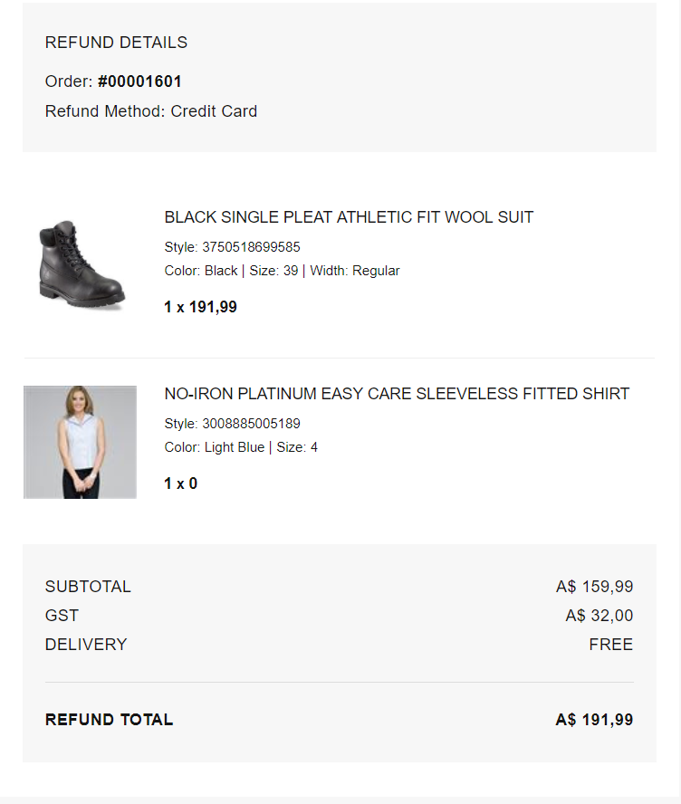

4). emailComponent - ‘newsletter-footer’ 🡪 Content Asset – ‘newsletter-footer’

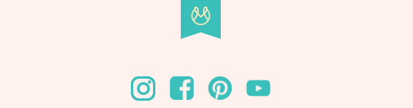

8. Forgot password email🡪 Email Template: resetPassword

Subject line: Forgotten your password?

Subject line: ¿Olvidaste tu contraseña?

1). emailComponent - ‘newsletter-header’ – Contains logo

Imagen que contiene objeto

Descripción generada con confianza alta

2). emailComponent - ‘resetpassword-newsletter-body’ 🡪 Content Asset – ‘resetpassword-newsletter-body’

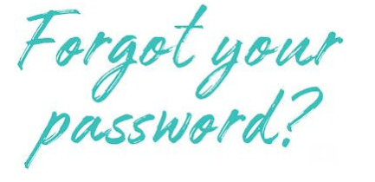

¿Olvidaste tu contraseña?

That’s okay, it happens! Click on the button below to reset your password.

No te preocupes, ¡a todos nos pasa! Solo tienes que hacer clic en el botón a continuación para restaurar tu contraseña. 🡪 Hecho

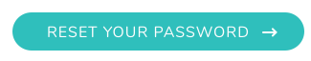

3). emailComponent - ‘newsletter-footer’ 🡪 Content Asset – ‘newsletter-footer’



9. New password confirmation email (after password reset) 🡪 Email Template: passwordResetSuccess

Subject line: Your Maaji password has been reset

Subject line: Tu contraseña de Maaji ha sido restaurada

1). ‘newsletter-header’ – Contains logo

Imagen que contiene objeto

Descripción generada con confianza alta

2). ‘pass-reset-succ-body’

Dear [First Name]

You’ve successfully reset the password for your Sunburn account.

* Update your personal information
* View your order history
* Add addresses (for a faster checkout experience)
* View and add items to your wish list
* Manage your newsletter subscription preferences

[First Name],

Has restaurado exitosamente tu contraseña de tu cuenta de Maaji. Ahora puedes:

* Actualizar tu información personal
* Ver tu historial de órdenes
* Agregar direcciones para una experiencia de checkout más ágil y rápida
* Ver y agregar items en tu lista de deseos
* Administrar tus preferencias de suscripción a nuestro newsletter 🡪 Hecho

3). emailComponent - ‘newsletter-footer’ 🡪 Content Asset – ‘newsletter-footer’



10. Email with purchased e-gift card details: Email component = ‘giftCardEmail’

Subject line: A gift from [NAME]!

Subject line: ¡Has recibido un regalo de [NAME]!

1). emailComponent - ‘newsletter-header’ – Contains logo

Imagen que contiene objeto

Descripción generada con confianza alta

2). emailComponent – ‘gift-purchase-email-content’ 🡪 Content Asset – ‘gift-purchase-email-content’

Hi [Recipient Full Name], you've just received a Maaji Gift Card from someone special. They must like you as much as we do!

C:\Users\Vibin\AppData\Local\Microsoft\Windows\INetCache\Content.Word\btn_shop_now_sf.png

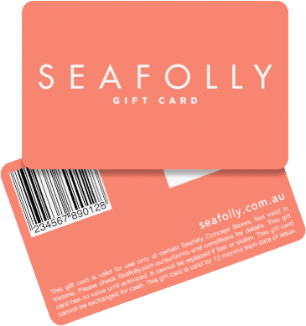

3). emailComponent - ‘gift-purchase-voucher-content’ 🡪 Template – ‘gift-purchase-voucher-content’

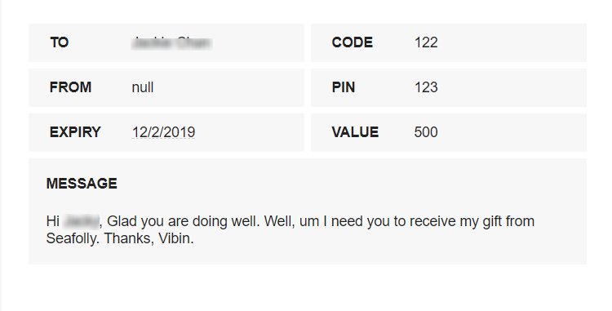

4). emailComponent - ‘newsletter-contact-us’ 🡪 Content Asset – ‘newsletter-contact-us’

Redeem this gift card online at www.seafolly.com.au or at an Australian Seafolly Concept store, click here to locate your nearest store. This gift card cannot be redeemed at Seafolly Melbourne Central, Seafolly stockist or outside of Australia. This gift card is in Australian Dollar (AUD) and cannot be exchanged for cash. Full Terms and Conditions can be found on our website www.seafolly.com.au/terms-and-conditions

Contact us on 1300 420 811 (+61 2 9291 8309) or at shop@seafolly.com.au

5). emailComponent - ‘newsletter-footer’ 🡪 Content Asset – ‘newsletter-footer’

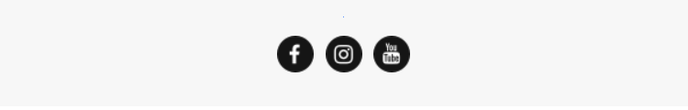

11. Email with returned e-gift card details: Email component = ‘giftCardEmail’

Subject Line: Refunded Gift Card

1). emailComponent - ‘newsletter-header’ – Contains logo

C:\Users\Vibin\AppData\Local\Microsoft\Windows\INetCache\Content.Word\seafolly-logo-email.png

2). emailComponent – ‘gift-refunded-email-content’ 🡪 Content Asset – ‘gift-refunded-email-content’

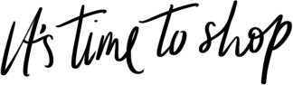

Hi [First Name], thank you for your return. We have successfully refunded this amount onto your new gift card below. Any remaining balance on your old card will still be available to use with the original code and pin.

C:\Users\Vibin\AppData\Local\Microsoft\Windows\INetCache\Content.Word\btn_shop_now_sf.png



3). emailComponent - ‘newsletter-contact-us’ 🡪 Content Asset – ‘newsletter-contact-us’

Redeem this gift card online at www.seafolly.com.au or at an Australian Seafolly Concept store, click here to locate your nearest store. This gift card cannot be redeemed at Seafolly Melbourne Central, Seafolly stockist or outside of Australia. This gift card is in Australian Dollar (AUD) and cannot be exchanged for cash. Full Terms and Conditions can be found on our website www.seafolly.com.au/terms-and-conditions

Contact us on 1300 420 811 (+61 2 9291 8309) or at shop@seafolly.com.au

4). emailComponent - ‘newsletter-footer’ 🡪 Content Asset – ‘newsletter-footer’

