**Buy Offer.**

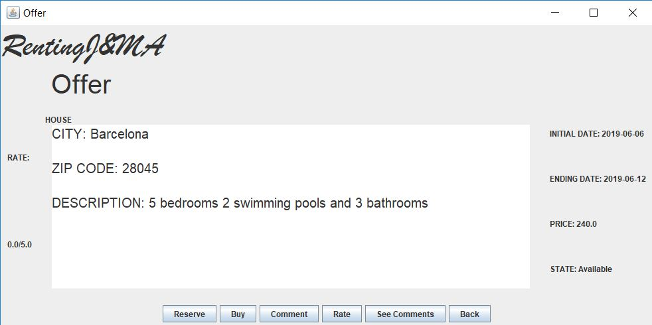

If the user selects ‘buy’ a window will pop up and tell him to introduce the subject.

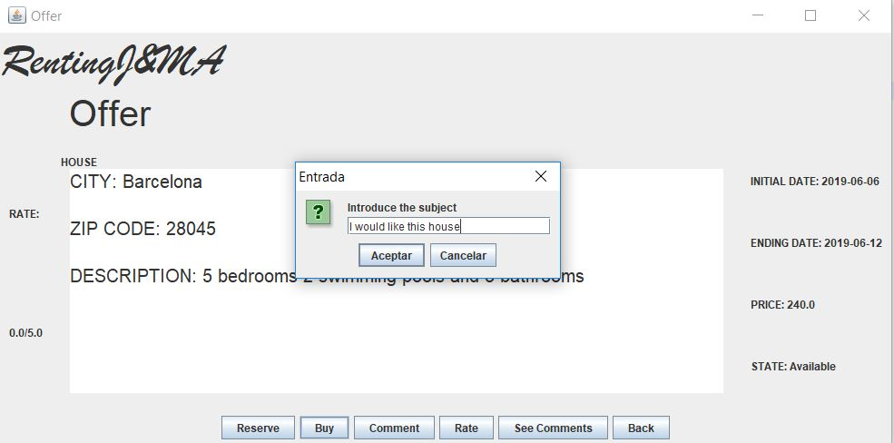

When the user writes the subject and presses ‘Aceptar’, if everything goes correctly a window will pop up and say ‘You have bought the offer’.

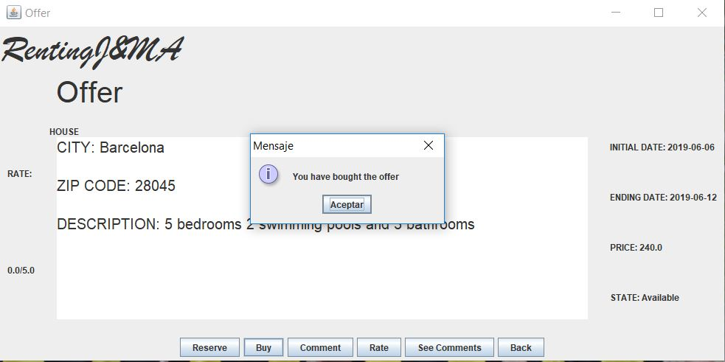

So now the offer has successfully been bought.

**Now we are going to see the alternative paths:**

In all of these alternative paths there is an error and the user can’t buy the offer.

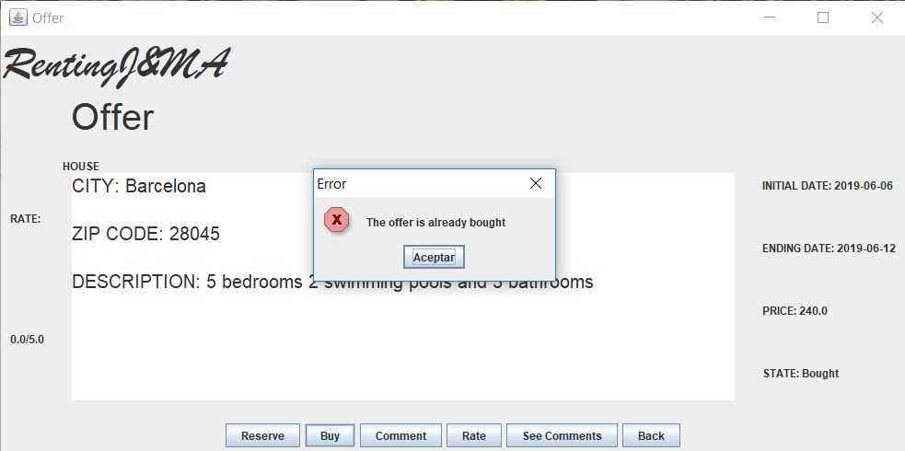

This is the error that appears if the offer has already been bought.

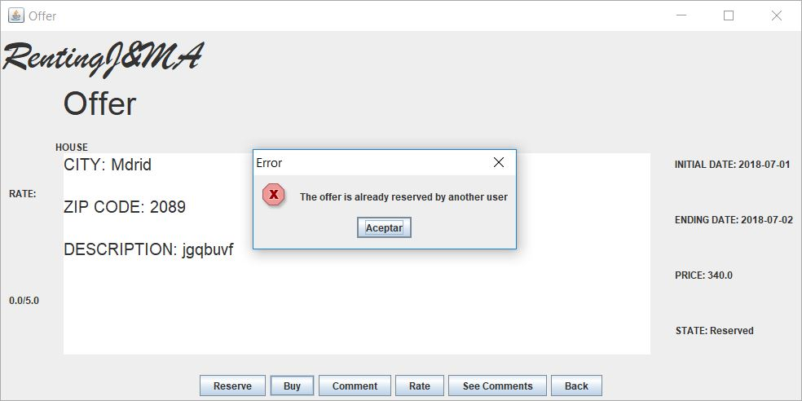

This is the error that appears if the offer has been reserved.

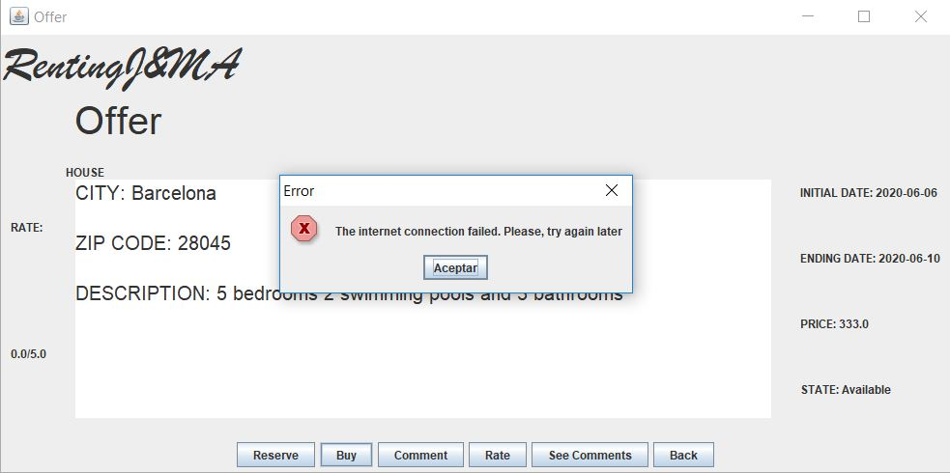

This is the error that appears if there is an error in the payment system

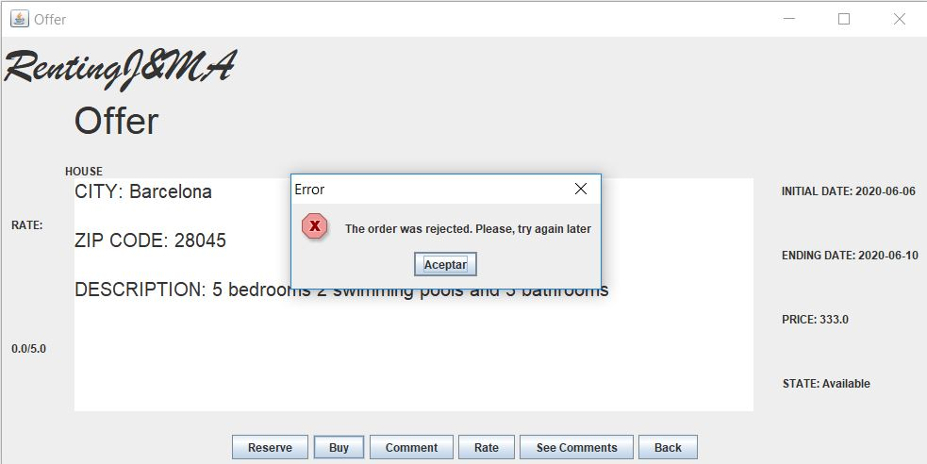

This is another error with the payment system.

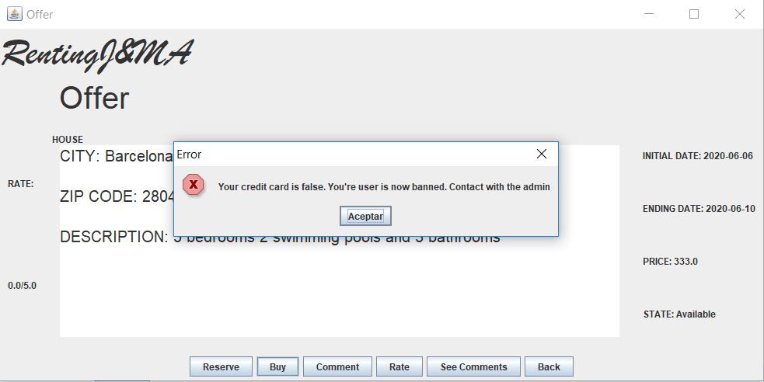

And this is what appears if your credit card is incorrect.

**Make living offer.**

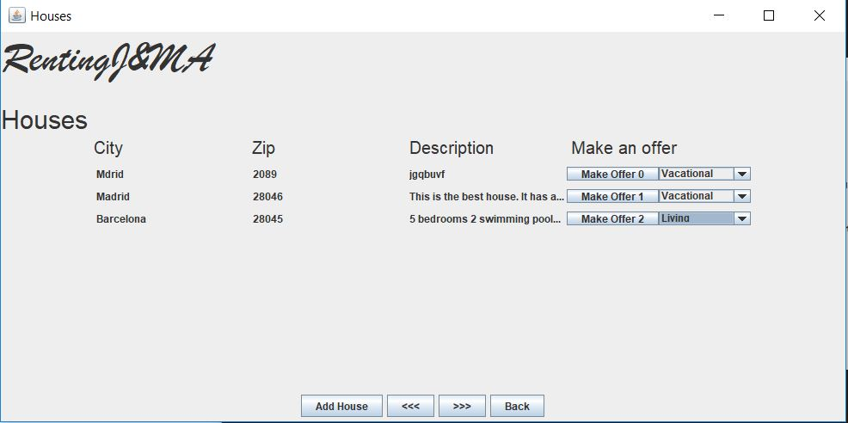

If the user selects ‘living’ in a combo box and presses the button ‘make offer’ next to that combo box he will see this next window:

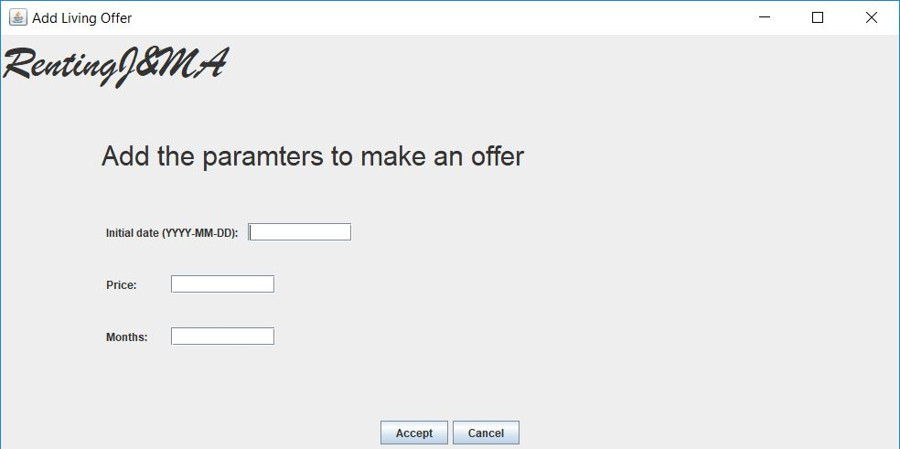

Now he introduces all the data and presses ‘Aceptar’. If everything is correct this next window will pop up:

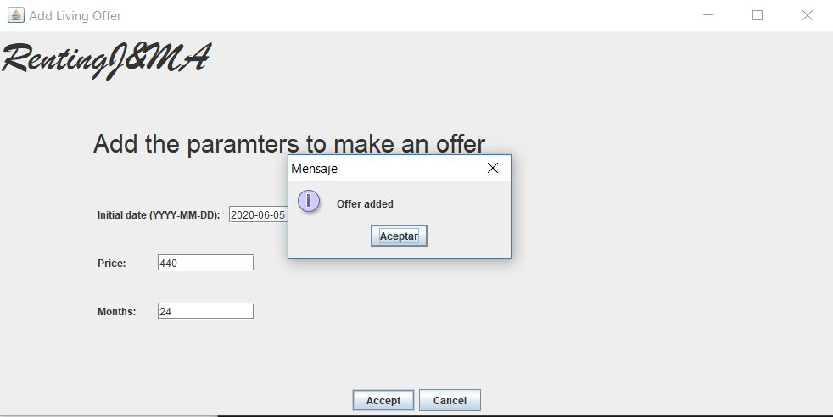

So now the offer has successfully been added.

**Alternative paths.**

In all of these alternative paths there is an error and the user can’t add the offer.

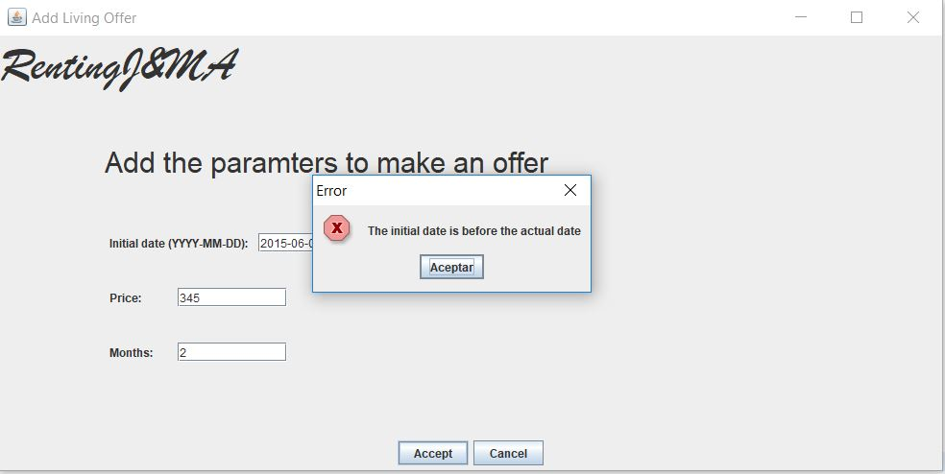

This is the error that appears if the initial date is before the actual date.

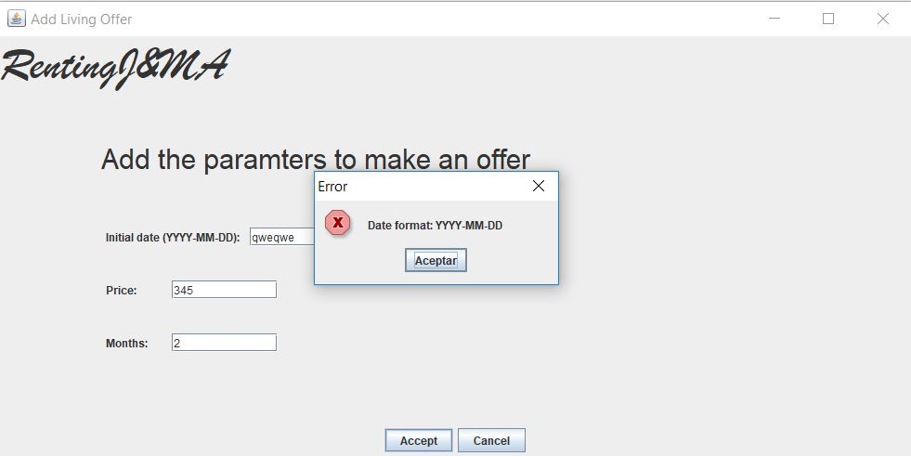

This is the error that appears if the date has an incorrect format.

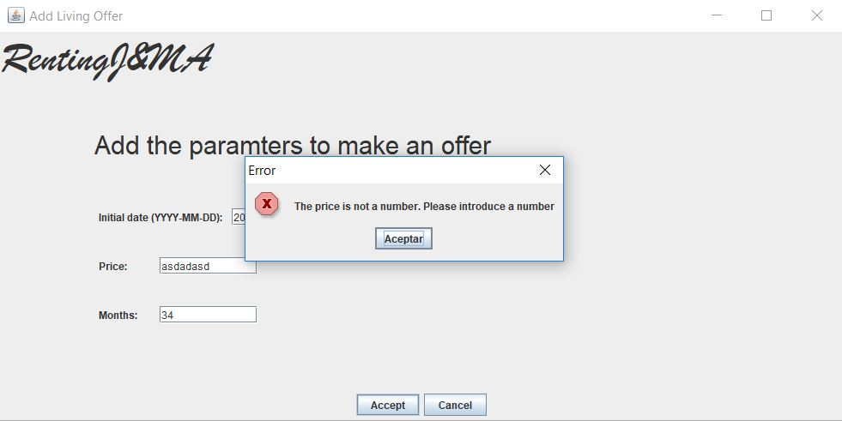

This is the error that appears if the price is not a correct number.

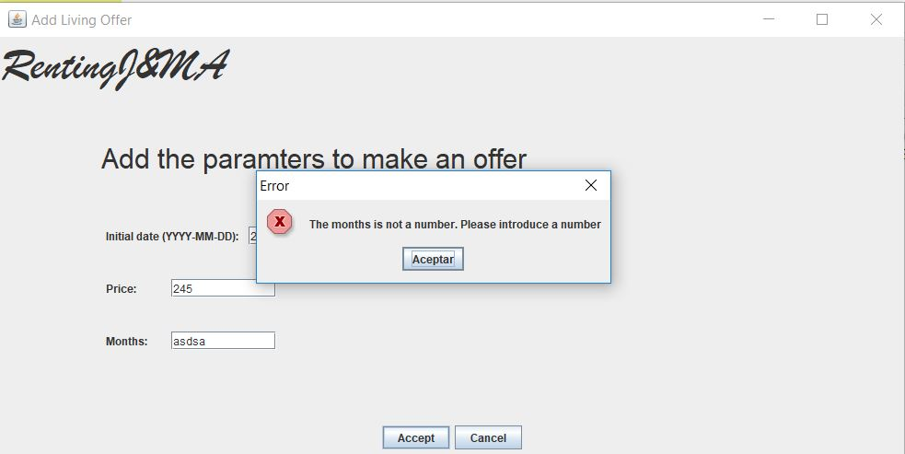

And this is the error that appears if the parameter Months is not a number.