Document Information
Division | Module Name
Villa Shipping | Villa Shipping | Vessels
Subject
Vessel Monitoring System

Version | Date | Author
.01 | March 22, 2026 | Juven Legaspi
Description
This is the proposed solution design to meet the requirements for Vessel Monitoring System under the Villa Shipping Division. The purpose of this system is to replace the current manual process of recording vessel activities and voyage logs with a centralized digital monitoring system. Through this system, authorized users will be able to record, monitor, and generate reports related to vessel operations and voyage activities. The solution is intended to improve data accuracy, operational efficiency, and real-time visibility of vessel movements and activities.

Table of Contents
Document Information 1
Overview 2
Objectives 2
Scope of the System 2
Requirements 3
Specifications 4
Expectation 6
Document Approval and Acceptance 11

Overview
The Vessel Monitoring System is designed to automate the process of tracking vessel activities and voyage logs within the Villa Shipping Division.
Currently, vessel operations and voyage activities are recorded manually. This manual approach can lead to:
- Inconsistent record keeping
- Delayed reporting
- Data inaccuracies
- Difficulty in tracking vessel movement history
By implementing a digital monitoring system, vessel information, voyage logs, and operational activities will be recorded and stored within a centralized system.
This will allow authorized personnel to easily monitor vessel operations, review voyage history, and generate reports when needed.
The system will also introduce structured access control to ensure that only authorized users can view or manage specific vessel records.

Objectives
The primary objectives of the Vessel Monitoring System are:
- To digitalize vessel voyage logging processes
- To improve operational transparency and monitoring
- To reduce human error caused by manual recording
- To provide a structured system for tracking vessel activities
- To allow authorized users to generate reports for operational review
- To ensure data consistency and historical tracking of vessel movements

Scope of the System
The Vessel Monitoring System will cover the following core functionalities:
- Vessel registration and management
The system will allow administrators to manage vessel information that will serve as the foundation for voyage tracking.
    - Vessel records will contain essential operational and identification details
    - Each vessel may have assigned personnel responsible for logging voyage activities
- Voyage Log Creation and Monitoring
Authorized users can create and manage voyage logs for specific vessels.
    - Each voyage log represents a single operational trip
    - Users input relevant voyage details such as cargo, location, and crew information.
- Activity Monitoring
Users can record operational activities during a voyage.
    - Activities include key operational events such as sailing, docking, anchoring, delays, and other events.
    - Activity types are configurable based on operational requirements.
    - Each activity contributes to a chronological timeline of vessel operations.
- Status Tracking
The system provides predefined status indicators reflecting vessel operational conditions.
    - Status updates support real-time monitoring of vessel operations.
- Reporting
The system includes functionality to generate operational reports.
    - Reports summarize voyage logs, vessel activities, and operational performance.
    - Reports can be exported or printed for management use.
- Dashboard Monitoring
The system includes a dashboard for real-time monitoring of vessel operations.
    - Displays key indicators: total vessels, total voyage logs, active voyages, completed voyages.
    - Includes charts and summary cards for clear, easy-to-understand visualizations.
- System Accessibility
The system will be accessible through a web-based interface and integrated within the Villa Shipping Division System.

Requirements
- Vessel Creation and Management
  - The system shall allow the System Administrator to create and manage vessel records.
  - Each vessel record must contain essential operational and identification details.
    - Conditions:
    - Only the System Administrator can create or modify vessel records.
    - Each vessel may have assigned personnel responsible for logging voyage activities.
- Creation of Voyage Logs
  - Voyage logs represent the operational journey of a vessel during a specific trip.
    - Condition
    - Only the Captain or an authorized user assigned to the vessel can create voyage logs.
    - Each voyage log must contain operational details such as cargo information, vessel location, and crew information.
    - A unique Voyage ID must be automatically generated.
- Voyage Activity Management
  - The system shall allow recording of operational activities throughout a voyage.
  - Activities represent operational events such as vessel movement, docking, sailing, anchoring, or other operational updates.
  - Each voyage log may contain multiple activity entries, creating a timeline of vessel operations throughout the voyage. Each activity entry will include:
      - Vessel operational status
      - Activity description
      - Additional remarks
      - System-recorded timestamps
    - Condition
    - Only the Captain or authorized users assigned to the vessel are allowed to add, update, or complete voyage activities.
    - Activities must follow the defined workflow rules for starting, ending, and completing activities.
    - Once a voyage is marked as Completed, no additional activities may be added or modified unless authorized by the System Administrator.
- Activity Execution
  - Users interact with system controls such as Add Activity, Start, End, Update, and Complete to record vessel activities.
  - This process allows the system to capture the timeline and operational status of the vessel throughout the voyage.
    - Rules:
- Adding and Starting an Activity
    - Only the Captain or authorized user may click Add Activity to create a new activity record.
    - After adding, clicking Start will save the activity and begin tracking its duration.
    - Each activity must be linked to an existing voyage log.
    - Multiple activities may be recorded under a single voyage.
  - Ending / Completing an Activity
    - Activities must be properly marked as Ended or Completed following the system workflow.
- Data Reporting
  - The system shall generate a PDF report for printing
  - The report shall include all voyage activities per voyage logged

- Dashboard Functionality
  - The system shall display vessel summary information on the dashboard for management review.
  - Users can drill through from summary metrics to detailed records.
  - Dashboard data shall update dynamically based on system records.
  - Metrics displayed include total vessels, active voyages, and completed voyages.

Specifications
The Vessel shipping module in Villa system and company will include the following fields:
Module | Field Name | Data Type / Control | Description | Values
Vessel | Vessel ID | Auto-generated number | Unique identifier for each vessel | Cannot be modified
Vessel | Vessel Name | Text | Name of the vessel | Required
Vessel | Vessel Type | Dropdown | Type of Vessel | e.g., Cargo, Tanker, Tug, Passenger
Vessel | Service Speed | Text/Integer | Standard operating speed of the vessel | Required
Vessel | IMO Number | Text/Integer | International Maritime Organization Number | Unique, required
Vessel | DWT | Text/Integer (tons) | Deadweight tonnage of the vessel | Required
Vessel | Fuel type | Text/Integer | Type of fuel used by vessel | Required
Vessel | Charter Type | Dropdown | Type of vessel assignment | Drydock, Voyage
Vessel | Call Sign | Text | Vessel’s official call sign | Optional
Vessel | Vessel Status | Dropdown | Operational condition of the vessel | Operational, Non-operational
Vessel > Voyage Logs | Voyage ID | Auto-generated number | Unique identifier for each voyage | Cannot be modified
Vessel > Voyage Logs | Cargo Volume | Text/Integer (tons) | Total cargo volume for the voyage | Required
Vessel > Voyage Logs | Cargo Type | Text | Type of cargo carried | Required
Vessel > Voyage Logs | Port Location | Dropdown | Current location of the vessel | Required
Vessel > Voyage Logs | Fuel ROB | Integer (litres) | Remaining fuel onboard at voyage start | Required
Vessel > Voyage Logs | Crew Onboard | Integer | Total number of crew members on vessel | Required
Vessel > Voyage Logs | Voyage Number | Text/Integer | Unique voyage number assigned by port | Required
Vessel > Voyage Logs | Date Created | Date (auto-populated) | Date when the voyage log is created | System-generated
Vessel > Voyage Logs > Activities | Status | Dropdown | Operational status of the vessel during activity | At Berth, Sailing, Anchored, Drydock, Delayed, etc.
Vessel > Voyage Logs > Activities | Activity Description | Text | Details of the activity performed | Required
Vessel > Voyage Logs > Activities | Remarks | Text | Additional notes or remarks on the activity | Optional
Vessel > Voyage Logs > Activities | Timestamp | System DateTime | Date and time when activity is recorded | System-generated

Expectation
- Vessel Registration Screen
User Action | System Response | Expected Result
Click “+ Add Vessel” | Opens a new activity form | User can input Vessel details before clicking “Save”

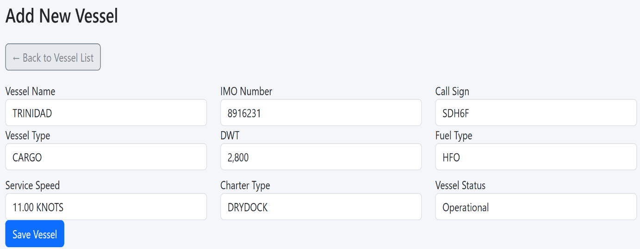
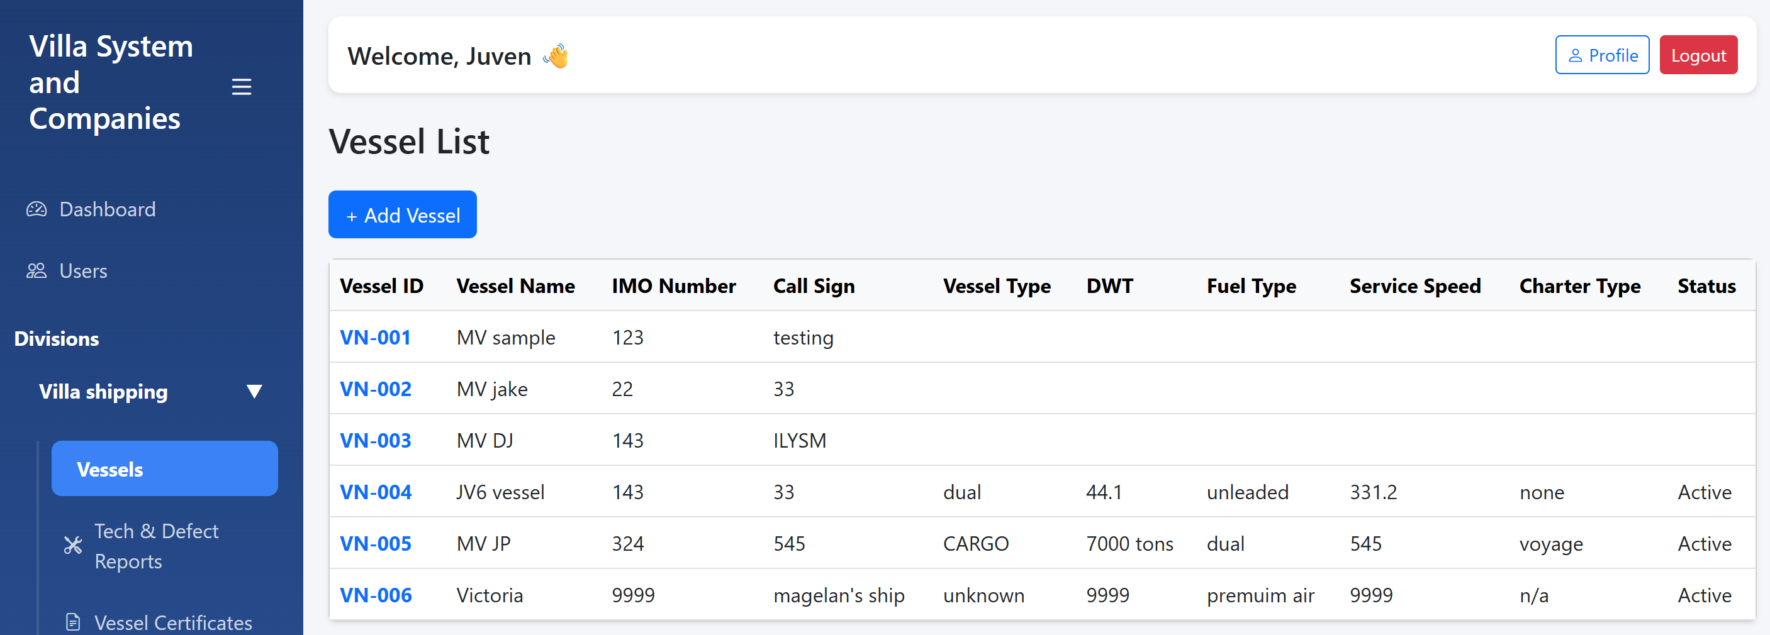

The administrator can enter Vessel Name, Vessel Type, Fuel Type, and assign personnel. Upon saving, the system validates required fields.

- Voyage Log Creation Screen
User Action | System Response | Expected Result
Click “+ Add Voyage” | Opens a new activity form | User can input Voyage details and can enter “Save” to save the Voyage details.

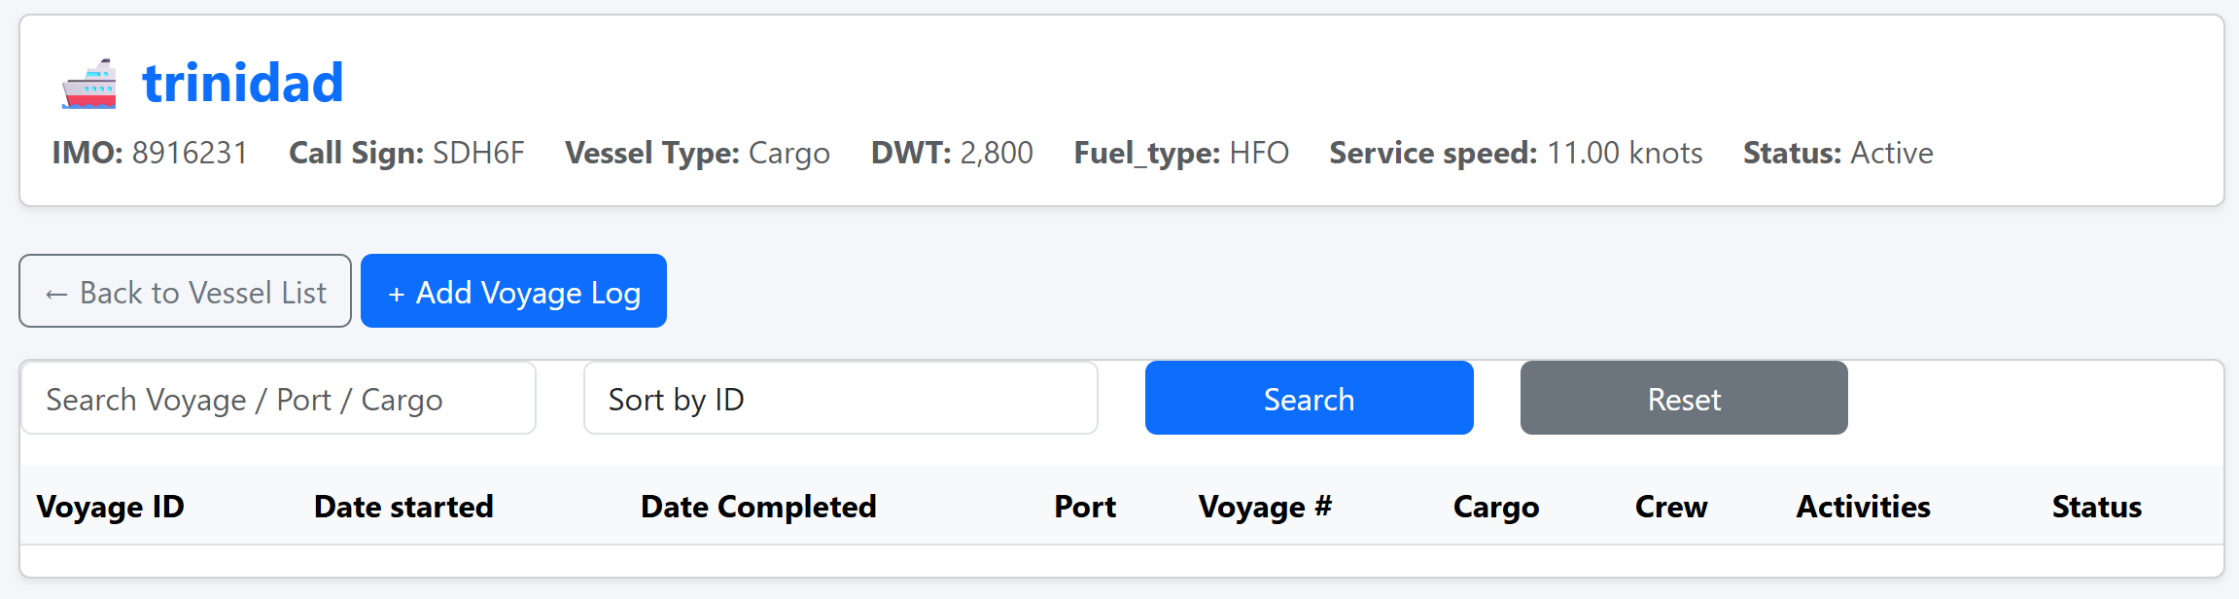
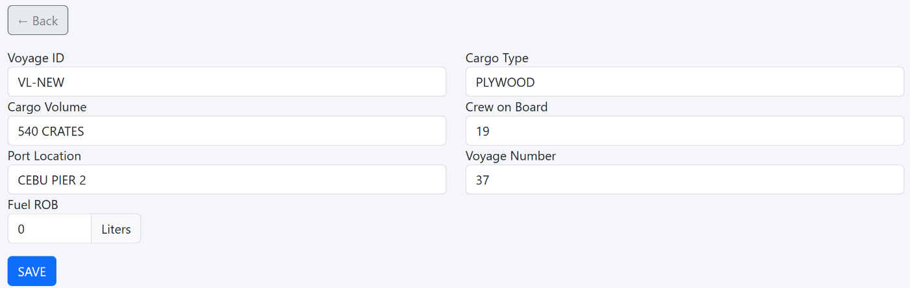
Authorized users can input cargo, port location, fuel onboard, and crew details. Voyage ID is auto-generated.

- Activity Monitoring
User Action | System Response | Expected Result
Click “ADD FIRST ACTIVITY” | Opens a new activity form | User can input activity details linked to the current voyage
Click “START” | Activity begins tracking | Total hours start counting from this moment
Click “END” | Total hours are calculated | System calculates duration from start to end
Click “END” | End details are recorded | End time and other metadata are displayed in the activity log
Click “END” | “COMPLETE” button becomes visible | User can proceed to finalize this activity
Click “COMPLETE” | “ADD” button becomes visible | Allows user to add another activity for the same vessel
Click “COMPLETE” | “COMPLETE VOYAGE” button appears in the header | User can finalize the overall voyage for the vessel
Click “COMPLETE VOYAGE” | Marks voyage as completed | All activities for the voyage are finalized; no further edits allowed unless authorized

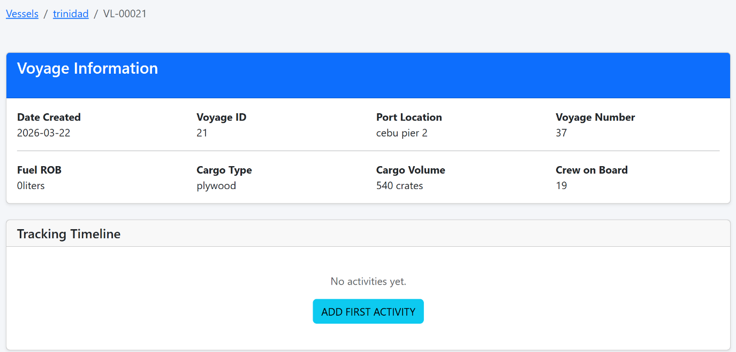

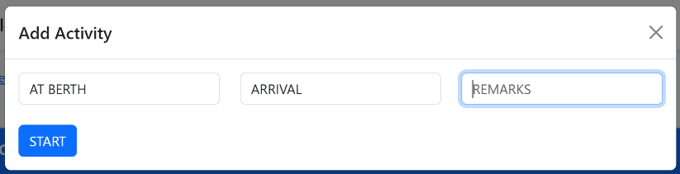

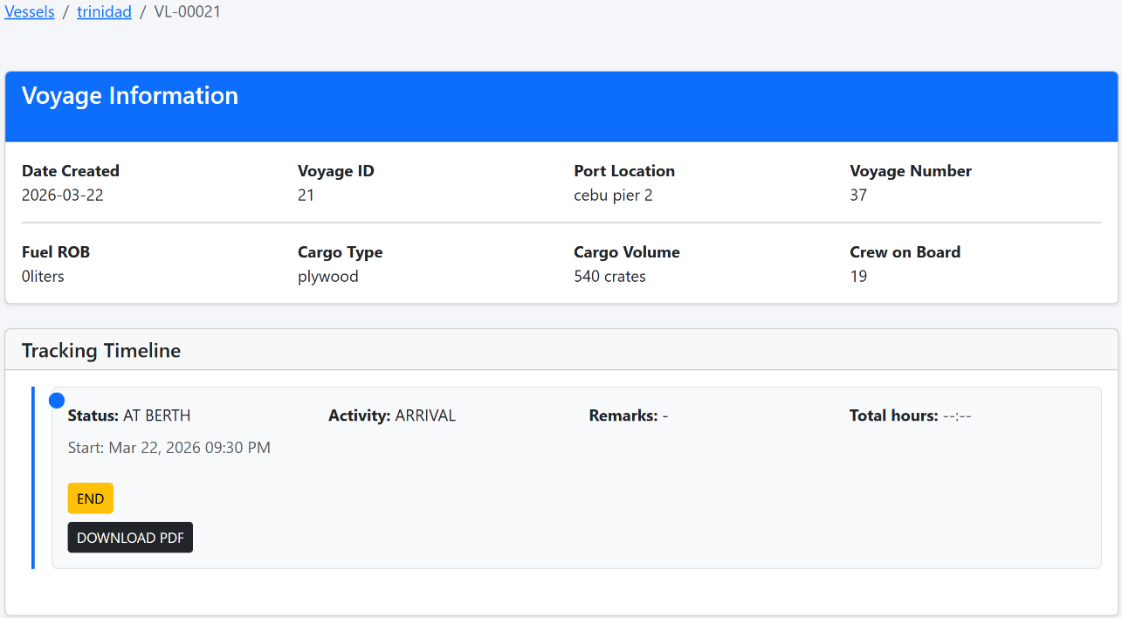
Users can select activity status, enter activity description, and save remarks. The system records a timestamp automatically.

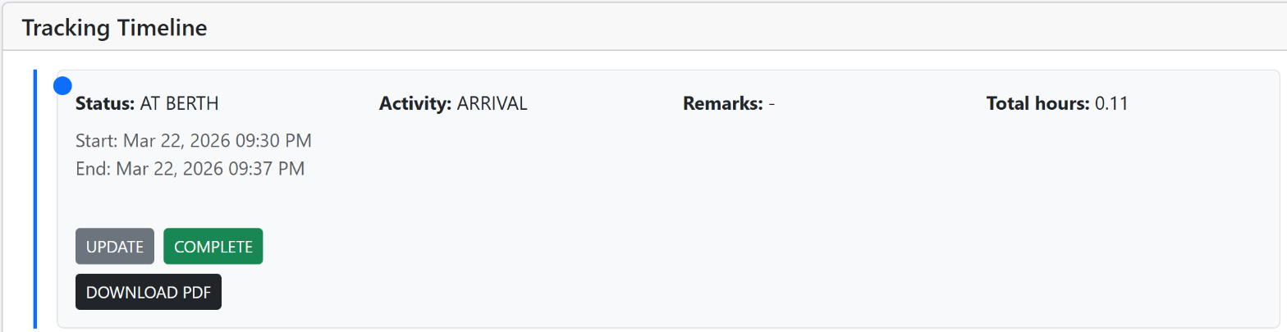

Once “END is clicked, details will be recorded and displayed.
Clicking the “END” button will calculate the total hours for the activity, from start to end.

After clicking “END” button the “COMPLETE” button will become visible.

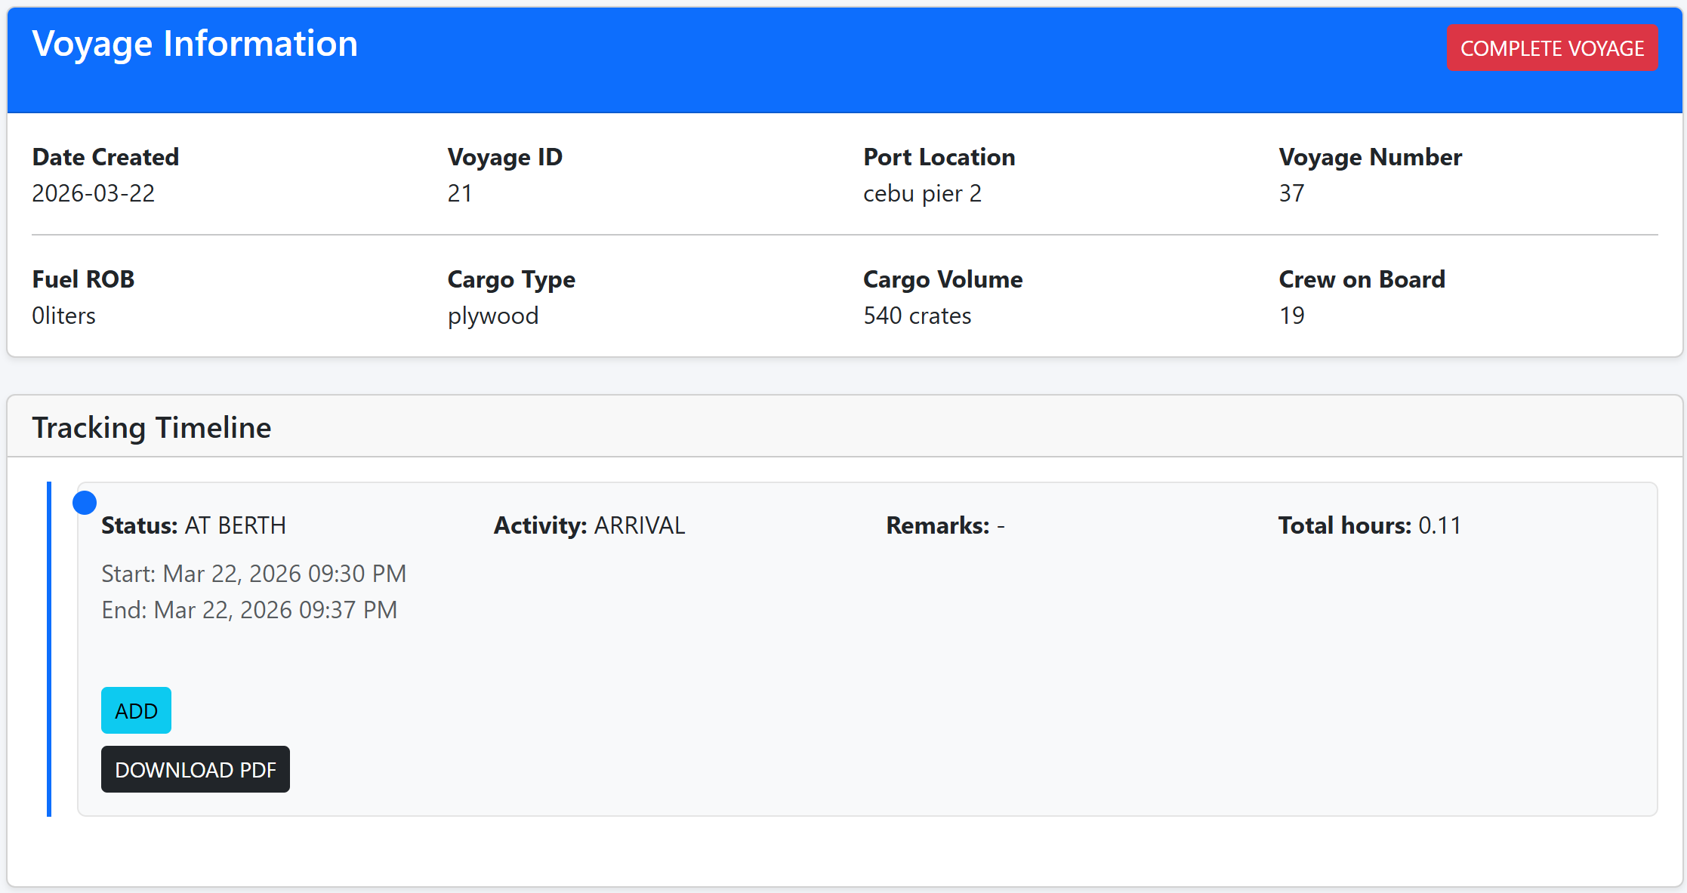
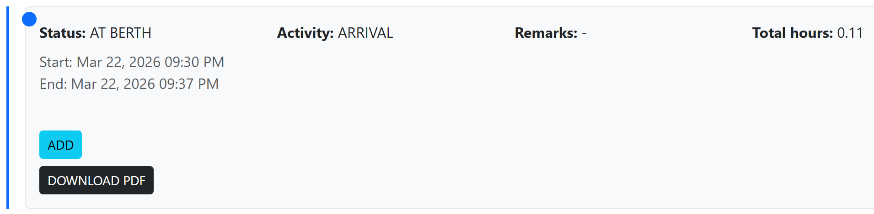
After clicking “COMPLETE” button the “ADD” button will appear, allowing the user to add another activity for the same vessel.

After clicking the “COMPLETE” button, the “COMPLETE VOYAGE” button in the header will be displayed, which finalizes the overall voyage for the vessel.



By clicking the “ADD” button opens a new activity pop-up form, allowing the user to create another activity for the same vessel.

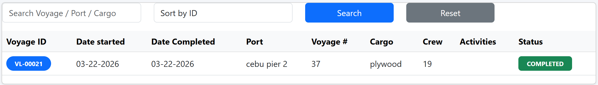

Clicking the “COMPLETE VOYAGE” button finalizes the voyage and all its activities. After completion, no additional activities can be added, and the voyage status will be set to “COMPLETED.” To start a new voyage, a new voyage record must be created.

- PDF Report Example
User Action | System Response | Expected Result
Click “Download PDF” | System generates a PDF of the selected activity or voyage | The user can download a PDF for a single activity or for the entire completed voyage. All completed activities and voyage details are included in the report
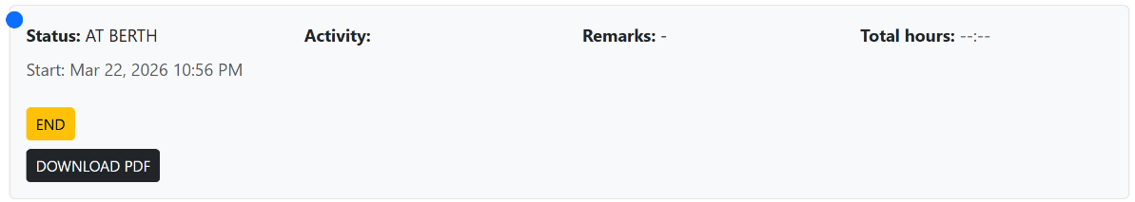

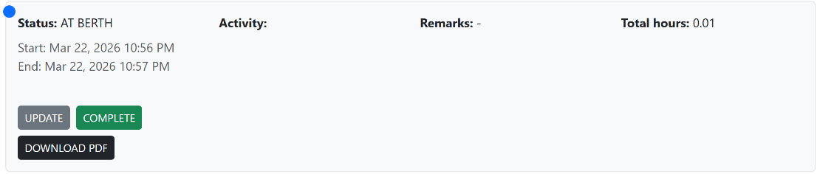

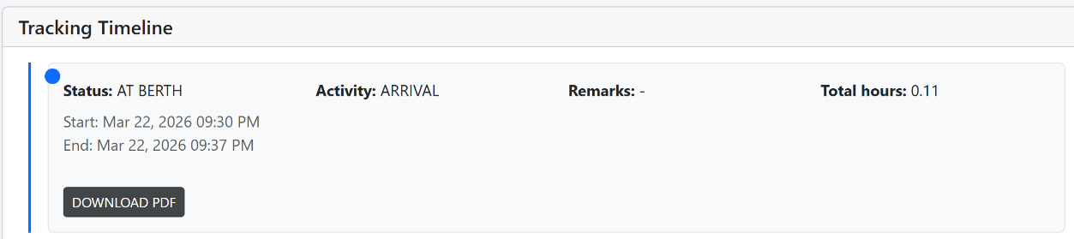

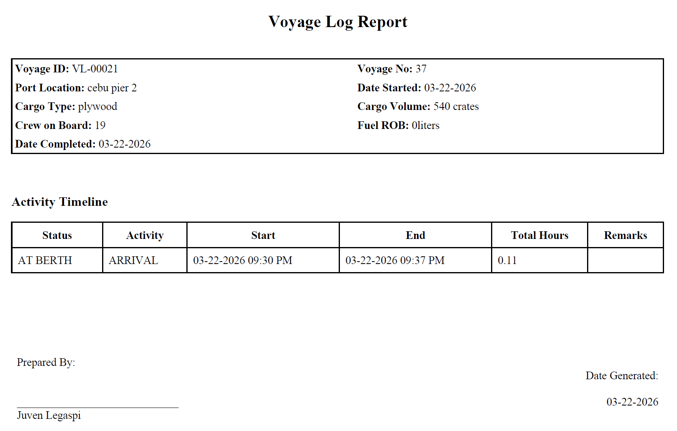

Document Approval and Acceptance
Signature  Name  Position | This document has been prepared by:  Juven Legaspi System Developer DATE
Signature  Name  Position | This document has been reviewed by:  Deniah Jean Placibe DATE  System Researcher
Signature  Name  Position | This document has been reviewed and approved by:  Dr. Guy D. Gabison DATE  HR Director
Signature  Name  Position | This document has been approved by:  Lloyd R. Bohol DATE  Villa Shipping President

