Document Information
Division | Module Name
Villa Shipping | Villa Shipping | Vessels
Subject
Vessel Monitoring System

Version | Date | Author
.01 | March 13 ,2026 | Juven Legaspi
Description
This is the proposed solution design to meet the requirements for Vessel Monitoring System under the Villa Shipping Division. The purpose of this system is to replace the current manual process of recording vessel activities and voyage logs with a centralized digital monitoring system. Through this system, authorized users will be able to record, monitor, and generate reports related to vessel operations and voyage activities. The solution is intended to improve data accuracy, operational efficiency, and real-time visibility of vessel movements and activities.

Table of Contents
Document Information 1
Overview 2
Objectives 2
Scope of the System 2
Requirements 3
Specifications 4
Expectation 6
Conditions 8
Test Script 9
Document Approval and Acceptance 12

Overview
The Vessel Monitoring System is designed to automate the process of tracking vessel activities and voyage logs within the Villa Shipping Division.
Currently, vessel operations and voyage activities are recorded manually. This manual approach can lead to:
- Inconsistent record keeping
- Delayed reporting
- Data inaccuracies
- Difficulty in tracking vessel movement history
By implementing a digital monitoring system, vessel information, voyage logs, and operational activities will be recorded and stored within a centralized system.
This will allow authorized personnel to easily monitor vessel operations, review voyage history, and generate reports when needed.
The system will also introduce structured access control to ensure that only authorized users can view or manage specific vessel records.

Objectives
The primary objectives of the Vessel Monitoring System are:
- To digitalize vessel voyage logging processes
- To improve operational transparency and monitoring
- To reduce human error caused by manual recording
- To provide a structured system for tracking vessel activities
- To allow authorized users to generate reports for operational review
- To ensure data consistency and historical tracking of vessel movements

Scope of the System
The Vessel Monitoring System will cover the following functionalities:
- Vessel registration and management
  - The system will allow administrators to create and manage vessel information that will be used for voyage tracking.
- Voyage log creation and monitoring
  - Authorized users will be able to create voyage logs associated with specific vessels.
- Activity Monitoring
  - Users will be able to record operational activities that occur during a voyage.
- Status Tracking
  - The system will provide status indicators that reflect the operational condition of the vessel.
- Reporting
  - The system will allow users to generate reports summarizing voyage logs and vessel activities.
The system will be accessible through a web-based interface and integrated within the Villa Shipping Division System.

Requirements
- Vessel Creation and Management
  - The system shall allow the System Administrator to create and manage vessel records.
  - Each vessel record must contain essential information required for operational monitoring.
    - Condition
    - Only the System Administrator can create or modify vessel records.
    - Vessel records must contain the necessary identification and operational details.
    - Each vessel may have assigned personnel responsible for logging voyage activities.
- Creation of Voyage Logs
  - Voyage logs represent the operational journey of a vessel during a specific trip.
  - Authorized users may create voyage logs for vessels assigned to them.
    - Condition
    - Only the Captain or an authorized user assigned to the vessel can create voyage logs.
    - Each voyage log must contain operational details such as cargo information and vessel location.
    - The system must generate a unique Voyage ID for each voyage
- Voyage Activity Management
  - Allows users to record operational activities that occur during a vessel’s voyage.
  - Activities represent operational events such as vessel movement, docking, sailing, anchoring, or other operational updates.
  - Each voyage log may contain multiple activity entries, creating a timeline of vessel operations throughout the voyage. Each activity entry will include:
      - Vessel operational status
      - Activity description
      - Additional remarks
      - System-recorded timestamps
    - Condition
    - Only the Captain or authorized users assigned to the vessel are allowed to add, update, or complete voyage activities. Each activity must be associated with an existing voyage log.
    - .Activities must follow the defined workflow for starting, ending, and completing activities. Once a voyage is marked as Completed, no additional activities may be added or modified unless authorized by the System Administrator.
- Activity Execution
  - The process of recording vessel operational events during a voyage. Users interact with system controls such as Add Activity, Start, End, Complete, and Update to record vessel activities accurately.
  - This process allows the system to capture the timeline and operational status of the vessel throughout the voyage.
    - Adding an Activity
    - Only the Captain or authorized user may click the Add Activity button to create a new activity record. Each activity must be linked to an existing voyage log.
    - Multiple activities may be recorded under a single voyage.

    - Starting an Activity
    - Only the Captain or authorized user may click the Add Activity button to create a new activity record. Each activity must be linked to an existing voyage log.
    - Multiple activities may be recorded under a single voyage.

  - The system should allow system admin to setup up and to create vessel. The created vessel should have the necessary fields:
    - Capture necessary data, of the vessel and its voyage/trip.
    - Condition: only the captain of the ship/allowed user can only view the logs of its designated vessel. Its an ownership on the vessel.
- Creation of Logs in the assigned vessel or adding activity voyage
  - Only the captain assigned to a specific ship is allowed to add voyages and view the listing of that ship
    - Captured necessary data and the important field is the location of the ship.
- Creation of Activity within that added logs.

- Status and sub status
  - The system shall provide the status of the activity for users to track.
- Data Reporting
  - The system shall generate a PDF report for printing
  - The report shall include all voyage activities per voyage logged
  - The report shall allow users to filter by desired data needed
  - Acceptance criteria:
    - The system shall generate the report with accurate and complete data.
    - The system shall allow users to export the report.
- Button access
  - Only the captain/allowed user and manager will can click the button add, start complete and complete voyage.

Specifications
The Vessel shipping module in Villa system and company will include the following fields:
- Vessels – vessel setup that is only seted up by the system administrator
  - Vessel name – Name of the vessel
  - Vessel type – type oy the vessel
  - Service speed – service speed
  - IMO Number -
  - DWT – dead weight
  - Fuel type – type of the fuel
  - Charter type – type of the vessel if drydock or voyage
  - Call sign –
  - Fuel type - type of…
  - Vessel Status (Dropdown: Operational and non operational)

- Adding of Voyage Logs – These logs are inputted per vessel
  - Voyage ID - Unique Id of the voyage
  - Cargo Volume –
  - Port Location - The location of the current vessel
  - Fuel ROB – ( in litres)
  - Cargo Type – kinds of cargos inside the vessel
  - Crew on board – lists and how many crew members are in the vessel
  - Voyage number – unique voyage number given on the vessel from the port
  - Date creation – an auto populated field, this is not found upon creating the voyage, but it is the date where the voyage is created in that location, This will display when you hit save the voyage log
- Adding of Activity
  - Status – a dropdown field where a lists of the vessel statuses is indicated (ex. At berth, sailing, anchored, drydock, delayed..etc)
  - Activity – a free text field where you put the activity detail
  - Remarks – where you put a note or remark on the activity.

Expectation
The following wireframe illustrates the expected user interface and layout of the Collection module.
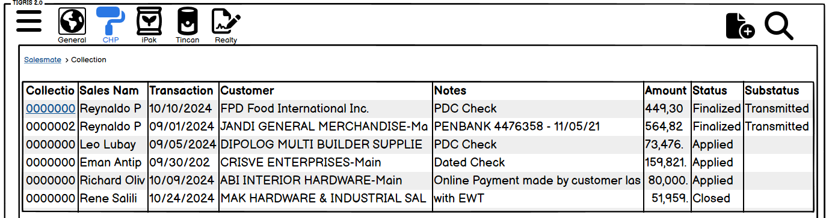

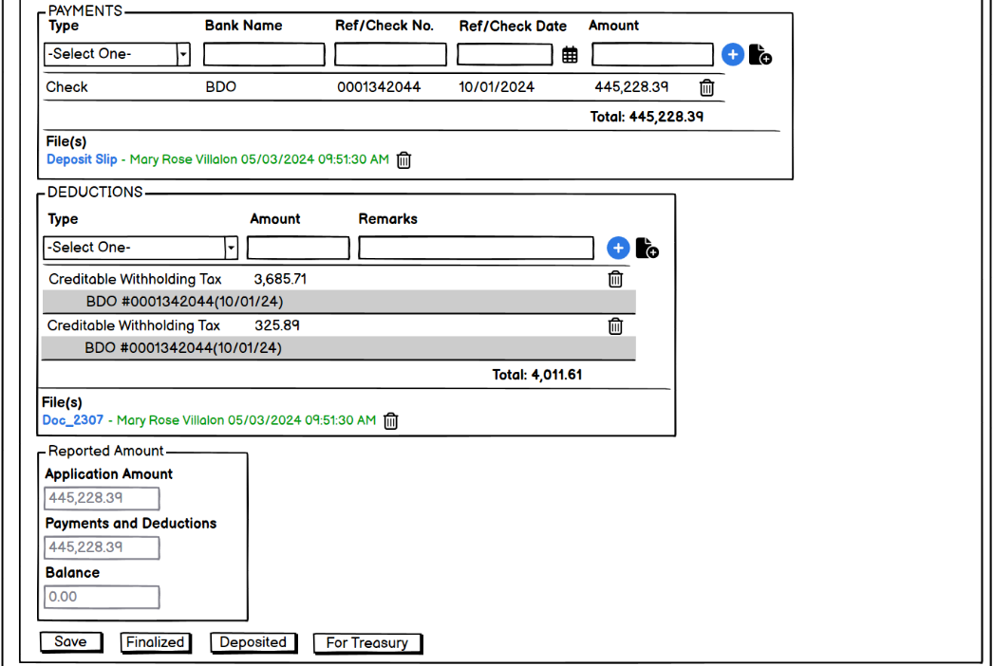
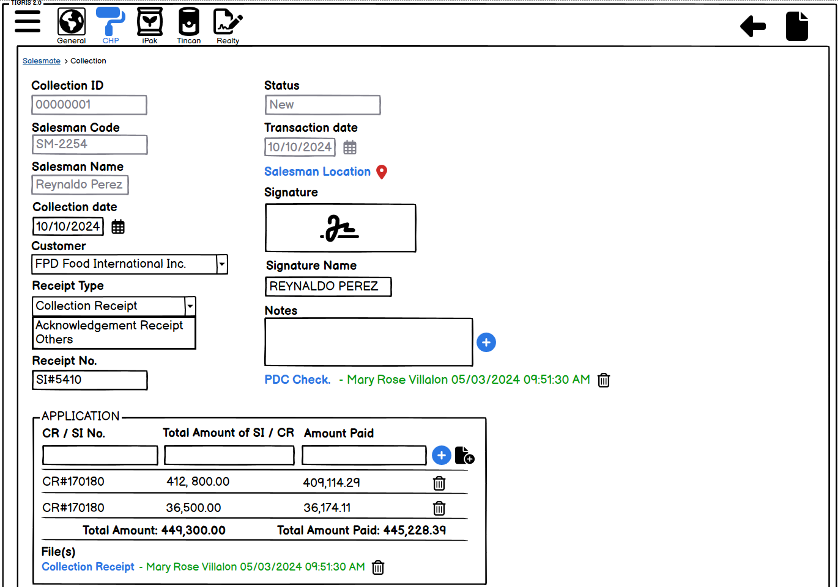

Below is the Daily Collection Report (DCR) of the collection officer / Salesman which is generated through the D365 system.

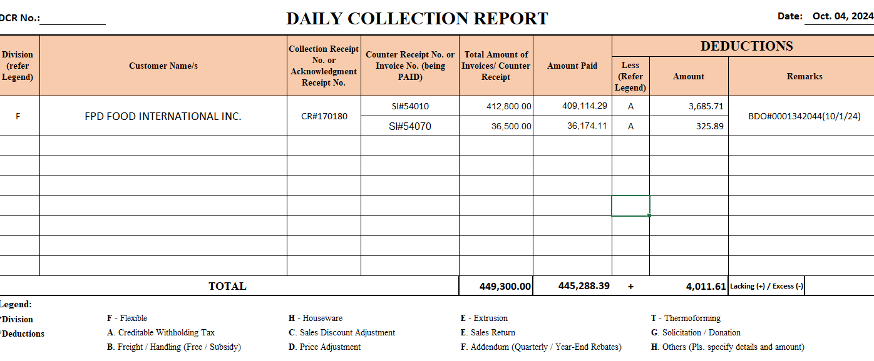

Conditions
Auto-populated data:
- Collection ID: Automatically generated upon creation of a new collection, with an incremental format.
- Salesman Code: Automatically populated with the corresponding salesman code of the user who logs in to the system.
- Salesman Name: Automatically populated with the corresponding salesman name of the user who logs in to the system.
- Status:
  - New: When a new collection is created.
  - Draft: When the collection is saved but not finalized.
  - Finalized: When the collection is finalized, with two buttons displayed: "For Treasury" and "Deposited".
  - Submitted: When the collection is submitted to Treasury and Statutory.
  - Deposited: When the collection is deposited to the bank
  - Confirmed: When the collection has been confirmed both by the Treasury and Statutory and the journal has been created in the D365 system. (This serves that the collection is now closed)
Receipt Type:
- If the receipt type is set to "Acknowledgement Receipt", the withholding tax dropdown choices under the deduction column will be omitted.
- If the receipt type is set to "Collection Receipt", the withholding tax will remain.

Finalized Button:
- After clicking the finalize button, the "Deposited" and "For Treasury" buttons will be displayed.
- The "Deposited" button will only be displayed if the payment type selected are Cash and Check.
Deposited Button:
- The “Deposited” button will only be displayed for the following payment types:
  - Check - Bills Payment (where the check has already been deposited to the bank)
- When the "Deposited" button is clicked, the auto-creation of journal in D365 will be omitted.
- An attachment (e.g., payment slip/deposit slip) will be required and uploaded under the payment column. Else the processes will not proceed.
Auto-creation of Journal:
- Once the collection has been submitted to Treasury with a submitted status, and they validate, and everything checks out they will click the "Confirmed" button. Once confirmed, there will be an auto-creation of journal, and auto-creation of journal will only be applicable to the following payment types:
  - Check - Regular Deposit
  - Cash
  - Fund Transfer
Reported Amount:
- This is a calculated field where the total Application Amount and the total Payments and Deductions should be balanced out means the Balance field below them should be marked Zero. Else the process will not proceed.

Test Script
- Login and Navigation
  - Login to the new domain: http://10.8.8.8/
  - Enter the username and password in the login form
  - Click the "Sign in" button to authenticate
  - Navigate to the hamburger icon on the upper left and click Collection under Accounting Module

- Adding New Collection
  - On the Collection window, you will see lists of Collection transactions.

  - To add a new collection, click the "+" icon on the upper left corner.
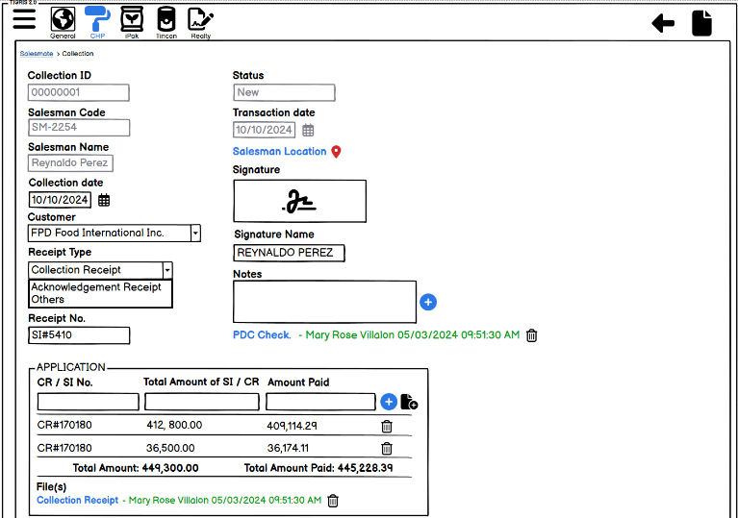

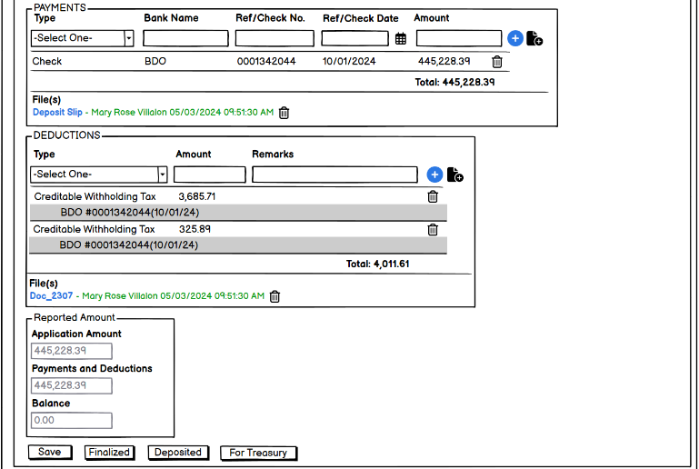

  - Fill in the necessary fields:
    - Collection Date
    - Select a Customer from the dropdown list.
    - Choose a Receipt Type from the dropdown list.
    - Enter a valid Receipt No.
    - Select a Salesman Location from the map
    - Enter a Signature.
    - Enter a Signature Name
    - Enter any relevant Notes.
    - Enter a valid CR / SI No.
    - Enter the Total Amount of SI / CR.
    - Enter the Amount Paid.
    - Upload a valid File
    - Choose a Payment Type from the dropdown list.
    - If the Payment Type is not Cash, enter a valid Bank Name.
    - If the Payment Type is not Cash, enter a valid Ref/Check No.
    - If the Payment Type is not Cash, enter a valid Ref/Check Date.
    - Enter a valid Amount.
    - Choose a Deduction Type from the dropdown list.
    - Enter any relevant Remarks.
  - Click the "Save" button to save the new collection.
  - Once reviewed, click “Finalized” button
  - After clicking, 2 buttons will appear, “Deposited” and “For Treasury”
    - Verify that the "Deposited" button is only applicable when the Payment Type is Check with a lead time of 1-7 business days (Bills Payment).
    - Verify that the "For Treasury" button is only applicable when the Payment Type is Check with a lead time of 7 or more business days (Post Dated Check (PDC)).

- Routing to Treasury and Statutory
  - Both Bills payment and PDC will route to Treasury and Statutory and will have the following interface:
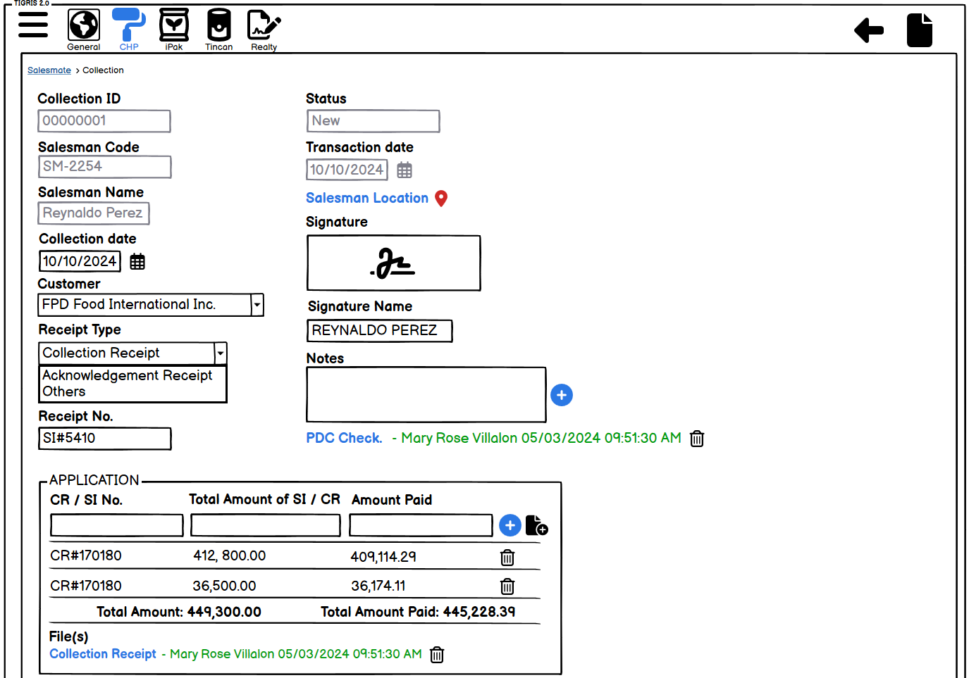

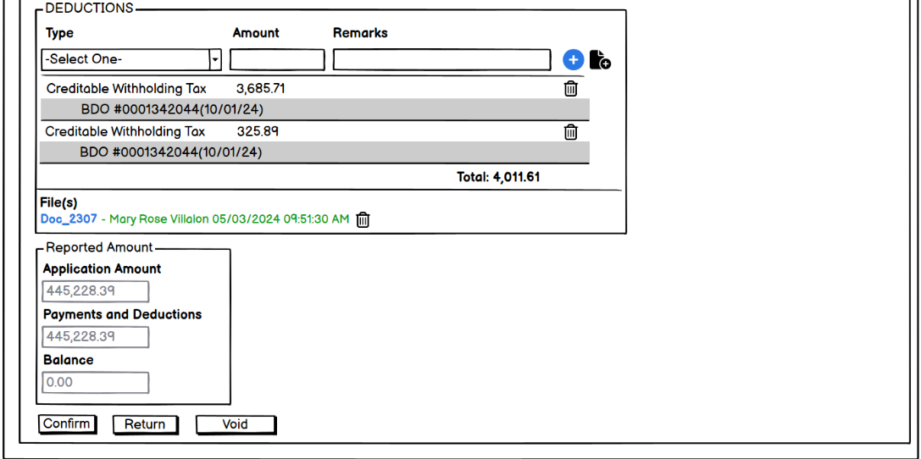

  - Click the "Confirm" button to complete the process.

Document Approval and Acceptance
Signature  Name  Position | This document has been prepared by:  Jesamarie Baylosis ERP Functional DATE
Signature  Name  Position | This document has been reviewed by:  Leoniel Lim DATE  DEV/ERP – IT Manager
Signature  Name  Position | This document has been reviewed and approved by:  Christopher Ong DATE  IT Director
Signature  Name  Position | This document has been approved by:  Emmanuel Ong DATE  SBU Head - CHEMPAINTS

