Table of Contents
Table of Contents 1
Version: Project #1 2
Storing & Initializing 2
Save Image 2
Load Image 3
Change Directory 3
Apply Negativity to an Image 3
Add Images 4
Subtract Images 5
Multiply Images 5
Log Transform 6
Power Transform 7
Choose Interpolation Method 9
Choose Connected Labeling Method 11
Version: Project #2 12
Update Input Image with Output Image 13
Histogram Equalization 14
Histogram Equalization Comparison 16
Gaussian Smoothing 22
Sobel Edge Detection 23
Unsharp Masking 24

Version: Project #1
Note: Click Version: Project #2 to see the Project#2 Update Content

Storing & Initializing
Images are expected to store in the “data” folder.

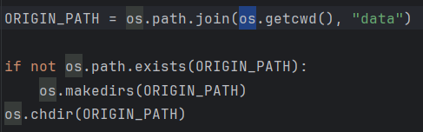

Only 3 images are loaded initially for input_image1 and input_image2
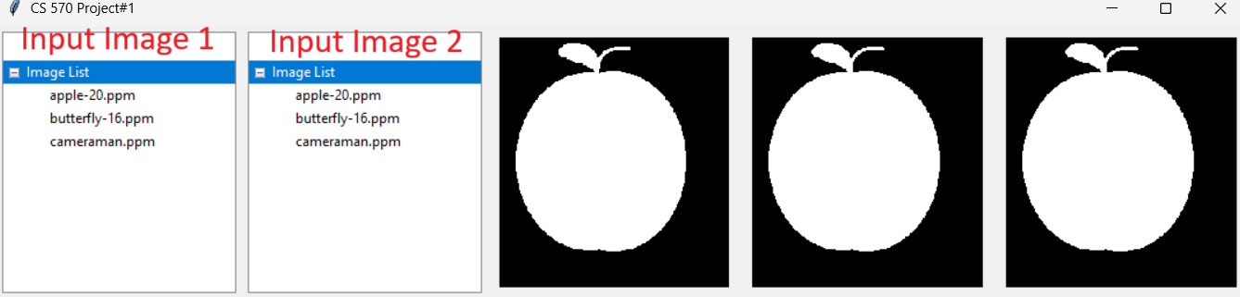
Destination of the current path:

Save Image
By typing save <imagename> like below will save the output image
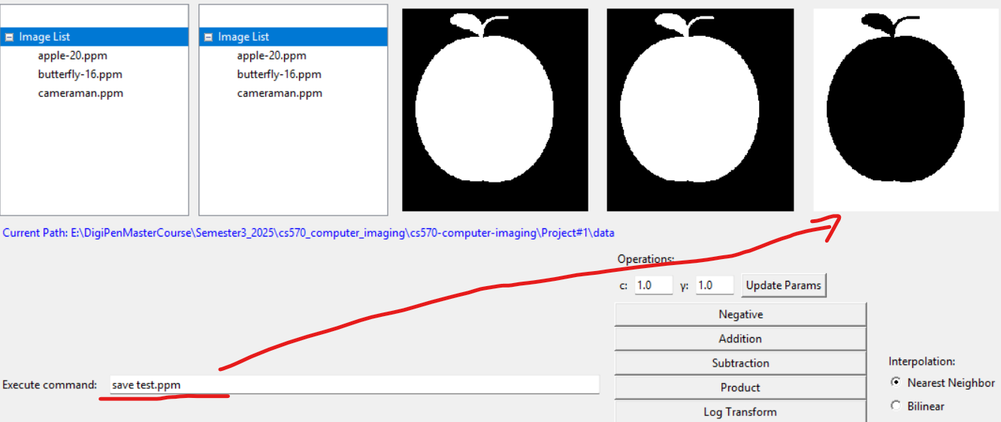
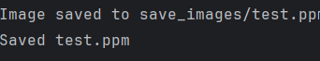
If you see the log below, it means that the image is successfully saved.

Load Image
By typing load <imagename> like below will load the target image
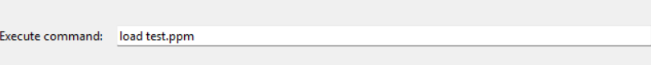
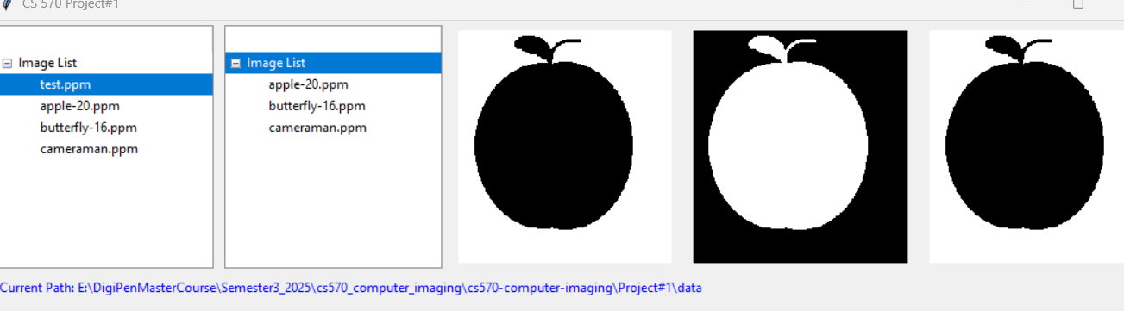

Change Directory
By typing cd <directory> like below will change the directory to the target
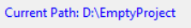

Apply Negativity to an Image
Press “Negative” here to apply a negative to an image.
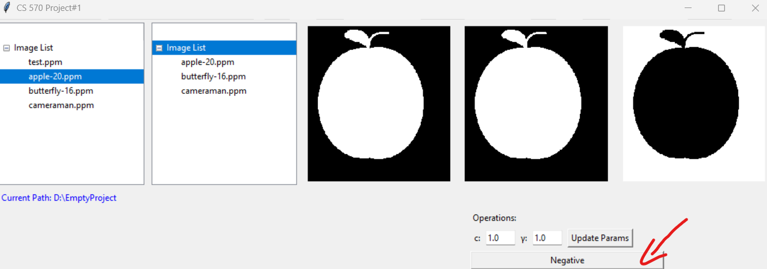
Command works as well

Add Images
Press “Addition” here to add 2 images
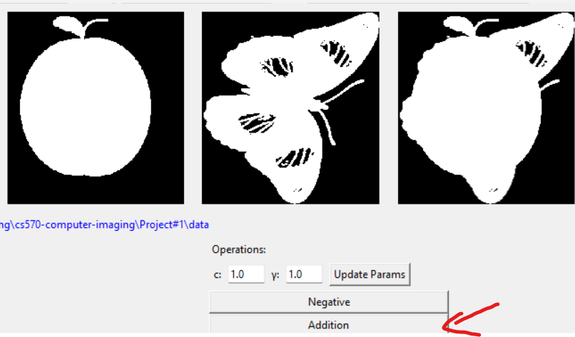

Command works as well

Subtract Images
Press “Subtraction” here to subtract 2 images
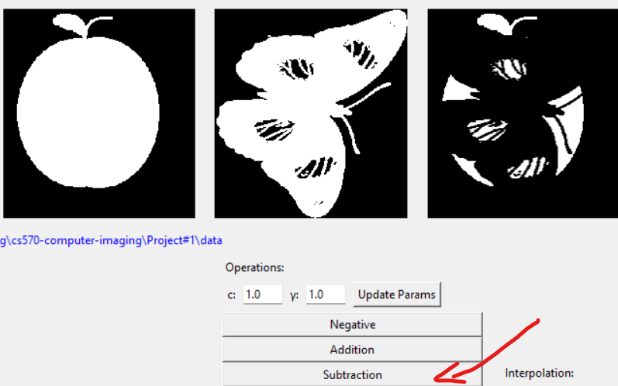
Command works as well

Multiply Images
Press “Product” here to multiply 2 images

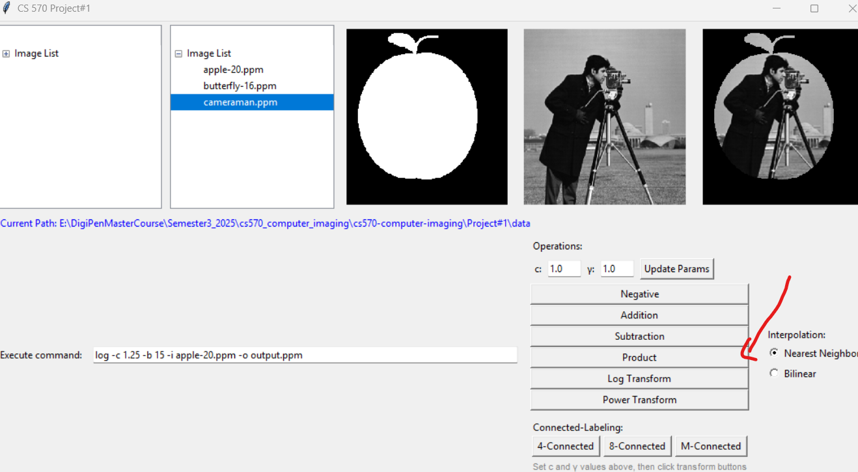
Command works as well

Log Transform
Press “Log Transform” here to log transform
You can modify ‘c’ at the top, and press “Update Params” to update
Version Project#2, you can just modify the variable without pressing “Update Params” now.
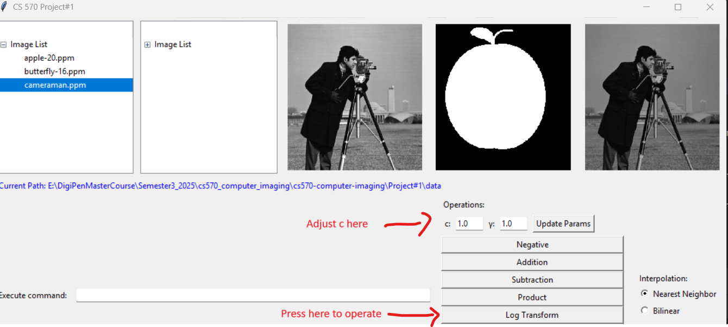
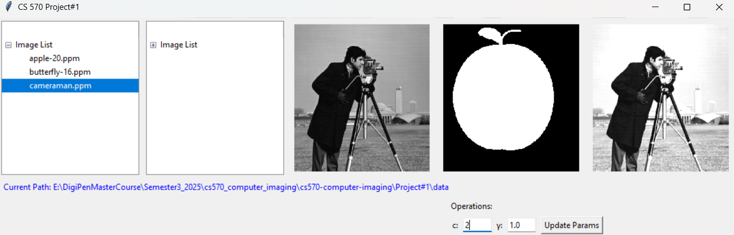
Command works as well

Power Transform
Press “Power Transform” here to power transform
You can modify ‘c’ and ‘gamma’ at the top, and press “Update Params” to update
Version Project#2, you can just modify the variable without pressing “Update Params” now.
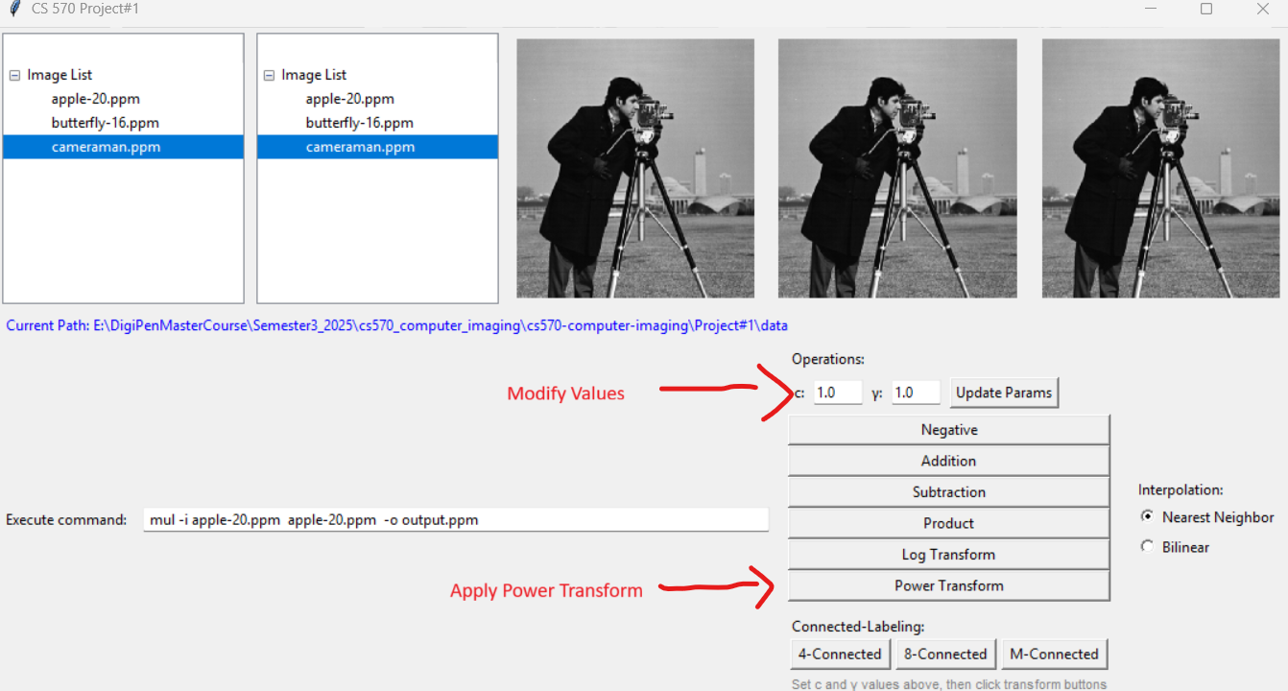
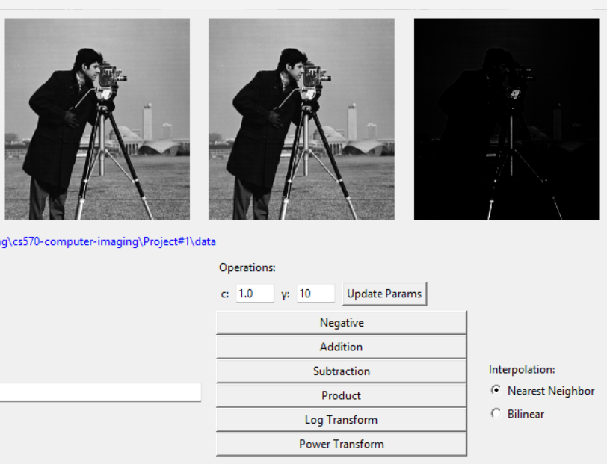
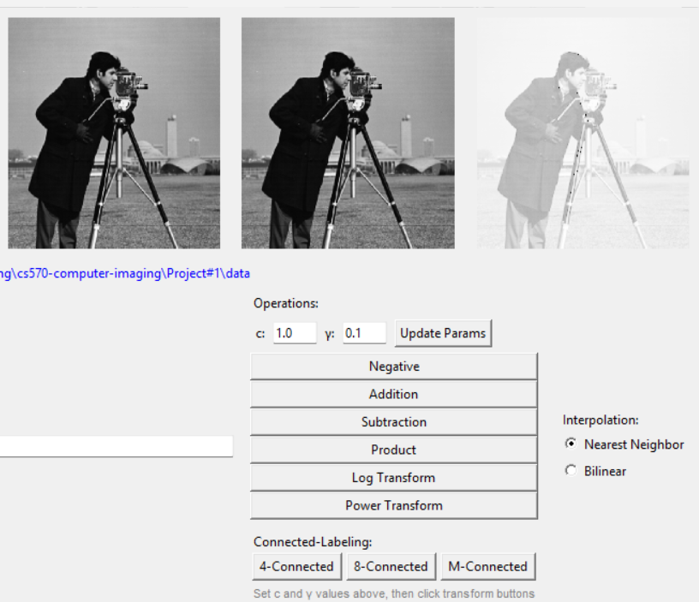
Command works as well

Choose Interpolation Method
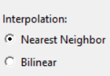

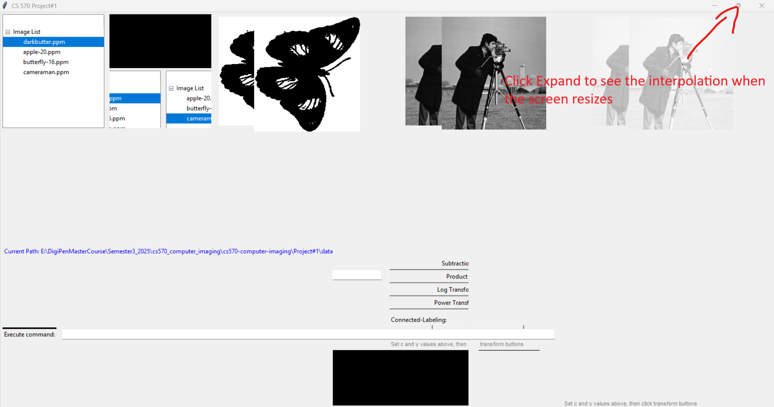

Choose Connected Labeling Method
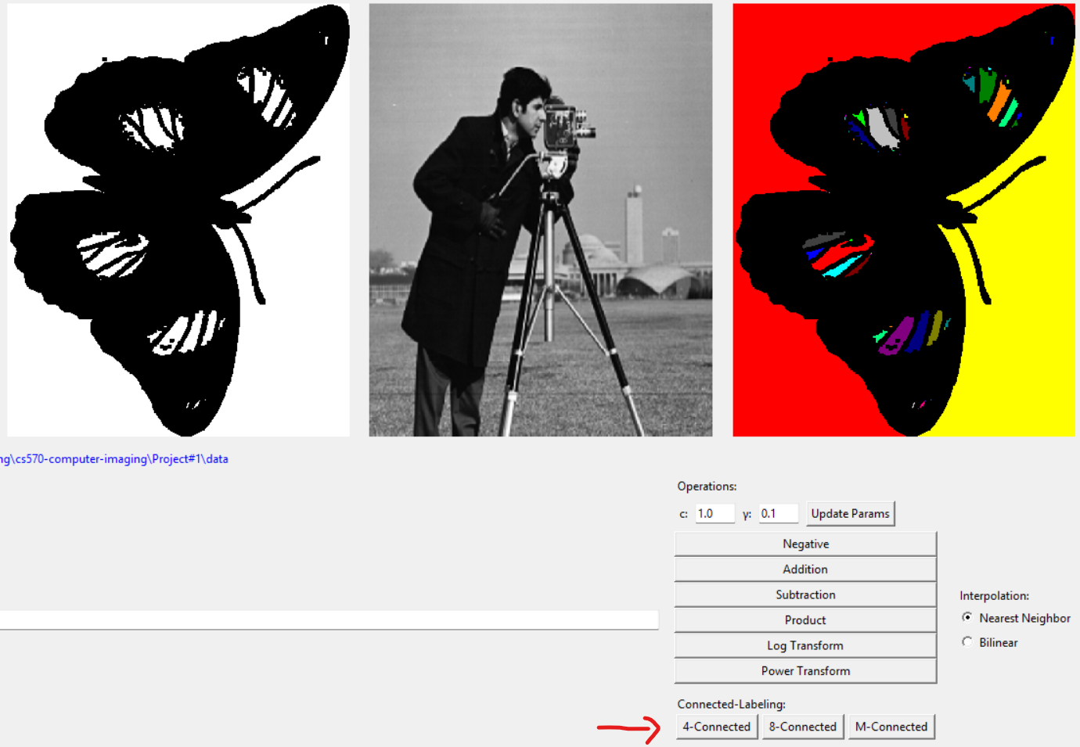

Version: Project #2
Change Logs
- Update the user interface window new features.
- New Features
  - Update Input Image with Output Image
  - Histogram Equalization (Standard Method)
  - Histogram Equalization OpenCV
  - Gaussian Smoothing
  - Sobel Edge Detection
  - Unsharp Masking

Update Input Image with Output Image
After performing an operation between 1 or 2 images resulting in the output image. You can press “Update Input Image with Output Image”, to update the input image without saving the output image with commands.

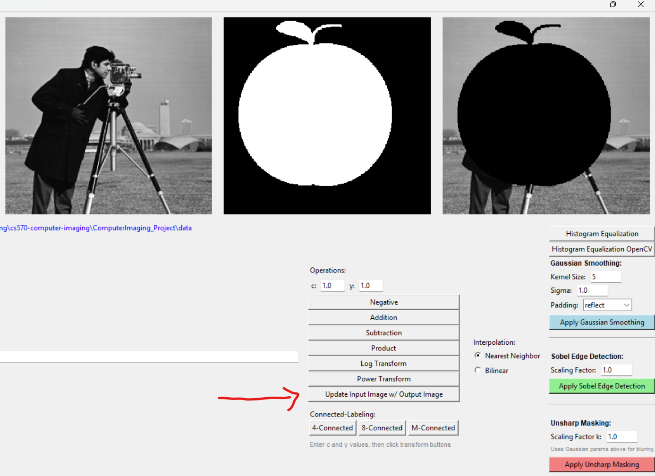
Now, the input image is updated, and you can do any operation you want after it.
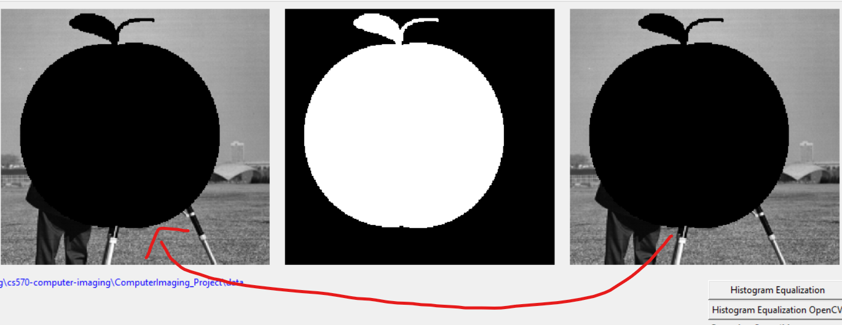

You can do this. This is an addition of images, after updating the input.
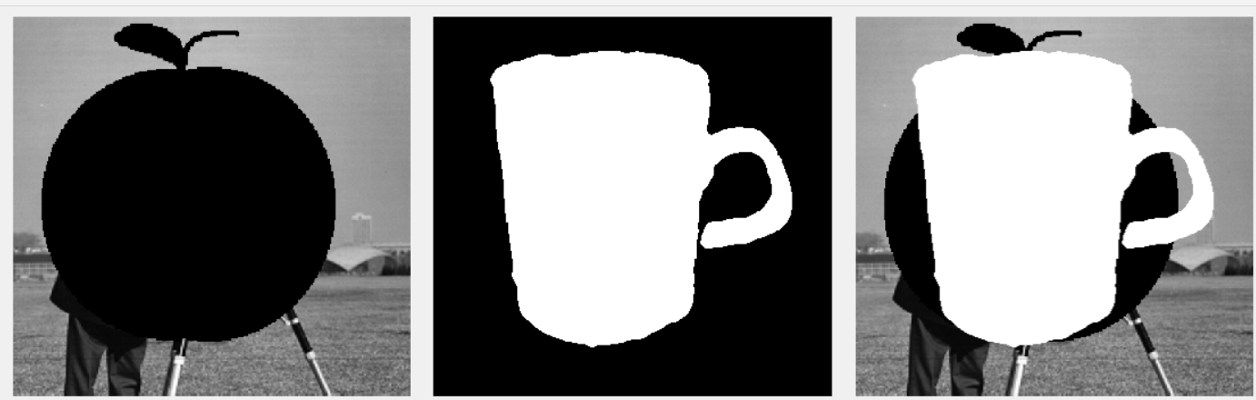

Histogram Equalization
Press these 2 buttons on the right to either perform Histogram Equalization traditionally or with OpenCV.

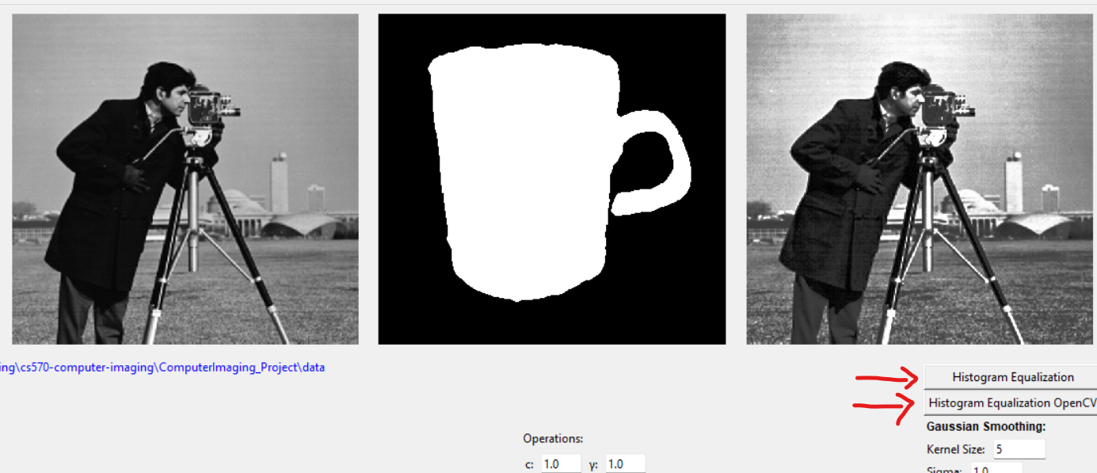

After you press either of them, the histogram tables will pop up.
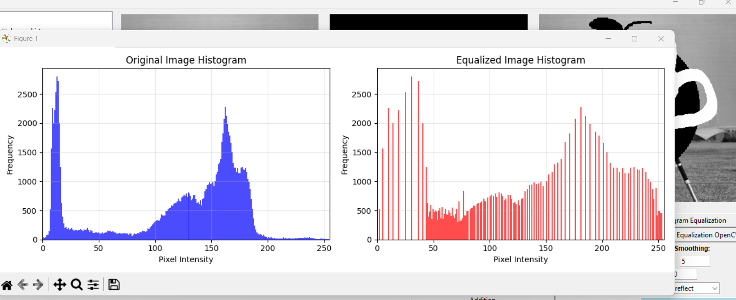
Note: you need to close the Histogram Table’s window to see the result of Histogram Equalized image.
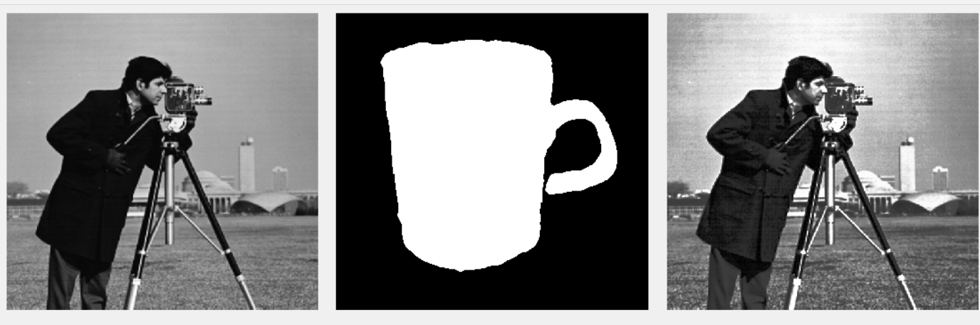

OpenCV Special Case: By using the OpenCV version, you will see an additional histogram table using a standard method for comparison. You will need to close the window to see the result of the output image.
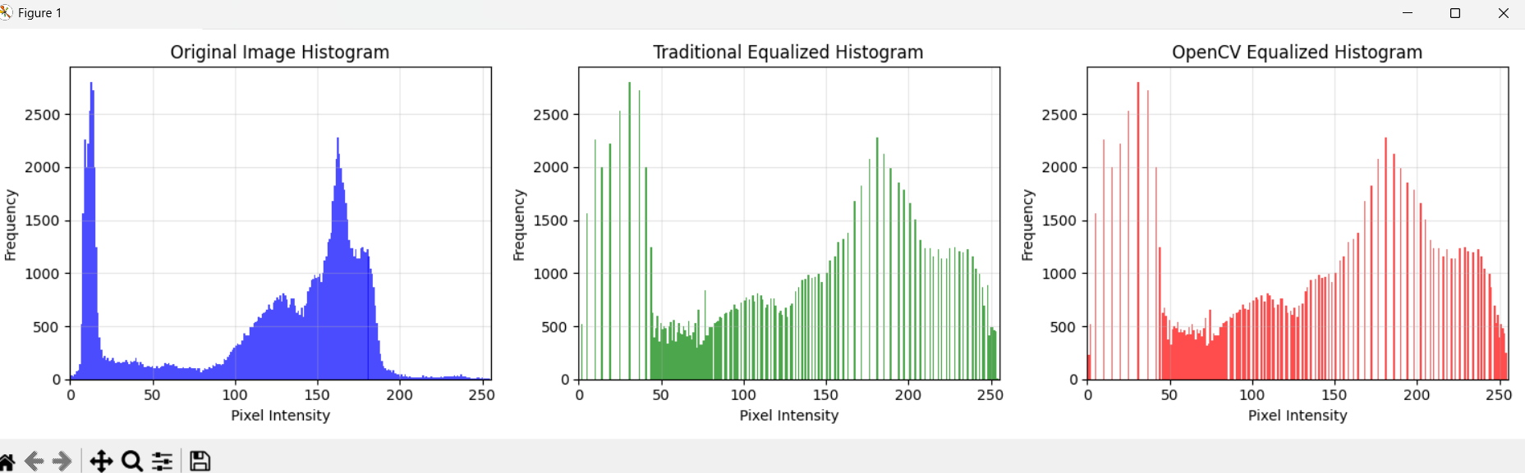
Command works as well (It uses the traditional method)
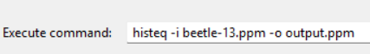
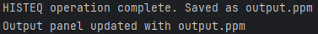

Histogram Equalization Comparison
Standard Vs OpenCV

Testing with beetle-13.ppm (Black and White Image)

Original Image


Standard Method
Output After Standard Histogram Equalization
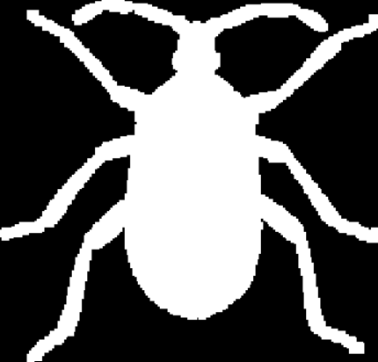

Standard Histogram Tables Comparison
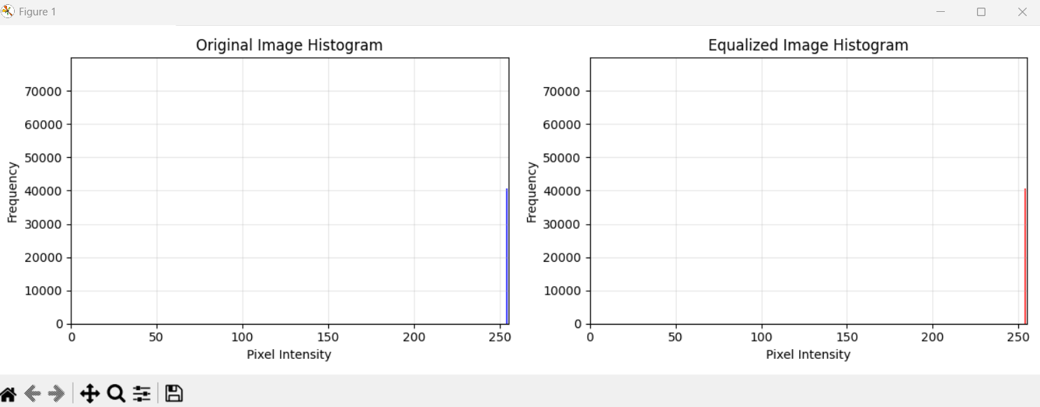
OpenCV Method
Output After OpenCV Histogram Equalization
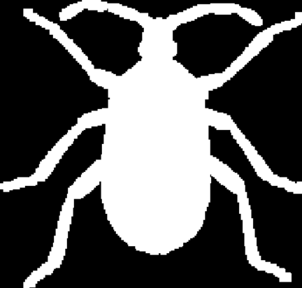

OpenCV Histogram Tables Comparison
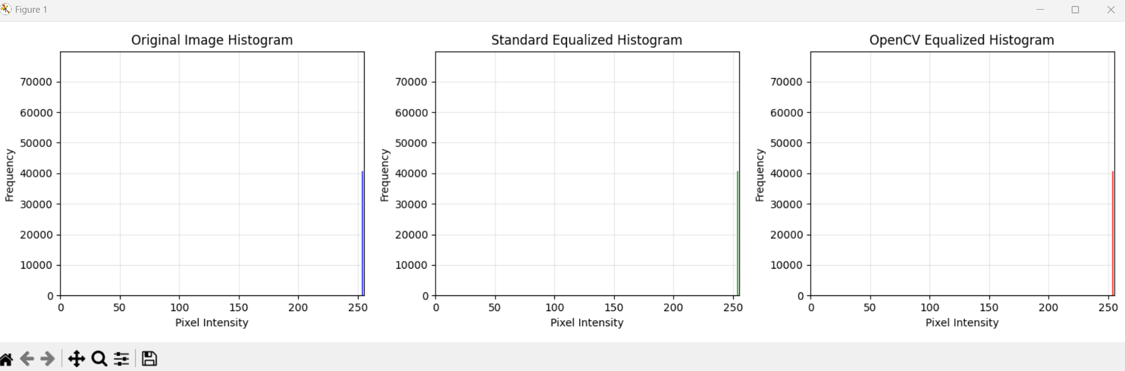

Standard vs OpenCV Tables
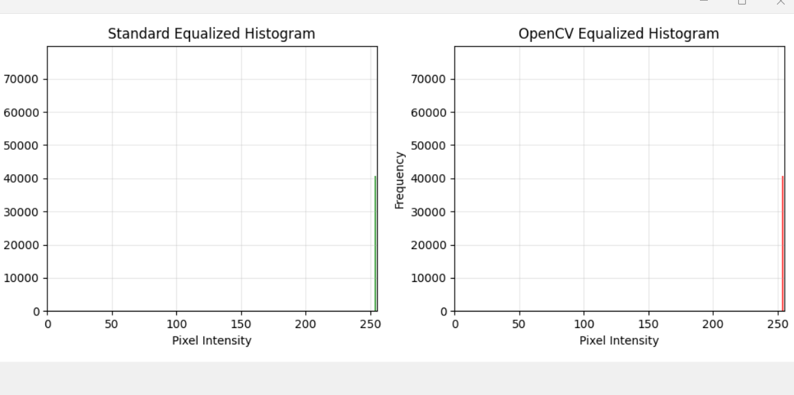
Testing with cameraman.ppm (Grayscale Image)

Original Image
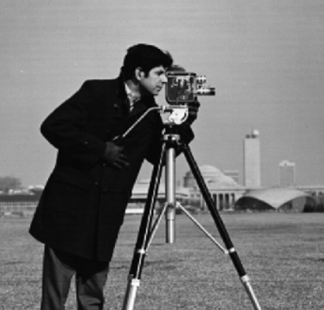

Standard Method
Output After Standard Histogram Equalization
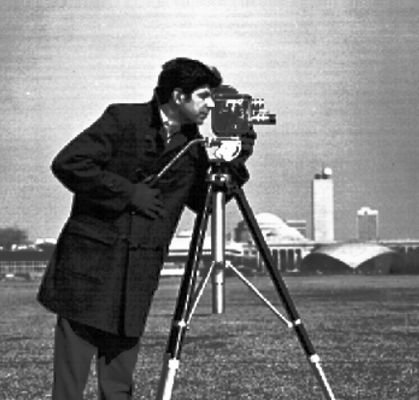

Standard Histogram Tables Comparison

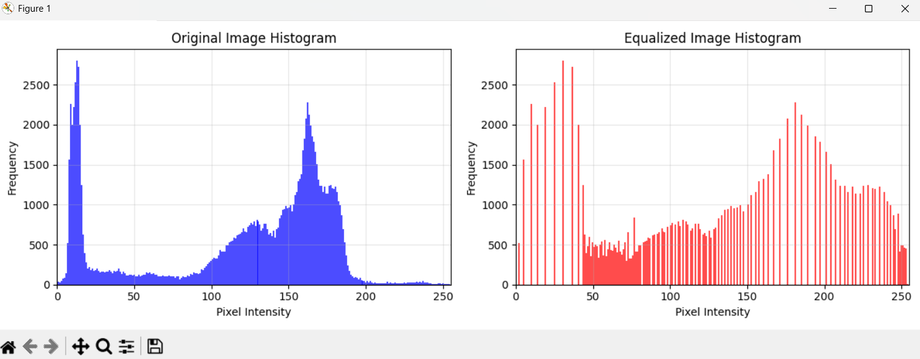

OpenCV Method
Output After OpenCV Histogram Equalization
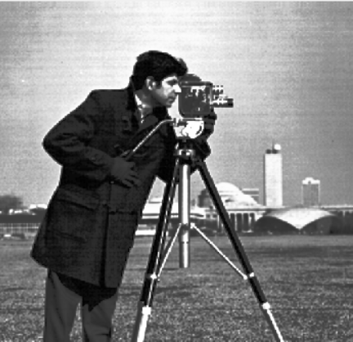

OpenCV Histogram Tables Comparison
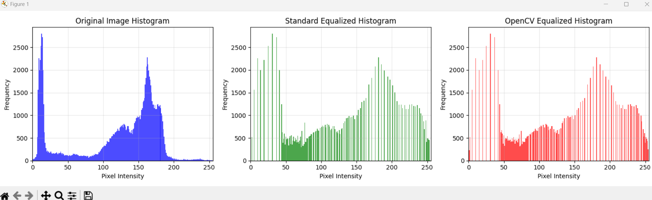

Standard vs OpenCV Tables
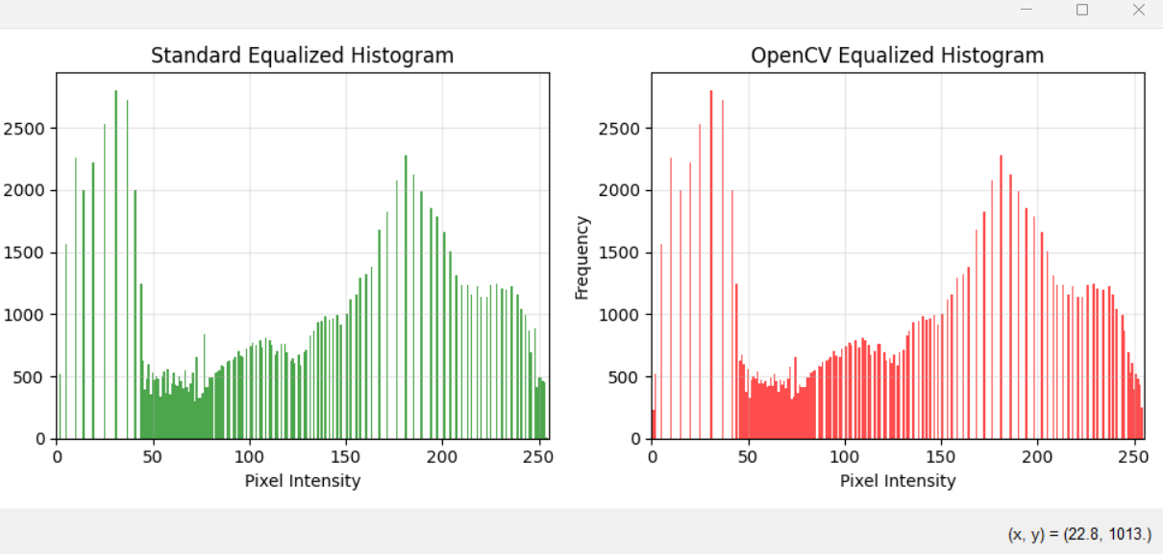
Standard vs OpenCV Outputs


Conclusion & Analysis of Standard Histogram vs OpenCV
For beetle-13.ppm (a black-and-white image containing only intensity values of 0 and 255), the histograms produced by both the standard and OpenCV equalization methods show no difference. This is because the image already uses only two extreme intensity values, leaving no range of gray levels to redistribute.
For cameraman.ppm (a grayscale image with a wider range of intensities), histogram equalization spreads the pixel intensities more evenly across the available range. As a result, the output images from both OpenCV and the standard implementation appear brighter and have improved contrast.
When comparing the two visually, both outputs look nearly identical to the naked eye. However, examining their histograms reveals small differences. Specifically, OpenCV’s equalized histogram shows slightly stronger peaks around intensity values 0 and 255, and a broader spread in the 0–50 range. There are also minor variations between 175–200.
Despite these subtle differences in the histogram distribution, the visual results remain effectively the same — which is what matters most in practice.

Gaussian Smoothing
Press “Apply Gaussian Smoothing” to perform gaussian smoothing. You can edit kernel size, sigma, and padding type. Make sure that kernel size is odd and at least 3 and sigma is positive.

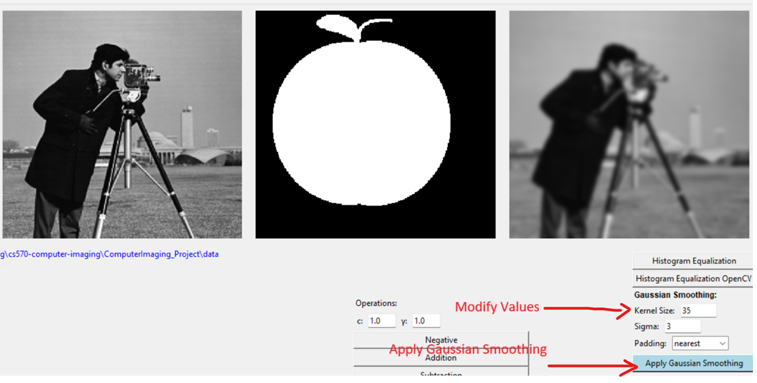

Command works as well
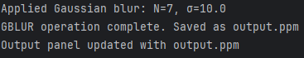

Sobel Edge Detection
Press “Apply Sobel Edge Detection” to perform sobel edge detection. You can also modify the scaling factor.

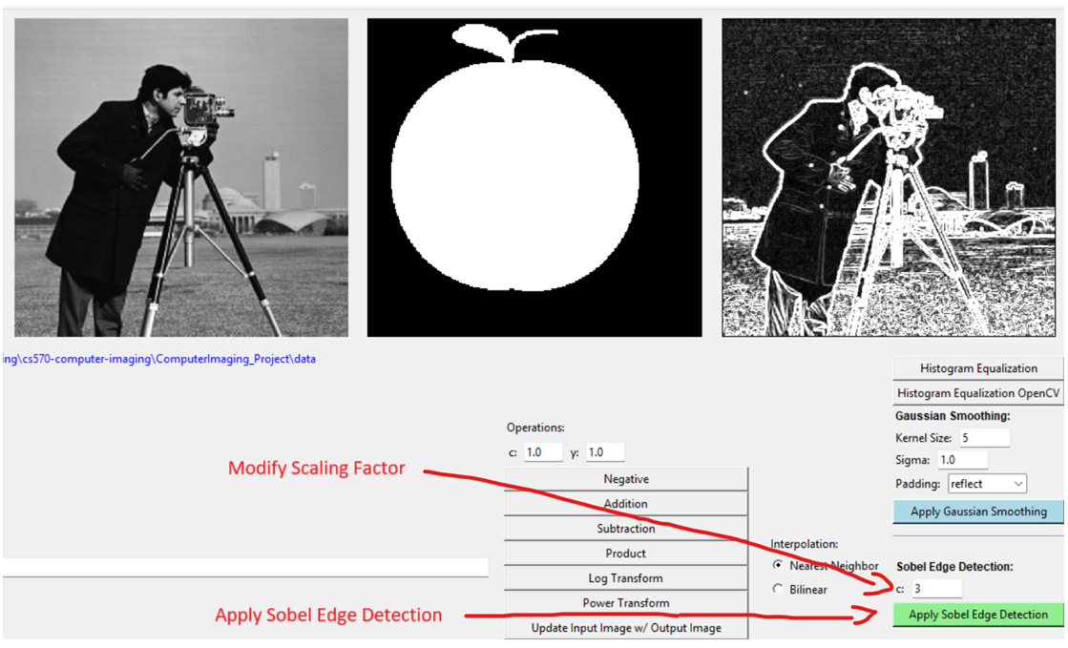
Command works as well
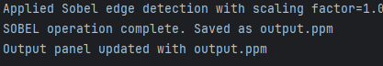

Unsharp Masking
Press “Apply Unsharp Masking” to perform unsharp masking. You can edit kernel size, sigma, and padding type at Gaussian Smoothing(as a process of it, it will use a method of gaussian smoothing to create a blur image). Make sure that kernel size is odd and at least 3 and sigma is positive. Additionally, you may edit a scale factor as well.

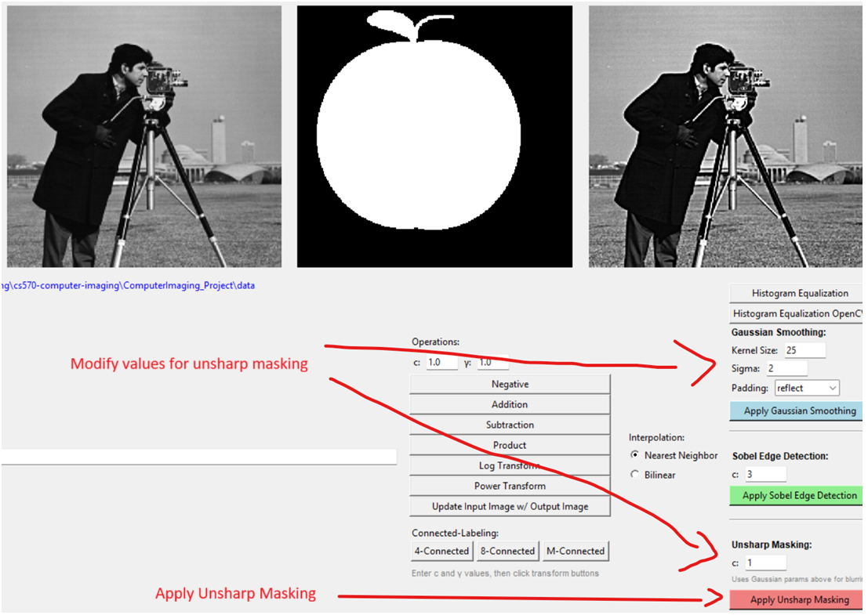
Command works as well
