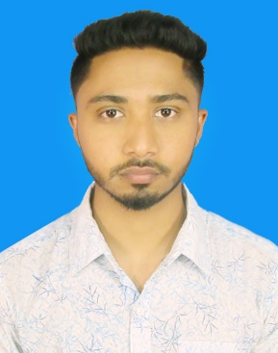**Resume of**

**Juel Ahmed**

Sadhapur, Saver, Dhaka

Mobile No:01681634774

Email :juwelahmed603@gmail.com

**Objective**

To pursue a more challenging job in a dynamic and esteemed organization where I will able to work in any kind of situation with full efforts to utilize my knowledge skills and experience for professional career development.

**Academic Pursuits**

* **Bachelor Of Software Engineering (fourth Year)**

Institution : Daffodil International University

Subject : Software Engineering

**Passing Year :** Running

* **Higher Secondary Certificate (H.S.C)**

Institution **:**Collage of Finance and Management

Group **:**Science

Board :Dhaka

Passing Year :2017

* **Secondary School Certificate (S.S.C)**

Institution **:** Chakulia High School

Group **:** Science

Board **:** Dhaka

GPA **:** 4.22 Out of 5.00

**Passing Year :** 2015

**Language Proficiency**

■ Bengali: Fluent in reading, writing, speaking & listening.

■ English: Reading, writing, speaking & listening.

**Computer Skills**

* Capable of working in windows operating System, Microsoft Office and internet browsing, etc, Capable of typing in English at a good speed.

**Responsibilities :**

* Preparation of various types of notes and dictations.
* Preparation the draft letters, statements reports.
* Maintain the files, records and documentation.

**Personal Information**

Name : Md. Juel Ahammed

Father’s Name : Md. Nasir Uddin

Mother’s Name : Julekha Begum

Date of Birth : 25 february, 2000

Permanent Address : Vill : Sadhapur Kajipara,

P.S: Nogor Kunda, Dist: Dhaka.

Religion : Islam

Nationality : Bangladeshi

Sex : Male

Marital Status : Single

**Declaration**

I, the undersigned certify that, to the best of my knowledge and belief, it correctly describes my qualification and myself.

Juel Ahammed

