Vendor Delivery Platform — Technical Architecture
Table of Contents

Vendor Delivery Platform — Technical Architecture
Status | Proof of concept complete; destroy-and-rebuild validated from automation
Audience | Engineers, architects, security reviewers
Companions | Business brief (leadership); SETUP-GUIDE.md (build walkthrough); RBAC-DELEGATION.md (access model) — platform-infra repository
Last updated | August 2026

1. Purpose and design principle
Vendor teams write and ship applications on our AWS estate without holding any infrastructure access. The platform’s single design principle: every boundary is structural, not procedural — enforced by credentials that don’t exist, trust policies that don’t match, and promotion paths that don’t connect, rather than by policy documents.

2. System architecture
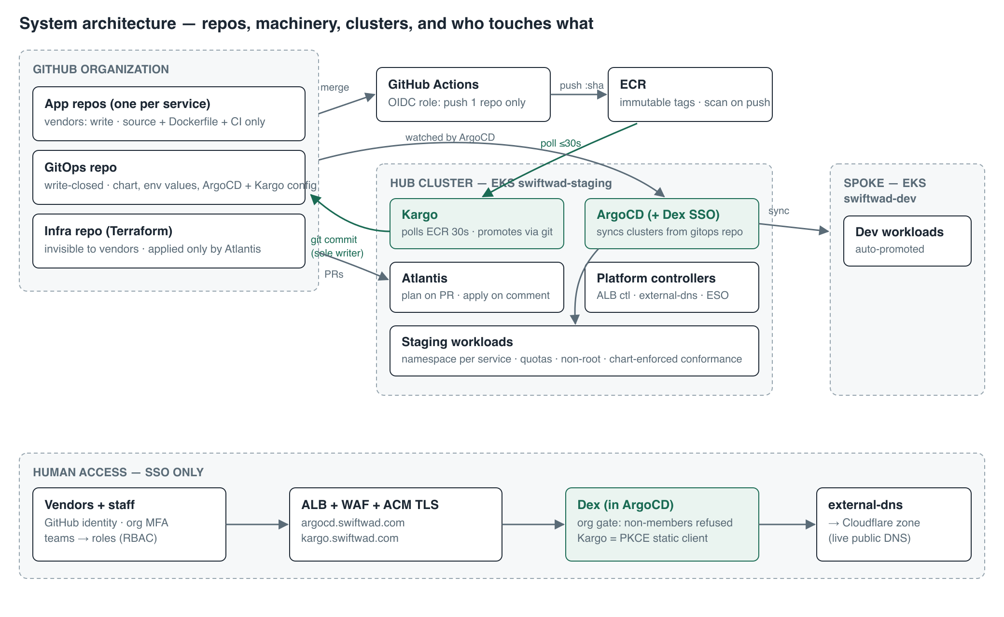
System architecture
Three repositories partition all write access; the partition is the security model:
Repository | Contents | Vendor access | Writers
App repos (one per service) | Source, Dockerfile, one CI workflow | Write | Vendor
GitOps repo | Helm chart template, envs/<env>/*.yaml, ArgoCD + Kargo config | None (read at most) | Humans by PR; Kargo is the only writer of image.tag (own deploy key)
Infra repo | Terraform, Atlantis config, docs, bootstrap script | None — not even read | Humans by PR; applied only by Atlantis
Component inventory (as deployed):
Component | Runs on | Version/pin | Identity
EKS clusters swiftwad-dev, swiftwad-staging | — | Kubernetes 1.34, AL2023 nodes | Operator access entries declared in Terraform (operator_principal_arns); creator-based admin disabled
ArgoCD (+ embedded Dex) | staging (hub) | argo-cd helm chart (v3.x app) | —
Kargo | staging | kargo helm chart 1.x | Controller: IRSA kargo-controller-swiftwad-staging (ECR read)
Atlantis | staging | runatlantis chart | IRSA atlantis-swiftwad-staging (admin, boundary-scoped in prod)
aws-load-balancer-controller | staging, kube-system | chart 1.13.0 (ArgoCD app) | IRSA (vendored official policy)
external-dns | staging | chart 1.15.2 (ArgoCD app) | Cloudflare provider — API token via ESO
external-secrets | staging | chart 0.14.4 (ArgoCD app) | IRSA scoped to argocd/*, platform/* secrets
cert-manager | staging | jetstack chart | — (Kargo webhook certs)

3. Network and infrastructure
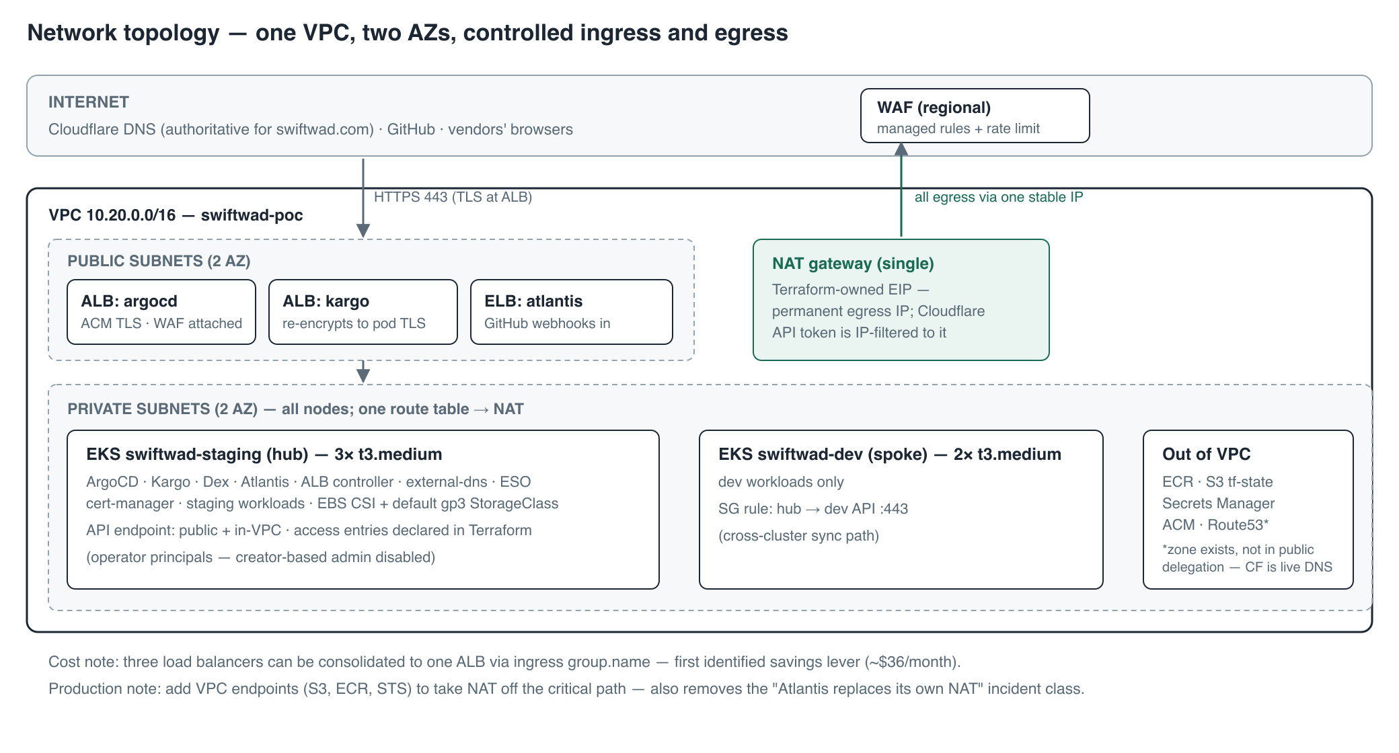
Network topology
Key decisions and their reasons:
- Single VPC, single NAT, terraform-owned EIP. The Cloudflare DNS token is IP-filtered to the egress address, so the address must survive rebuilds — an aws_eip passed via external_nat_ip_ids, not the module’s auto-allocated one.
- DNS reality check: the account’s Route53 zone for the domain is not in the public delegation path — the registrar delegates to Cloudflare. external-dns therefore runs the Cloudflare provider; records written to Route53 would never resolve. Verify with dig +short NS <domain> before assuming.
- Storage: EKS ships no CSI driver and current EKS marks no StorageClass default. Terraform installs the EBS CSI addon; bootstrap creates a default encrypted gp3 class. Without both, any PVC waits forever.
- Cross-cluster path: hub → spoke API on :443 requires an explicit SG rule (hub_to_dev_api) even inside one VPC.
IAM role inventory (all created by Terraform):
Role | Assumed by | Permissions | Trust condition
gh-actions-<service> | Vendor CI via GitHub OIDC | Push/pull one ECR repo + GetAuthorizationToken | sub matches the repo — both plain and ID-pinned forms (repo:org@id/repo@id:*)
kargo-controller-… | Kargo controller (IRSA) | DescribeImages, BatchGetImage, GetDownloadUrlForLayer, ListImages on service repos | SA kargo:kargo-controller
atlantis-… | Atlantis pod (IRSA) | Admin (POC); permissions boundary in production | SA atlantis:atlantis
alb-controller-… | ALB controller (IRSA) | Vendored official policy | SA kube-system:aws-load-balancer-controller
external-dns-… | external-dns (IRSA) | Route53 on one zone (legacy; CF token is the live path) | SA external-dns:external-dns
external-secrets-… | ESO (IRSA) | GetSecretValue/DescribeSecret on argocd/*, platform/* | SA external-secrets:external-secrets
ebs-csi-<cluster> | EBS CSI controller (IRSA) | AmazonEBSCSIDriverPolicy | SA kube-system:ebs-csi-controller-sa

4. Identity and authorization
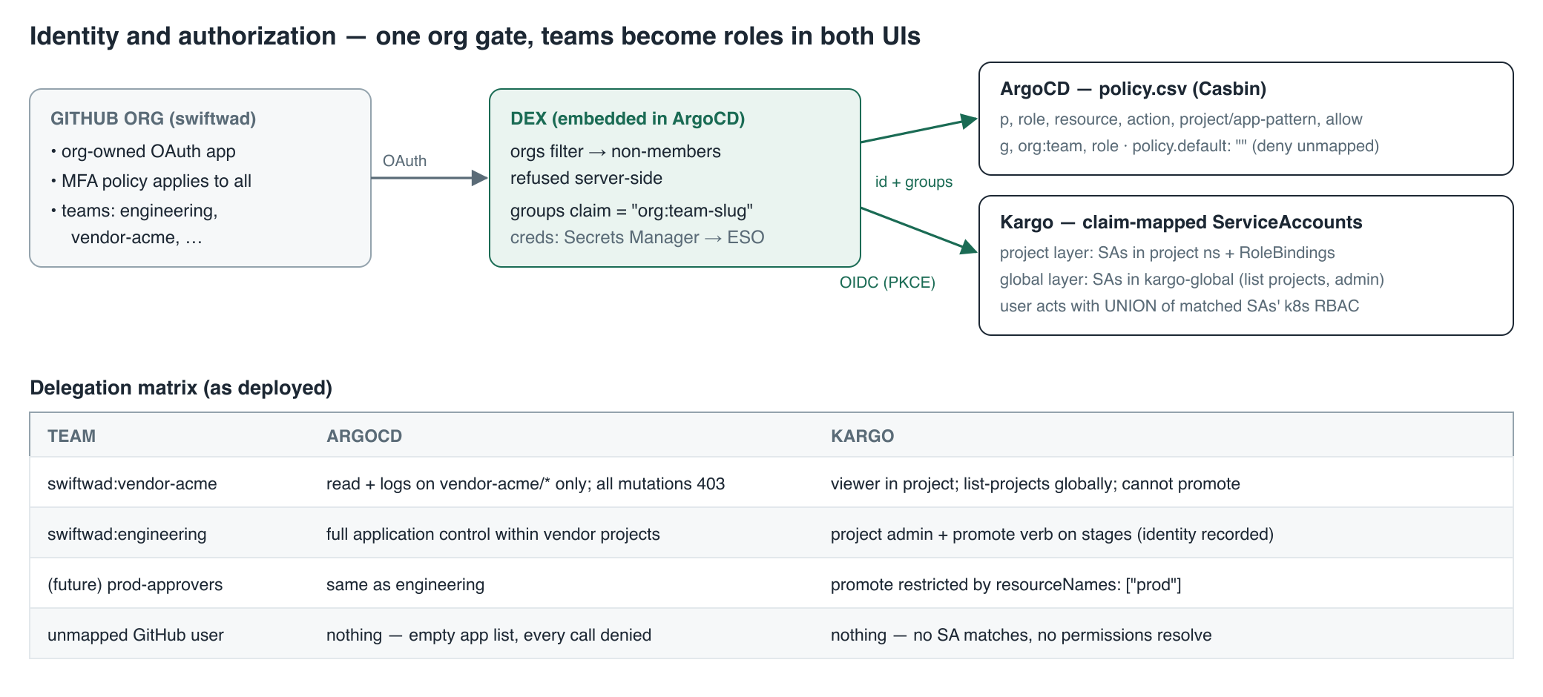
Identity and authorization
Authentication chain: GitHub org OAuth app → Dex (embedded in ArgoCD) with orgs: [swiftwad] — login fails at Dex, server-side, for any non-member, regardless of what the user authorizes. Dex issues identity + groups claims (org:team-slug). Kargo authenticates against the same Dex as an OIDC PKCE public static client (id: kargo) — one OAuth app, one gate, both UIs. Dex credentials live in Secrets Manager, delivered by ExternalSecret (part-of: argocd label required for $secret:key references in dex.config).
ArgoCD authorization: AppProjects bound what applications may do (source repos, destinations, resource kinds); policy.csv bounds users, scoped project/app-pattern, with policy.default: "" denying anything unmapped. Environment granularity via app-name patterns (vendor-acme/*-dev).
Kargo authorization is Kubernetes RBAC resolved through claim-annotated ServiceAccounts (rbac.kargo.akuity.io/claim.groups: org:team), in two mandatory layers: project-namespace SAs (RoleBindings to kargo-admin/kargo-user/kargo-viewer) and global SAs in kargo-global (registered via api.oidc.globalServiceAccounts.namespaces) for cluster-scoped verbs — without the global layer, every login fails at “list projects.” The custom promote verb on Stages (supports resourceNames per stage) is the release-manager grant; EKS access policies do not satisfy custom verbs, so it is always an explicit binding. Every Promotion records create-actor (e.g. email:approver@company.com).
Two integration gotchas (both solved in config): Kargo’s UI fetches Dex discovery cross-origin from the browser, and ArgoCD’s embedded Dex discards web.allowedOrigins — the CORS header is injected by the ArgoCD ALB via listener-attributes annotation, scoped to the Kargo origin. And GitHub org prerequisites (MFA required, base repo permission none, no member public repos) are part of the auth boundary, not optional hygiene.

5. CI/CD and promotion
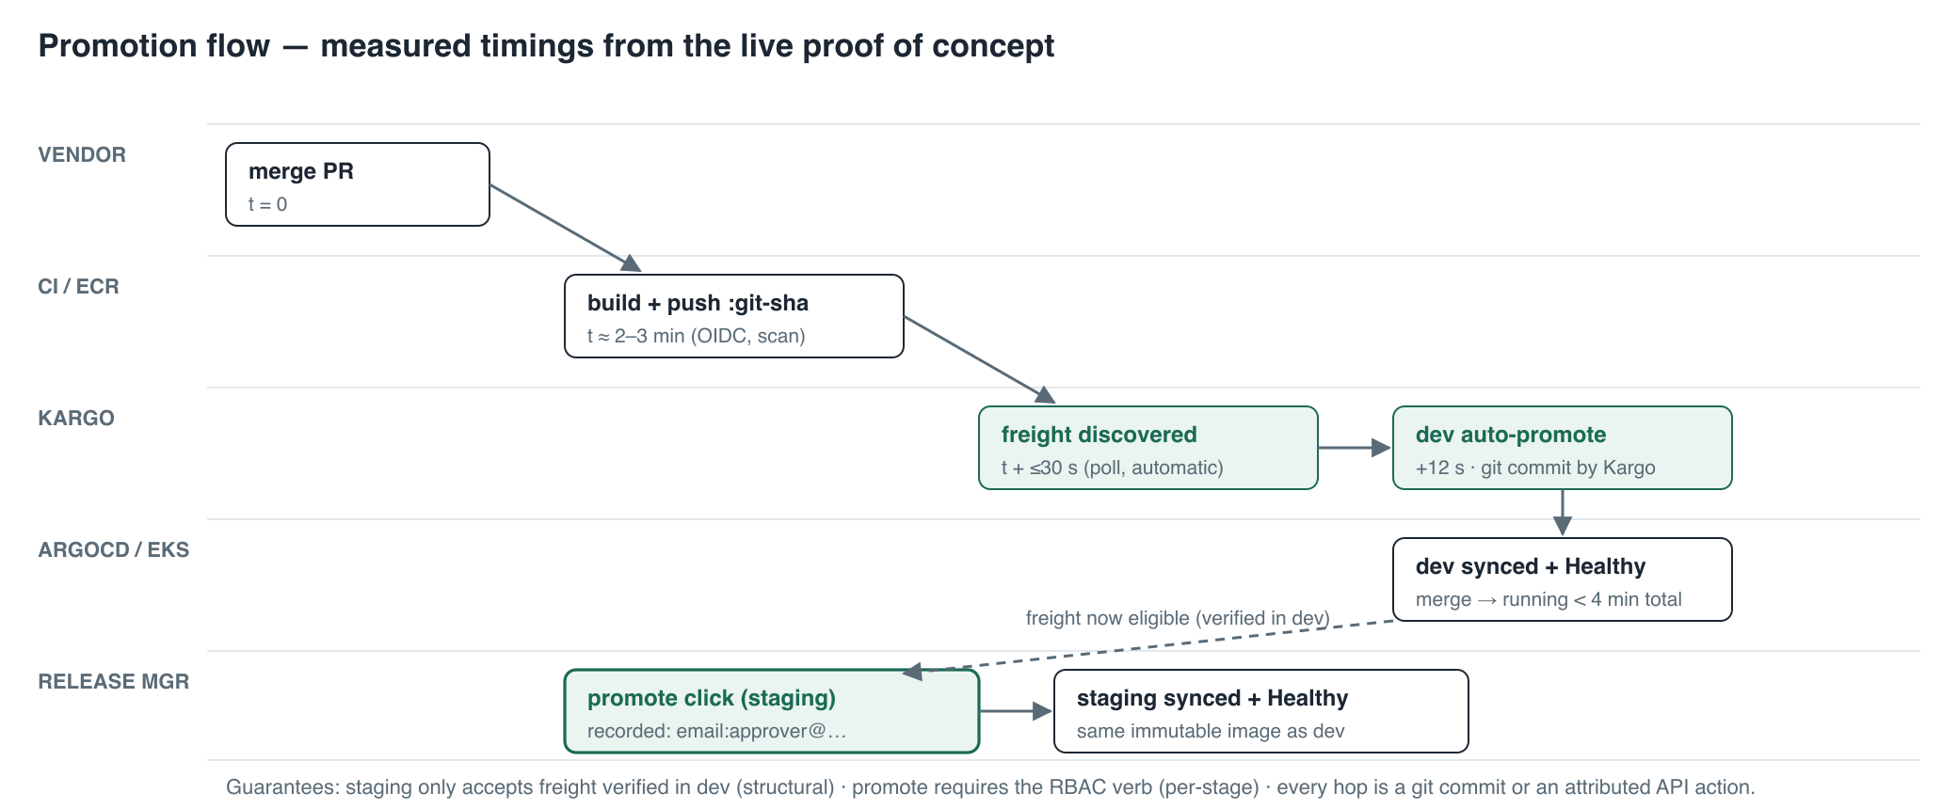
Promotion flow
Build: vendor merge → GitHub Actions assumes the per-repo OIDC role → builds → pushes :$GITHUB_SHA to ECR (immutable tags, scan-on-push). CI holds no other credential and writes to no other system. At >3 services, the workflow body moves to an org-level reusable workflow so vendors can edit their pipelines without touching credentialed steps.
Promotion (Kargo): the Warehouse polls ECR every 30 s (imageSelectionStrategy: NewestBuild — tags are SHAs, SemVer matches nothing). New images become Freight; the dev Stage has autoPromotionEnabled: true; staging’s requestedFreight.sources.stages: [dev] makes untested builds structurally ineligible. Promotion steps: git-clone → yaml-update → git-commit → git-push → argocd-update, using Kargo’s own write deploy key (secret labeled kargo.akuity.io/cred-type: git); target ArgoCD Applications carry kargo.akuity.io/authorized-stage: <project>:<stage>. The Kargo project is named <service>-delivery because a Project owns a namespace of its own name on the hub, where <service> may already exist.
Conformance is chart-enforced: one Helm chart template for all services; values.schema.json rejects non-ECR registries, latest, privileged ports, missing probes/resources; the securityContext (non-root, read-only rootfs, dropped capabilities) is hardcoded in templates, not exposed in values.
Measured timings (live POC, not projected): build ≈ 2–3 min · freight ≤ 30 s after push · dev promotion +12 s · merge → running in dev < 4 min · staging = one attributed click.

6. Infrastructure change management (Atlantis)
Plan-on-PR, apply-on-comment (atlantis apply), state locking, re-plan on every push. apply_requirements: [approved, mergeable] once more than one operator exists. Production upgrades: GitHub App auth, ingress + TLS, webhook restricted to GitHub IP ranges, permissions boundary on the role.
Operational rules paid for in incident time:
- Atlantis cannot replace the NAT it egresses through — destroy-then-create severs its own AWS/S3/GitHub path mid-apply. Run VPC-egress surgery from break-glass credentials outside the cluster, or add VPC endpoints (S3/STS/ECR) which removes the failure class entirely.
- Never force-unlock a possibly-live lock — a stalled apply resumed after egress recovery and overwrote interim state; repair required terraform state rm + import. Kill the pod first or wait out the lock.
- The EKS module ignores desired_size after creation — scale desired via aws eks update-nodegroup-config before raising min_size in Terraform.

7. Secrets management
All platform secrets follow one path: AWS Secrets Manager → External Secrets Operator → Kubernetes Secret, so nothing sensitive enters git, Terraform state, or CI logs. Terraform creates the secret containers; values are set out-of-band (aws secretsmanager put-secret-value).
Secret | Store key | Consumer | Notes
Dex GitHub OAuth | argocd/dex-github | argocd namespace (label part-of: argocd) | Referenced as $argocd-dex-github:clientID/clientSecret
Cloudflare DNS token | platform/cloudflare-dns | external-dns | Zone-scoped, DNS-edit only, IP-filtered to the NAT EIP
Kargo admin password | injected at helm install (bcrypt hash) | kargo-api | Re-set on every rebuild — the bootstrap re-applies its input; feed a fresh secret
Kargo gitops deploy key | k8s secret in project ns | Kargo promotion steps | cred-type: git label; repoURL must match clone URL exactly
ArgoCD admin (break-glass) | in-cluster initial secret | humans, emergencies only | Both UIs are SSO-only for daily use
Sync-ordering note: ESO’s own CRs (ClusterSecretStore, ExternalSecret) ship in the same root sync that installs ESO — they carry SkipDryRunOnMissingResource=true, and the platform AppProject syncs at the earliest wave, or the app-of-apps deadlocks (both observed).

8. Environments, scaling, disaster recovery
- Environments: dev (spoke) and staging (hub) today; production is one more cluster + one more Kargo stage gated on staging with its own prod-approvers team — mechanically identical. Production belongs in a separate AWS account (organization with per-env accounts + shared services); consolidate account sprawl, never environment boundaries.
- Service scaling: 1→10: ApplicationSets (directory generator over envs/), reusable CI workflow, services map in Terraform, Karpenter. 10→100: shard the ArgoCD application controller, raise repo-server replicas, mandatory ResourceQuotas + NetworkPolicies per vendor namespace.
- DR: everything rebuilds from three repos + scripts/bootstrap.sh (phased, idempotent, resumable). Validated: 112 resources destroyed, full rebuild ≈ 45 minutes, end-to-end vendor loop re-passed. Post-rebuild checks: re-set the Kargo admin password; ELB hostnames rotate (webhooks re-wired by the script); apps show Degraded until the first CI run repopulates a purged ECR — correct, not broken.
- Cost (POC sizing): ≈ $395/month — control planes $146, 5× t3.medium ≈ $150, NAT ≈ $35, 3 ELBs ≈ $54, WAF ≈ $10. First levers: single shared ALB via group.name (−$36), spot for non-prod nodes, park idle environments (validated rebuild makes this cheap).

9. Gotcha index
Nineteen operational traps were hit and documented during the POC; the full list with fixes lives in SETUP-GUIDE.md §12. Highest-value five: ID-pinned GitHub OIDC sub claims; the cluster-creator access-entry flip-flop (fix: enable_cluster_creator_admin_permissions = false + operators in code, day one); no default StorageClass on current EKS; Kargo’s two-layer RBAC; Atlantis vs. its own NAT.

