**Motion Planning and Decision Making for Autonomous Vehicles**

**프로젝트 목적 :**

이 프로젝트에서는 기존 계층적 플래너의 두 가지 주요 구성 요소인 행동 플래너와 동작 플래너를 구현합니다. 둘 다 함께 작동하여 다음을 수행할 수 있습니다.

도로 옆에 주차된 정적 물체(자동차, 자전거 및 트럭)를 피합니다(하지만 여전히 차선을 침범합니다). 차량은 "넛지" 또는 "차선 변경" 기동을 실행하여 이러한 차량과 충돌하지 않아야 합니다.

모든 교차로(3방향, 4방향 교차로 및 원형 교차로)에서 정지하여 처리합니다(기본값).

주행 차선의 중앙선을 추적합니다.

**파일 구성 :**

[**https://github.com/udacity/nd013-c5-planning-starter**](https://github.com/udacity/nd013-c5-planning-starter)

[**https://github.com/udacity/nd013-c5-planning-starter/tree/master/project**](https://github.com/udacity/nd013-c5-planning-starter/tree/master/project)

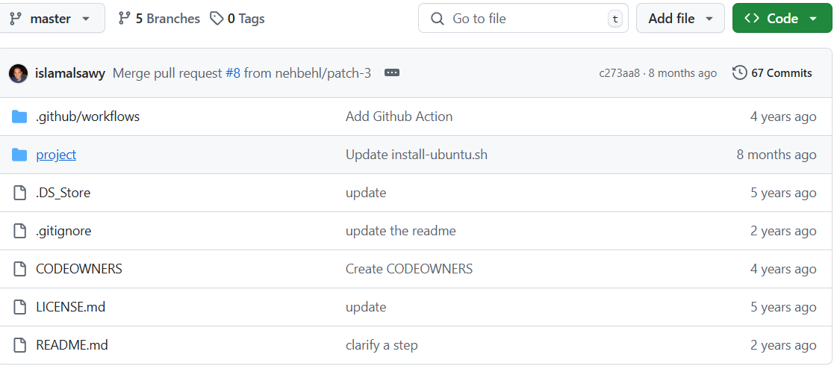

**https://github.com/udacity/nd013-c5-planning-starter/tree/master/project/starter_files**

**project/starter_files**

|  |  |
| --- | --- |
| [.clang-format](https://github.com/udacity/nd013-c5-planning-starter/blob/master/project/starter_files/.clang-format) |  |
| [CMakeLists.txt](https://github.com/udacity/nd013-c5-planning-starter/blob/master/project/starter_files/CMakeLists.txt) |  |
| [README.md](https://github.com/udacity/nd013-c5-planning-starter/blob/master/project/starter_files/README.md) |  |
| [behavior_planner_FSM.cpp](https://github.com/udacity/nd013-c5-planning-starter/blob/master/project/starter_files/behavior_planner_FSM.cpp) | Student's Update Item |
| [behavior_planner_FSM.h](https://github.com/udacity/nd013-c5-planning-starter/blob/master/project/starter_files/behavior_planner_FSM.h) |  |
| [cost_functions.cpp](https://github.com/udacity/nd013-c5-planning-starter/blob/master/project/starter_files/cost_functions.cpp) | Student's Update Item |
| [cost_functions.h](https://github.com/udacity/nd013-c5-planning-starter/blob/master/project/starter_files/cost_functions.h) |  |
| [cubic_spiral.cpp](https://github.com/udacity/nd013-c5-planning-starter/blob/master/project/starter_files/cubic_spiral.cpp) |  |
| [cubic_spiral.h](https://github.com/udacity/nd013-c5-planning-starter/blob/master/project/starter_files/cubic_spiral.h) |  |
| [integral.cpp](https://github.com/udacity/nd013-c5-planning-starter/blob/master/project/starter_files/integral.cpp) |  |
| [integral.h](https://github.com/udacity/nd013-c5-planning-starter/blob/master/project/starter_files/integral.h) |  |
| [json.hpp](https://github.com/udacity/nd013-c5-planning-starter/blob/master/project/starter_files/json.hpp) |  |
| [main.cpp](https://github.com/udacity/nd013-c5-planning-starter/blob/master/project/starter_files/main.cpp) |  |
| [matplotlibcpp.h](https://github.com/udacity/nd013-c5-planning-starter/blob/master/project/starter_files/matplotlibcpp.h) |  |
| [motion_planner.cpp](https://github.com/udacity/nd013-c5-planning-starter/blob/master/project/starter_files/motion_planner.cpp) | Student's Update Item |
| [motion_planner.h](https://github.com/udacity/nd013-c5-planning-starter/blob/master/project/starter_files/motion_planner.h) |  |
| [numpy_flags.py](https://github.com/udacity/nd013-c5-planning-starter/blob/master/project/starter_files/numpy_flags.py) |  |
| [planning_params.h](https://github.com/udacity/nd013-c5-planning-starter/blob/master/project/starter_files/planning_params.h) | Student's Update Item |
| [plot_utils.cpp](https://github.com/udacity/nd013-c5-planning-starter/blob/master/project/starter_files/plot_utils.cpp) |  |
| [plot_utils.h](https://github.com/udacity/nd013-c5-planning-starter/blob/master/project/starter_files/plot_utils.h) |  |
| [spiral_base.cpp](https://github.com/udacity/nd013-c5-planning-starter/blob/master/project/starter_files/spiral_base.cpp) |  |
| [spiral_base.h](https://github.com/udacity/nd013-c5-planning-starter/blob/master/project/starter_files/spiral_base.h) |  |
| [spiral_equations.cpp](https://github.com/udacity/nd013-c5-planning-starter/blob/master/project/starter_files/spiral_equations.cpp) |  |
| [spiral_equations.h](https://github.com/udacity/nd013-c5-planning-starter/blob/master/project/starter_files/spiral_equations.h) |  |
| [structs.h](https://github.com/udacity/nd013-c5-planning-starter/blob/master/project/starter_files/structs.h) |  |
| [utils.cpp](https://github.com/udacity/nd013-c5-planning-starter/blob/master/project/starter_files/utils.cpp) |  |
| [utils.h](https://github.com/udacity/nd013-c5-planning-starter/blob/master/project/starter_files/utils.h) |  |
| [vehicle_dynamic_model.cpp](https://github.com/udacity/nd013-c5-planning-starter/blob/master/project/starter_files/vehicle_dynamic_model.cpp) |  |
| [vehicle_dynamic_model.h](https://github.com/udacity/nd013-c5-planning-starter/blob/master/project/starter_files/vehicle_dynamic_model.h) |  |
| [velocity_profile_generator.cpp](https://github.com/udacity/nd013-c5-planning-starter/blob/master/project/starter_files/velocity_profile_generator.cpp) | Student's Update Item |
| [velocity_profile_generator.h](https://github.com/udacity/nd013-c5-planning-starter/blob/master/project/starter_files/velocity_profile_generator.h) |  |

**Hierarchy of File Structure (파일의 계층구조):**

**Blue text : student가 직접 수정하는 파일**

**planning_params.h (매개변수 정의)**

**├─ main.cpp (메인 실행 파일)**

**├─ behavior_planner_FSM.cpp (차량의 행동 상태 관리)**

**├─ motion_planner.cpp (경로 계획 및 생성)**

**├─ cost_functions.cpp (경로 비용 계산) <-- main.cpp와 직접 연결되지 않음**

**├─ velocity_profile_generator.cpp (속도 프로파일 생성) <-- main.cpp와 직접 연결되지 않음**

**├─ utils.cpp (수학적 계산, 보조 함수 제공)**

**├─ vehicle_dynamic_model.cpp (차량의 물리 모델)**

**├─ spiral_equations.cpp (나선형 궤적 생성 알고리즘)**

**├─ spiral_base.cpp (나선형 궤적 기반 클래스)**

**├─ cubic_spiral.cpp (3차 나선 궤적 관련 계산)**

**├─ integral.cpp (수학적 적분 연산)**

**├─ plot_utils.cpp (디버깅용 시각화 유틸리티)**

**planning_params.h 파일은 다른 파일들에게 값을 주는 mother파일임.**

**실행 방법:**