

Help Me Project

Requirement Specifications

Version 1.1

15 June 2021

*Group Members*

Arber Lala

Emiljan Ndoka

Evelin Uliu

Ina Sholli

Irv Lika

Juxhin Allaisufi

Table of Contents

1. Executive Summary 3.

1.1 Project Overview **3.**

1.2 Purpose and Scope of this Specification **3.**

2. Product/Service Description 3.

2.1 Product Context **4.**

2.2 User Characteristics **4.**

2.3 Assumptions **4.**

2.4 Constraints **5.**

2.5 Dependencies **5.**

3. Requirements 5.

3.1 Functional Requirements **5.**

3.2 Non-Functional Requirements **9.**

3.2.1 User Interface Requirements **9.**

3.2.2 Usability **11.**

3.2.3 Performance **11.**

3.2.4 Manageability/Maintainability **12.**

3.2.5 System Interface/Integration **12.**

3.2.6 Security **12.**

3.2.7 Data Management **13.**

3.2.8 Standards Compliance **14.**

3.2.9 Portability **14.**

3.2.10 Other Non-Functional Requirements **14.**

3.3 Domain Requirements **16.**

4. User Scenarios/Use Cases 16.

APPENDIX 59.

**1.Executive Summary**

* 1. **Project Overview**

Our project’s goal is to create a website where people can create or take services or jobs. Our software is called Help Me! because we aim to help people earn money from the jobs or services they complete. On the Homepage the users will become familiar with the features and a preview that our website provides. Users can register and login in their accounts. They can create jobs or services or take them created by other users. Our users can communicate with each other for specifications about their task or completion request. When the service is completed, employers can pay in cash or in debit card. A serial code will be generated automatically when each job or service is created. After the job is completed, the employer can give the serial code to the employee. This is a security measurement and it provides security between users. Website is created with JavaScript and Bootstrap. On the backend we will use PHP and MySQL.

* 1. **Purpose and Scope of this Specification**

In Scope

* Clients will be able to take and create new jobs or services.
* Every user can see the history of the completed tasks.
* Every user is saved in the database.
* Clients can rate employees.
* Website is simple and easy to use

Out Scope

* Our website provides information about the services and jobs only to people registered in our website.
* Relationships between users can be affected because of the reviews.

**2. Product Service and Description**

Our software provides people a way to earn money by completing some simple services for other people, who are not capable of performing these services themselves. Also, we tend to simplify the process of hiring employees by making it more comfortable for both the employer and the applying employee. The product we are offering is intended to be used by both clients and employees.

**2.1 Product Context**

Our product is an independent and self-contained product. It doesn’t interface with other businesses. Every data related to the clients and employees is the main component for our software to function. The information related to the clients and employees is important because based on employees’ capabilities, clients can hire them to do the service and based on the job the client offers, employees can apply to take the job.

**2.2 User Characteristics**

This product will have these types of users:

Administrator

Administrator of the system is the person who has access to everything that is going on in the system. He will have to take care of the database by keeping the system up to date and will make sure that every information is entered in the right way. The main job of the administrator is to make sure that everything in the system is working properly. He has to offer help to other users of the website if they are facing any problems while using the software.

Client

Clients of the systems are the ones that either can hire people to complete some simple services or offer people a job in their company. As a person who is willing to hire an employee to complete a service, a client can be from any type of background. On the other hand, if they are looking to hire people in their company, they surely must come from business profiles. Our system will try to provide the clients all the functionalities they need by making their work a lot easier and less complicated.

Employee

Employees of the system are the ones that are either interested in earning money by completing some simple tasks or by finding a stable job in some company. Employees can be from all different types of backgrounds. They can apply to any company they want, as long as they fulfil the company’s requirements. And they can be hired by clients to complete simple services based on the abilities they offer. Our system will try to provide the employees all the functionalities they need as well.

**2.3 Assumptions**

The system should be kept to date always by the system administrator. All information for each job will be posted on the website with all the specifications including the job payment, location, information regarding the employee and information about the job, and the timeframe of the required job and contact numbers. Every operation taken that day will be recorded in the database and saved in the logs if there are any problems. Ex: if a payment is done by credit card, the payment will be recorded and it will generate a receipt and in the case the transaction doesn't go through it will result in an error and it will be saved in the logs (with the exact date and hour).

The employees will provide information regarding the state of the job, for example whether it's in progress, it’s completed or whether it’s declined. The employers will be able to track the progress of the job and whether problems arise during the job.

**2.4 Constraints**

Before we used to keep the data in Excel and text files and before we start working with the website, we should spend some time transferring the data to a more secure database. It holds very important information like usernames and passwords and possibly credit card numbers.

The website will be mainly accessed by pc so it will be difficult for the admin to access it on the phone. There may not be an IT specialist at all times, so in case of problems or bugs, they will have to wait for the service a bit longer.

**2.5 Dependencies**

Our website will be dependent on the database that will provide the website the logins and passwords. We are dependent on the employees and employers providing the information.

**3. Requirements**

**3.1 Functional Requirements**

|  |  |  |  |  |  |
| --- | --- | --- | --- | --- | --- |
| Req# | Requirement | Comments | Priority | Date | SME reviewed/  approved |
| BR_01 | The project is designed a website | Users will be able to access it using a browser | 2 | 15/06/2021 | Juxhin Allaisufi |
| BR_02 | Employee users offer services | Employees will be registered into the website | 1 | 15/06/2021 | Juxhin Allaisufi |
| BR_03 | Client users will ask for services | Clients choose employees to perform their desired services | 1 | 15/06/2021 | Juxhin Allaisufi |
| BR_04 | User registration will be done in the login page | Users depending on what they want to register as in the website | 1 | 15/06/2021 | Juxhin Allaisufi |
| BR_05 | Employees will be able to display the abilities | Employees will put on their profile their abilities and skills | 2 | 15/06/2021 | Juxhin Allaisufi |
| BR_06 | Employees can share their location | As a desired option, each employee can share their location for clients to see who is nearest | 2 | 15/06/2021 | Juxhin Allaisufi |
| BR_07 | Employees can contact clients | When employees have questions about the service, they can ask client to be clear on the service they are providing | 1 | 15/06/2021 | Juxhin Allaisufi |
| BR_08 | Employees notify the client when the service is done | In order for the client to know there will be an option which indicates the termination of the service | 1 | 15/06/2021 | Juxhin Allaisufi |
| BR_09 | Employees can share their CV | For clients who have more detailed service requests, the employee has an option to upload their CV to impress the client | 2 | 15/06/2021 | Juxhin Allaisufi |

|  |  |  |  |  |  |
| --- | --- | --- | --- | --- | --- |
| BR_10 | Employees can see service requests from clients | Client can send their service requests or apply for them to different employees | 1 | 15/06/2021 | Juxhin Allaisufi |
| BR_11 | Employees can accept or deny service requests | If an employee can do the service of a client, he/she accept that service request or if they are unable to do it, they can deny it | 1 | 15/06/2021 | Juxhin Allaisufi |
| BR_12 | Employees can add personal information to their profile | As a desired feature, employees can add personal information about themselves, or different way of direct contact from the client | 1 | 15/06/2021 | Juxhin Allaisufi |
| BR_13 | Clients can send service requests to employees | Client can send service requests to employees directly to them, if they find the employee capable of doing the desired service | 1 | 15/06/2021 | Juxhin Allaisufi |
| BR_14 | Clients choose whomever employee they want | Depending on the abilities of the employee, each client can contact the employee | 2 | 15/06/2021 | Juxhin Allaisufi |
| BR_15 | Clients can share their location | Same as employees, clients can share their location, in order for the employee to know where the service will be performed | 2 | 15/06/2021 | Juxhin Allaisufi |
| BR_16 | Clients can contact employees | If clients have specific requests for the employee, they can contact them in the website or via direct contact (depending if the employee has given such contact in their profile) | 1 | 15/06/2021 | Juxhin Allaisufi |
| BR_17 | Clients can review employees | Each client has the right to review the service they had from certain employees | 1 | 15/06/2021 | Juxhin Allaisufi |
| BR_18 | Employees have rating | The resting of each employee is very important, because based on their rating the client is biased and determines if the employee is worth sending the service request or not | 1 | 15/06/2021 | Juxhin Allaisufi |
| BR_19 | Clients can add personal information | Clients can also add personal information to their profile, as an optional feature | 2 | 15/06/2021 | Juxhin Allaisufi |
| BR_20 | Clients can terminate the request | Clients will have a feature which gives them the right to terminate a service request they have made to the employee | 1 | 15/06/2021 | Juxhin Allaisufi |
| BR_20 | Each user has a username and password | In order to enter into the website, each user will have a distinct username, and a password | 1 | 15/06/2021 | Juxhin Allaisufi |
| BR_21 | Each user has to register | When registering into the website, each user will have an option to choose between being an employee or a client | 1 | 15/06/2021 | Juxhin Allaisufi |
| BR_22 | The phone number is necessary for every user when they register | For security policies, each user has to identify themselves correctly by entering a phone number while registering, to prove they are not a fake account | 1 | 15/06/2021 | Juxhin Allaisufi |
| BR_23 | Each user has a history button | Users can view their past activity in the website’s history of their own account, and see what services they have provided, or been provided before | 1 | 15/06/2021 | Juxhin Allaisufi |
| BR_24 | Users can delete the account | Each user will be given the feature to delete their own account, if they no longer have need for it | 2 | 15/06/2021 | Juxhin Allaisufi |

|  |  |  |  |  |  |
| --- | --- | --- | --- | --- | --- |
| BR_25 | Admin authentication | The administrator of the system can log in and out of the system based on a single username and password | 1 | 15/06/2021 | Juxhin Allaisufi |
| BR_26 | Admin access in the system | The admin can access to the balance of each of the users account but cannot withdraw or deposit | 1 | 15/06/2021 | Juxhin Allaisufi |
| BR_27 | Admin can suspend accounts | The administrator of the system can suspend (temporarily accounts) | 2 | 15/06/2021 | Juxhin Allaisufi |
| BR_28 | Admin can block accounts | As opposed to suspending accounts, the administrator can also block them permanently | 2 | 15/06/2021 | Juxhin Allaisufi |
| BR_29 | Maintenance of the system | The administrator is responsible for maintaining the system | 1 | 15/06/2021 | Juxhin Allaisufi |
| BR_30 | Employees can make friend requests | Employees have the right to make friend requests to another employee or client | 2 | 15/06/2021 | Juxhin Allaisufi |
| BR_31 | Clients can make friend requests | Clients, as well as employees can make friend requests to other clients and employees | 2 | 15/06/2021 | Juxhin Allaisufi |
| BR_32 | Double account | The system accepts accounts which serve as employees and clients at the same time | 1 | 15/06/2021 | Juxhin Allaisufi |

**3.2 Non – Functional Requirements**

**3.2.1 Product Requirements**

**3.2.1.1 User Interface Requirements**

The elements of our software will be:

* A welcome page which will be designed with various details to make it as eye-catching as possible but also simplistic in its own kind of way. It will be designed with its own title (which for our page we decided to be: “HELP ME!’). The welcome page will have a description to make it much easier for the user to understand what he is walking on to but also will have a guide on how to register and pages that lead into Sign in but also Log in if they already have an account. For people who are lost on the Welcome page, there will be a help button which will guide them.
* If a new user decides to register then he will be introduced to our Sign in page which will guide the user with various information on how he should fulfill the details. The Sign in is a really important part for the user because that’s where our security system is based. When the user puts on his email and his number, then he needs to prove that they are indeed his. So, he will receive a code on both (email and phone number) which he will need to put on the page to verify that they are his. In case of fraud by the user we can use the phone number to track him back since all phone numbers are registered into cell phone companies with their IDs. People make the choice to pay cash or debit when they get registered on the site.

* The home screen is a mix of our own ideas and that’s what makes it beautiful. It is simple, easy to understand and to use but most importantly it is unique. When you get into the home screen you are greeted with 3 panels which are the middle panel which takes the most space and which has the most important components which are :(jobs and services) , left panel is equipped with :(messages , home, add job or service , profile , notifications , settings and more ideas which we will implement soon) and finally the right panel for which we have many ideas about : ( map location which pinpoints where the nearest services and jobs are , adds, add friends or topics etc. . )
* Services - This section of the home screen is supposed to be for people who want to get their service completed fast and with a level of security for which they would have to pay a fee (that they decide how much). Then from the other side there are the people who want to make some quick earnings so they will accept services and complete them in order to get a certain fee. Every service which will be posted on the main page will have a rating, description, how much will the user get paid if they complete the service, profile picture and the distance of how far away this user is from your location.
* On the right corner of this post there will be a button which will allow other users to accept the service.
* Jobs - In order to enter this section, the user would need to upload a CV first to his profile. That would give the option of the user to unlock the page and look for jobs which will be permanent and offered by certain companies. When he applies to those companies, the CV will be an important aspect of the user getting accepted. The posts will be the same format as the services but the button will read Apply Instead of Accept.
* Notifications - This page will be a connection (bridge) between pages and it is the most interesting concept that we thought about. So, as we explained, on the main page there will be updates on recent jobs and services for which users can apply or accept. Now let’s think about the side of the users who published the service that needs to be completed by a certain someone or the users who published a job and they need certain people with abilities at a custom field to work for them against a specific fee. As soon as someone accepts the service, the publisher will receive a notification with the name of the user who applied and 2 buttons which say accept or cancel. Upon pressing one of the buttons an alarm box will appear just to make sure that the user did not make any accidental clicks. By clicking on the name of the people who apply for the service, the publisher is able to see their rating and comments which will allow them to pick the best choice. Same thing goes for the job section. After the user gets accepted, the publisher's notification will change with buttons (cancel, report) but also, he will get a direct connection with the user where he can text, send pictures but also have a feature for which we will talk later on.
* Processing -While the service is being completed, the user's main page will be changed. The user will not be able to apply for other services until he completes the one that he already has active. His homepage will have a notification which tells him which contract with which service he has on, a report button, a cancel button. Jobs don’t work that way. In the job section, the user gets contacted by the company which will get the user's information from the CV and they will talk privately about their permanent job. When the user has completed the service, he needs to go to the messaging page where he will find a really important button. The button is called REQ/COMP which stands for “Request Completed”. The user and the publisher need to work together in order for both of them to get what they need. If the user is trying to scam and he presses the button, he will not get the money transfer until the publisher presses the same button for approval (there will be an alarm box for this option too to prevent accidental clicks). If the user completes the service and presses the button then the cancel button will get removed from the publisher's privilege. If any of the sides have some sort of non-agreement, they can report one another and they will be dealt with by our customer service. Any service post or Job post will be shown on the publisher's profile too.
* After completion both sides will be asked to rate one another and after doing that the users main page will be able to show other services for which he can apply and gain money for. When the service is completed, the user is able to get the money transfer that he deserves or he gets the cash payment option.
* The administrator homepage will contain all the options and functionalities other users have, as well as an extra option to create, edit and delete other users. Administrator has also an option to view the transfers and money payments between the users.

**3.2.1.2 Usability**

* The system is simple and easy to use, so the user can learn it in a fast time.
* The system will make sure the users have no difficulties using it but if any question arises, an instruction manual will be attached to it.
* In order to help the users as much as possible, error messages will be shown if the user enters wrong input validation, such as wrong credentials.
* Also, while dealing with risky activity such as accidentally deleting something that they shouldn’t, the system will ask to confirm it twice before executing that action.

**3.2.1.3 Performance**

The system is a web-based application. And one of the main factors that will affect his performance is that the hardware device should have a high-speed internet connection.

**3.2.1.3.1 Capacity**

* The maximum number of concurrent users should be 200.
* Memory requirements: 2 GB RAM.
* Average page load should be less than 500ms.

**3.2.1.3.2 Availability**

* Our website will be available twenty-four hours a day, and can be accessed at any time.
* It can also be accessed in any geographical area.
* Depending on the number of users using the website at the same time, the performance may be affected a little, but not too noticeably.
* The system should be available 99.9% of time.

**3.2.1.3.3 Latency**

* Depending on the availability of each user, the response to a certain service request change. If the user is online and using the website, the response can be immediate.

**3.2.1.4 Manageability/Maintainability**

**3.2.1.4.1 Monitoring**

* The system will monitor every activity happening in the software and will fix errors if any of them occurs.
* The server will get the HTTP requests form the users at the fastest time possible.
* During a crash the system should restart as soon as possible by reconfiguring the server.

**3.2.1.4.2 Maintenance**

* The website will be under constant maintenance service by the developers, which will fix bug issues caused in the website.
* Also, different updates can be added to the website from time to time to improve its performance.

**3.2.1.5 System Interface/Integration**

**3.2.1.5.1 Network and Hardware Interfaces**

* Our software is a web-based application and the client-server connection will be a simple HTTP connection based on TCP protocol.

**3.2.1.5.2 System Interfaces**

* Our software is an independent application and will not interact with any other system.

**3.2.1.6 Security**

* Our website has many security policies, which prevent the violation of the user’s privacy.
* The first security policy is when a user registers into the website.
* That person has to provide a phone number, and to that phone number a code will be sent as a message, to prove that the account that person is creating is real.
* Sensitive information such as passwords will be encrypted.

**3.2.1.7 Data Management**

Entities:

* User
* Service
* Credit Debit
* Messages
* Bonds

User Specification:

* Last_Name varchar 40
* First_Name varchar 40
* Email varchar 40
* Phone_Nr int
* ID int
* Bio varchar 250
* Joined_date datetime

Service Specifications:

* Description varchar 200
* Location varchar 30
* Service_ID int
* Titles varchar 25
* Time_created datetime
* Time_ended datetime
* Price decimal (12,2)
* ID int
* takerID int

Credit Debit Specifications:

* Amount decimal (12,2)
* Card_Number varchar 16
* CVV_CV2 varchar 3
* MM int
* YY int
* ID int

Messages Specifications:

* time_s datetime
* Message varchar 1000
* ID int
* senderID int

Bonds Specifications:

* requested varchar 3
* accepted varchar 3
* friends varchar 3
* ID int
* requestingID int

**3.2.1.8 Standards Compliance**

* Our software will protect all users' data according to the standards and regulations applied by the laws of Albania government.

**3.2.1.9 Portability**

* The system is a web-based application, meaning that it will operate the same regardless of the operating system.

**3.2.2 Organizational Requirements**

**3.2.2.1 Environmental Requirements**

Our software will be well organized and effective, helping the users of the system. Because the software is web based, it will be stored in a server maintained by a software house. It needs to be kept up to date in order to work properly. The servers running your web application also require occasional review and updates, like updating the database (MySQL) and the web server (Apache). For the system to work properly, each user should be able to connect his device to the internet and also fulfill the Capacity Requirements stated above.

**3.2.2.2 Operational Requirements**

The Help Me System will be a web-based platform that enables the communication between users of the system, while maintaining a proper management system for the business. As such, this system should be able to allow all users to manage their own information. The administrator of the system is the only user who will have access to CRUD operations.

**3.2.2.3 Development Requirements**

Client-Side Programming (Front-End)

* HTML (Hyper Text Markup Language)
* CSS (Cascading Style Sheet)
* Bootstrap (To maintain the connection between HTML and CSS)
* JavaScript

Server-Side Programming (Back-End)

* PHP as programming language
* MySQL for the database
* Server – Apache

**3.2.3 External Requirements**

**3.2.3.1 Regulatory Requirements**

* Privacy policies will be adopted in compliance with the provisions of the Law No. 9887, dated 10.03.2008 "On the Protection of Personal Data" and related sublegal acts.
* The Privacy Policy describes the types of collected information as well as the way how this information will be used.
* IP addresses of visitors to this website will be used to help diagnose problems with the main server and to administer ‘Help Me’ by identifying how the site is being used. IP addresses are not linked to anything personally identifiable, meaning that the user will remain anonymous.

**3.2.1.2 Ethical Requirements**

Users must agree to share their personal information within the system. The personal information they will share:

* Full Name
* Email Address
* Public ID
* Phone Number

This information provided by the users of Help Me software will never be shared with other businesses or non-profit organizations.

**3.2.1.3 Legislative Requirements**

* Personal information of every user of this system will be protected by the regulations and legislative rules that are applied within Albanian territory.
* According to the law No.9887, dated 10.03.2008, as amended with law No.48/2012, “On the Protection of Personal Data”, the personal information of each user should be private and possible to be accessed only by the specified actors.

**3.3 Domain Requirements**

* The system is an independent and self-contained software. It doesn’t interface with any other system.
* The system manages different activities such as posting services, applying for service requests, applying for job positions, exchanging messages etc.
* Each user will have access only to his personal information and not to others.

**4.User Scenarios/Use Cases**

**4.1 User Scenarios**

General Scenarios

**Scenario Title: Successful User Log In**

* The user opens the system's homepage in order to log-in into the system.
* At the navigation bar, he clicks the log-in button which will direct him to the login page.
* After filling in the form with the correct login credentials, he clicks the submit button to enter the page.
* User is successfully logged in the system and his homepage is displayed.

**Scenario Title: User Forgets His Password.**

* The user opens the system's homepage in order to log-in into the system.
* At the navigation bar, he clicks the log-in button which will direct him to the login page.
* He enters his credentials but they won’t get accepted by the system showing a ‘Invalid Credentials’ error message.
* After realizing he has forgotten his password, the user goes to the ‘Forgot Password’ button at the bottom of the page.
* This will send him to the ‘Recover Password’ page, asking the user for his username. After entering the username, he will receive the reset code by email and by his phone number.
* He is requested to enter the code.
* After entering the code correctly his password will be reset and he can enter the website.

**Scenario Title: User wants to edit his credentials.**

* After the user has entered the website, his home page will be displayed.
* He wants to change his password, so he goes to the ‘Settings’ section.
* After clicking on the ‘Change Password’ button, he has to complete a form asking for his old password, his new password and reconfirming his new password.
* User fills the form successfully and presses on the submit button.
* He will be redirected to his home page. The password is successfully changed and the database is updated.

**Administrator Scenarios**

**Scenario Title: Administrator wants to create a new user**

* Administrator is logged in the system. His homepage will be displayed.
* Administrator goes to the ‘Manage Users’ menu.
* Here he chooses the ‘Create User’ option. A list with the types of users he can create is shown.
* He chooses the type of user he wants to create.
* After that he fills out a form with the required credentials for creating a user, such as name, surname, phone number, public ID and email address.
* After correctly completing the form, he clicks on the ‘Create User’ button, to create the user.
* The new user is now created and the records on the database are updated.

**Scenario Title: Modify User**

* Administrator is logged in the system. His homepage will be displayed.
* Administrator goes to the ‘Manage Users’ menu.
* Here he chooses the ‘Edit User’ option. A list with the users of the system is shown and he picks the user whose information wants to edit.
* After making the necessary changes he clicks on the ‘Save Changes’ button.
* User is now modified and the database record is updated.

**Scenario title: Delete User**

* Administrator is logged in the system. His homepage will be displayed.
* Administrator goes to the ‘Delete Users’ menu.
* Here he chooses the ‘Delete User’ option. A list with the users of the system is shown and he picks the user he wants to delete.
* Administrator clicks on the ‘Delete User’ button and the user will be deleted. Also, the database will be updated.

**Employee Scenarios**

**Scenario Title: Apply for a service request**

* The employee is logged in into the system.
* A client has sent him a service request.
* Employee goes to the service section.
* Employee applies the service request and waits for the client to confirm if he is going to take the service.

**Scenario Title: Service request application is approved.**

* Employee has applied for a service request.
* Client approves the service request application of the employee
* Employee is notified he has taken the service.

**Scenario Title: Service request application is denied.**

* Employee has applied for a service request.
* Client denies the service request application of the employee
* Employee is notified he hasn't taken the service.

**Scenario Title: Request for job position**

* The employee is logged in into the system and wants to apply for a job position.
* Employee goes to the job section.
* He uploads his CV, if he hasn’t done it yet.
* He checks the list of available job positions and applies to the ones he is interested in.

**Scenario Title: Employee notifies the client he wants to cancel the contract.**

* Employee has taken a service.
* He wants to cancel the service contract.
* He goes to the service section and presses the cancel contract button.
* Client is notified that the employee canceled the contract.

**Scenario title: Employee notifies the client he has finished the service.**

* Employee has taken a service contract.
* He finishes the service.
* He goes to the service section and presses the request completed button.
* Client is notified that the employee finished the service.

**Scenario title: Employee wants to message the client.**

* Employee has an active service contract and the message section is now available.
* Employee wants to message the client.
* Employee goes to the message section and starts chatting with the client.

**Scenario title: Employee wants to update his personal details.**

* The employee is logged in into the system.
* He goes to the profile page section.
* He edits his personal details and presses the save changes button to save the changes.

**Client Scenarios**

**Scenario Title: Accept Service Request**

* Client is logged in the system.
* Clint opens the list of service requests under the ‘Service’ section on his home page.
* After reviewing the application, he accepts the service request made by the employee.

**Scenario Title: Deny Service Request**

* Client is logged in the system.
* Client opens the list of service requests under the ‘Service’ section on his home page.
* After reviewing the application, he denies the service request made by the employee.

**Scenario Title: Post Service**

* Client is logged in the system.
* Clint opens the ‘Service’ section on his home page.

**Scenario Title: Terminate Service**

* Client has already an active contract with an employee.
* Employee notifies the client that he has completed the service.
* Client goes under the ‘Service’ section on his home page.
* He clicks on the Req/Completed button to indicate the service termination.
* Employee is notified the service has been terminated.

**Scenario Title: Rate Employee**

* After termination of the service, the client should rate and pay the employee.
* Under the ‘Service’ section, after clicking on the Req/Completed button a message will pop up asking the client to rate the employee.
* Client rates the employee and presses the 'Done’ button.
* Employee is notified about his rating.

**Scenario Title: Pay Employee**

* Client has terminated the service.
* He adds the discussed amount of money to the employee’s account or does the payment in cash.
* Employee is notified his payment has been made.

**Scenario title: Client wants to message the employee.**

* Client has an active service contract and the message section is now available.
* Client wants to message the employee.
* Client goes to the message section and starts chatting with the employee.

**Scenario title: Client wants to update his personal details.**

* The client is logged in into the system.
* He goes to the profile page section.
* He edits his personal details and presses the save changes button to save the changes.

**4.2 Use Cases Diagram**

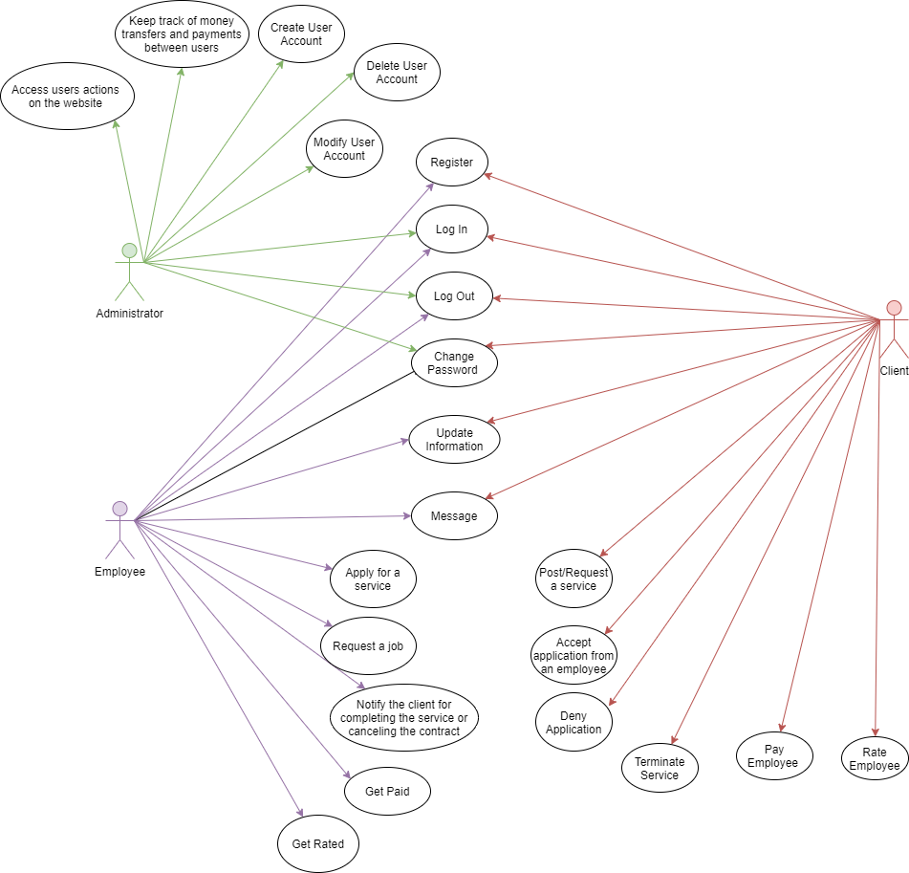

**4.3 Use Cases Extended**

Use Case 1

|  |  |
| --- | --- |
| Name | Register |
| Summary | User can register to the website. |
| Actors | All types of users (administrator, client, employee) |
| Description | In order to use the website, users must create an account first. Account is created by completing a form with the required data such as name, surname, phone number, email and public ID. |
| Pre-Condition | Everyone who is willing to use our website can register. There is no specific requirement. |
| Post-Condition | Users will be able to log in, log out and use the website. |

Use Case 2

|  |  |
| --- | --- |
| Name | Log In |
| Summary | Users can log in the system by entering the required credentials |
| Actors | All types of users (administrator, client, employee) |
| Description | For the user to log in, he must enter the username and password. If his credentials are correct user will be logged in to the system. If not, an error message will be displayed telling the user to enter the correct credentials. A forgot password button will, which will reset the user’s password will be available in case the user forgets his password. |
| Pre-Condition | User must register to the website first. |
| Post-Condition | User’s homepage will be displayed. |

Use Case 3

|  |  |
| --- | --- |
| Name | Log Out |
| Summary | Users can log out of the system. |
| Actors | All types of users (administrator, client, employee) |
| Description | After finishing their activities on the system, users can log out from it, by clicking the log out button on the navigation bar. |
| Pre-Condition | Users should have already logged in to the system |
| Post-Condition | Users will be directed to the welcoming page. |

Use Case 4

|  |  |
| --- | --- |
| Name | Change Password |
| Summary | The user can change the password of his account. |
| Actors | Client, Employee, Administrator |
| Description | Whenever a certain user (whether it is an administrator, client or employee), feels like changing the password of his/her account due to security or different reasons, he/she can immediately change it. |
| Pre-Condition | The user must be logged into the system.  The user must put the current password in.  The user must put the new desired and password and confirm it. |
| Post-Condition | The password of that account will be changed and the old one is no longer correct. |

Use Case 5

|  |  |
| --- | --- |
| Name | Update Information |
| Summary | The user can update their personal information previously put in the account. |
| Actors | Client, Employee |
| Description | The personal information of a user is constantly changing, whether it is his/her location, surname, contact number etc. So, whenever a user has changes to make to his/her personal information, he/she can update the information from the settings of the profile. |
| Pre-Condition | The user must be logged into the system. |
| Post-Condition | Old information will be updated.  New information can be put into the user’s profile. |

Use Case 6

|  |  |
| --- | --- |
| Name | Message |
| Summary | Clients and employees can message one another. |
| Actors | Client, Employee |
| Description | The client can contact the employee and vice versa, while working on a service. Messages can be exchanged for more additional information regarding the service and the way the clients wants it to be provided. |
| Pre-Condition | Client and employee must be logged into the system.  The employee must be working on the client’s service request. |
| Post-Condition | Messages will be exchanged between the client and the employee. |

Use Case 7

|  |  |
| --- | --- |
| Name | Notify the client for completing the service. |
| Summary | Employee should notify the client if he completed the service. |
| Actors | Employee |
| Description | After taking a service, the employee must complete it and notify the client. He goes to ‘Service’ section and clicks on the complete button. System will send the notification to the client. |
| Pre-Condition | Employee has an active contract. |
| Post-Condition | Client will be notified by the system when employee completes the service. |

Use Case 8

|  |  |
| --- | --- |
| Name | Notify the client for canceling the service. |
| Summary | Employee should notify the client if he is canceling the contract. |
| Actors | Employee |
| Description | After taking a service, the employee must complete it and notify the client. But he can change his mind and cancel the contract. He goes to ‘Service’ section and clicks on the cancel contract button. System will send the notification to the client. |
| Pre-Condition | Employee has an active contact. |
| Post-Condition | Client will be notified by the system if the employee has canceled the contract. |

Use Case 9

|  |  |
| --- | --- |
| Name | Get Paid and Rated |
| Summary | Employee gets paid and rated by the client. |
| Actors | Employee |
| Description | After completing the service, the client should pay the employee by either depositing the money into employees’ bank account or by cash. Also, the client should rate the employee based on how he performed the service. |
| Pre-Condition | Employee should have finished the service. |
| Post-Condition | System will notify the employee about his payment and rating. |

Use Case 10

|  |  |
| --- | --- |
| Name | Get Paid and Rated |
| Summary | Employee gets paid and rated by the client. |
| Actors | Employee |
| Description | After completing the service, the client should pay the employee by either depositing the money into employees’ bank account or by cash. Also, the client should rate the employee based on how he performed the service. |
| Pre-Condition | Employee should have finished the service. |
| Post-Condition | System will notify the employee about his payment and rating. |

Use Case 11

|  |  |
| --- | --- |
| Name | Post/Request Service |
| Summary | The client can post a service request to the system. |
| Actors | Client |
| Description | Whenever a client needs a service (job) to be completed, he/she can post this service to the system with all the detail specified in it, so it could also be clear for the employees applying to that service request. |
| Pre-Condition | Client must be logged into the system.  Client must have the affordable amount of money in the account. |
| Post-Condition | The client can choose whoever applicant seems more suitable.  The client must pay the service provided by the employee. |

Use Case 12

|  |  |
| --- | --- |
| Name | Accept application from an employee |
| Summary | The client revises all the applications and chooses the one who seems more suitable for the service. |
| Actors | Client |
| Description | After the client has posted the service request, it becomes available for all employees to apply for. The client checks all the applications and after revising all the applicants and their abilities and skills, he/she decides who gets to provide the service to him/her. |
| Pre-Condition | Client must be logged in.  There should be at least one application to the service request. |
| Post-Condition | The chosen applicant provides the service to the client and notifies him/her when it is done. |

Use Case 13

|  |  |
| --- | --- |
| Name | Deny application from an employee |
| Summary | The client has the right to immediately deny the application of an employee. |
| Actors | Client |
| Description | Besides accepting applications, the client also has the right to deny one. Meaning that when the client is entirely sure that, that specific application is not right to provide the service, he/she can immediately deny that application and the employee is therefore not able to provide the service. |
| Pre-Condition | Client must be logged into the system.  There should be applications to the service request in order to deny them. |
| Post-Condition | The applicant who has been denied is immediately not a candidate to provide the service request anymore. |

Use Case 14

|  |  |
| --- | --- |
| Name | Terminate Service |
| Summary | Only the client can decide when a service is completed. |
| Actors | Client |
| Description | The client who posts the service request, can decide whether that service is completed thoroughly and then proceeds to terminate the service. |
| Pre-Condition | Client must be logged into the system.  The service must have been fully completed by the employee. |
| Post-Condition | The employee will be notified that the service has been fully completed by his/her part.  The service will no longer appear in the system. |

Use Case 15

|  |  |
| --- | --- |
| Name | Pay Employee |
| Summary | After terminating the service, the client pays the employee. |
| Actors | Client |
| Description | Each service is provided in return of an amount of money. This amount of money is specified in the service requests’ details, and once the service has been terminated by the client, he/she is obliged to pay the employee who provided him/her that service. |
| Pre-Condition | Client must be logged into the system.  Client must have the sufficient amount of money in his/her balance. |
| Post-Condition | The amount of money of the service will withdraw from the client’s balance and deposited into the employee’s balance. |

Use Case 16

|  |  |
| --- | --- |
| Name | Rate Employee |
| Summary | The client can rate the employee’s performance. |
| Actors | Client |
| Description | After terminating the service, the client has the right to rate the performance of the employee who provided that service. The rating is based on the satisfaction the clients get from the employee and his/her thoughts on the skills of the employee. |
| Pre-Condition | Client must be logged into the system.  The service the employee has provided must be terminated. |
| Post-Condition | The specific rating will be added to the average rating the employee |

Use Case 17

|  |  |
| --- | --- |
| Name | Create User Account |
| Summary | Administrator has access to create user accounts. |
| Actors | Administrator |
| Description | Administrator goes to Manage Users section. First, he chooses the type of user he wants to create and after he fills a form with the required credentials. To create the user, he clicks on ‘Create User’ button. If the credentials are completed correctly a new user will be created and the database will be updated. |
| Pre-Condition | Administrator should have already registered into the system. |
| Post-Condition | A new user will be created and the database will be updated by adding a new record. |

Use Case 18

|  |  |
| --- | --- |
| Name | Modify User Account |
| Summary | Administrator has access to modify user accounts. |
| Actors | Administrator |
| Description | Administrator goes to Manage Users section. First, he chooses the user he wants to modify and then makes the necessary changes. To save the changes, he clicks on ‘Save’ button. |
| Pre-Condition | Administrator should have already registered into the system. |
| Post-Condition | The user information and the database record will be updated. |

Use Case 19

|  |  |
| --- | --- |
| Name | Delete User Account |
| Summary | Administrator has access to delete user accounts. |
| Actors | Administrator |
| Description | Administrator goes to Manage Users section. First, he chooses the user he wants to delete and then clicks on the ‘Delete’ button. |
| Pre-Condition | Administrator should have already registered into the system. |
| Post-Condition | The user will be deleted and the database will be updated. |

Use Case 20

|  |  |
| --- | --- |
| Name | Access users’ actions on the website |
| Summary | Administrator has access to every user action on the website. |
| Actors | Administrator |
| Description | Administrator can view user information and his actions on the website, but without compromising his privacy. |
| Pre-Condition | Administrator should have already registered into the system. |

Use Case 21

|  |  |
| --- | --- |
| Name | Keep track of money transfers and payments between users. |
| Summary | Administrator has access to view transfers and payments between users. |
| Actors | Administrator |
| Description | To view the money transfers and payments he goes to Finance section on the navigation bar. |
| Pre-Condition | Administrator should have already registered into the system. |

**4.4 Activity Diagrams**

*Accept Service*

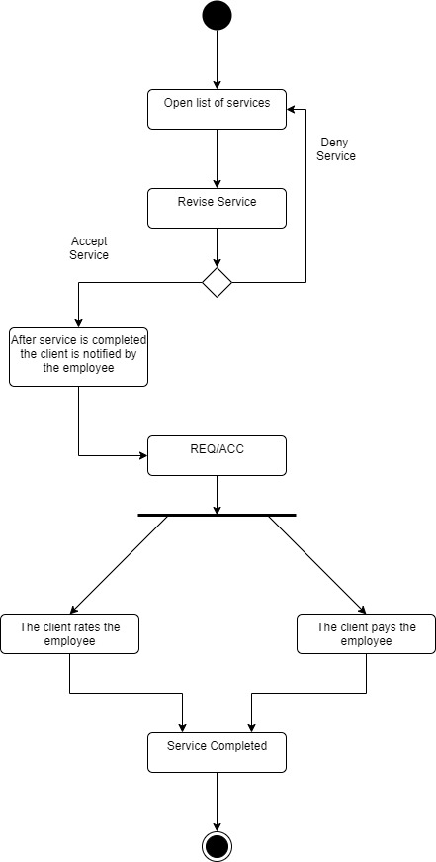

*Create, Update and Modify Users*

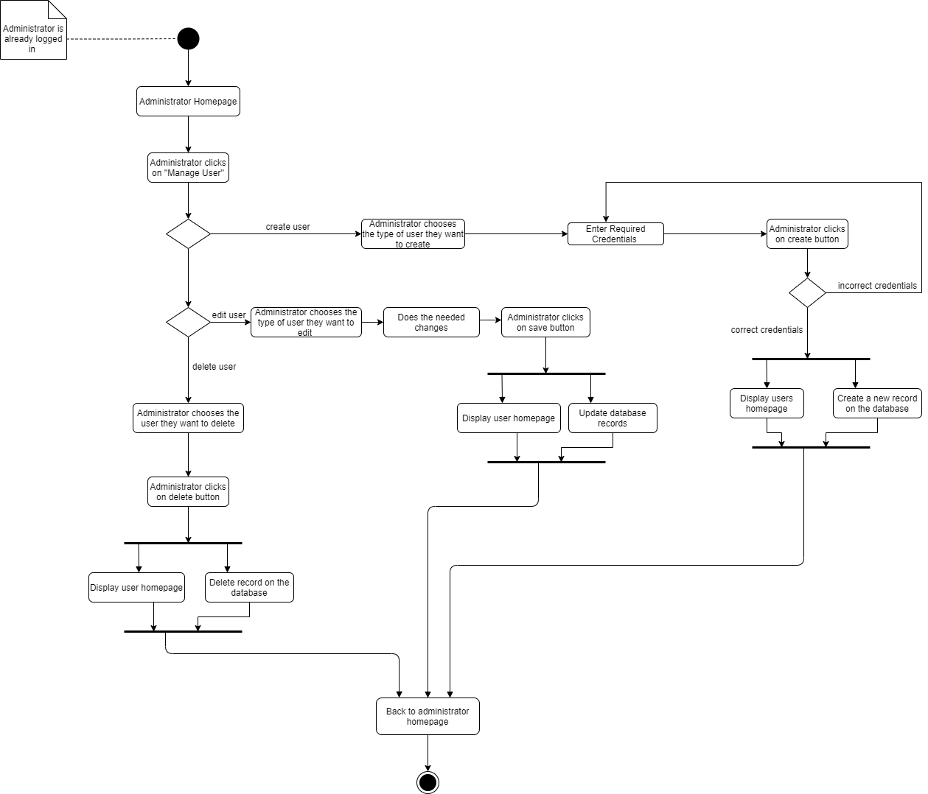

*Apply For Job*

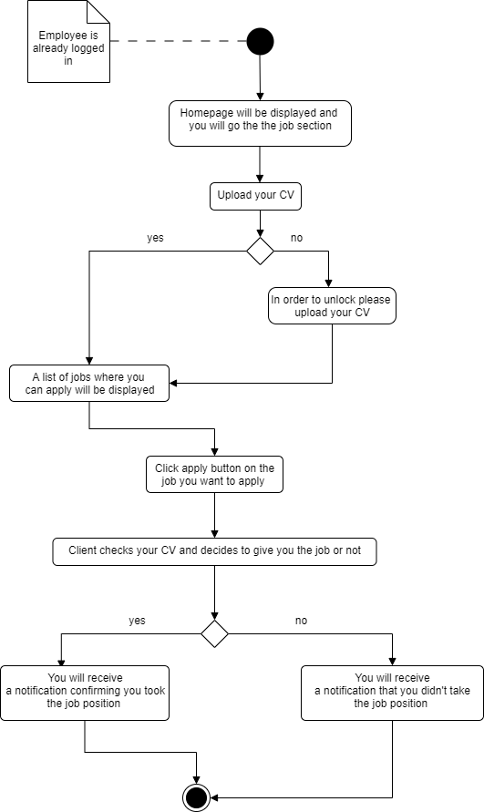

*Apply For Service*

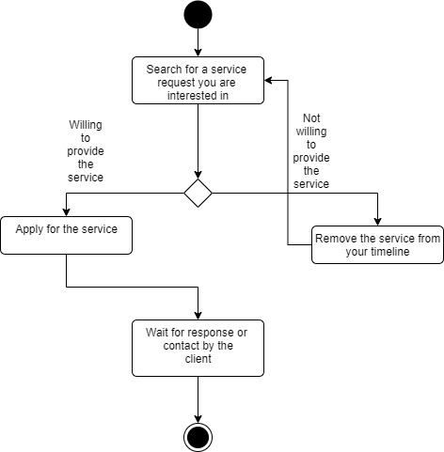

*Change Password*

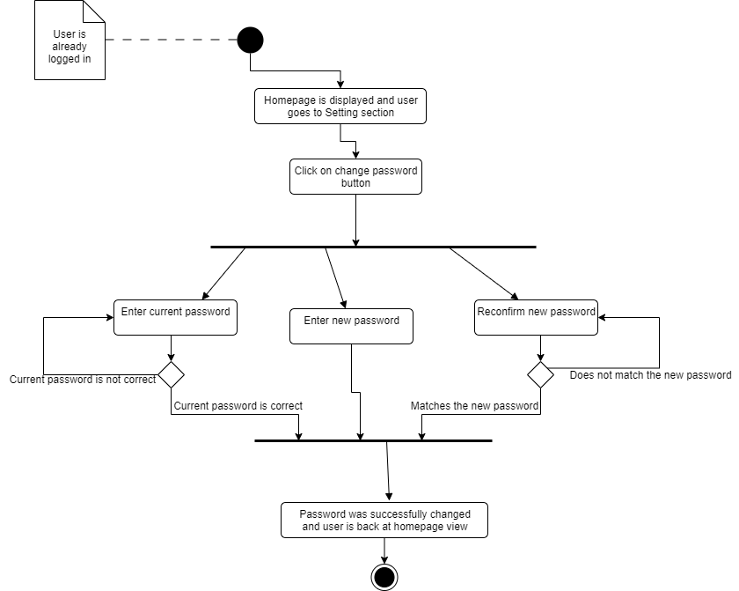

*Employee Get Paid and Rated*

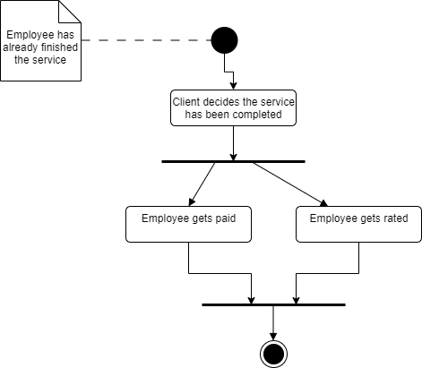

*Log In*

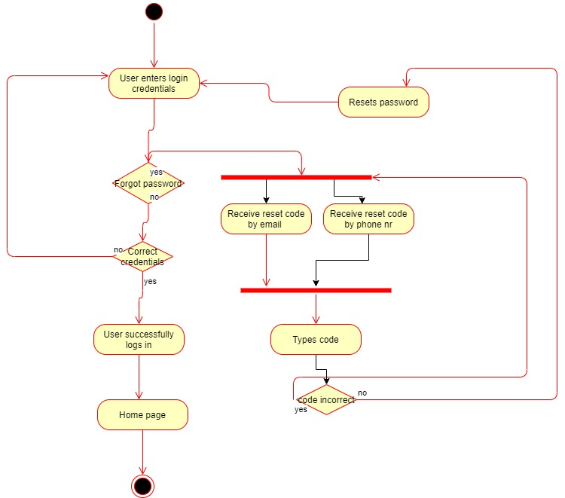

*Notify Client*

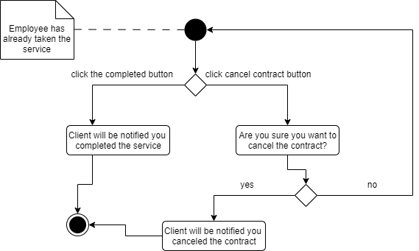

*Post Service*

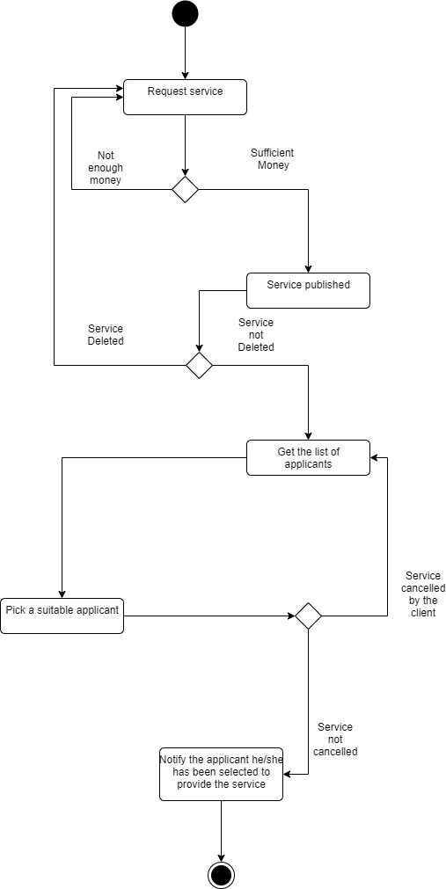

*Rate And Pay Employee*

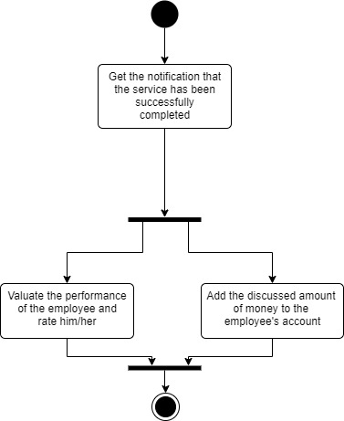

*Registration*

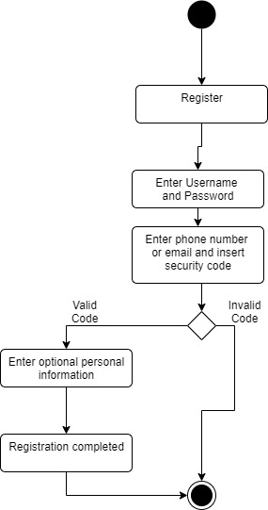

*Terminate Service*

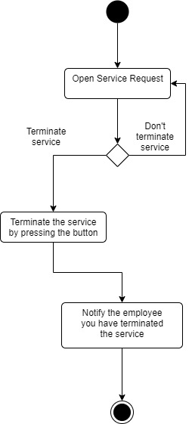

*Update User Information*

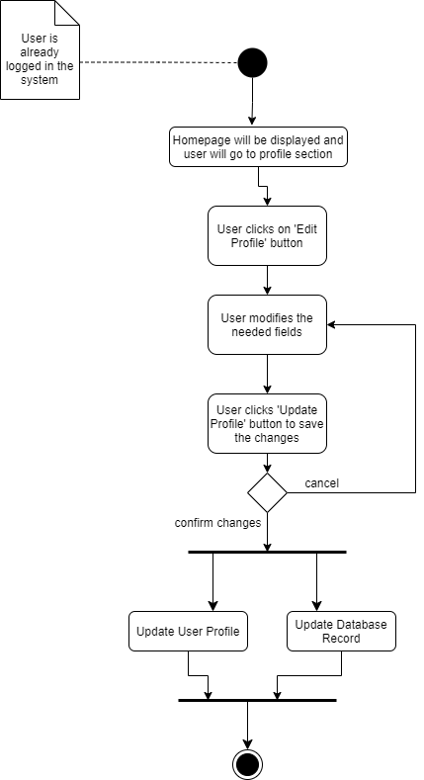

*User Message*

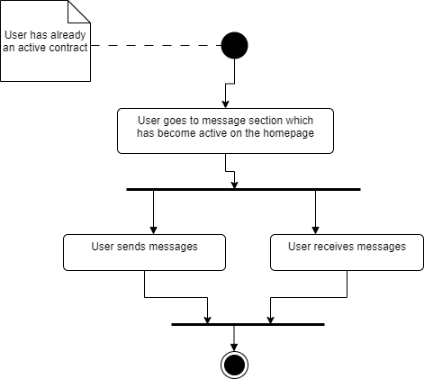

*Apply for service request*

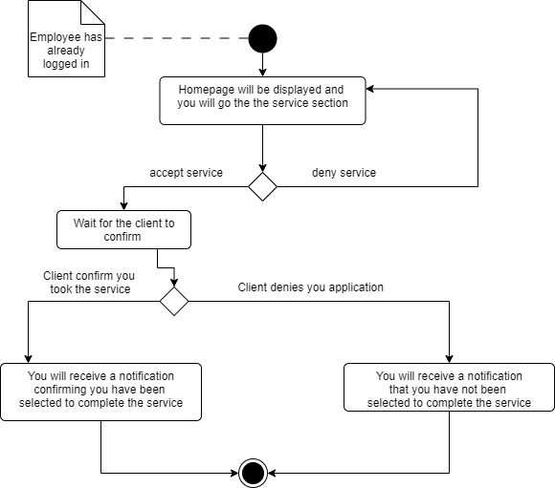

**Sequence Diagram**

*Administrator*

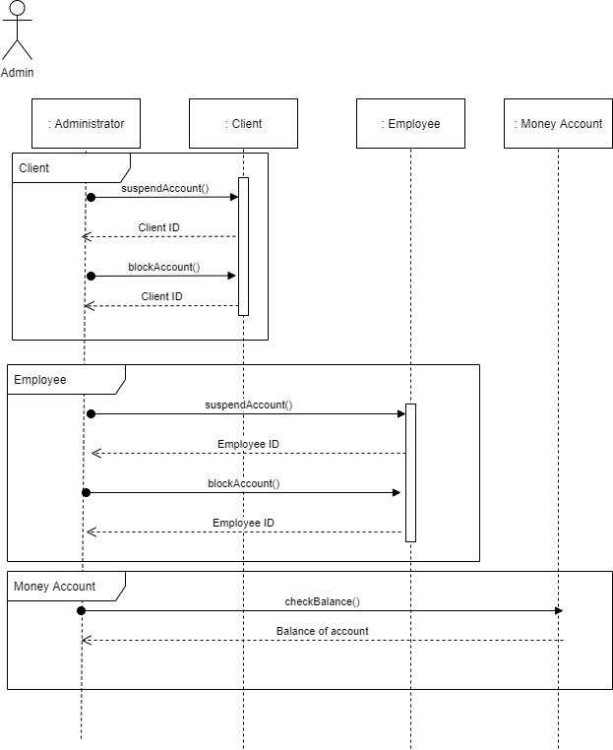

*Employee*

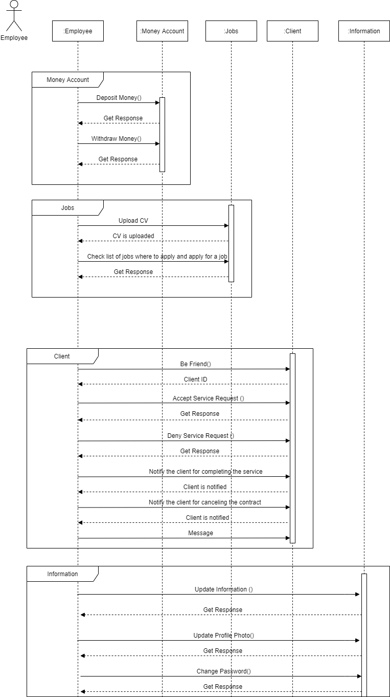

*Client*

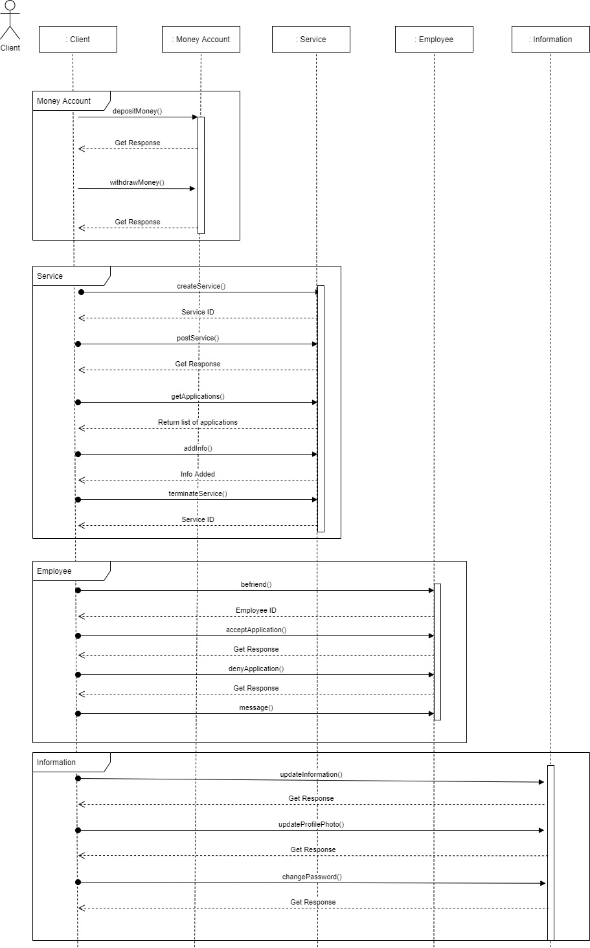

**Collaboration Diagram**

*Client*

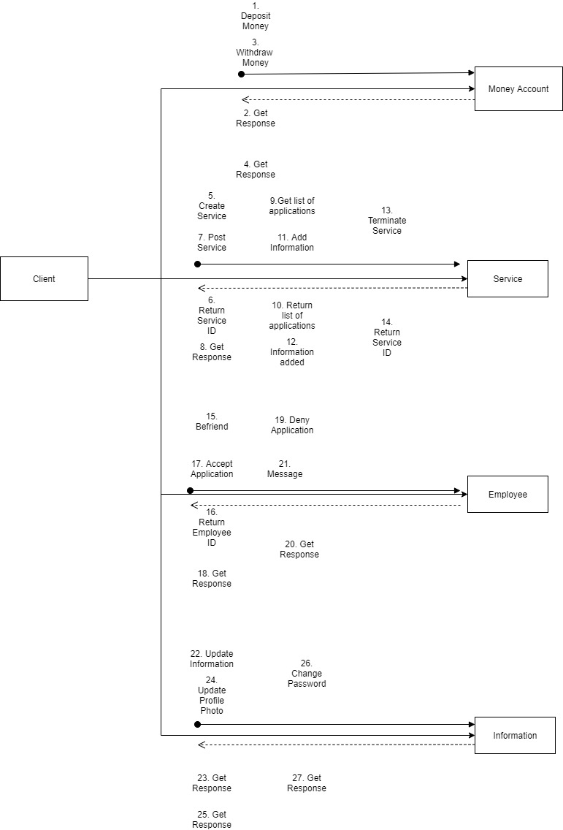

*Employee*

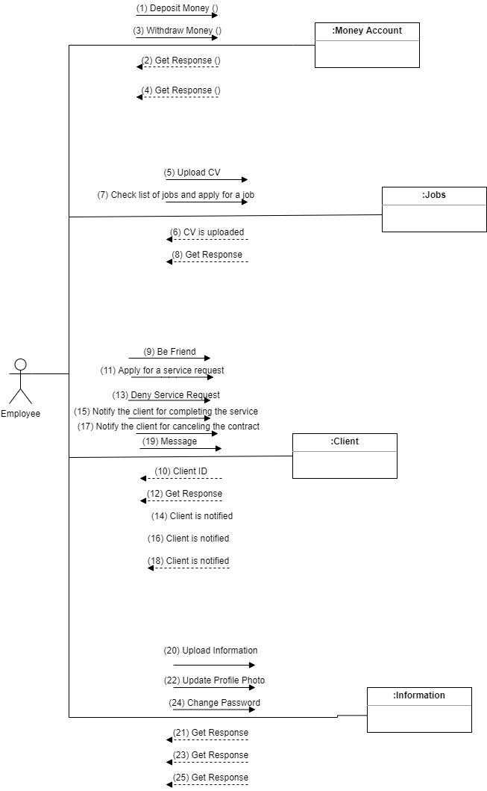

**Class Diagram**

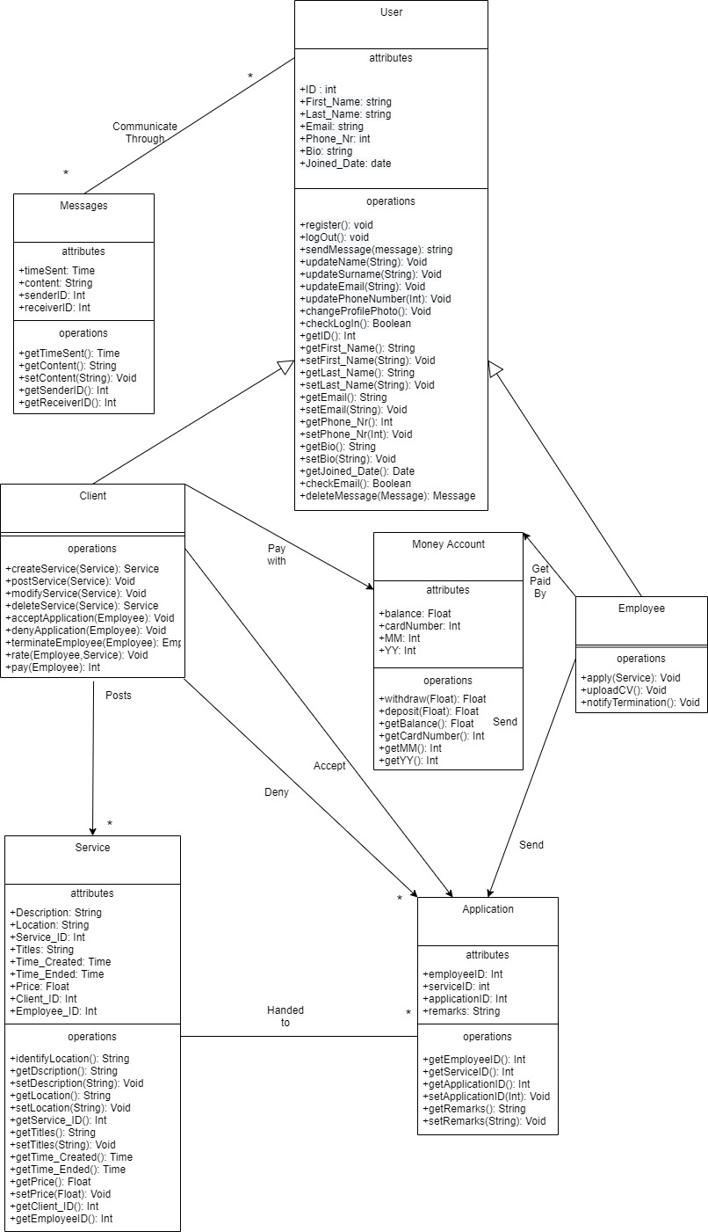

**Object Diagram**

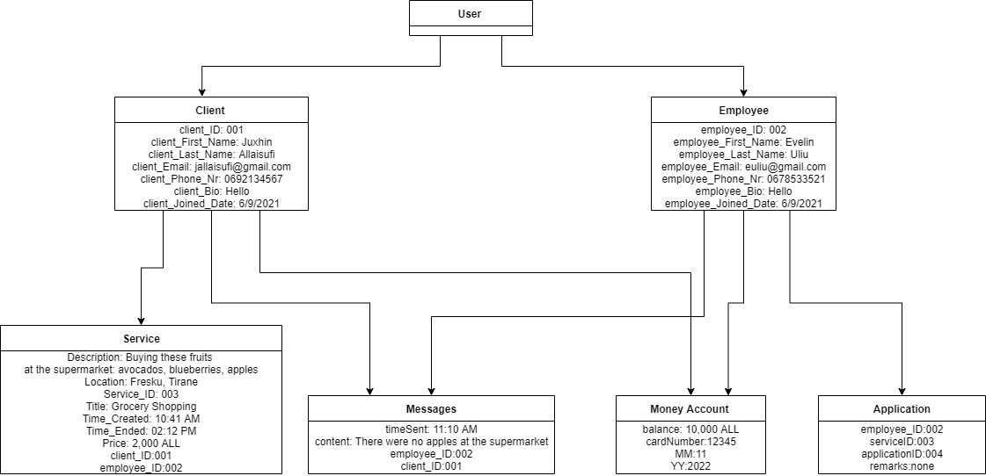

**Component Diagram**

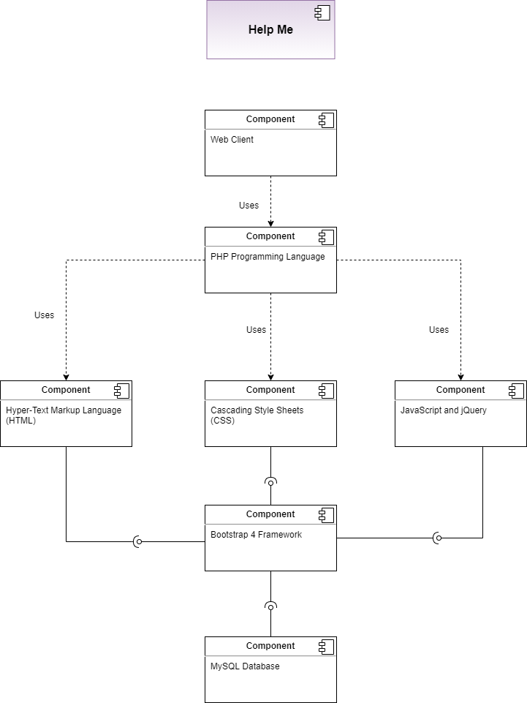

**Deployment Diagram**

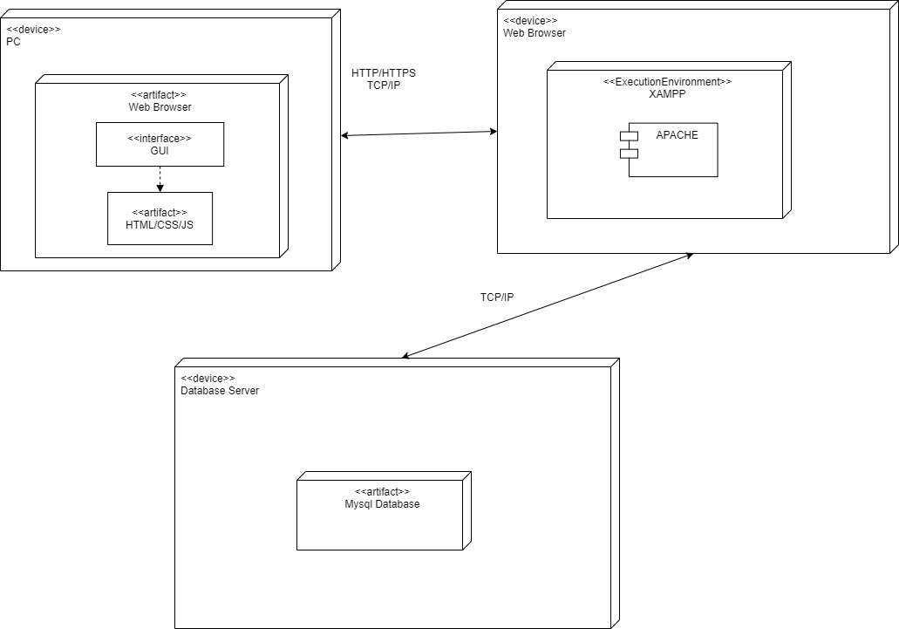

**DFD Level Zero**

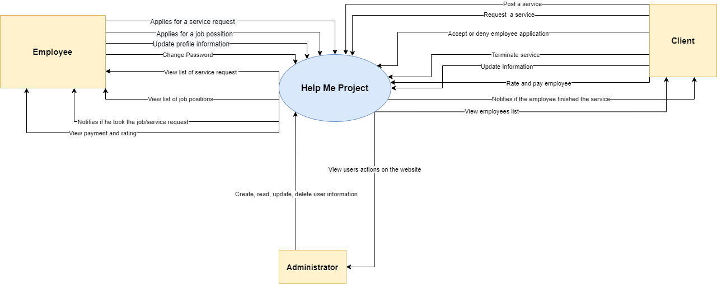

**DFD Level 1**

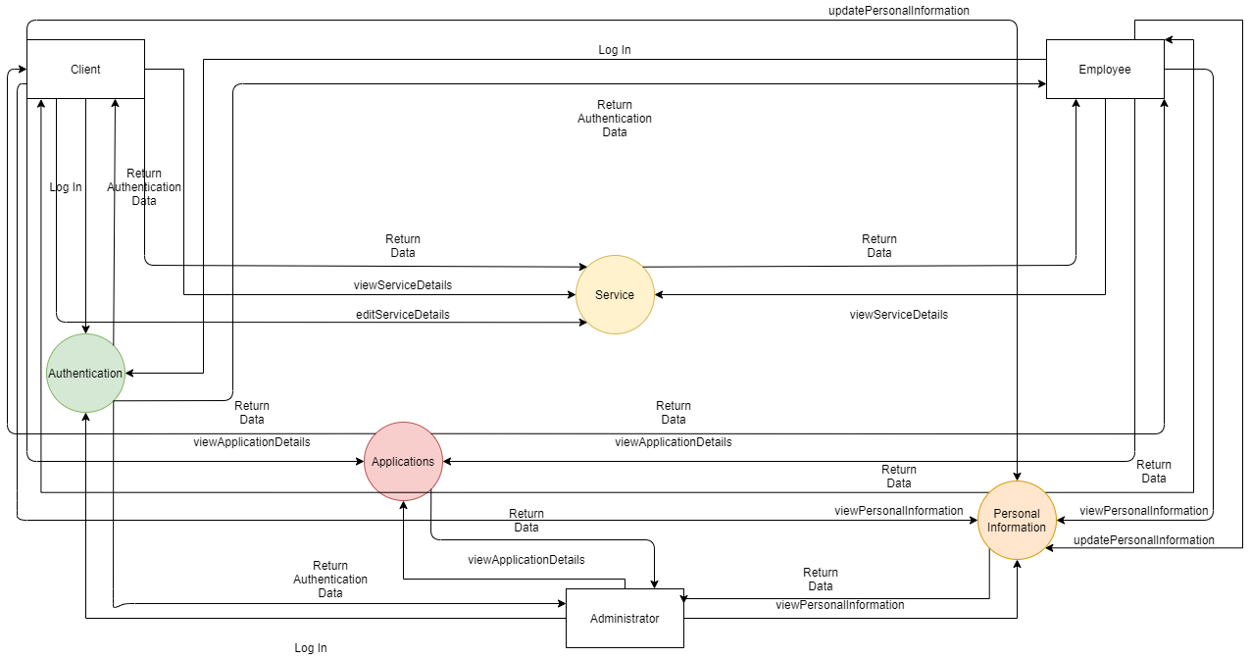

**DFD Level 2**

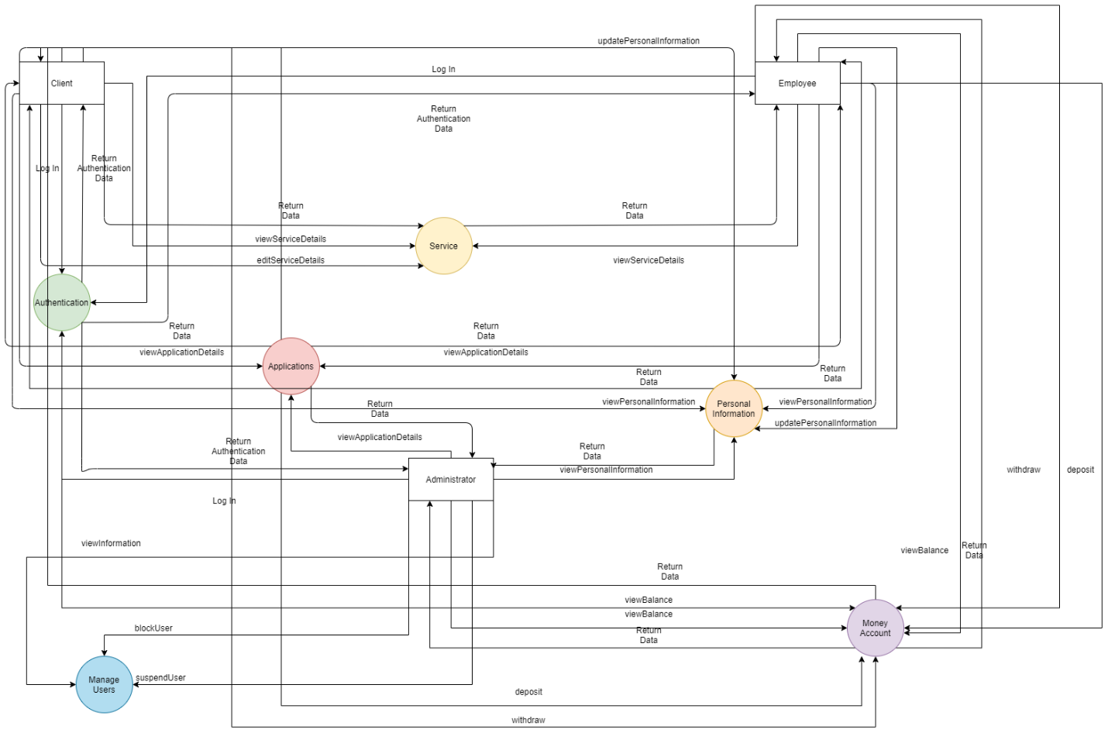

**State Diagram**

*Administrator*

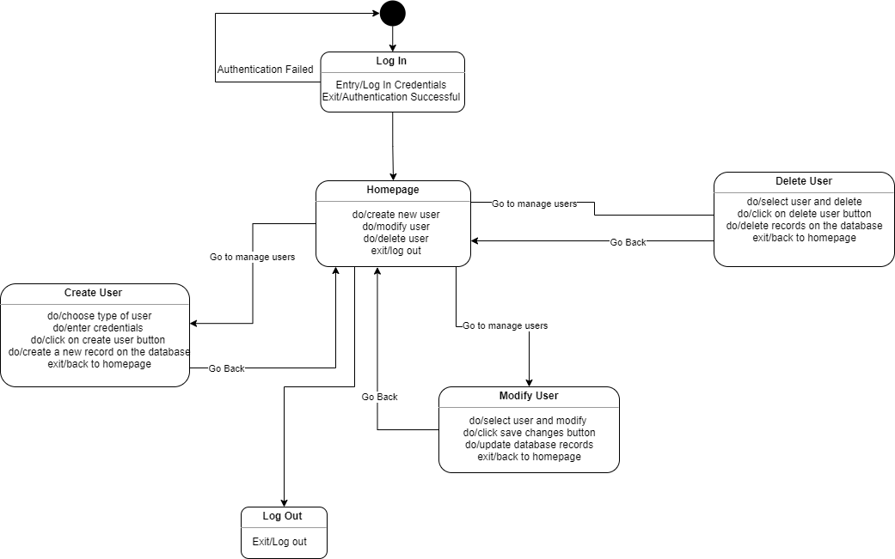

*Employee*

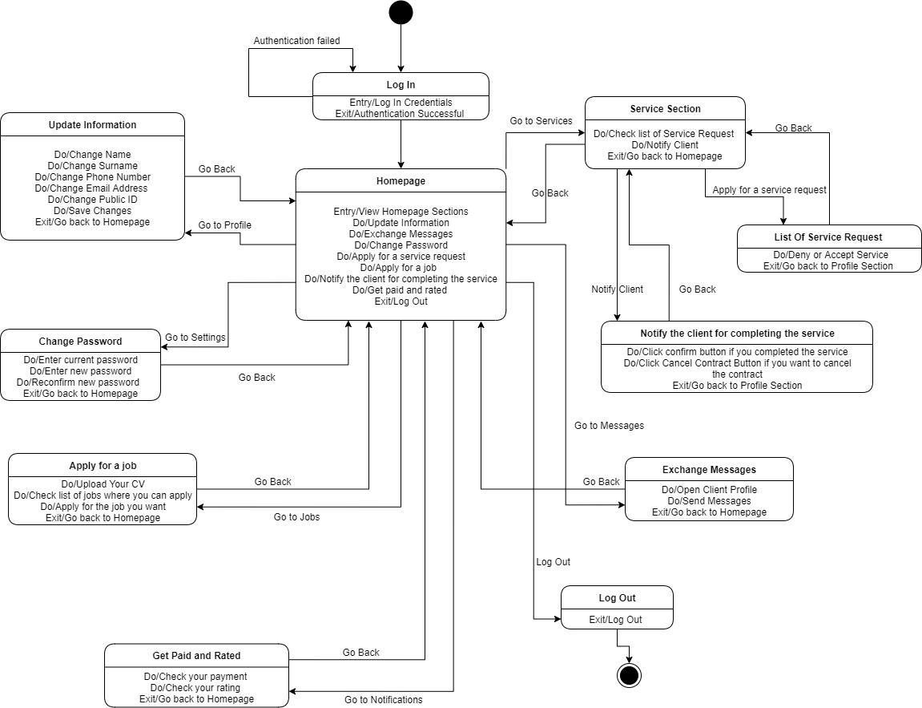

*Client*

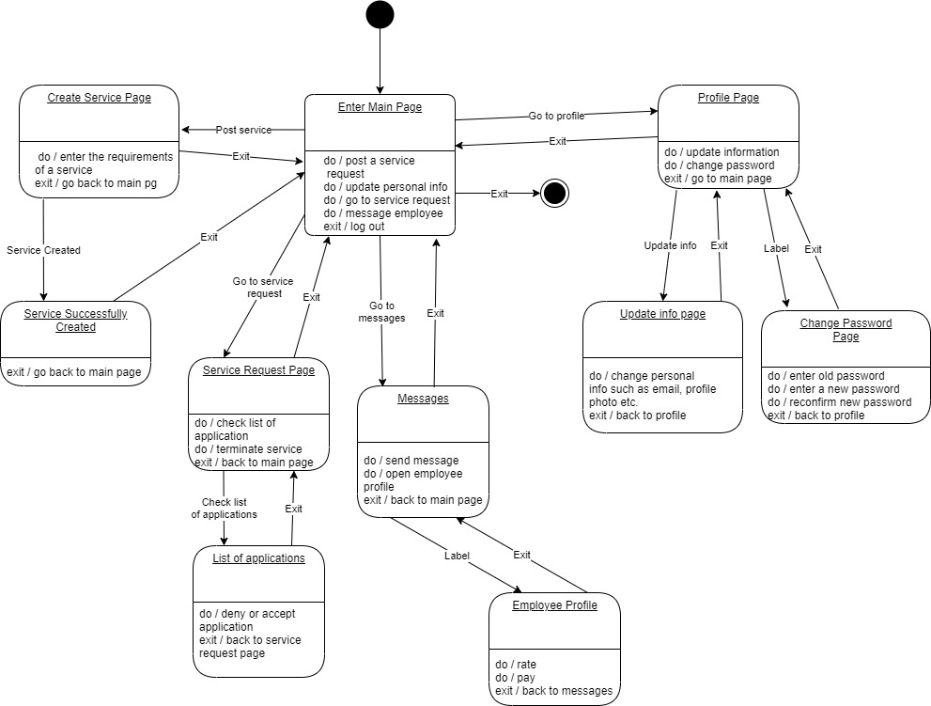

**Entity Relationship Diagram**

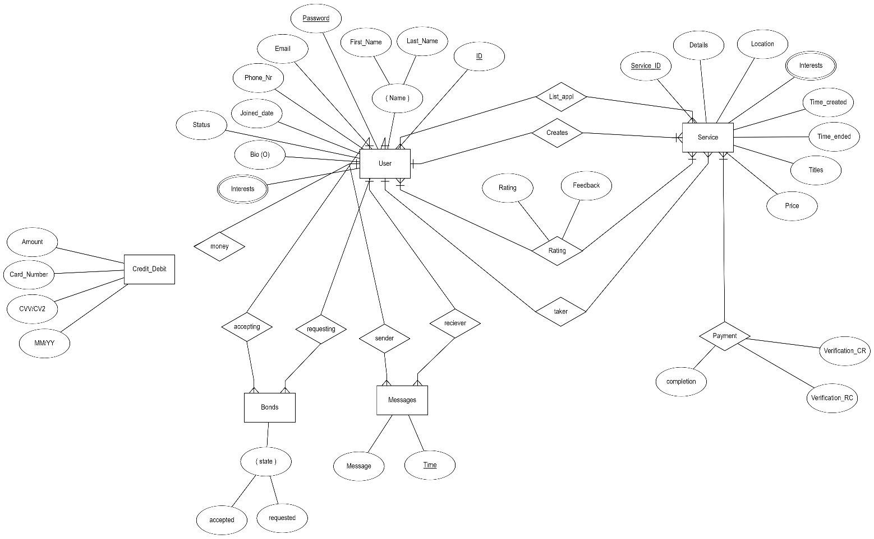

**Relational Schema**

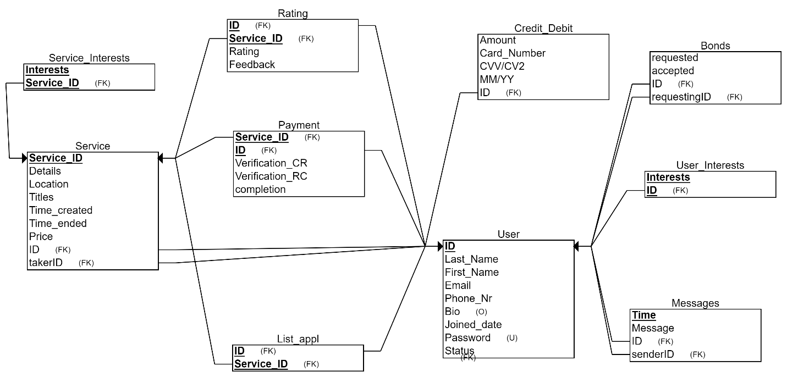

**Appendix – Software Screenshots**

