**데이터베이스**

**Homework for Lecture 9**



|  |  |  |  |
| --- | --- | --- | --- |
| SUBJECT  PROFESSOR SUBMISSION DATE | 데이터베이스  아지즈 교수님  2021.10.15 | MAJOR STUDENT NUMBER  NAME | 소프트웨어학과 2019038044  신주영 |

**Task**

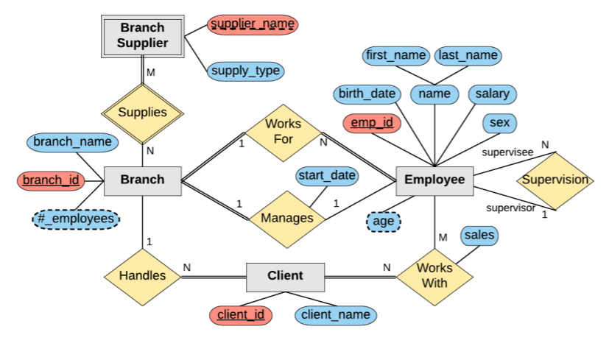

|  |
| --- |
| Step 1 : Strong entity types and single valued attributes  Branch(branch_id, branch_name)  Client(client_id, client_name)  Employee(emp_id, birth_date, first_name, last_name, salary, sex) |
| Step 2 : Weak Entity Type and Single Value Attribute  Branch_Supplier(branch_id, supplier_name, supply_type) |
| Step 3 : Binary 1:1 Relationship Type  Branch(branch_id, branch_name, Manages, start_date) |
| Step 4 : Regular binary 1:N relationship type  Employee(emp_id, birth_date, first_name, last_name, salary, sex, branch_id)  Client(client_id, client_name, branch_id)  Employee(emp_id, birth_date, first_name, last_name, salary, sex, Subemp_id) |
| Step 5 : Binary M:N relationship type  WorksWith(client_id, emp_id, sales)  Supplies(branch_id, supplier_id) |
| Step 6 : Ternary or higher relationship types  X |
| Step 7 : Multi-valued attribute  X |

|  |
| --- |
| 최종  Employee(emp_id, birth_date, first_name, last_name, salary, sex, branch_id)  Branch(branch_id, branch_name, Manages, start_date)  Client(client_id, client_name, branch_id)  WorksWith(client_id, emp_id, sales)  Supplies(branch_id, supplier_id) |