Experimental results under the bare-bone network

1. Measurement under infinite queue size

In the first experiments, we measured average end-to-end delay and rate of packets that arrive later than 150 ms, which is the end-to-end delay constraints, under bottleneck bandwidth at 100 Kbps, 500 Kbps and 1 Mbps, respectively.

1.1. Measure average End-to-End delay with infinite queue size

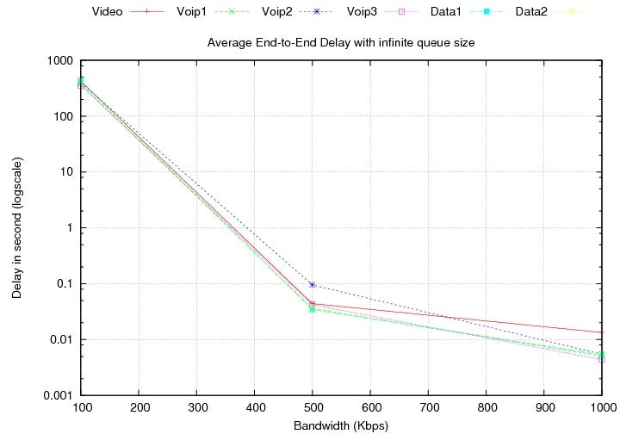

First, we define 20000 of queue size as the infinite queue size since there is no different result with larger queue size than 20000.

As we expected, we can observe that the higher bandwidth, the lower delay. Since we used the infinite queue, there is no dropped packet. As a result, the end-to-end delay exponentially increases at lower bandwidth.

1.2. Measure rate of packets that do not arrive on time (150 ms)

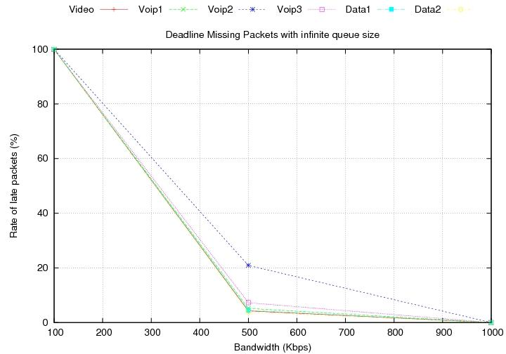

Real-time traffic is time-sensitive. It should meet a specified time limit, which is 150 ms in our experiment. We measured how many packets do not arrive on time (150 ms) and calculated its percentage at different bandwidth. All the packets arrive later than 150 ms at 100Kbps. Less than 10 % of packets for all traffic except for Voip2 do not arrive on time at 500 Kbps. On the other hand, all packets are received on time at 1 Mbps.

2. Experiments with varying queue sizes

In the second experiments, we perform the same experiment, but with different queue sizes. Average delay, packet drop rate and late packet rate are measured in these experiments.

2.1. Average delay

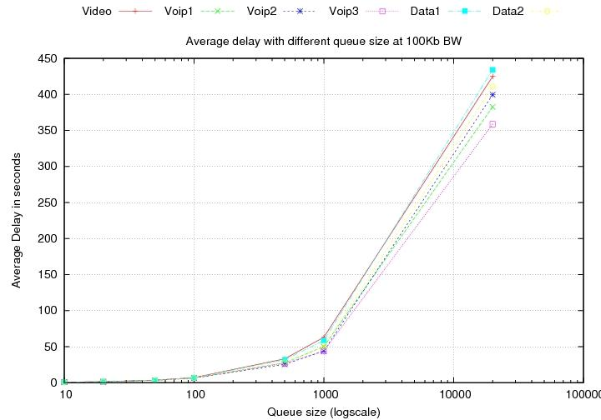

At 100 Kbps, average delay exponentially soars up according to queue sizes. To satisfy the time constraints (150 ms), queue size should not exceed 100 at this bandwidth.

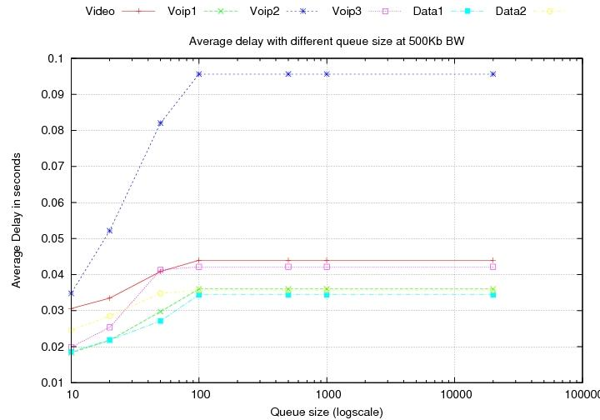

At 500 Kbps, average delay does not exceed 150 ms regardless of queue sizes. In particular, after 100 queue size, there is no significant change. Thus, we can conclude that queue size over 100 does not matter at 500 Kbps.

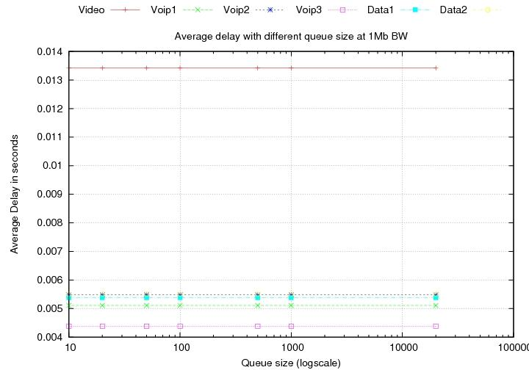

Like the case of 500 Kbps, average delay does not exceed 150 ms and is constant regardless of queue sizes at 1 Mbps, which means that the network is capable of trasferring all traffic at the same time. Therefore, we can conclude that every packet does not wait in the queue.

2.2. Drop rate

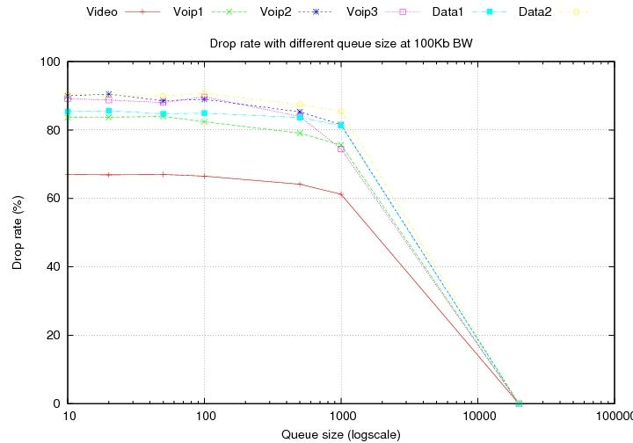

Drop rate significantly decrease after 1000 of queue size at 100 Kbps. This is obvious because every packet that arrives at the core router can be stored in the large queues. We find out that the system needs much larger queue than 1000 to reduce the packet drop rate.

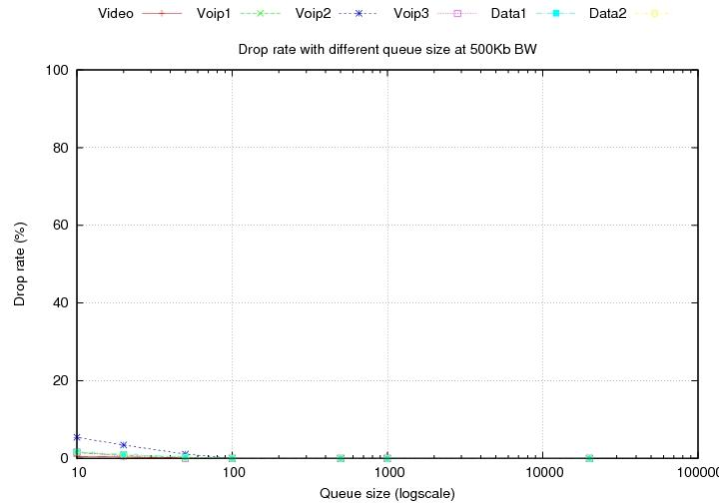

At 500 Kbps, packet drop rate is insignificant, especially with larger queue than 100. We expect that we can adjust drop rates of each of the traffic by applying QoS mechanism in the system. In this case, VoIP2 has a higher packet rate even though it is real-time traffic whereas Data1 and 2 that does not require end-to-end time constraints have really low packet drop rates. We will see their rates are changed after we perform experiments under QoS supported environment.

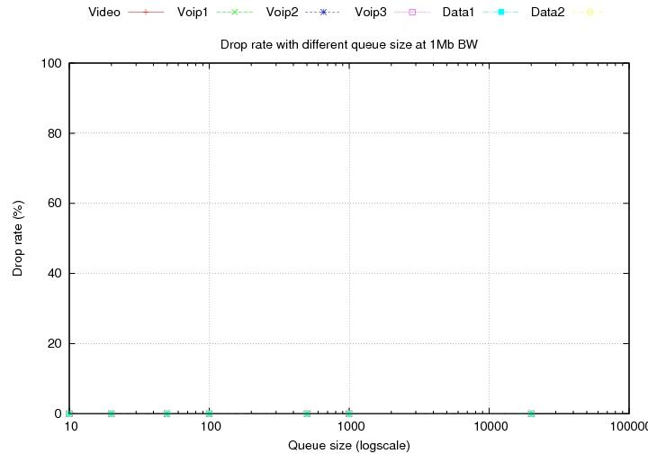

There is no packet drop at 1 Mbps. As I mentioned above, we don’t have to consider queue sizes since the network is capable enough.

2.3. Delayed packet rate

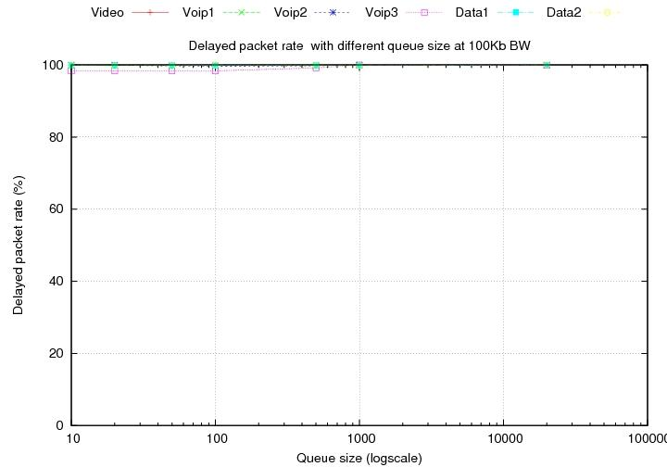

Almost 100 % of packets are received later than 150 ms for all kinds of traffic at 100 Kbps. We may observe how much the delayed packet rate decreases after we apply QoS policy.

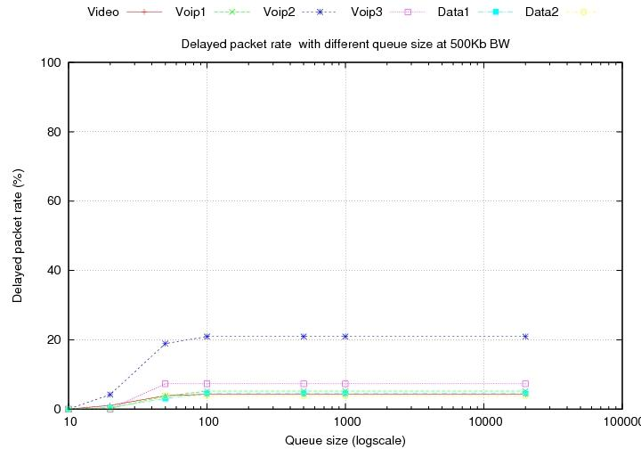

Around 20 % of packets of VoIP2 arrive later than 150 ms at 500 Kbps even though it is time-sensitive data, whereas less than 10 % of delay packets occur for other traffic. After applying QoS, we expect that the rate for VoIP2 is reduced and the rates for Data1 and 2 increase.

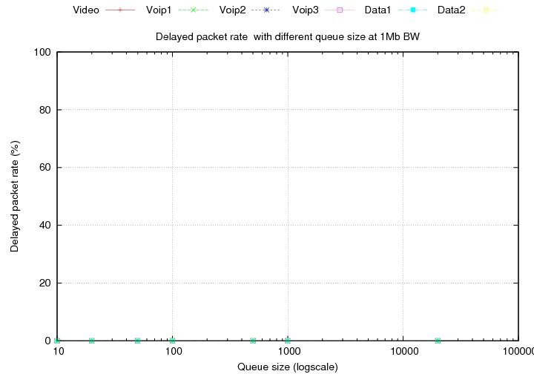

There is no packet that arrives later than 150 ms at 1 Mbps. We can consistently verify that queue size at 1 Mbps bandwidth does not affect the system.