HW1

Graphs:

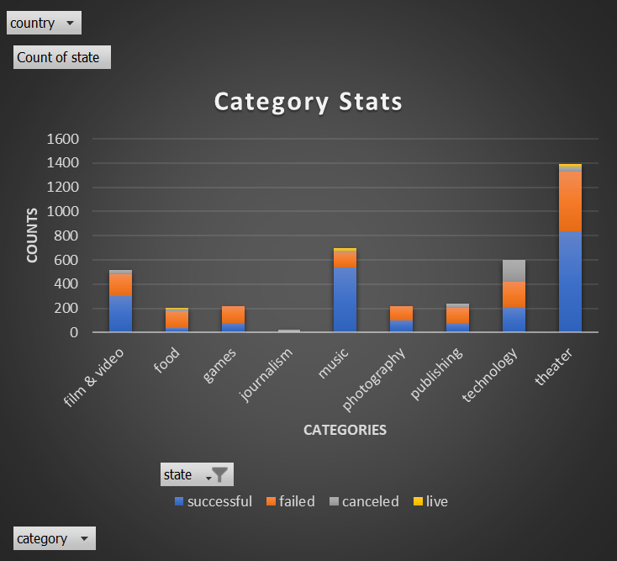

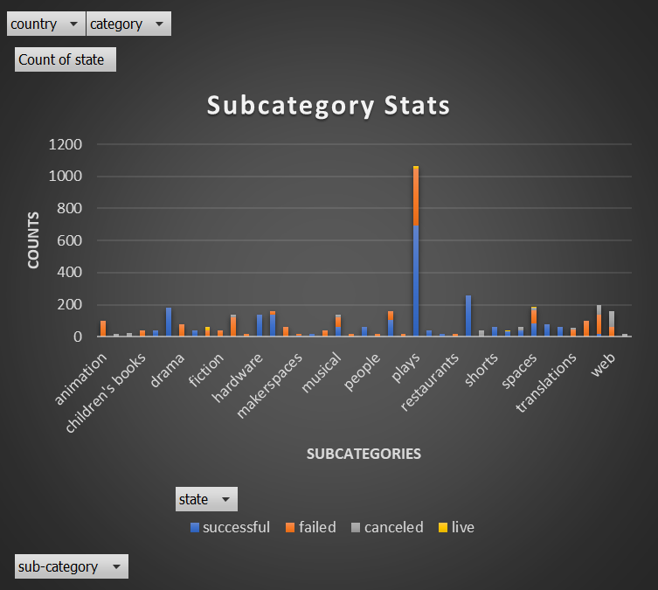

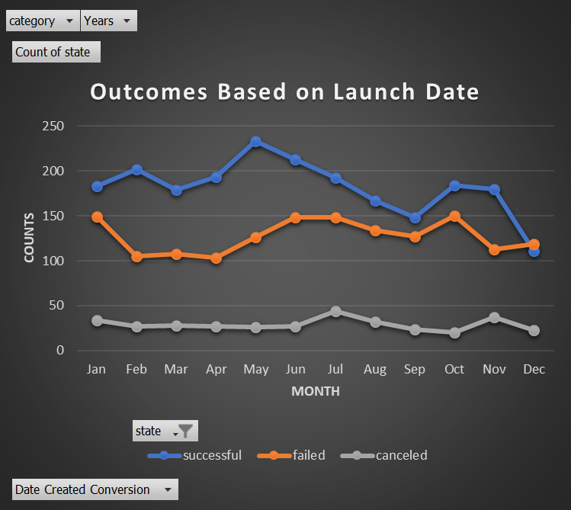

Q&A:

1. What are three conclusions we can make about Kickstarter campaigns given the provided data?

"Music" has the highest success rate and "Theater" has the most campaigns and successes, among all categories.

"Plays" has the most successes of campaigns, among all subcategories.

Successful campaigns counts are highest in May. Successful campaigns exceeds both failed ones, and canceled ones, for all months except for December.

2. What are some of the limitations of this dataset?

Some failed campaigns may successfully raise funds after the kick-starter campaign deadline or from other sources.

Some successful campaigns may not deliver products effectively, returns and refunds may happen, and thus the companies may not collect the funds initially raised during the campaign.

3. What are some other possible tables/graphs that we could create?

Pivot Charts:

Pledged Vs Category

Average of Percentage Founded Vs Category

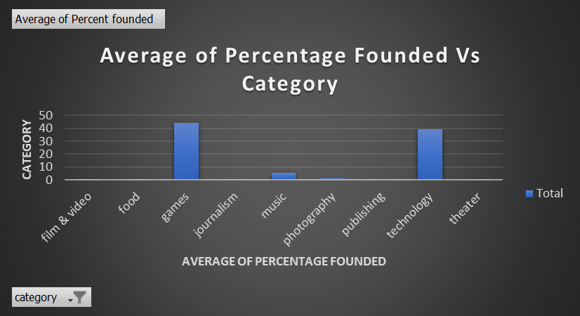

Scattered Plots:

Percent founded Vs Backers count

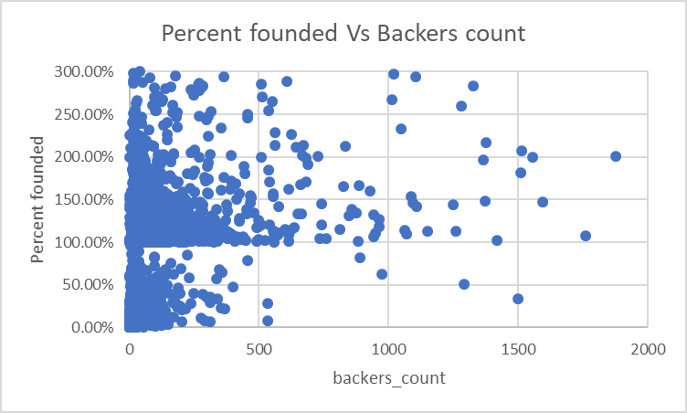

Percent founded Vs Goal

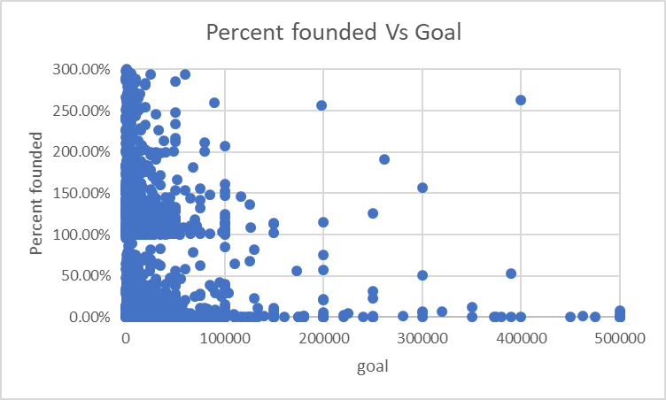

Bonus:

