**Nagios服务器架设**

1. Nagios服务器安装过程
2. 1）配置服务器端IP地址

[root@localhost ~]# vi /etc/sysconfig/network-scripts/ifcfg-eth0

# Advanced Micro Devices [AMD] 79c970 [PCnet32 LANCE]

DEVICE=eth0

BOOTPROTO=none

HWADDR=00:0c:29:fe:39:A1

ONBOOT=yes

NETMASK=255.255.255.0

IPADDR=192.168.6.199

GATEWAY=192.168.6.1

TYPE=Ethernet

2）安装Nagios

A，安装前准备

1）创建nagios程序用户、组

[root@localhost ~]# useradd -s /sbin/nologin nagios

[root@localhost ~]# mkdir /usr/local/nagios

[root@localhost ~]# chown -R nagios.nagios /usr/local/nagios/

2)保证系统中sendmail服务器要开启

[root@localhost ~]# service sendmail status

sendmail (pid 3090) 正在运行...

B、编译安装Nagios

[root@localhost ~]# cd /aaa/

[root@localhost aaa]# tar zxf nagios-3.2.0.tar.gz

[root@localhost aaa]# cd nagios-3.2.0

[root@localhost nagios-3.2.0]# ./configure --prefix=/usr/local/nagios/

[root@localhost nagios-3.2.0]# make all ; make install ; make install-init ; make install-commandmode ; make install-config

[root@localhost nagios-3.2.0]# chkconfig --add nagios

[root@localhost nagios-3.2.0]# chkconfig nagios on

[root@localhost nagios-3.2.0]# chkconfig --list nagios

nagios 0:关闭 1:关闭 2:启用 3:启用 4:启用 5:启用 6:关闭

C、安装Nagios插件

你可以从<http://www.nagios.org官方网站上下载最新的nagios>插件

[root@localhost nagios-3.2.0]#cd /aaa

[root@localhost aaa]# tar zxf nagios-plugins-1.4.14.tar.gz

[root@localhost aaa]# cd nagios-plugins-1.4.14

[root@localhost nagios-plugins-1.4.14]# ./configure --prefix=/usr/local/nagios/ ; make ; make install

D、安装Nagios的汉化包

[root@localhost nagios-plugins-1.4.14]# cd /aaa/

[root@localhost aaa]# tar jxf nagios-cn-3.2.0.tar.bz2

[root@localhost aaa]# cd nagios-cn-3.2.0

[root@localhost nagios-cn-3.2.0]# ./configure ; make all ; make install

E、安装LAMP架构

[root@localhost ~]# mount /dev/cdrom /media/

[root@localhost ~]# vi /etc/yum.repos.d/rhel-debuginfo.repo

[rhel-debuginfo]

name=Red Hat Enterprise Linux $releasever - $basearch – Debug

baseurl=file:///media/Server

enabled=1

gpgcheck=0

gpgkey=file:///etc/pki/rpm-gpg/RPM-GPG-KEY-redhat-release

[root@localhost ~]# yum -y install php* mysql* http*

[root@localhost ~]# service httpd start

启动 httpd： [确定]

[root@localhost ~]# chkconfig httpd on

[root@localhost ~]# vi /etc/httpd/conf/httpd.conf

231 User apache

232 Group apache

391 DirectoryIndex index.php index.html index.html.var

992 #setting for nagios

993 ScriptAlias /nagios/cgi-bin "/usr/local/nagios/sbin"

994 <Directory "/usr/local/nagios/sbin">

995 AuthType Basic

996 Options ExecCGI

997 AllowOverride None

998 Order allow,deny

999 Allow from all

1000 AuthName "nagios access"

1001 AuthUserFile /usr/local/nagios/etc/htpasswd

1002 Require valid-user

1003 </Directory>

1004 Alias /nagios "/usr/local/nagios/share"

1005 <Directory "/usr/local/nagios/share">

1006 AuthType Basic

1007 Options ExecCGI

1008 AllowOverride None

1009 Order allow,deny

1010 Allow from all

1011 AuthName "nagios access"

1012 AuthUserFile /usr/local/nagios/etc/htpasswd

1013 Require valid-user

1014 </Directory>

创建apache目录的验证文件“/usr/local/nagios/etc/htpasswd”

[root@localhost ~]# htpasswd -c /usr/local/nagios/etc/htpasswd benet

New password:

Re-type new password:

Adding password for user benet

重启apache服务器并进行验证nagios登陆情况

[root@localhost ~]# service httpd restart

停止 httpd： [确定]

启动 httpd： [确定]

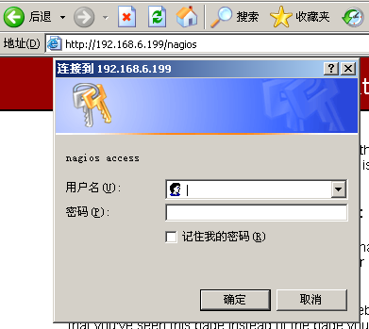

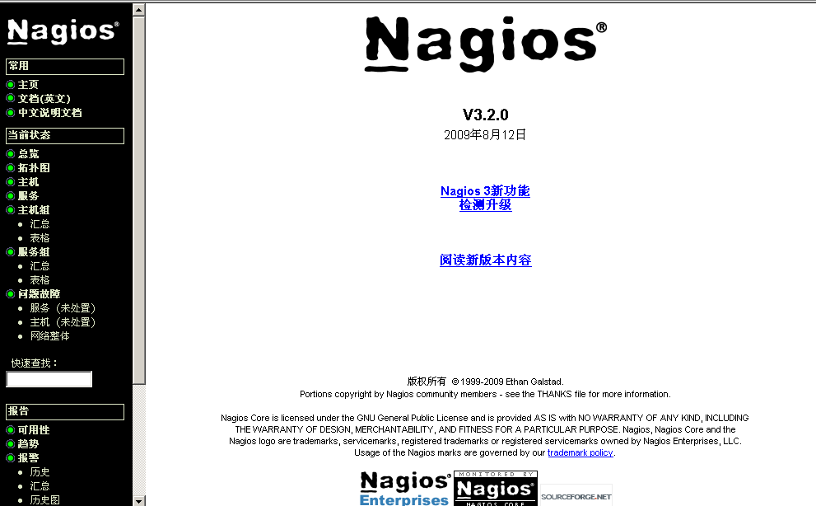

至此nagios服务器安装结束

1. Nagios服务器配置过程

Nagios的配置过程：主机，主机组，服务，服务组，联系人，联系人组，监控时间，监控命令等，配置文件及配置项之间相互关联，彼此引用。

（Nagios配置的核心思想）

**最重要的4点：**

**第一：要定义监控哪些主机、主机组（hosts.cfg），服务，服务组(services.cfg)**

**第二：要定义这个监控项需要通过什么命令实现(commands.cfg)**

**第三：要定义监控的时间段(timeperiods.cfg)**

**最后：要定义主机或服务出现问题时要通知的联系人或联系人组(contacts.cfg)**

1. 定义hosts.cfg文件（**监控哪些主机、主机组（hosts.cfg））**

[root@localhost ~]# cd /usr/local/nagios/etc/

[root@localhost etc]# vi hosts.cfg

define host{

use linux-server

host_name web

alias benet-web

address 192.168.6.199

}

define host{

use linux-server

host_name mysql

alias benet-mysql

address 192.168.6.200

}

define hostgroup{

hostgroup_name sa-servers

alias sa servers

members web,mysql

}

2）定义services.cfg(**监控哪些服务，服务组(services.cfg))**

[root@localhost etc]# vi services.cfg

################- benet web -##########################

define service{

use local-service

host_name web

service_description PING

check_command check_ping!100.0,20%!500.0,60%

}

define service{

use local-service

host_name web

service_description SSH

check_command check_ssh

}

define service{

use local-service

host_name web

service_description SSHD

check_command check_tcp!22

}

define service{

use local-service

host_name web

service_description http

check_command check_http

}

#####################- MYSQL -##########################

define service{

use local-service

host_name mysql

service_description PING

check_command check_ping!100.0,20%!500.0,60%

}

define service{

use local-service

host_name mysql

service_description SSH

check_command check_ssh

}

define service{

use local-service

host_name mysql

service_description ftp

check_command check_ftp

}

define service{

use local-service

host_name mysql

service_description mysqlport

check_command check_tcp!3306

}

注意：hosts.cfg和services.cfg两个文件默认在/usr/local/nagios/etc并不存在，需要手动创建。

Check_ping!100.0,20%!500.0,60%

命令！告警延时，丢包率！严重告警延时，丢包率。

Check_ssh!22!10

命令！端口！连接超时时间

3）定义contacts.cfg(**定义主机或服务出现问题时要通知的联系人或联系人组)**

[root@localhost etc]# cd /usr/local/nagios/etc/objects/

[root@localhost objects]# vi contacts.cfg

35 email root@localhost ;

4)定义cgi.cfg

[root@localhost etc]# cd /usr/local/nagios/etc/

[root@localhost etc]# vi cgi.cfg

107 default_user_name=benet

119 authorized_for_system_information=nagiosadmin,benet

131 authorized_for_configuration_information=nagiosadmin,benet

144 authorized_for_system_commands=benet

157 authorized_for_all_services=nagiosadmin,benet

158 authorized_for_all_hosts=nagiosadmin,benet

171 authorized_for_all_service_commands=nagiosadmin,benet

172 authorized_for_all_host_commands=nagiosadmin,benet

5)定义nagios.cfg

[root@localhost etc]# vi nagios.cfg

19 log_file=/usr/local/nagios/var/nagios.log

30 cfg_file=/usr/local/nagios/etc/hosts.cfg //添加本行

31 cfg_file=/usr/local/nagios/etc/services.cfg //添加本行

32 cfg_file=/usr/local/nagios//etc/objects/commands.cfg

33 cfg_file=/usr/local/nagios//etc/objects/contacts.cfg

34 cfg_file=/usr/local/nagios//etc/objects/timeperiods.cfg

35 cfg_file=/usr/local/nagios//etc/objects/templates.cfg

38 #cfg_file=/usr/local/nagios//etc/objects/localhost.cfg

[root@localhost objects]# ls ../

cgi.cfg hosts.cfg nagios.cfg services.cfg

commands.cfg htpasswd objects templates.cfg

contacts.cfg localhost.cfg resource.cfg timeperiods.cfg

1. Nagios的运行和维护
2. 验证nagios主配置文件的语法正确性

[root@localhost etc]# /usr/local/nagios/bin/nagios -v /usr/local/nagios/etc/nagios.cfg

Total Warnings: 0

Total Errors: 0

Things look okay - No serious problems were detected during the pre-flight check

1. 启动与停止nagios

[root@localhost etc]# service nagios start

Starting nagios:This account is currently not available.

done.

[root@localhost etc]# service nagios status

nagios (pid 5106) is running...

[root@localhost etc]# service nagios stop

Stopping nagios: .done.

[root@localhost etc]# service nagios restart

Running configuration check...done.

Stopping nagios: No lock file found in /usr/local/nagios//var/nagios.lock

Starting nagios:This account is currently not available.

done.

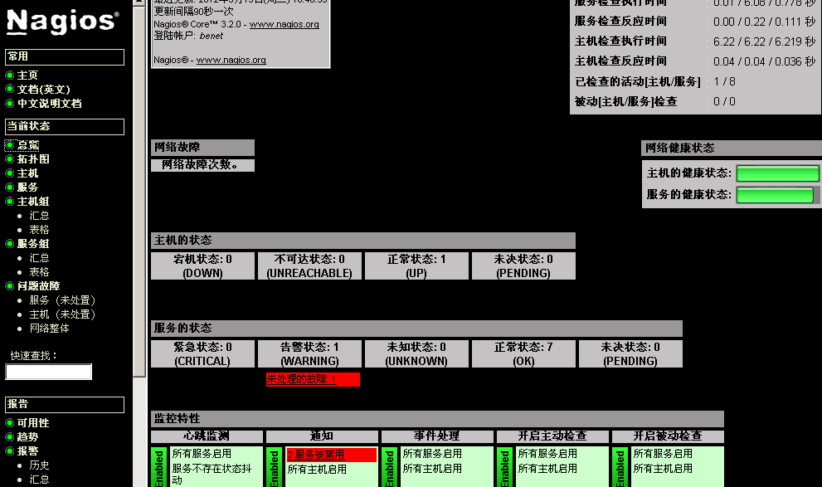

1. Nagios性能分析图表的实现
2. 安装PNP支持包rrdtool工具

[root@localhost aaa]# tar zxf rrdtool-1.4.5.tar.gz

[root@localhost aaa]# cd rrdtool-1.4.5

[root@localhost rrdtool-1.4.5]# ./configure --prefix=/usr/local/rrdtool ; make ; make install

2）安装PNP

[root@localhost rrdtool-1.4.5]# cd /aaa/

[root@localhost aaa]# tar zxf pnp-0.4.13.tar.gz

[root@localhost aaa]# cd pnp-0.4.13

[root@localhost pnp-0.4.13]# ./configure --with-nagios-user=nagios --with-nagios-group=nagios --with-rrdtool=/usr/local/rrdtool/bin/rrdtool --with-perfdata-dir=/usr/local/nagios/share/perfdata ; make all ; make install ; make install-config ; make install-init

1. 配置PNP

A,创建默认配置文件

[root@localhost pnp-0.4.13]# cd /usr/local/nagios/etc/pnp/

[root@localhost pnp]# cp process_perfdata.cfg-sample process_perfdata.cfg

[root@localhost pnp]# cp npcd.cfg-sample npcd.cfg

[root@localhost pnp]# cp rra.cfg-sample rra.cfg

[root@localhost pnp]# chown -R nagios:nagios /usr/local/nagios/etc/pnp/

B，修改process_perfdata.cfg

[root@localhost pnp]# vi /usr/local/nagios/etc/pnp/process_perfdata.cfg

44 LOG_LEVEL = 2

1. 修改Nagios主配置文件

A,增加小太阳图标

[root@localhost pnp]# cd /usr/local/nagios/etc/objects/

[root@localhost etc]# vi templates.cfg

define host{

name hosts-pnp

register 0

action_url /nagios/pnp/index.php?host=$HOSTNAME$

process_perf_data 1

}

define service{

name services-pnp

register 0

action_url /nagios/pnp/index.php?host=$HOSTNAME$&srv=$SERVICEDESC$

process_perf_data 1

}

B、修改nagios.cfg

找到如下几行去掉注释

[root@localhost etc]# vi nagios.cfg

833 process_performance_data=1

845 host_perfdata_command=process-host-perfdata

846 service_perfdata_command=process-service-perfdata

C、修改commands.cfg

227 # 'process-host-perfdata' command definition

228 define command{

229 command_name process-host-perfdata

230 command_line /usr/local/nagios/libexec/process_perfdata.pl

231 }

232

233

234 # 'process-service-perfdata' command definition

235 define command{

236 command_name process-service-perfdata

237 command_line /usr/local/nagios/libexec/process_perfdata.pl

238 }

D、修改hosts.cfg文件和services.cfg文件

[root@localhost ~]# vi /usr/local/nagios/etc/hosts.cfg

define host{

use linux-server,hosts-pnp

host_name web

alias benet-web

address 192.168.6.199

}

define host{

use linux-server,hosts-pnp

host_name mysql

alias benet-mysql

address 192.168.6.200

}

define hostgroup{

hostgroup_name sa-servers

alias sa servers

members web,mysql

}

[root@localhost ~]# vi /usr/local/nagios/etc/services.cfg

################- benet web -##########################

define service{

use local-service,services-pnp

host_name web

service_description PING

check_command check_ping!100.0,20%!500.0,60%

}

define service{

use local-service,services-pnp

host_name web

service_description SSH

check_command check_ssh

}

注意项：别心急看小太阳数据，等会儿就有了。

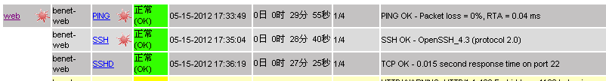

点击小太阳，出现对主机或服务的监控页面

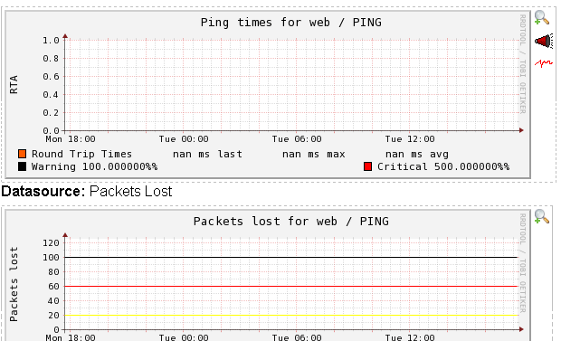

五，利用插件扩展Nagios的监控功能

下面我们通过在nagios服务端和客户端安装NRPE插件来搭建一个更加完善的Nagios监控系统。

1）配置nagios客户端（即远端被监控主机192.168.6.200）

A）安装Nagios插件

登陆192.168.6.200客户端

[root@localhost ~]# cd /aaa/

[root@localhost aaa]# useradd -s /sbin/nologin nagios

[root@localhost aaa]# tar zxf nagios-plugins-1.4.14.tar.gz

[root@localhost aaa]# cd nagios-plugins-1.4.14

[root@localhost nagios-plugins-1.4.14]# ./configure ; make ;make install

[root@localhost nagios-plugins-1.4.14]# chown nagios:nagios /usr/local/nagios/

[root@localhost nagios-plugins-1.4.14]# chown -R nagios.nagios /usr/local/nagios/libexec/

B）安装NRPE插件

[root@localhost nagios-plugins-1.4.14]# cd /aaa/

[root@localhost aaa]# tar zxf nrpe-2.12.tar.gz

[root@localhost aaa]# cd nrpe-2.12

[root@localhost nrpe-2.12]# ./configure ; make all ; make install-plugin ; make install-daemon ; make install-daemon-config

C）修改NRPE配置文件

[root@localhost nrpe-2.12]# vi /usr/local/nagios/etc/nrpe.cfg

79 allowed_hosts=127.0.0.1,192.168.6.199

192.168.6.199：指定nagios服务器地址

D）启动NRPE

[root@localhost nrpe-2.12]# /usr/local/nagios/bin/nrpe -c /usr/local/nagios/etc/nrpe.cfg -d

[root@localhost nrpe-2.12]# netstat -antl |grep 5666

tcp 0 0 0.0.0.0:5666 0.0.0.0:* LISTEN

E)测试NRPE

[root@localhost nrpe-2.12]# /usr/local/nagios/libexec/check_nrpe -H 127.0.0.1

NRPE v2.12

如果出现NRPE v2.12表明NRPE已经正常工作

定义让nagios服务器监控我本机上的内容（当前用户数，CPU，内存，硬盘等信息）

[root@localhost libexec]# vi /usr/local/nagios/etc/nrpe.cfg

199 command[check_users_1]=/usr/local/nagios/libexec/check_users -w 5 -c 10

200 command[check_load_1]=/usr/local/nagios/libexec/check_load -w 15,10,5 - c 30,25,20

201 command[check_sda1_1]=/usr/local/nagios/libexec/check_disk -w 20% -c 10 % -p /dev/sda1

202 command[check_zombie_procs_1]=/usr/local/nagios/libexec/check_procs -w 5 -c 10 -s Z

203 command[check_total_procs_1]=/usr/local/nagios/libexec/check_procs -w 1 50 -c 200

重启NRPE

[root@localhost ~]# ps -elf |grep nrpe

5 S nagios 22379 1 0 75 0 - 1243 - 17:59 ? 00:00:00 /usr/local/nagios/bin/nrpe -c /usr/local/nagios/etc/nrpe.cfg -d

0 R root 22586 4247 0 78 0 - 1039 - 18:09 pts/0 00:00:00 grep nrpe

[root@localhost ~]# kill -9 22379

[root@localhost ~]# /usr/local/nagios/bin/nrpe -c /usr/local/nagios/etc/nrpe.cfg –d

2，配置nagios服务器端

登陆nagios服务器端：192.168.6.199

1）安装NRPE插件

[root@localhost etc]# cd /aaa/

[root@localhost aaa]# tar zxf nrpe-2.12.tar.gz

[root@localhost aaa]# cd nrpe-2.12

[root@localhost nrpe-2.12]# ./configure ; make ; make install-plugin

1. 测试插件能否取得与客户端192.168.6.200的联系

[root@localhost nrpe-2.12]# /usr/local/nagios/libexec/check_nrpe -H 192.168.6.200

NRPE v2.12

出现NRPE v2.12就证明成功联系上客户端

3）定义一个check_nrpe监控命令

[root@localhost nrpe-2.12]# vi /usr/local/nagios/etc/objects/commands.cfg

define command{

command_name check_nrpe

command_line $USER1$/check_nrpe -H $HOSTADDRESS$ -c $ARG1$

}

1. 添加远程主机监控项

[root@localhost nrpe-2.12]# vi /usr/local/nagios/etc/services.cfg

################- benet web -##########################

define service{

use local-service,services-pnp

host_name web

service_description PING

check_command check_ping!100.0,20%!500.0,60%

}

define service{

use local-service,services-pnp

host_name web

service_description SSH

check_command check_ssh

}

define service{

use local-service,services-pnp

host_name web

service_description SSHD

check_command check_tcp!22

}

define service{

use local-service,services-pnp

host_name web

service_description http

check_command check_http

}

#####################- MYSQL -##########################

define service{

use local-service,services-pnp

host_name mysql

service_description PING

check_command check_ping!100.0,20%!500.0,60%

}

define service{

use local-service,services-pnp

host_name mysql

service_description SSH

check_command check_ssh

}

define service{

use local-service,services-pnp

host_name mysql

service_description ftp

check_command check_ftp

}

define service{

use local-service,services-pnp

host_name mysql

service_description mysqlport

check_command check_tcp!3306

}

################## nrpe ###################################

define service{

use local-service

host_name mysql

service_description users

check_command check_nrpe!check_users_1

}

define service{

use local-service

host_name mysql

service_description load

check_command check_nrpe!check_load_1

}

define service{

use local-service

host_name mysql

service_description disk

check_command check_nrpe!check_sda1_1

}

define servicegroup{

servicegroup_name servergroup

alias server-group

members web,PING,web,SSH,web,SSHD,web,http,mysql,users,mysql,load,mysql,disk

}

6)测试并重新启动nagios服务

[root@localhost ~]# service nagios restart

